Dr. Nadia Hameed
M.B.ChB/ FIBMS Path

Chronic inflammation

Chronic inflammation Chronic inflammation is defined as prolonged process in which tissue destruction, inflammation and attempt to repair occur at the same time.

Causes of chronic inflammation:
Chronic inflammation can be caused by one of the following 3 ways:
- Progression of acute inflammation e.g. osteomyelitis
- Recurrent attacks of acute inflammation lead to chronicity e.g. in recurrent urinary tract infection leading to chronic pyelonephritis, repeated acute infection of gallbladder leading to chronic cholecystitis.
- Chronic inflammation starting de novo:
- Infection: Tuberculosis. TB. Leprosy, Syphilis, Cat-scratch disease, parasitic infection (Schistosomiasis)
- Foreign body : surgical sutures, silicon, atherosclerotic patch in vessles
- Hypersensitivity reactions (HSR): Systemic Lupus Erythematous (SLE), Rheumatoid Arthritis (RA)

Morphological Features of Chronic Inflammation
I - Infiltration by mononuclear cells:
The mononuclear cells are become predominant after 48 hours.
These include: Macrophages, Lymphocytes, Plasma cells.
Eosinophils, Mast cells can be seen in certain circumstances .
Macrophages
  - Scattered all over (microglia, Kupffer cells, sinus histiocytes, alveolar macrophages, etc.
  - Circulate as monocytes and reach site of injury within 24 – 48 hrs and transform to tissue macrophages
  - Become activated by T cell-derived cytokines, endotoxins, and other products of inflammation
T and B lymphocytes
  - Antigen-activated (via macrophages and dendritic cells)
  - Release macrophage-activating cytokines (in turn, macrophages release lymphocyte-activating cytokines until inflammatory stimulus is removed)
Plasma cells
Terminally differentiated B cells (of lymphocytes).Produce antibodies.
Eosinophils
Found especially at sites of parasitic infection, or at allergic (IgE-mediated) sites.
Eosinophils have highly cationic proteins, which are toxic to parasites

Other cells in chronic inflammation:
- Multinucleate giant cells: huge cells with many nuclei formed by fusion of macrophages/epitheloid cells. They are associated with foreign materials or accompany reactions to certain organisms as TB.
- Fibroblasts and collagen: Collagen production is a common feature of chronic inflammation. Chemical mediators stimulate collagen secreting cells and fibrosis.

II - Tissue destruction
Occur due to:
- Inflammatory cell mediators.
- Persistent infecting material.
III - Removal of damaged tissue, (healing):
- Occur by proliferation of small blood vessels, (angiogenesis).
- Proliferation of fibroblast, (fibrosis-repair).

Types of chronic inflammation
chronic inflammation is subdivided into 2 types:
- Chronic non-specific inflammation. It is characterised by mononuclear chronic inflammatory cell infiltration e.g. chronic osteomyelitis, lung abscess.
- Chronic granulomatous inflammation. It is characterized by formation of granulomas e.g. tuberculosis, foreign body

Chronic non-specific inflammation. Due to Progression of acute inflammation e.g. osteomyelitis or recurrent attacks of acute inflammation lead to chronicity. The tissue infiltrated by chronic mononuclear cells.

Chronic Granulomatous Inflammation (GI)
 Definition: a type or pattern of chronic inflammation defined by the presence of granulomas which are small,0.5 to 2 mm collections of modified "epithelioid" macrophages and giant cells (fused epithelioid or macrophages), surrounded by a rim of lymphocytes with a background of new capillaries, fibroblasts, and new collagen (fibrosis).
Granulomas occur in response to various diseases
- Foreign body: surgical suture, …..etc
- Tuberculosis (Tb) , Fungal (mycotic) infections, syphilis
- Tumor
Two factors necessary for granuloma formation
 Presence of indigestible organisms or particles (Tb, mineral oil, etc)
 Cell mediated immunity (T cells)

Composition of granuloma
a granuloma has the following structural composition:
1. Necrosis. Necrosis may be a feature of some granulomatous conditions e.g. central caseation necrosis of tuberculosis
1. Epithelioid cells which are modified macrophages
2. Multinucleate giant cells. Multinucleate giant cells are formed by fusion of adjacent epithelioid cells and may have 20 or more nuclei. These nuclei may be arranged at the periphery like horseshoe or ring, or are clustered at the two poles (Langhans’ giant cells), or they may be present centrally (foreign body giant cells). The former are commonly seen in tuberculosis while the latter are common in foreign body tissue reactions.
3. Lymphocytes cuff
4. Fibrosis. Fibrosis is a feature of healing by proliferating fibroblasts at the periphery of granuloma.

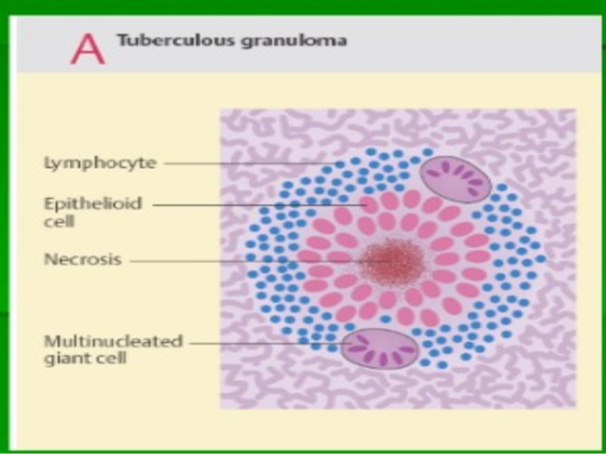

Modified macrophages are characteristic:
Epithelioid cells modified macrophages developed when indigestible antigen counteracted – seen in tuberculosis and sarcoidosis and others
Multinucleate giant cells are formed by fusion of macrophages or epithelioid cells –they may be seen in chronic granulomatous. According to nuclei arrangement, the cell gained special name and diagnosis – foreign body giant cell (in foreign body granuloma), Langhans giant cell (TB granuloma), Touton giant cell (tumor). IL-1 is important in the initiation, while TNF is responsible for its maintenance.

Local and general systemicEffects of chronic inflammation:
1. Local
a. Tissue destruction (e.g. peptic ulcer perforation, rheumatoid arthritis)
b. Fibrosis (e.g. cardiac valves)
2. General
a. Hyperplasia of mononuclear/phagocytic cells in lymph nodes, spleen, liver and bone marrow
b. Immune response
i. Antibody production – increase in γ-globulins
ii. Cell-mediated immunity (tissue destruction e.g. tuberculosis)
iii. Splenomegaly
c. Changes in blood
i. Normocytic, normochromic anaemia
ii. Persistence of acute phase reaction proteins (e.g. c-reactive protein), serum amyloid A protein, haptoglobins, complement components, fibrinogen, ceruloplasmin

Outcome of chronic inflammation
 Resolution/regeneration/restitution of normal structure.
 Repair/organization/healing by connective tissue/ fibrosis/ scarring.
 It can continue indefinitely--some disease processes are capable of continuing indefinitely such as rheumatoid arthritis.

