NEOPLASIA
Neoplasia is a very important topic in pathology because neoplasms are both common and serious diseases. A neoplasm means a new growth which is characterized by uncontrolled tissue proliferation.
Oncology (greek onco=tumor=swelling, logy=study) is the study of neoplasm. Cancer is a term applied for any malignant tumor.
The entire population of cells within a tumor arises from a single cell, referred to as tumor initiating cell (T-IC). This cell has the initial genetic change (mutation). A given tumor, therefore, consist of T-IC and its progeny which called collectively clone of cells and hence tumors are said to be clonal.
Role of tumor suppressor genes in tumor development:
Normally, the cell enters nuclear and cytoplasmic phases of division after receiving growth signals from growth factors. This will activate three pathways
- The JAK- STAT pathway and JAK - MAP kinase pathway, both are responsible for activation of gene expression producing components required for cell division and formation of E2F molecule that lead to upgrading the nuclear cell division cycle from G1-S phase.
- JAK - AKT pathway that block apoptosis.
If there is any genetic aberration tumor suppressor gene P53 will activated producing mediators that activate RB gene (retinoblastoma gene tumor suppressor gene) which interne block the E2F molecule and cell cycle will be interrupted.
If the genetic aberration repaired the cell cycle will re-enhanced, if not P53 will activate apoptosis (programmed cell death)
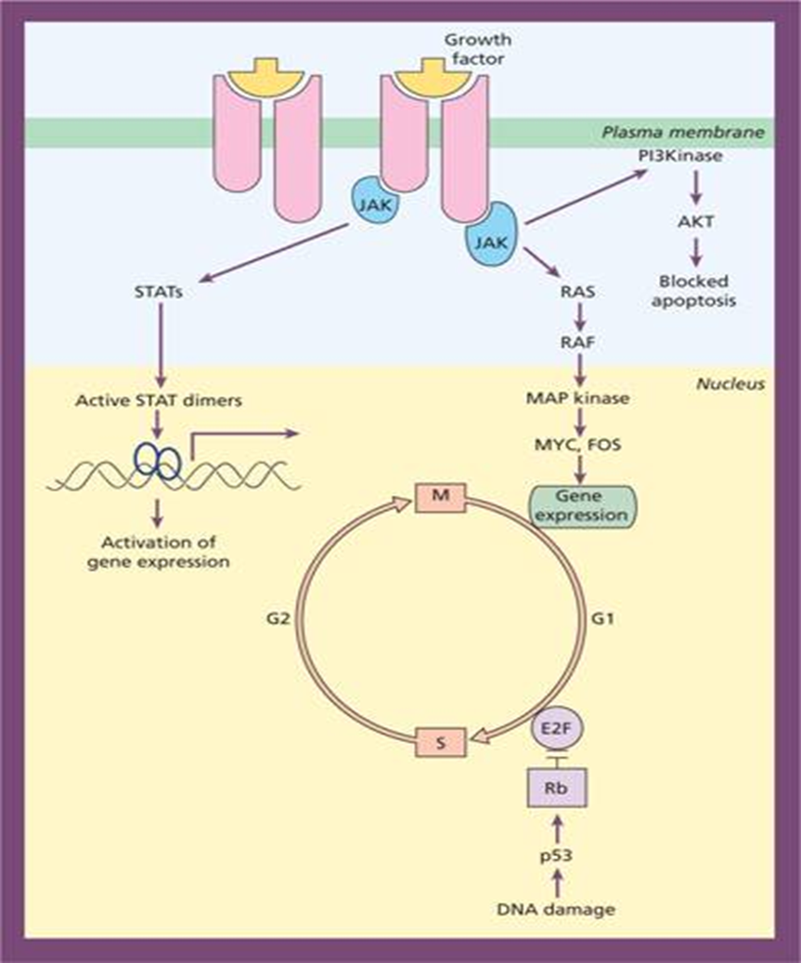

Component of each tumor: Each tumor consists of:
- Neoplastic cell
- Stromal cells: which made of connective tissue and blood vessels providing nutrition and blood supply.
The relative proportions of the two components vary in different tumors. If the stroma is scant i.e. the tumor consist predominantly of neoplastic cells this tumor will be soft and fleshy. Conversely, if the tumor with abundant stroma, especially fibrous stroma, the tumor was referred to as desmoplastic.
Nomenclature of neoplasms:
Tissues in general are:
- epithelial tissue (include epithelial tissue of skin and mucous membrane e.g. squamous cells from one side and epithelial cells that forming glands from the other)
- mesenchymal tissues (also called stroma or connective tissues include bone cartilage, fibrous tissue, muscle, adipose cells……)
- Benign tumors:
In general tumors are named by attaching suffix – oma to the cell of origin.
- Benign Tumors of mesenchymal cells generally fellow this rule. For example, tumor of fibrous cells is called fibroma, tumor of cartilage= chondroma, tumor of osseous (bone)= osteoma , fat cell= lipoma, striated muscle= rhabdoma, smooth muscle= leiomyoma…..
There is special type of tumor called Teratoma: which is Benign Germ cell tumors derived from totipotent cells in adult found in ovary and testes so the tumor cells may contain epithelial and mesenchymal cells (bone, cartilage, tooth, sebum, hair, sequamous epithelia…..
- Benign epithelial cells: nomenclature here classified according to their cell of origin and microscopic and/or macroscopic appearance.
If cells derived from glandular epithelia, tumor named by adding term adenoma after cell of origin e.g. benign tumor of thyroid follicles= follicular adenoma, benign tumor of adrenal cortical gland= adrenal cortical adenoma….
If the tumor arise from epithelia cells the name somewhat different according to microscopic and macroscopic feature e.g:
Papilloma (epithelia with finger like projection under microscope ….
- Malignant tumor:
- Malignant mesenchymal tumor: by adding word sarcoma to the tissue of origin e.g fibrous tissue= fibrosarcoma, cartilage= chondrosarcoma, bone= osteosarcoma, fat= liposarcoma, striated muscle= rhabdomyosarcoma, smooth muscle= leiomyosarcoma…..
- Malignant epithelial cell tumor: by adding carcinoma for epithelial cell origin and adenocarcinoma for glandular epithelial one. E.g. squamous cell carcinoma, trasitional cell carcinoma,….
Follicular adenocarcinoma, adrenal cortical adenocarcinoma…

Summary:
Cells |  | Benign | malignant
Epithelia cells | Epithelia | …..oma | …..carcinoma
 | Papillary squamous  Papillary trasitional cells | Squamous cell papilloma | Squamous carcinoma
 |  | Trasitional cell papilloma | Trasitional cell carcinoma
 | Glandular epithelia | …….. adenoma | …..adenocarcinoma
 | Thyroid follicle  Pancreas | Follicular adenoma | Follicular adenocarcinoma
 |  | pancreatic adenoma | pancreatic adenocarcinoma
Mesenchymal cells |  | ……oma | …… sarcoma
 | Fat cell | Lipoma | liposarcoma
 | Fibrous tissue | Fibroma | fibrosarcoma
Exceptions:
Lymphoma and leukemia: are malignancies derived from blood forming cells
Seminoma: Malignant germ cell tumor in males.
Hepatoma: malignant hepatic tumor now correctly called hepatocellular carcinoma
Melanoma of the skin: malignant tumor of melanocytes now correctly called malignant melanoma

Biological differences between benign and malignant tumor:
Malignant tumor differs from benign ones by four features:
- Malignant transformation of the cells:: The malignant cells differ than benign one by having the following features
- Pleomorphism: variation in size and shape of neoplastic cells
- Abnormal nuclear morphology
- Hyperchromatism: the nucleus of malignant cell becom deep blue when stained with hematoxylin and eosin stain because the abnormal high content of DNA
- High nuclear to cytoplasmic ratio (high N/C)
- Variation in nuclear shape with clumped chromatin
- Large prominent nucleoli
- Frequent mitosis including atypical ones. Normal mitosis is bipolar sometimes tripolar quadripolar or multipolar mitosis. This reflects the proliferative activity of the tumor.
- Loss of polarity (dysplasia): this mean disturb organization and orientation of the cells.
Note: dysplasia that involves the entire thickness of the epithelium, it considered a pre-invasive neoplasm, while the mild dysplasia does not necessarily progress to cancer.
- Other changes: formation of tumor giant cells, areas of ischemic necrosis.
- Growth rate of the transformed cells: affect the tumor size and response to therapy. Cancers with high growth fraction more sensitive to cancer therapy but with faster metastases than cancers with low growth fraction.
Tumors with high growth fraction include leukemia, lymphoma and small cell carcinoma of the lung.
Tumors with low growth fraction include breast cancer and colonic cancer.
At the beginning of cell transformation in malignant tumor it has high growth fraction so most of cancers treated well if they discovered early.
- Local invasion: benign tumor grows as cohesive mass and remaining confined to the site of origin without having the ability to invade locally or metastasize to distant sites. Benign tumors usually develop a rim of compressed connective tissue called fibrous capsule separating them from normal host tissue. Malignant tumor usually discohesive and penetrating the surrounding normal host tissue.
- Metastasis:
Metastasis means presence of cancer cells at distant site than the site of primary tumor.
The malignant cells can be metastasize through:
- Blood vessels
- Lymphatic vessels
Almost all malignant cancers can metastasize except:
- Malignant glioma of CNS (derived from glial cells)
- Basal cell carcinoma of the skin

Grading and Staging of tumors:
To assess prognosis and effectiveness of various forms of treatment, malignant tumor should be arranged into various groups; each of these groups appreciated according to the degree of differentiation (GRADE) and extend of cancer spread (STAGE). Both grade and stage are taken as parameters reflecting the seriousness of the neoplasm.
Grading: represent the degree of malignant cellular and nuclear changes with
Grades of tumor from GI-GIV
GI= well differentiated cancer cell
GII= moderately differentiated cancer cell
GIII= poorly differentiated cancer cell
GIV=undifferentiated cancer cell
Staging:
- UICC (Union International Contre Cancer) staging design: in which staging of tumor depending on the followings (TNM):
- Size of the primary tumor=T. tumor size scale from T1-T4
- Lymph node metastases = N. lymph node metastases scale from N0-N3
- Blood borne distant metastases = M. from M0-M1

- AJC (American Join Committee) staging design: staging of tumor range from stage O-IV, in each of these stages tumor size, nodal and distant metastases represented.
Generally tumor of high grade present at high stage and vice versa

