Genetic Pathology
- Gene Locus: location of the gene on the specific chromosome
- Alleles: different molecular forms for the same genes
- Homozygus alleles: the same allele will present in the homologous chromosomes
- Heterozygout alleles: different alleles inherited for the same gene in the homologous chromosomes
- Gene Locus: location of the gene on the specific chromosome
- Alleles: different molecular forms for the same genes
- Homozygus alleles: the same allele will present in the homologous chromosomes
- Heterozygout alleles: different alleles inherited for the same gene in the homologous chromosomes

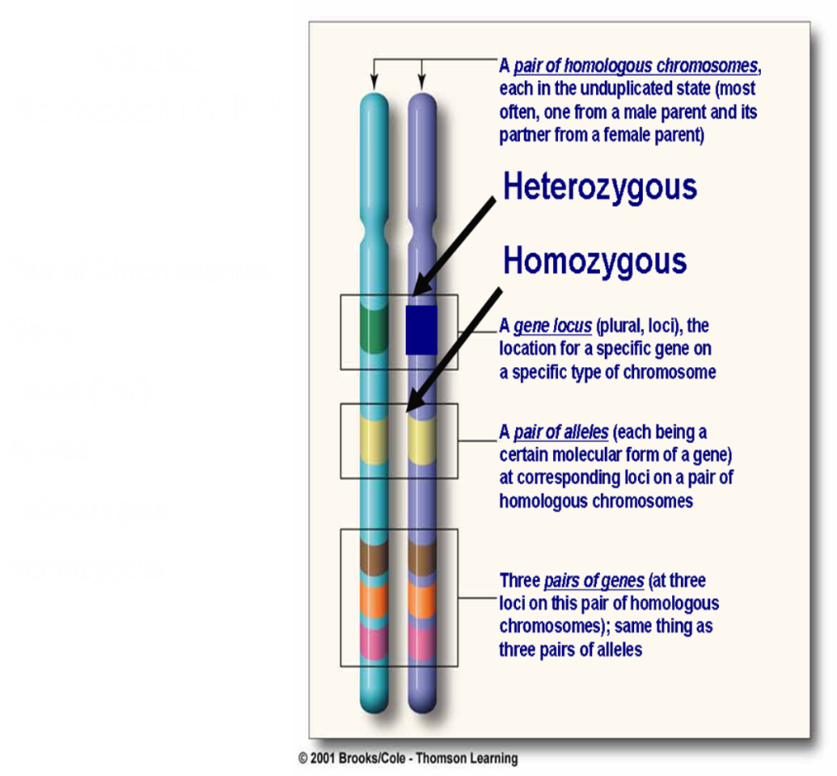
Genetic pathology deals with the diseases that have genetic origin. It estimated that:
- 50% of spontaneous abortion during the early months of gestation has a demonstrable chromosomal abnormality.
- About 1% of all newborn infants possess a gross chromosomal abnormality.
- 20% of pediatric in patients have genetic diseases.
- 5% of individuals under age 25 develop a serious disease with a significant genetic component.
Classification of genetic disorders:
- Classical genetic diseases
- Chromosomal disorders
- Single gene disorder (Mendelian disorders)
- Multifactorial disorders.
- Non classical genetic diseases (single gene disorders with atypical pattern of inheritance)
- Diseases caused by mutation in the mitochondrial genes.
- Triplet repeat mutation
- Uniparental disomy/genomic imprinting
- Gonadal mosaicism
I//Classical genetic disorders:
1-chromosomal disorders:
Human somatic cells contain 46 chromosomes; these comprise 22 homologous pairs of autosomes and two sex chromosomes, XX in the female and XY in the male. The study of chromosomes—karyotyping—is the basic tool of the cytogeneticist.
Chromosomal disorders include alterations that affect autosomes or sex chromosomes that could be :
- Numerical
- Structural
A-Numerical: defined as gain or loss of a whole chromosome whether autosomal or sex chromosome. The half number of chromosomes (n) is called haploid. The normal person has 2n, one set from paternal side and the other from maternal side. The normal chromosomal count is 46 ie 2n=46 this is called euploid. Any number that is not exact multiple of haploid is called aneuploidy.
A gain of chromosome is a state known as trisomy eg trisomy of autosomal chromosome 21 called downs syndrome. Trisomy of sex chromosome is exemplified by klienfelter syndrome xxy in male and xxx in female.
Loss of chromosome is a state known as monosomy. Monosomy of autosomal chromosome is usually non compatible with life. Monosomy of sex chromosome is called turner syndrome (xo) .
B-Structural abnormalities:
1-Deletion: Loss of some segment of a chromosome. Most are lethal or cause serious disorder because the lost piece could be carrying important genes and the disorder related to the loss of gene product.
2-Inversion: result from two breaks in the chromosome and the piece between the two breaks will rotate 180 degree and fixed again.
3-Translocation: an exchange of segments of chromosomes between non homologous chromosomes.
4-Isochromosome: horizontal rather than perpendicular centromere division.
5-Ring chromosome: result from deletion of both ends of a chromosome and the ends, because the adhesive nature of the exposed DNA, will stick together forming a ring or a circle.
2- defects of single genes with large effect (mendelian disorders MD):
The number of known mendelian disorders MD has grown to more than 5000, but although each is rare. MD account for 1% gene defect in adult and 6-8% in pediatrics only. MD results from mutation in a single gene. Mutation is a disturbance in the sequence of the nucleotide arrangement in the DNA molecule; simply it is a permanent change in the DNA. Mutations affecting the germ cells are transmitted to the progeny and may give rise to inherited disorders. Those occurring in the somatic cells are not transmitted to the progeny but are important in the causation of cancers and some congenital malformation.
A gene is that part of DNA that code for polypeptide chain. Only about 2% of the DNA codes directly for information called exons ie coding sequence, 98% of DNA not code for information (non coding sequence), 24% of these are present between the coding sequence of the gene called introns and 74% present out of the gene.
MENDELIAN inheritance patterns
- AUTOSOMAL DOMINANT
- AUTOSOMAL RECESSIVE
- SEX-LINKED (recessive), involving “X” chromosome
AUTOSOMAL DOMINANT
- Disease is in HETEROZYGOTES
- NEITHER parent may have the disease (NEW mut.)
- REDUCED PENETRANCE (environment?, other genes?)
- VARIABLE EXPRESSIVITY (environment?, other genes?)
- May have a DELAYED ONSET
- Usually result in a REDUCED PRODUCTION or INACTIVE protein
AUTOSOMAL RECESSIVE
Disease is in HOMOZYGOTES
More UNIFORM expression than AD
Often COMPLETE PENETRANCE
Onset usually EARLY in life
NEW mutations rarely detected clinically
Proteins show LOSS of FUNCTION
Include ALL inborn errors of metabolism
MUCH more common than autosomal dominant
SEX (“X”) LINKED
- MALES ONLY
- HIS SONS are affected.
- ALL his DAUGHTERS are CARRIERS

- Multifactorial inheritance: it is the additive effect of many genes of small effect PLUS a suitable environment causes such disorders.
II// Non classical genetic disorders (single gene defect with atypical pattern of inheritance)
a- mitochondrial gene disorder (mtDNA): mtDNA differ from other nuclear DNA in that the former is associated with maternal inheritance (from mother only) and random segregation of mtDNA to the daughter cell. So any mutation in mtDNA cannot be predicted.(eg leber hereditary optic neuropathy)
b- Triplet repeat mutation: it is characterized by a long repeating sequence of three nucleotides (pathological expansion of trinucleotide). (eg fragile x syndrome)
c- uniparental disomy/genomic imprinting: it has been established that there is a functional differences exist between the maternally or paternally derived genes. These differences arise from a process called genomic imprinting whereby certain genes are differentially inactivated or switched off during gametogenesis. Genetic disorder occur when the mutation affect the functioning gene only. eg angelman //prader willi.
e-Gonadal mosaicism: mutation not occur in the germ cell of either parent during gametogenesis (sperm or ovum formation)but in an undifferentiated cells of the post fertilization zygote. So there are two sets of cells cluster one carrying the mutation and the other not. If it happens that these mutated cells participate in the formation of future testis or ovary of the growing embryo, a state of mosaicism is formed. This mutation is usually an autosomal dominant mutation without previous family history.

