Case: A 54-year-old insulin-dependent diabetic woman has come to the emergency department complaining of increasing pain in the right foot for the past week. The pain is worse at night and is relieved by hanging her leg over the side of the bed. For the past few days she has noticed swelling, redness and discolouration over the base of the big toe. Her glucose control has been recently reviewed by the general practice nurse and her insulin regimen changed. She is afebrile, her pulse is 86/min, her blood pressure is 130/60 mmHg and her blood glucose is 13.2 mmol/L on BM stick testing. Femoral pulses are palpable bilaterally. No popliteal, posterior tibial or dorsalis pedis pulses are palpable in either limb. The great toe is erythematous with a large fluctuant swelling at the base.
INVESTIGATIONS
An x-ray of the foot is shown in Figure 1.
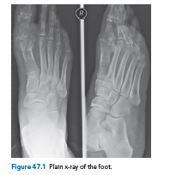
Questions:
• What do the clinical appearances suggest?
• What does the x-ray show?
• What other investigations does she require?
• How would you manage this patient?

ANSWER:
This patient has peripheral vascular disease and poor diabetic control. Examination describes swelling and erythema over the base of the first metatarsal, which may indicate an underlying collection of pus. A full vascular examination should be carried out and ankle–brachial indices measured. All areas of the foot, especially between the toes and the heel should be examined for other areas of ulceration, and the foot examined for the presence of diabetic neuropathy.

Investigations should include:
• Full blood count
• Renal function and C-reactive protein
• Blood sugar
• Foot x-ray
The patient should be commenced on intravenous broad-spectrum antibiotics and an insulin sliding scale. The priority is to release the pus and debride necrotic tissue. The x-ray changes (osteopenia, osteolysis, sequestra and periostial elevation) suggest there is underlying osteomyelitis (Figure 2). This will also need to be debrided in order to remove all the infection.

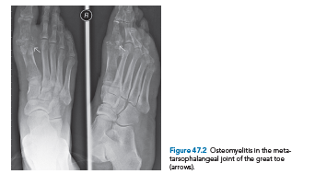

A duplex scan or intra-arterial angiogram should then be carried out to ascertain whether the blood supply to the foot is compromised and whether any revascularization procedure is necessary. As a rule, revascularization should be carried out prior to any surgical debridement/amputation in order to ensure that the blood supply is adequate for tissues to heal. In this particular case, however, delaying surgery would result in further damage to the foot. Revascularization of the foot should be carried out as soon as possible after surgery.
KEY POINT
• Diabetic feet are at risk of ischaemia (progressive distal ischaemia) and neuropathy (sensory, motor and autonomic), and are more prone to infections.

