PATHOLOGY OF URINARY SYSTEM-2
DISORDERS OF GLOMERULAR FUNCTION
Glomerular disorders affect the glomerular capillary-membrane structures that filter materials from the blood. It is the leading cause of chronic renal failure in the United States, accounting for one half of persons with end-stage renal disease. Causes and pathogenesis:
I// Primary (idiopathic)
II// Secondary:
- due to immune mediated injury. Two types of immune mechanisms have been implicated in the development of glomerular disease:
- injury resulting from antibodies reacting with fixed glomerular antigens (type II HSR)
- injury resulting from circulating antigen-antibody complexes that become trapped in the glomerular membrane (type III HSR)
Antigens responsible for development of the immune response may be:
- Endogenous origin, such as DNA in SLE
- Exogenous origin, such as streptococcal membrane antigens in poststreptococcal glomerulonephritis.
- The source of the antigen is unknown.
- Affection by other chronic disorders (eg DM, Hypertension)

The cellular changes that occur with glomerular disease include
Proliferative changes: refers to an increase in the cellular components of the glomerulus regardless of origin
Sclerotic changes: increase in the non-cellular components of the glomerulus primarily collagen and fibrous tissue
Membranous changes: an increase in the thickness of the glomerular capillary wall caused by immune complex deposition.
Patern of glomerular changes (area that involved)
Glomerular changes can be diffuse, involving all glomeruli and all parts of the glomeruli; focal, in which only some glomeruli are affected and others are essentially normal; segmental, involving only a certain segment of each glomeruli;
or mesangial, affecting only the mesangial cell.

Glomerular diseases include broadly two conditions: nephritis and nephrotic syndroms.
Nephritic syndromes are caused by diseases that produce proliferative inflammatory responses that decrease the permeability of the glomerular capillary membrane.
The nephrotic syndrome is caused by disorders that increase the permeability of the glomerular capillary membrane, causing massive loss of protein in the urine.

Nephritic Syndromes (glomerulonephritis)
Glomerulonephritis is characterized by
- hematuria
- oliguria and diminished glomerular filtration rate (GFR),
- azotemia (presence of nitrogenous wastes in the blood),
- hypertension.
It is caused by diseases that provoke a proliferative inflammatory response of the endothelial, mesangial, or epithelial cells of the glomeruli. The inflammatory process damages the capillary wall, permitting red blood cells to escape into the urine and producing hemodynamic changes that decrease the GFR. The nephritic syndromes include: acute proliferative glomerulonephritis and rapidly progressive glomerulonephritis.
A//Acute Proliferative Glomerulonephritis
The glomerular changes are proliferative and the pattern is diffuse (diffuse proliferative glomerulonephritis), which follows infections caused by strains of group A β-hemolytic streptococci. Diffuse proliferative glomerulonephritis also may occur after infections by other organisms, including staphylococci and a number of viral agents, such as mumps, measles, and chickenpox. With this type of nephritis, the proliferative inflammatory response is caused by an immune reaction that occurs when circulating immune complexes become entrapped in the glomerular membrane. The disease primarily in children but adults of any age also can be affected.
cola-colored urine may be the first sign of the disorder. Sodium and water retention gives rise to edema, particularly of the face and hands, and hypertension.
Important laboratory findings include an elevated streptococcal exoenzyme (antistreptolysin O) titer, a decline in C3 complement. The immediate prognosis is favorable, and approximately 95% of children recover spontaneously
B// Rapidly Progressive Glomerulonephritis
Rapidly progressive glomerulonephritis is a clinical syndrome characterized by signs of severe glomerular injury that does not have a specific cause. As its name indicates, this type of glomerulonephritis is rapidly progressive, often within a matter of months. The cellular changes are proliferative and the pattern of involvement is focal or segmental (focal or segmental proliferation glomerulonephritis).
Rapidly proliferative glomerulonephritis may be caused by a number of immunologic
disorders, some are systemic eg (SLE, vasculitis) and others are restricted to the kidney eg Goodpasture’s syndrome (It is a rare disease and is associated with a triad of pulmonary hemorrhage, iron-deficiency anemia, and glomerulonephritis. It is caused by antibodies to the glomerular basement membrane (GBM), accounts for approximately 5% of cases of rapidly progressive glomerulonephritis).

Nephrotic Syndrome
The nephrotic syndrome is characterized by:
- massive proteinuria(>3.5 g/day)
- hypoalbuminemia (<3 g/dL)
- generalized edema
- hyperlipidemia (cholesterol >300 mg/dL) and lipiduria (e.g., free fat, oval bodies, fatty casts).
- The initiating event in the development of nephrosis is a derangement in the glomerular membrane that causes increased permeability to plasma proteins.
- Generalized edema, which is a hallmark of nephrosis, results
from salt and water retention and a loss of serum albumin below that needed to maintain the colloid osmotic pressure of the vascular compartment.
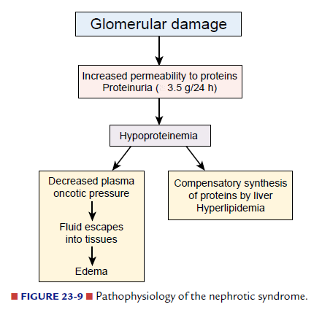
- The hyperlipidemia that occurs in persons with nephrosis is characterized by elevated levels of triglycerides and low-density lipoproteins (LDL). Levels of high-density lipoproteins (HDL) usually are normal. These abnormalities are thought to be related, in part, to increased synthesis of lipoproteins in the liver secondary to a compensatory increase in albumin production.
- Thrombotic complications can occur in persons with nephrotic syndrome due to renal loss of coagulation and anticoagulation factors. Renal vein thrombosis, deep vein thrombosis and pulmonary emboli are the major thrombotic complications of nephrotic syndrome.

Glomerular Lesions Associated with Diabetes and Hypertension

Diabetic nephropathy (Glomerulosclerosis)
Diabetic nephropathy, or kidney disease, is a major complication of diabetes mellitus. It affects approximately 30% of persons with type 1 diabetes and accounts for 20% of deaths in diabetic patients younger than 40 years of age. The glomerulus is the most commonly affected structure in diabetic nephropathy. Diabetic patients clinically pass through the following stages: non-nephrotic proteinuria, nephrotic syndrome, and renal failure.
Pathologically diabetic glomerulosclerosis changes include:
- Widespread thickening of the glomerular capillary basement membrane occurs in almost all persons with diabetes and can occur without evidence of proteinuria (arteriolosclerosis).
- This is followed by a diffuse increase in mesangial matrix, with mild proliferation of mesangial cells (diffuse glomerulosclerosis) .
- Then nodular deposition of hyaline in the mesangial portion of the glomerulus leads to (nodular glomerulosclerosis).
- The sclerotic process progresses in both the diffuse and nodular forms of glomerulosclerosis, there is complete obliteration of the glomerulus, with impairment of renal function.

Pathophysiology of diabetic glomerulosclerosis changes
- defectivesynthesis of the glomerular basement membrane and mesangial matrix
- elevations in blood glucose produce an increase in GFR and glomerular intracapillary pressure that leads to an enlargement of glomerular capillary pores by a mechanism that is at least partly mediated by angiotensin II.
This enlargement impairs the size-selective function of the membrane so that the protein content of the glomerular filtrate increases, which in turn requires increased endocytosis of protein by the tubular endothelial cells, a process that ultimately leads to nephron destruction and progressive deterioration of renal function.
The clinical manifestations of diabetic glomerulosclerosis are closely linked to stage of changes.
- The increased GFR that occurs in persons with early alterations in renal function is associated with microalbuminuria, defined as urinary albumin excretion greater than 30 mg/24 hours and no more than 300 mg/ 24 hours.Microalbuminuria is an important predictor of future diabetic nephropathies.
- Edema
- Hypertension
- Renal failure
In many cases, these early changes in glomerular function can be reversed by careful control of blood glucose levels. Inhibition of angiotensinII by angiotensin-converting enzyme inhibitors (e.g., captopril) has been shown to have a beneficial effect, possibly by reversing increased glomerular pressure.

Hypertensive Glomerular Disease
Renal failure and azotemia occur in 1% to 5% of persons with long-standing hypertension. Hypertension is associated with sclerotic changes in glomerular structures. As the glomerular vascular structures thicken and perfusion diminishes, the blood supply to the nephron decreases, causing the kidneys to lose some of their ability to concentrate the urine. Blood urea nitrogen levels also may become elevated, Proteinuria may occur as a result of changes in glomerular structure.

Drug-Related Nephropathies
Drug-related nephropathies involve functional or structural changes in the kidneys that occur after exposure to a drug. The kidneys are either filter the drugs from bloodor enhance metabolic transformation of drugs and therefore are exposed to a number of toxic metabolites.
The tolerance to drugs varies with age and depends on renal function, state of hydration, blood pressure, and the pH of theurine.
Mechanisms of drug related nephropathies:
- Some drugs and toxic substances damage the kidneys by causing a decrease in blood flow eg NSAIDs inhibit prostaglandin synthesis particularly PGI2 and PGE2) which are contribute to regulation of tubular blood flow
- Direct toxic damage to tubulointerstitial structures (aspirin)
- Damage by producing acute drug related hypersensitivity reactions ends with tubulointerstitial nephritis. sulfonamide drugs, furosemide and the thiazide diuretics methicillin and other synthetic antibiotics included
- can cause kidney damage by obstructing urinary flow and crystal formation (methoprim + vit c)
- multifactorial mechanism that involves direct vasoconstriction, altered systemic hemodynamics, and myoglobulin-induced renal failure (cocaine intoxication) .

ACUTE RENAL FAILURE ARF
Acute renal failure is caused by conditions that produce an acute shutdown in renal function. It represents a rapid decline in renal function sufficient to increase blood levels of nitrogenous wastes and impair fluid and electrolyte balance. It is a common threat to seriously ill persons in intensive care units, with a mortality rate ranging from 42% to 88%.
The most common indicator of acute renal failure is azotemia, an accumulation of nitrogenous wastes (urea nitrogen, uric acid, and creatinine) in the blood.
Because of the high morbidity and mortality rates associated with acute renal failure, identification of persons at risk is important to clinical decision making. Acute renal failure often is reversible, making early identification and correction
of the underlying cause (e.g., improving renal perfusion, discontinuing nephrotoxic drugs) important.
Causes of acute renal failure
prerenal failure It can result from decreased blood flow to the kidney;
I// Hypovolemia
- Hemorrhage
- Dehydration
- Excessive loss of gastrointestinal tract fluids
- Excessive loss of fluid due to burn injury
II// Decreased vascular filling
- Anaphylactic shock
- Septic shock
III// Heart failure and cardiogenic shock
IV// Decreased renal perfusion due to vasoactive mediators, drugs, diagnostic agents: endotoxins, radiocontrast agents as those used for cardiac catheterization, cyclosporine (an immunosuppressant drug that is used to prevent transplant rejection), amphotericin B (an antifungal agent), epinephrine, and high doses of dopamine. NSAIDs) can reduce renal blood flow through inhibition of prostaglandin synthesis.
Normally, the kidneys receive 22% of the cardiac output. As renal blood flow falls, the GFR decreases, the amount of sodium and other substances that are filtered by the glomeruli is reduced, and the blood flow needed for the energy-dependent mechanisms that reabsorb these substances is reduced. Because of their high metabolic rate, the tubular epithelial cells are most vulnerable to ischemic injury. Improperly treated, prolonged renal hypoperfusion can lead to ischemic tubular necrosis with significant morbidity and mortality.

intrinsic or intrarenal failure disorders that disrupt the structures in the
kidney( Acute tubular necrosis)
- Prolonged renal ischemia (prerenal ischemia ends with intrarenal damage)
- Exposure to nephrotoxic drugs, heavy metals, and organic solvents
- Intratubular obstruction resulting from hemoglobinuria, myoglobinuria, myeloma light chains, or uric acid casts
- Acute renal disease (acute glomerulonephritis, pyelonephritis)
postrenal failure Postrenal failure results from obstruction of urine outflow from the kidneys. The obstruction can occur in the ureter (i.e., calculi and strictures), bladder (i.e., tumors or neurogenic bladder), or urethra (i.e., prostatic hyperplasia). Prostatic hyperplasia is the most common underlying problem.

Chronic Renal Failure CRF
Chronic renal failure results from the destructive effects of many forms of renal disease. Regardless of the cause, the consequences of nephron destruction in ESRD
are alterations in the filtration, reabsorption, and endocrine functions of the kidneys. The progression of chronic renal failure usually occurs in four stages: diminished renal reserve, renal insufficiency, renal failure, and End Stage Renal Diseases ESRD.
- Diminished renal reserve occurs when the GFR drops to approximately 50% of normal. At this point, the serum BUN and creatinine levels still are normal, and no symptoms of impaired renal function are evident.
- Renal insufficiency represents a reduction in the GFR to approximately 20% to 50% of normal. During this stage, azotemia, anemia, and hypertension appear.
- Renal failure, a reduction to less than 20% to 25% of normal. Renal failure develops when the GFR is less than 20% of normal. At this point, the kidneys cannot regulate volume and solute composition, and edema, metabolic acidosis, and hyperkalemia develop. These alterations affect other body systems to cause neurologic, gastrointestinal, and cardiovascular manifestations.
- ESRD, a decrease in GFR to less than 5% of normal. Histologic findings of an end-stage kidney include a reduction in renal capillaries and scarring in the glomeruli. Atrophy and fibrosis are evident in the tubules.
The treatment of ESRD can be divided into two types:
- conservative management of renal insufficiency (measures to prevent or retard deterioration in remaining renal function)
- renal replacement therapy with dialysis or transplantation.

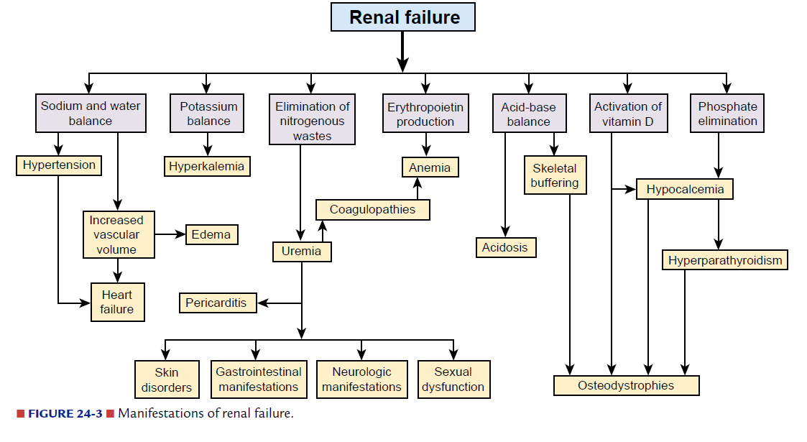

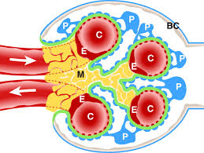
Histology of glomeruli
E=Endothelial cells
P=podocytes (epithelia)
C=Capillary
M=Mesengyme
BM=Bacement Membrane
BC=Bowman Capsule

