**Almustansyiriah University**

**College of pharmacy**

**Department of pharmaceutical chemistry**

Practical pharmaceutical chemistry

**For third year students**

**Assist. Prof Karima Fadhil Ali**

**Part II (organic)**

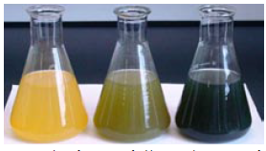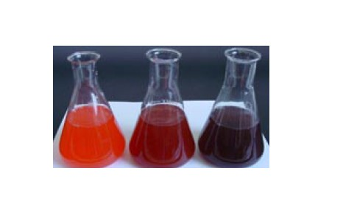

|  |
| --- |
| **University of Al-Mustasyria** |
| **College of Pharmacy** |
| **Department of Pharmaceutical Chemistry** |
| Title of the course: ***Practical organic Pharmaceutical Chemistry*.** |
| Level: 3th Class, 2 edSemester |
| Credit hours: **Laboratory 1 credit 2 hours / week** |
| Reference text: **Pharmaceutical Drug Analysis; Ashutosh Kar.** |

**Objectives:**

**Practical Pharmaceutical chemistry /stage 3 /2nd semester**

**Ingredients of the course:-**

**1. Partition coefficient of succinic acid**

**Acid - base titration**

**2. Assay of indomethacin.**

**3. Assay of aspirin by (direct and indirect)**

**4. Assay of Furocemid (Lasix).**

**Oxidation- reduction titration (Redox)**

**5. Assay of paracetamol.**

**Iodemetric -titration**

**6. Assay of Vit .C (ascorbic acid).**

**7. Assay of benzylpenicilline**

**Non aqueous titration**

**8. Assay of methyldopa**

**Practical Lab 1**

**Partition coefficient of succinic acid**

**Introduction:**

Partition Coefficient

The most common physicochemical descriptor is the molecule's partition coefficient in an octanol/water system. For example an orally administered drug will go through a series of partitioning steps:

(a) Leaving the aqueous extracellular fluids,

(b) Passing through lipid membranes, and

(c) Entering other aqueous environments before reaching the receptor.

In this sense, a drug is undergoing the same partitioning phenomenon that happens to any chemical in a reparatory funnel containing water and a non-polar solvent such as hexane, chloroform, or ether.

The partition coefficient (P) is the ratio of the molar concentration of chemical in the non-aqueous phase (usually 1-octanol) versus that in the aqueous phase. For reasons already discussed, it is more common to use the logarithmic expression.

The difference between the reparatory funnel model and what actually occurs in the body is that the partitioning in the funnel will reach an equilibrium at which the rate of chemical leaving the aqueous phase and entering the organic phase will equal the rate of the chemical moving from the organic phase to the aqueous phase. This is not the physiological situation. Note that there are dynamic changes occurring to the drug, such as it being metabolized, bound to serum albumin, excreted from the body, and bound to receptors.

The partition coefficient is one of the main physiochemical properties of drugs. It is the most important property for determining the distribution and partitioning of a drug through the lipid bilayer.

The most widely used solvent to mimic the lipid bilayer is 1-octanol. The long hydrocarbon chain will solvate non-polar compounds, like dissolves like. The aqueous layer mimics the plasma.

The partitioning of succinic acid, k, HOOCCH2CH2COOH between two immiscible solvents, water and 1-butanol will be studied. In this study, four different concentrations will be used as well as different volume ratios.

**Equipment and Chemicals**

1. Four 100 ml Reparatory funnels
2. Four Conical flasks
3. Two 50ml burettes
4. Four 250ml beakers
5. Two 10ml graduated pipettes
6. 20mg/L Succinic acid
7. 0.05M NaOH
8. 100ml 1-butanol
9. Phenolphthalein

**Procedure/ Safety Measures**

1. Prepare four mixtures of 1-butanol, water, succinic acid into the separatory funnels as in Table 1.1.
2. Shake gently the reparatory funnels with prepared solutions for 20 minutes.
3. Leave the mixtures for few minutes to separate.
4. Pour the aqueous layer into a beaker.
5. Using a graduated pipette, transfer 5ml of the aqueous layer into a conical flask
6. Add 2 drops of phenolphthalein
7. Titrate with NaOH solution.
8. Repeat the titration and fill in table 1.2.
9. Carry out a similar treatment for the organic layer.

**Results:**

Fill in Tables 1.1 and 1.2.

1. Calculate the concentration of succinic acid in the two layers.
2. Calculate the partition coefficient k of succinic acid at each composition
3. Find the average of k.

**Discussion and evaluation:**

Discuss possible source of errors in this experiment.

Comment on the precision and accuracy of the results.

Table 1. 1. Composition of Partition mixtures

|  |  |  |  |
| --- | --- | --- | --- |
| Funnel no. | Succinic acid solution, ml | Water, ml | 1-Butanol, ml |
|  |  |  |  |
|  |  |  |  |
|  |  |  |  |
|  |  |  |  |

Table 1.2 Experimantal Data

|  |  |  |  |  |  |  |  |  |  |
| --- | --- | --- | --- | --- | --- | --- | --- | --- | --- |
| No. | Volume of titrant, ml | | | | | | Corg.  (M) | Caq. (M) | k |
| Organic layer | | | Aqueous layer | | |
| Run 1 | Run 2 | mean | Run 1 | Run 2 | mean |
|  |  |  |  |  |  |  |  |  |  |
|  |  |  |  |  |  |  |  |  |  |
|  |  |  |  |  |  |  |  |  |  |
|  |  |  |  |  |  |  |  |  |  |

**Practical Lab 2**

**Assay of indomethacin**

**Assay by acid-base titration:**

**Introduction:**

Indomethacin is a white or yellow, crystalline powder, practically insoluble in water sparingly soluble in alcohol. Its chemical formula is (C19H16ClNO4) , its melting point is(158°Cto162°C) and its pka (4.5) Its action and uses are cyclo-oxygenase inhibitor (COX), (the enzyme responsible for catalyzes the rate-limiting step in prostaglandin synthesis via the arachidonic acid pathway); analgesic; and anti-inflammatory. Its preparations are capsules and suppositories.

Indomethacin contains not less than 90% and not more than 110.0%of {1-(4-chlorobenzoyl)-5-methoxy-2-methylindol-3-yl} acetic acid, calculated with reference to the dried substance.

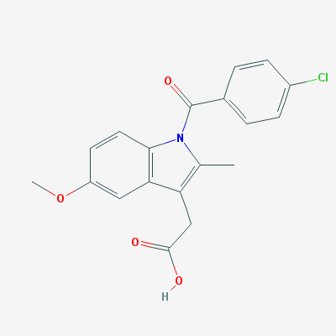

Indomethacin M. wt. (357.8g /mol)

**Principle:**

Indomethacin contains an acidic group (COOH) so it considered as acid hence it can be determined by titration against 0.01N NaOH using phenolphthalein (ph.ph) indicator. At the end point the color changes to pink.

**Procedure:**

1. Dissolve the content of **one** capsule (25mg) in a beaker by addition of 10 ml of neutral acetone.

2. Shake then filter into a conical flask and wash twice with 10 ml of neutral acetone.

3. Titrate the filtrate with N/100 NaOH using ph.ph as an indicator.

4. Carry out a blank titration.

**Calculations:**

Recovery % = practical content/ theoretical = $\frac{( V_{B}XN_{B}X Eq.Wt) }{25}$ **X 100**

**Discussion and Evaluation**

**Additional activity**

1. Using a graph paper, draw pH ionization profiles for indomethacin and compare it with that of ephedrine, Indicate % ionization at pH of empty and full stomach, plasma and intestine as well as the half ionization.
2. Comment on the implications of such chemical structure on the drugs distribution and possible side effects.

**Practical lab 3**

**(A) Assay of aspirin by direct acid- base titration**

**Introduction:**

Aspirin is acetyl salicylic acid, occurs as white crystals, used as analgesic to relieve minor aches and pain, as antipyretic to reduce fever and as anti- inflammatory medication. Its molecular formula (C9H8O4).

It is a monoprotic weak acid, [K](http://www.ausetute.com.au/ka.html)[a](http://www.ausetute.com.au/ka.html) = 2.8 x 10 4 at 25oC, so very little of the molecular aspirin (acetylsalicylic acid) dissociates to form acetylsalicylate ions.   
For the equilibrium dissociation reaction:

|  |  |  |  |  |
| --- | --- | --- | --- | --- |
| **aspirin (acetylsalicylic acid)** | **http://www.ausetute.com.au/images/eqlarrow.gif** | **acetylsalicylate ion** | **+** | **H+** |
| http://www.ausetute.com.au/images/aspirin.gif | http://www.ausetute.com.au/images/eqlarrow.gif | http://www.ausetute.com.au/images/aspirinneg.gif | + | H+ |

It is slightly soluble in water (1:300) and soluble in alcohol (1:5), chloroform (1:17) and ether (l: 15), Also it dissolves easily in glycerin. Its melting point (135°C), and Molecular weight = 180.2 g/mole. It slowly decomposed to acetic and salicylic acid in the presence of heat and moisture.

The salicylates being acidic in nature are readily absorbed from stomach and small intestine. Their absorption depends strongly on the pH of the environment, thus coadministration of antacid or other buffering agent should be avoided because it greatly hinders their absorption. Salicylic acid is the main metabolite of aspirin, it undergoes extensive phase-II metabolism and it excreted via the kidneys as the water soluble glycine conjugate or acyl glucouronides.

**Principle:**

Titration method used to determine how much acid is in a solution by adding just enough base of a known concentration to neutralize the acid. In neutralization,

the number of moles of acid, H+, is combined with an equal number of moles of base, OH_ In the titration you will be performing, you will dispense base into a known amount of acid solution to find the unknown concentration. If you wanted to know the concentration of an unknown base, you could titrate the base with an acid in the same manner. The aspirin will be titrated against a standard solution of base, **0.1 N NaOH**. Base will be dispensed from a burette into a beaker containing the dissolved acid (in ethanol) and phenolphthalein indicator, which show a faint pink color in basic solutions.

C9H8O4+NaOH C9H7O4Na+H2O

**Procedure:**

1. Dissolve a quantity of powdered aspirin equivalent to 0.2gm in 10.0ml ethanol.
2. Add 3 drops ( ph.ph) indicator.
3. Titrate with N/10 NaOH.

**Calculation:**

**Recovery % =** **practical content/ theoretical** = $\frac{( V_{B}XN_{B}X Eq.Wt) }{theoretical}$ **X 100**

**Practical lab 3**

**(B) Assay by indirect acid- base titration**

**Principle:**

Many reactions are slow or present unfavorable equilibria for direct titration. Aspirin is weak acid that also undergoes slow hydrolysis; i.e., each aspirin molecule reacts with two hydroxide ions. To overcome this problem, a known excess amount of base is added to the sample solution and an HCl titration is carried out to determine the amount of unreacted base. This is subtracted from the initial amount of base to find the amount of base that actually reacted with the aspirin and hence the quantity of aspirin in the analyte

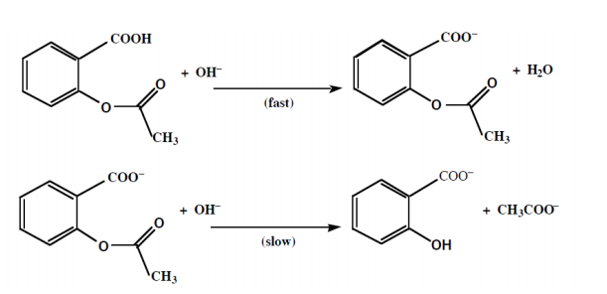

**Procedure:**

1. Accurately record the weight of a group of three aspirin tablets so that you can determine an average tablet weight. Use a mortar and pestle to crush enough tablets to produce approximately ( 1 g) tablet powder.

2. Weigh approximately 300 mg aspirin powder, into labeled 250 mL Erlenmeyer flasks .

3. To each flask, add 20 mL of ethanol (measure by graduated cylinder) and three drops of phenolphthalein indicator. Swirl gently to dissolve. (Aspirin is not very soluble in water — the ethanol helps the aspirin dissolve. Note that an aspirin tablet contains other compounds in addition to aspirin. Some of these are not very soluble. Your solution will be cloudy due to insoluble components of the tablet.)

**Aspirin Titration with Base**

4. Titrate the first aspirin sample with (0.1 N) NaOH to the first permanent cloudy pink color.

5. The aspirin/NaOH acid-base reaction consumes one mole of hydroxide per mole of aspirin. The slow aspirin/NaOH hydrolysis reaction also consumes one mole of hydroxide per mole of aspirin, and so for a complete titration we will need to use a total of twice the amount of NaOH that you have already used, plus we will add some excess NaOH to ensure we really have reacted with all of the aspirin in the sample. (For example: if you used 26 mL of base in the previous step, the volume of base you would add now would be 26 + 10 = 36 ml. Thus, you would have added a total of 26 + 26 + 10 = 62 mL of base.) Heating for Completion of Reaction

6. Heat gently the flask contents in a water bath. Avoid boiling, because the sample may decompose. While heating, swirl the flasks occasionally. After 15 minutes, remove samples from the water bath and cool for 5 minutes.

7. If the solution is colorless, add a few more drops of phenolphthalein. If it remains colorless, add 10 mL more of the base and reheat. (Don't forget to add this additional volume of base to the previously recorded total volume.)

8. The only base remaining in each flask will be excess base that has not reacted with the aspirin. Using your burette with your ~0.1 NHCl solution, titrate the excess base in each flask with HCl until the pink color just disappears. The endpoint is best described as “cloudy white”

9. Record all the volumes of bases and acid in the data table.

**Data & Calculations**

1. Calculate the total volume of NaOH?

2. Calculate the volume of HCl?

3. Wt of aspirin = (VNaOH – VHCl) x NNaOH x Eq.wt of aspirin

4. Recovery % = practical content / theoretical x 100

**Practical lab 4**

**Assay of furosemid**

**Introduction:**

Furosemide (FUR), chemically known as 4-chloro-2-[(2-furanylmethyl) amino]-5-Sulphamoyl benzoic acid, is structurally a sulfonamide, an antibacterial agent. However, FUR is a potent diuretic widely used in the treatment of edematous states associated with cardiac chronic renal failure hypertension, congestive heart failure and cirrhosis of the liver. Its appearance is white, crystalline powder, melting point 2100C with decomposition. Practically insoluble in water, methylene chloride, soluble in acetone, sparingly soluble in ethanol; it dissolves in dilute solutions of alkali hydroxides. Furosemide is a weak acid with an acidic p*K*a value of 3.8 (carboxylic acid).Light sensitive, air sensitive, slightly soluble in water. Its molecular weight (330.74), the official methods for the determination of FUR in dosage forms are based on titrimetry spectrophotometry and HPLC



**Furosemide M. wt (330 74g / mol)**

**Principle:**

furosemide contain acidic group (COOH) so it considered as acid which can be determined by titration against 0.01N NaOH using phenol red as indicator. At the end point the color changes to pink

 C12H11ClN2O5S  + NaOH (C12H10ClN2O5S) Na + H2O

**Procedure:**

1. Weight 10 tablets and calculate the quantity of powderd tablets equivalent to one tablet and dissolve this amount in 10 ml of hot alcohol then filter it.
2. Titrate the filtrate with 0.01N NaOH using phenol red as indicator.

**Calculation:**

**Furosemide%**= practical content/ theoretical = $\frac{( V_{B}XN_{B}X Eq.Wt) }{theoretical}$ **X 100**

**Practical lab 5**

**Assay of paracetamol**

**Introduction:**

**Paracetamol, (**acetaminophen),chemically named N-acetyl-p-aminophenol, is a widely used [analgesic](http://en.wikipedia.org/wiki/Analgesic) (pain reliever) and antipyretic (fever reduce). Paracetamol is classified as a mild analgesic. It is commonly used for the relief of headache and other minor aches and pains and is a major ingredient in numerous cold and flu remedies.

In combination with [opioid analgesics](http://en.wikipedia.org/wiki/Opioid_analgesic), paracetamol can also be used in the management of more severe pain such as pot-surgical pains and providing [palliative care](http://en.wikipedia.org/wiki/Palliative_care) in advanced cancer patients Though paracetamol is used to treat inflammatory pain, it is not generally classified as an [NSAID](http://en.wikipedia.org/wiki/NSAID) because it exhibits only weak anti-inflammatory activity.

Its **content** 99.0% to 101.0 % (dried substance). Its **appearance**: white crystal powder, sparingly soluble in water freely soluble in alcohol,slightly soluble in methylene chloride, and its melting point (168 °C to 172 °C). Asaturated aqueous solution has a pH of about 6 and is stable (half-life over 20 years) but stability decreases in acid or alkaline conditions, the paracetamol being slowly broken down into acetic acid.



**ParacetamolM.wt. 151.2 g/mol**

Paracetamol is 4-acetamidophenol and may be represented by the following formula (C8H9NO2), with molecular weight (151.2), pKa (9.5).

Several papers in the literature describe the assay of Paracetamol and its combination in pharmaceuticals or biological fluids. Determination of Paracetamol

using electrical method has been reported, Spectrophotometry high performance liquid chromatography, and titration method.

**Principle:**

The British Pharmacopoeia method for the analysis of paracetamol involves heating it under reflux with sulfuric acid. This is a straightforward, acid catalyzed, hydrolysis of an amide to an amine and a carboxylic acid. The 4-aminophenol which is formed is then titrated with an oxidizing agent, ammonium cerium (IV) sulfate using ferroin as the indicator. The first reaction is as follows:

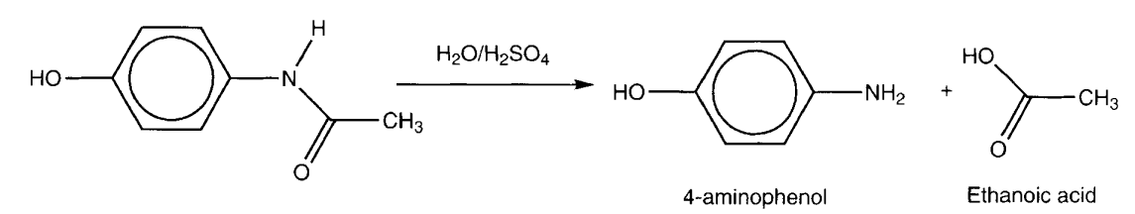

The titration step is much more interesting. 4-Aminophenol can easily be oxidized as follows:

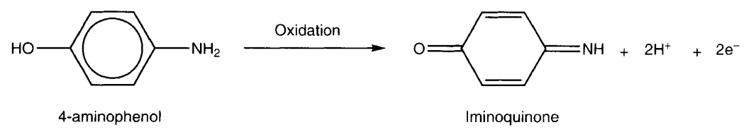

The role of the ammonium cerium(IV) sulfate is to oxidize the 4-aminophenol to the iminoquinone. Only after all the 4-aminophenol has been oxidized will the cerium (IV) reagent oxidize the ferroin indicator from Fe2+ to Fe3+ (ferriin).

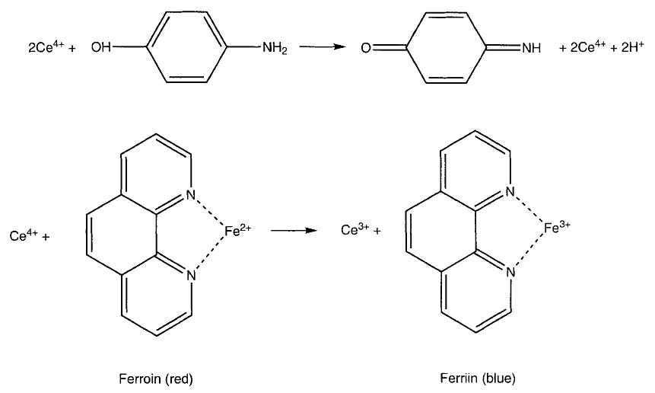

During the titration the solution should be red, and the yellow end point is the transition from red to pale blue. It is easy to work out that, since 1 mole of Ce4+ is equivalent to 0.5 mole of paracetamol, the conversion factor given in the method is correct.

**Procedure:**

1. Weight a quantity of the powdered tablets equivalent to 0.300gm of paracetamol.
2. Dissolve it in a mixture of 10ml of water and 30ml of dilute H2SO4 (10% w/v).
3. Boil under reflux condenser for 1h cool and dilute to 100ml of water.
4. To 20ml of a solution add 40ml of ice, 15ml of dilute HCL (10%w/v) and 0.1ml of ferroin.
5. Titrate with 0.1N ceric ammonium sulphate until a greenish yellow color is obtained,
6. Carry out the blank titration.

**Practical Lab 6**

**Assay of Ascorbic Acid (Vit C)**

**Introduction**

Ascorbic acid (Vitamin C), molecular formula (C6H8O6) is a naturally occurring organic compound with [antioxidant](http://en.wikipedia.org/wiki/Antioxidant) properties. It is a white solid, but impure samples can appear yellowish. Its melting point ( 190°C) with decomposition. It dissolves well in water to give mildly acidic solutions and sparingly soluble in ethanol. It is practically insoluble in ether and chloroform. Ascorbic acid solution rapidly oxidized in air and alkali media. Because it is derived from [glucose](http://en.wikipedia.org/wiki/Glucose), many animals are able to produce it (as a hormone), but humans require it as part of their nutrition.

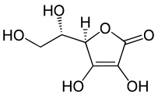

**Ascorbic acid M.wt (176 g / mole)**

**Principle:**

This method determines the vitamin C concentration in a solution by a redox titration with potassium iodate in the presence of potassium iodide. Ascorbic acid is a reducing agent and can be oxidized to form dehydroascorbic acid by iodine via the following reaction

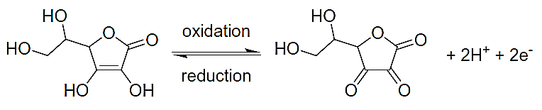

When iodate ions (IO3−) are added to an acidic solution containing iodide ions (I−), an oxidation-reduction reaction occurs;

**-** The iodate ions are reduced to form iodine.

**IO3− + 6 H+ + 5 e− → ½ I2 + 3 H2O**

**-** While the iodide ions are oxidized to form iodine.

**2I− → I2 + 2 e−**

Combining these half-equations demonstrates the reaction between iodate and iodide.

**2 IO3- + 10 I− + 12 H+ → 6 I2 + 6 H2O**

It is the iodine formed by this reaction that oxidizes the ascorbic acid to dehydroascorbic acid as the iodine is reduced to iodide ions.

**Ascorbic acid + I2 → 2 I− + dehydroascorbic acid**

Due to this reaction the iodine formed is immediately reduced to iodide as long as there is any ascorbic acid present. Once all the ascorbic acid has been oxidized, the excess iodine is free to react with the starch indicator, forming the blue-black starch-iodine complex. This is the endpoint of the titration.

The method is suitable for use with Vitamin C tablets, fresh or packaged fruit juices and solid fruits and vegetable.

**Procedure:**

**(A) Solutions Needed:**

* Potassium iodate solution: (0.002 mol /L) If possible, dry 1 g of potassium iodate for several hours or overnight at 100°C. Allow to cool and accurately weigh about 0.43g of potassium iodate and dissolve in 1 L of distilled water in a volumetric flask.
* Starch indicator solution: (0.5%) Weigh 0.25 g of soluble starch and add it to 50 mL of near boiling water in a 100 mL conical flask. Stir to dissolve and cool before using.
* Potassium iodide solution: (0.6 mol /L) Dissolve 10 g solid KI in about 50 mL of distilled water in a 100 mL volumetric flask and dilute to 100 mL with distilled water.
* Dilute hydrochloric acid: (1mol /L).

**Sample Preparation:**

For vitamin C tablets: Weight then dissolves a single tablet in 200 mL of distilled water (in a volumetric flask if possible).

**(B) Titration:**

1. Pipette 20 mL of the sample solution into a 250 mL conical flask and add about 150 mL of distilled water, 5 mL of (0.6 mol /L) potassium iodide, 5 mL of (1 mol /L) hydrochloric acid and 1 mL of starch indicator solution.
2. Titrate the sample with the (0.002 mol /L) potassium iodate solution. The endpoint of the titration is the first permanent trace of a dark blue-black color due to the starch-iodine complex.
3. Repeat the titration with further aliquots of sample solution until you obtain concordant results (titers agreeing within 0.1 mL).

**Calculations**

1. Calculate the average volume of iodate solution used from your concordant titers?

2. Calculate the moles of iodate that reacted forming iodine?

3. Using the equation of the reaction between the iodate ions and iodide ions (below) calculate the moles of iodine formed?

**2 IO3− + 10 I− + 12 H+ → 6 I2 + 6 H2O**

4. From the titration equation (below) determine the moles of ascorbic acid reacting.

**Ascorbic acid + I2 → 2 I− + dehydroascorbic acid**

5. Calculate the concentration in mol /L of ascorbic acid in the solution?

6. Calculate the Wt % of Vit C in the tablets?

* Another method; by using potassium iodate only (Andrew reaction) as shown in the equation below:

|  |  |  |
| --- | --- | --- |
| **6C6H8O6 + 2KIO3** |  | **6C6H6O6 + 2KI + 6H2O** |
| **5KI +KIO3 + 6HCl** |  | **3I2 + 6KCl + 3H2O**  **(Brown)** |
| **KIO3 + 2I2 + 6HCl** |  | **5ICL + KCl + 3H2O**  **(Yellow)** |
| **6C6H8O6 + 3KIO3 + 6HCl** |  | **6C6H6O6 + 3ICl + 3KCl + 9H2O** |

**Procedure:**

1. Weight and powdered 10 tablets ,transfer a quantity of the powdered tablets equivalent to 0.15 gm ascorbic acid to G.S.C.F
2. Add 20ml conc. HCL and 5ml CHCL3 (As indicator).
3. Titrate with M/20 KIO3 till the violet color disappears from the chloroform layer.

**Calculation**:

Calculate the Wt. % of Vit C in the tablets?

**IODIMETRIC ASSAYS**

**Introduction:**

**Iodimetric and iodometric** titrations constitute another class of oxidation reduction titrations where in either iodine solutions are employed directly for the assay or an equivalent amount of iodine is liberated indirectly from the reaction mixture and then assayed.

**Iodimetry** is a procedure based on the following reversible reaction:

2I– I2 + 2e

Hence, it can be utilized for the quantitative estimation of reducing agents like arsenites (H3AsO3) and thiosulphates (Na2S2O3) by employing a standard solution of iodine.

**Iodometry** is an indirect procedure based on the aforesaid reversible reaction whereby the assay of oxidizing agents, for instance: ‘available chlorine’ in bleaching powder, cupric and ferric salts may be carried out by reducing them with an excess potassium iodide thereby liberating an equivalent quantity of iodine which can be estimated using a standard solution of thiosulphate.

**IODIMETRIC ASSAYS**

In such estimations, the pharmaceutical substances can be measured either directly or back titration of excess iodine with sodium thiosulphate solution.

In **iodimetry**, quantitative oxidation of reducing agents, such as arsenious acid (H2AsO3) may be carried out by employing standard solutions of iodine as shown under:

H3AsO3 + H2O + I2 H3AsO4 + 2H+ + 2I–

This type of assay is known as **‘direct method of iodimetry’. :** Iodine in aqueous solution acts as an oxidizing agent which forms the basis of assay methods Involving direct titration with iodine.

 Iodine is sparingly soluble in water but undergoes rapid dissolution in the presence of potassium iodide due to the formation of the corresponding tri iodide ion

I2 I–            I3-

Thus, potassium iodide plays dual role, *viz.*, in iodimetry—to solubilize iodine in aqueous KI solution, and in iodometry—as reducing agent, the excess KI helps in retaining liberated I2 in solution through interaction with KI.

                                                

**Residual Titration Method: (**Titrated with Sodium Thiosulphate) In this titration method an excess of iodine solution is added to the solution of the substance and thus, the latter gets oxidized quantitatively. The excess of iodine is subsequently back titrated with sodium thiosulphate using freshly prepared starch solution as indicator with an end-point from violet to colorless.

**Practical lab 7**

**Iodimetric titratration of benzylpenicillin**

**(Residual titration method)**

**Introduction:**

Benzylpenicillin, is A penicillin derivative commonly used in the form of its sodium or potassium salts in the treatment of a variety of infections. It is effective against most gram-positive bacteria and against gram-negative cocci. It is amorphous white powder, Molecular Formula: C16H18N2O4S   Molecular Weight: 334.390, sparingly soluble in water; insoluble in petroleum ether soluble in methanol, ethanol, ether, ethyl acetate, benzene, chloroform and acetone.  

IUPAC Name: (2S, 5R, 6R)-3, 3-dimethyl-7-oxo-6-[(2-phenylacetyl) amino]-4-thia-1-azabicyclo [3.2.0] heptane-2-carboxylic acid

**Principle:**

Benzylpenicillin can be assayed efficiently by adopting the following **three** steps sequentially, namely:

**Step 1:** Benzylpenicillin is first converted to the corresponding penicilloic acid (a dicarboxylic acid) by carrying out the hydrolysis with sodium hydroxide solution, as follows:

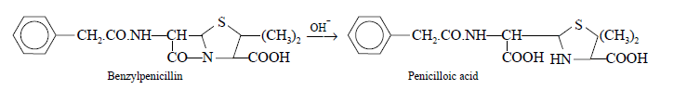

**Step 2:** Penicilloic acid on treatment with acid yields D-penicillamine and benzylpenicillic acid, as shown under:

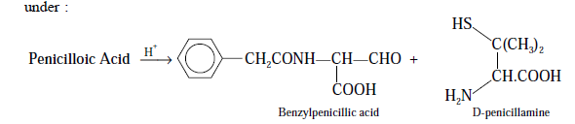

5. To another flask transfer 10.0 ml of the initial solution add 20 ml of the buffer solution and 25.0 ml of 0.02 N iodine solution; allow to stand for 20 minutes in the dark.

6. titrate with 0.02 N sodium thiosulphate, using starch solution, added towards the end of the titration as indicator ( V1). The difference between the two titrations represents the volume of 0.02 N iodine equivalents to the total penicillins present in the given sample of benzylpenicillin. An assay may be carried out simultaneously by benzylpenicillin sodium (reference sample) so as to determine the exact equivalent of each ml of 0.02 N iodine

**Calculations:**

1. Calculate the weight of benzylpenicilin?

**Wt. of benzylpenicili (mg) = (V2 –V1) x N x Eq.wt(of benzylpenicillin)**

**(In 10ml of solution)**

**Wt. of benzylpenicillin (mg) = 10 x wt. of benzynpenicillin**

**(In 100ml of solution) (In 10ml of solution)**

2. Calculate the % recovery of benzynpenicilin?



**Practical lab 8**

**Assay of methyldopa**

**ASSAY BY NON-AQUEOUS TITRATIONS**

**Introduction:**

 (Methyldopa) is an [antihypertensive](http://www.rxlist.com/script/main/art.asp?articlekey=2284) drug. Methyldopa, the *L*-isomer of alpha-methyldopa, is levo-3-(3, 4-dihydroxyphenyl)-2-methylalanine. Its formula is (C10H13NO4) with a molecular weight of 211.22 g/mol, and its structural formula is:

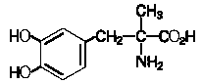

**Methyldopa M.wt. 211.22 g/mol**

Methyldopa is a white to yellowish white, odorless fine powder, and is soluble in water.(Methyldopa) is supplied as tablets, for oral use, in three strengths: 125 mg, 250 mg, or 500 mg of methyldopa per tablet.

**Principle:**

In order to perform feasible titrations of weak bases, the solvent system should be selected specifically in such a fashion so as to eliminate as far as possible the competing reaction of water for the proton besides enhancing the strength of the basic species.

In general, the reaction taking place between a primary amine and perchloric acid may be expressed as follows:

R.NH2 + HCl4 → [R.NH3] + + ClO4-

The specific reaction between methyldopa and perchloric acid is expressed by the following equation:

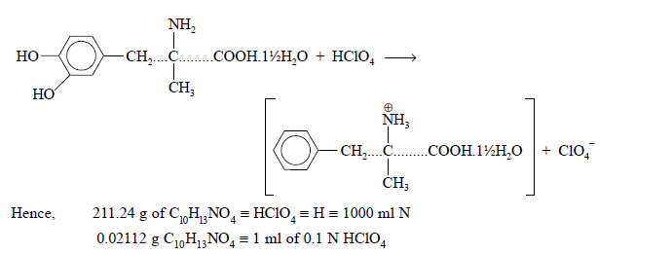

**Materials Required:**

Methyldopa 0.2 g; anhydrous formic acid: 15 ml; glacial acetic acid: 30 ml;

dioxane: 30 ml ; 0.1 N perchloric acid and crystal violet solution.

**Procedure:**

1. Weigh accurately about 0.2 g( methyldopa) and dissolve it in 15 ml of anhydrous formic acid, 30 ml of glacial acetic acid and 30 ml of dioxane
2. Add 0.1 ml of crystal violet solution.
3. Titrate with 0.1 N perchloric acid
4. Perform a blank determination and make any necessary correction.

( 15ml of anhydrous formic acid ,30ml glacial acetic acid, 30ml dioxin).

Each ml of 0.1 N perchloric acid is equivalent to 0.02112 g of C10H13NO4.

**Calculations:**

The percentage of methyldopa present in the sample is given by:

% Methyldopa = VHCIO4 x 0.02112g / (theoretical wt.) X 100