Practical Lab 2
Assay of indomethacin
Assay by acid-base titration:
Introduction:
Indomethacin is a white or yellow, crystalline powder, practically insoluble in water sparingly soluble in alcohol. Its chemical formula is (C₁₉H₁₆ClNO₄) , its melting point is(158°C to 162°C) and its pk_{a} (4.5) Its action and uses are cyclo-oxygenase inhibitor (COX), (the enzyme responsible for catalyzes the rate-limiting step in prostaglandin synthesis via the arachidonic acid pathway); analgesic; and anti-inflammatory. Its preparations are capsules and suppositories.
Indomethacin contains not less than 90% and not more than 110.0%of {1-(4-chlorobenzoyl)-5-methoxy-2-methylindol-3-yl} acetic acid, calculated with reference to the dried substance.
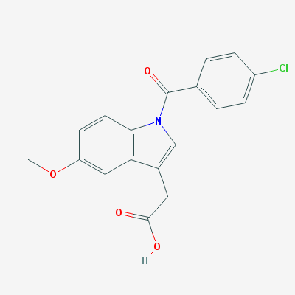
Indomethacin M. wt. (357.8g /mol)
Principle:
Indomethacin contains an acidic group (COOH) so it considered as acid hence it can be determined by titration against 0.01N NaOH using phenolphthalein (ph.ph) indicator. At the end point the color changes to pink.

Procedure:
1. Dissolve the content of one capsule (25mg) in a beaker by addition of 10 ml of neutral acetone.
2. Shake then filter into a conical flask and wash twice with 10 ml of neutral acetone.
3. Titrate the filtrate with N/100 NaOH using ph.ph as an indicator.
4. Carry out a blank titration.

Calculations:
Recovery % = practical content/ theoretical = $\frac{( V_{B}XN_{B}X Eq.Wt) }{25}$ X 100
Discussion and Evaluation
Additional activity
- Using a graph paper, draw pH ionization profiles for indomethacin and compare it with that of ephedrine, Indicate % ionization at pH of empty and full stomach, plasma and intestine as well as the half ionization.
- Comment on the implications of such chemical structure on the drugs distribution and possible side effects.

