Practical lab 5
Assay of paracetamol
Introduction:
Paracetamol, (acetaminophen),chemically named N-acetyl-p-aminophenol, is a widely used analgesic (pain reliever) and antipyretic (fever reduce). Paracetamol is classified as a mild analgesic. It is commonly used for the relief of headache and other minor aches and pains and is a major ingredient in numerous cold and flu remedies.
In combination with opioid analgesics, paracetamol can also be used in the management of more severe pain such as pot-surgical pains and providing palliative care in advanced cancer patients Though paracetamol is used to treat inflammatory pain, it is not generally classified as an NSAID because it exhibits only weak anti-inflammatory activity.
Its content 99.0% to 101.0 % (dried substance). Its appearance: white crystal powder, sparingly soluble in water freely soluble in alcohol,slightly soluble in methylene chloride, and its melting point (168 °C to 172 °C). Asaturated aqueous solution has a pH of about 6 and is stable (half-life over 20 years) but stability decreases in acid or alkaline conditions, the paracetamol being slowly broken down into acetic acid.
ParacetamolM.wt. 151.2 g/mol

Paracetamol is 4-acetamidophenol and may be represented by the following formula (C₈H₉NO_{2),} with molecular weight (151.2), pKa (9.5).
Several papers in the literature describe the assay of Paracetamol and its combination in pharmaceuticals or biological fluids. Determination of Paracetamol
using electrical method has been reported, Spectrophotometry high performance liquid chromatography, and titration method.

Principle:
The British Pharmacopoeia method for the analysis of paracetamol involves heating it under reflux with sulfuric acid. This is a straightforward, acid catalyzed, hydrolysis of an amide to an amine and a carboxylic acid. The 4-aminophenol which is formed is then titrated with an oxidizing agent, ammonium cerium (IV) sulfate using ferroin as the indicator. The first reaction is as follows:
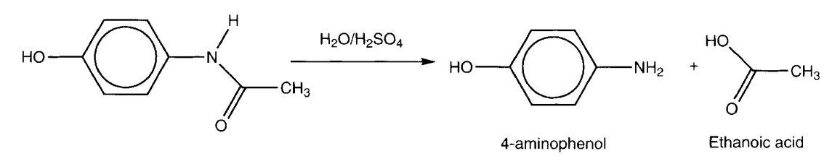
The titration step is much more interesting. 4-Aminophenol can easily be oxidized as follows:
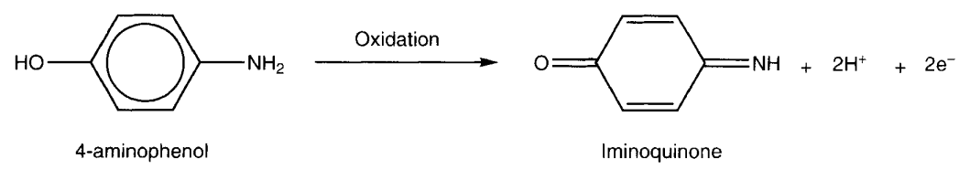
The role of the ammonium cerium(IV) sulfate is to oxidize the 4-aminophenol to the iminoquinone. Only after all the 4-aminophenol has been oxidized will the cerium (IV) reagent oxidize the ferroin indicator from Fe2+ to Fe3+ (ferriin).

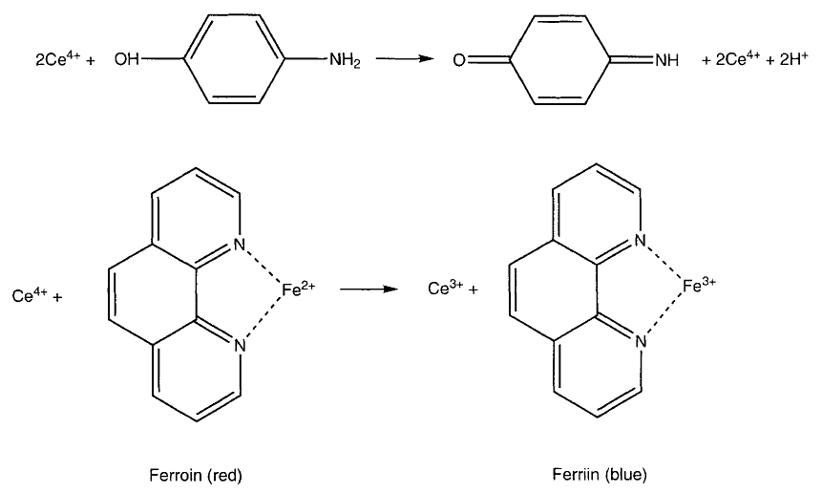
During the titration the solution should be red, and the yellow end point is the transition from red to pale blue. It is easy to work out that, since 1 mole of Ce⁴⁺ is equivalent to 0.5 mole of paracetamol, the conversion factor given in the method is correct.
Procedure:
- Weight a quantity of the powdered tablets equivalent to 0.300gm of paracetamol.
- Dissolve it in a mixture of 10ml of water and 30ml of dilute H₂SO₄ (10% w/v).
- Boil under reflux condenser for 1h cool and dilute to 100ml of water.
- To 20ml of a solution add 40ml of ice, 15ml of dilute HCL (10%w/v) and 0.1ml of ferroin.
- Titrate with 0.1N ceric ammonium sulphate until a greenish yellow color is obtained,
- Carry out the blank titration.

Q. Why must the conical flask contents be cold when ammonium cerium (VI) sulphate reacts with paracetamol?
Because when it ammonium cerium sulphate reacts with paracetamol it give rice to acid known as( ammoniaparacetasulphaterous) and 2cerium.so this gets hotter if the chemicals added before are hotter and gives a pop sound.
Calculation:
Each ml of 0.1N of ceric ammonium sulphate = 0.00756 mg of paracetamol
Calculate the recovery % of paracetamol in the tablet?

