IODIMETRIC ASSAYS

Introduction:
Iodimetric and iodometric titrations constitute another class of oxidation reduction titrations where in either iodine solutions are employed directly for the assay or an equivalent amount of iodine is liberated indirectly from the reaction mixture and then assayed.
Iodimetry is a procedure based on the following reversible reaction:
2I– I₂ + 2e
Hence, it can be utilized for the quantitative estimation of reducing agents like arsenites (H₃AsO₃) and thiosulphates (Na₂S₂O₃) by employing a standard solution of iodine.
Iodometry is an indirect procedure based on the aforesaid reversible reaction whereby the assay of oxidizing agents, for instance: ‘available chlorine’ in bleaching powder, cupric and ferric salts may be carried out by reducing them with an excess potassium iodide thereby liberating an equivalent quantity of iodine which can be estimated using a standard solution of thiosulphate.

IODIMETRIC ASSAYS
In such estimations, the pharmaceutical substances can be measured either directly or back titration of excess iodine with sodium thiosulphate solution.

In iodimetry, quantitative oxidation of reducing agents, such as arsenious acid (H₂AsO₃) may be carried out by employing standard solutions of iodine as shown under:
H₃AsO₃ + H₂O + I₂ H₃AsO₄ + 2H⁺ + 2I–

This type of assay is known as ‘direct method of iodimetry’. : Iodine in aqueous solution acts as an oxidizing agent which forms the basis of assay methods Involving direct titration with iodine.
Iodine is sparingly soluble in water but undergoes rapid dissolution in the presence of potassium iodide due to the formation of the corresponding tri iodide ion
I₂ I– I₃⁻
Thus, potassium iodide plays dual role, viz., in iodimetry—to solubilize iodine in aqueous KI solution, and in iodometry—as reducing agent, the excess KI helps in retaining liberated I₂ in solution through interaction with KI.

Residual Titration Method: (Titrated with Sodium Thiosulphate) In this titration method an excess of iodine solution is added to the solution of the substance and thus, the latter gets oxidized quantitatively. The excess of iodine is subsequently back titrated with sodium thiosulphate using freshly prepared starch solution as indicator with an end-point from violet to colorless.

Practical lab 7

Iodimetric titratration of benzylpenicillin
(Residual titration method)
Introduction:
Benzylpenicillin, is A penicillin derivative commonly used in the form of its sodium or potassium salts in the treatment of a variety of infections. It is effective against most gram-positive bacteria and against gram-negative cocci. It is amorphous white powder, Molecular Formula: C₁₆H₁₈N₂O₄S Molecular Weight: 334.390, sparingly soluble in water; insoluble in petroleum ether soluble in methanol, ethanol, ether, ethyl acetate, benzene, chloroform and acetone.
IUPAC Name: (2S, 5R, 6R)-3, 3-dimethyl-7-oxo-6-[(2-phenylacetyl) amino]-4-thia-1-azabicyclo [3.2.0] heptane-2-carboxylic acid

Principle:
Benzylpenicillin can be assayed efficiently by adopting the following three steps sequentially, namely:

Step 1: Benzylpenicillin is first converted to the corresponding penicilloic acid (a dicarboxylic acid) by carrying out the hydrolysis with sodium hydroxide solution, as follows:
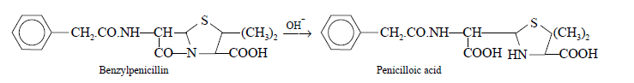
Step 2: Penicilloic acid on treatment with acid yields D-penicillamine and benzylpenicillic acid, as shown under:
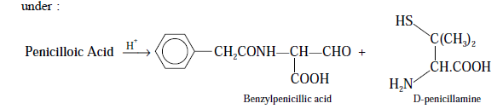

5. To another flask transfer 10.0 ml of the initial solution add 20 ml of the buffer solution and 25.0 ml of 0.02 N iodine solution; allow to stand for 20 minutes in the dark.
6. titrate with 0.02 N sodium thiosulphate, using starch solution, added towards the end of the titration as indicator ( V₁). The difference between the two titrations represents the volume of 0.02 N iodine equivalents to the total penicillins present in the given sample of benzylpenicillin. An assay may be carried out simultaneously by benzylpenicillin sodium (reference sample) so as to determine the exact equivalent of each ml of 0.02 N iodine

Calculations:
- Calculate the weight of benzylpenicilin?

Wt. of benzylpenicili (mg) = (V₂ –V₁) x N x Eq.wt(of benzylpenicillin)
(In 10ml of solution)

Wt. of benzylpenicillin (mg) = 10 x wt. of benzynpenicillin
(In 100ml of solution) (In 10ml of solution)

2. Calculate the % recovery of benzynpenicilin?

