EXPERIMENT 7

IDENTIFICATION OF AMINES
Amines are organic compounds and functional groups that contain a basic nitrogen atom with lone pair. Amines are derivatives of ammonia, wherein one or more hydrogen atoms have been replaced a subsistent such as an alkyl or aryl group. Important amines including amino acids, biogenic amines, trimethyl amine and aniline. For aliphatic amines name groups attached to N; use suffix -amine.

Biological Activity:
Amines have strong, characteristic odors, and are toxic. The smells of ammonia, old fish, urine, rotting flesh, and semen are mainly composed of amines. Many kinds of biological activity produce amines by breakdown of amino acids. Many hormones like epinephrine, nor epinephrine, and dopamine, are amines.
Chemical Reactions:
1. General test (The hydrochloric acid test).
Amines are characterized chiefly through their basicity. A water insoluble compound that dissolves in cold dilute hydrochloric acid or a water-soluble compound whose aqueous turn litmus blue.

Procedure:
Place 3 ml of water in a clean test tube. Add one drop or a spatula tip of your unknown. Swirl the mixture. If your unknown is soluble, test the pH of the solution. An alkaline pH is indicative of an amine. If your unknown is not soluble in water, add 3 ml of 5% HCl solution. If your unknown dissolves in the acid solution, an amine is indicated.

2. Tests for differentiation between. Primary and secondary amines.
The Hinsberg Test .
An electrophilic reagent, benzenesulfonyl chloride, reacts with amines in a fashion that provides a useful test for distinguishing primary, secondary and tertiary amines (the Hinsberg test). As shown in the following equations, 1º and 2º-amines react to give sulfonamide derivatives with loss of HCl, whereas 3º-amines do not give any isolable products other than the starting amine. In the latter case a quaternary "onium" salt may be formed as an intermediate, but this rapidly breaks down in water to liberate the original 3º-amine (lower right equation).

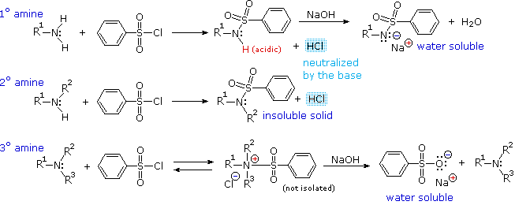

The Hinsberg test is conducted in aqueous base (NaOH or KOH), and the benzenesulfonyl chloride reagent is present as an insoluble oil. The amine dissolves in the reagent phase, and immediately reacts (if it is 1º or 2º), with the resulting HCl being neutralized by the base. The sulfonamide derivative from 2º-amines is usually an insoluble solid. However, the sulfonamide derivative from1º-amines are acidic and dissolve in the aqueous base. Acidification of this solution then precipitates the sulfonamide of the 1º-amine.
Benzenesulphonyl chloride reacts with primary and secondary but not with tertiary amines to yield substituted sulphonamides. The substituted sulphonamide formed from a primary amine dissolves in the alkali medium whilst that produced from a secondary amine is insoluble in alkali.

Procedure:

Place 0.5 mL (or 0.5 g) of the compound, 15 - 10 mL of 5% NaOH and 1 mL of benzenesulphonyl chloride in a test tube, stopper the tube and shake until the odor of the sulphonyl chloride has disappeared. The solution must be kept alkaline (if no reaction has occurred, the substance is probably a tertiary amine).
If a precipitate appears in the alkaline solution, dilute with about 10 mL of water and shake; if the precipitate does not dissolve, a secondary amine is indicated.
If there is no precipitate, acidify it cautiously to congo red with concentrated hydrochloric acid (added drop wise): a precipitate is indicative of a primary amine.

