EXP.6
Mechanochemical synthesis of racemic 1,1'-bi-2-naphthol and 2,3-diphenylquinoxaline

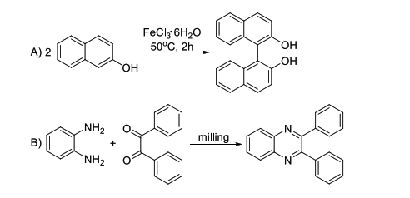

Experimental procedure:
Synthesis of racemic 1,1'-bi-2-naphthol
Place a mixture of 2-naphthol (1 g, 7 mmol) and iron(III) trichloride hexahydrate (3.8 g, 14 mmol) in a mortar, powder it thoroughly and transfer to a test tube. Heat the tube at 50 °C for 2 hours. Cool the reagents to room temperature, mix them with a diluted hydrochloric acid and filter with suction. Wash the solid on the sinter with diluted hydrochloric acid and water and dry it. Recrystallize the crude product from ethanol. Typical yield of the reaction is 0.95 g (95%).

Synthesis of 2,3-diphenylquinoxaline
Place a mixture of o-phenylenediamine (324 mg, 3 mmol) and benzil (630 mg, 3 mmol) in the ball mill and stir the reagents for 1 hour at room temperature.
Alternatively, powder the reagents in a mortar and transfer them into a beaker equipped with a magnertic stirrer bar. Stir the reagents for 1 hour. Typical yield of this reacion is 846 mg (100%).

