University of Mustansiriyah
College of Pharmacy
Pharmaceutical Chemistry
Department

Organic Chemistry Laboratory Experiments
Stage 2
2nd semester
2018-2019

Organic chemistry – laboratory methods

Description:

This course deals with laboratory techniques in organic chemistry laboratory. Upon successful completion of this course students will possess practical skills required for work in modern chemical laboratory.

Learning objectives:

- Synthesis
- Isolation of the product from a mixture containing reagents.
- Purification of the product by crystallization.

Grading and Rules of evaluation:

The final grade will be weighted arithmetic mean of two grading elements:

- Lab work (60%)
Lab work grade will be arithmetic mean of:
- Data sheet reports
- Quiz
- Ethics

- Final-lab work (40%).

The lab work grade will be based on:

- following the safety regulations and good work practices in chemical laboratory
- punctuality (starting and finishing the lab work on time)
- preparation for the class, theoretical knowledge of experimental techniques that will be used in the experiment
- a proper planning of the activities in time
- tidiness of the work space
- the proper use of glassware and equipment
- independence in the lab work
- knowledge of the proper disposal of chemical waste
- the proper conducting of notes from lab work
Data sheet grade will be based on:

- punctuality – the report should be submitted maximum 3 days after the class; reports submitted after 3 days will be given 5.0 grade.
- completeness of the report and correctness of the physicochemical data that must be provided for the characterization of each compound.

Preparation for the class:

Before starting the class all students must:
- carefully read the experimental procedure for the experiment

- identify all the potential hazards that might appear during the experiment and find a way to prevent them and deal with them
- read the Material Safety Data Sheet (MSDS) for each reagent that will be used during the experiment
- think of and prepare a sketch of the glassware set and equipment that will be used during the experiment; this will be discussed with the Instructor and should be modified according to Instructor’s suggestions
- plan all of the activities in time (and write them down in points)
- learn about a proper way of disposal of chemical waste generated during the experiment
- get acquainted with instructional materials related to the experimental techniques that will be used in the experiment

Organic chemistry – laboratory methods
Safety Rules in the Organic Chemistry Laboratory:

1. When working in the Organic Chemistry Laboratory you should remain calm and behave properly. All students are responsible for the tidiness of their work environment.
2. Wearing lab coat and the proper eye protection is obligatory. When working with corrosive reagent it is obligatory to wear protective gloves.
3. Wearing contact lenses during the lab work is not recommended. Pregnant women cannot take part in organic chemistry lab classes. Students who suffer from the chronic diseases like epilepsy or allergies are obligated to inform the Instructor about it.
4. All students need to have a lab book for making notes during experiments. All the products of syntheses should be given to the Instructor in the end of the class following by the post-lab report. This is obligatory for a successful completion of the course.
5. Only diluted solutions of acids and bases might be disposed in a sink. The concentrated solutions of acids and bases should be diluted prior the disposal. All of the organic solvents have to be transferred into the appropriate container, which is located under the special fume hood. Students will be instructed how to dispose different types of liquid and solid waste. It is not allowed to put any solid waste into the sink.
6. All lab work with organic reagents and solvents must be performed under the fume hood.
7. Students must be extremely cautious when working with concentrated solutions of acids, bases, flammable liquids (diethyl ether, acetone, alcohols, benzene and other organic solvents), bromine and toxic reagents.
8. Any type of emergency or dangerous situation should be immediately reported to the Instructor who will provide the first aid.
9. In the case of fire students should remain calm, switch off electricity sources and remove the flammable materials from the area covered with the fire. To fight the fire, you should use a proper fire extinguisher or a fire blanket. Covering the burning area with a wet towel might stop small fire. In the case of any fire it is absolutely necessary to report the incident to the Instructor.
10. Burning people should be toppled to the floor and covered with a blanket fire or doused with water. You musn’t use a fire
extinguisher to fight a fire on a burning person.
11. It is not allowed to:
a) pipet with your mouth, b) use flammable solvents in the close proximity to the source of fire or heat, c) eat or taste
chemicals, d) run the experiments that are not included in the lab schedule.
12. In the laboratory you mustn’t:
a) smoke cigarettes, b) eat or drink, c) leave any apparatus unattended, d) leave the lab without informing the Instructor, e) bring other people, f) bring the jackets, coats or bags of any type.
13. This is the obligation of a student on a duty (picked by the Instructor) to bring, take care and return the special equipment from the lab Technicians. This student is also responsible for taking care of the tidiness of the laboratory during the class and when the class finishes. The student on a duty will leave the laboratory, as the last person once the lab Technicians will approve the tidiness of the laboratory.
14. Students are financially responsible for the equipment and glassware.
15. Students will confirm that they have read and understood the Safety Rules by signing its copy.

Using the Balances:

Before you weigh an object, there are certain considerations you must follow:

- Any object to be weighed must be at room temperature; air currents from hot or cold objects will affect the weighing. Likewise, on the analytical balance, close the doors before weighing.

- Chemicals must be held in a weighing boat, on weighing paper, or in a beaker. Never place any chemicals directly on the balance. Don’t forget to weigh the empty container as well so you can find the weight of the chemicals alone.

- Clean up any spills carefully and promptly using a small brush.

Using a Pipet:

The pipet is used when exact volumes are required. Gently fit the pipet piston over the pipet. Be careful to hold the pipet at the “top” end when fitting it with the piston; we have sent several students to the hospital who broke a pipet in their hands and were cut badly. Turn the thumbwheel to raise the piston and draw liquid into the pipet. Adjust the thumbwheel until the liquid meniscus is aligned with the mark on the pipet stem. Hold the pipet over the destination flask, and depress the release lever to transfer the liquid.

Using a Graduated Cylinder:

A graduated cylinder is the simplest general tool for measuring volume; simply fill it with the desired quantity of liquid and pour to dispense. The cylinders we use are made of plastic and thus should not exhibit a meniscus; they also should deliver all the solution they contain. Do not worry about getting the last drop out of the cylinder.

EXP.1
Aldol Condensation - Synthesis of Dibenzalacetone

Purpose - The objectives of this experiment are to learn aldol condensation mixture of aldehydes and ketones, which used extensively in organic synthesis to form C-C bonds and make bigger molecules.

Introduction

Like the Grignard reaction, the Aldol Condensation is an extremely useful carbon-carbon bond-forming reaction in organic chemistry. Under the reaction conditions in the experiment, two equivalents of aldehyde will react.

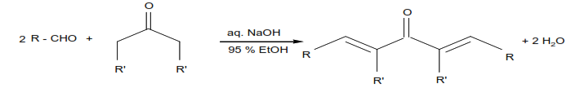

The aldol condensation is a reaction that is named based on the type of product formed when two aldehydes (or ketones), in the presence of dilute base, yields a molecule having both alcohol and aldehyde functional groups. An example of the type of base-catalyzed aldol condensation that you will perform is shown below.
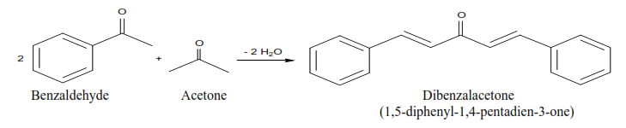

These products are a ß-hydroxyaldehyde (or a ß-hydroxyketone). This reaction is used extensively in organic synthesis to form C-C bonds and make bigger molecules. In every case, the product results from the addition of one molecule of an aldehyde (or ketone) to a second molecule in such a way that the a-carbon of the first becomes attached to the carbonyl carbon of the second.

MECHANISM OF THE ALDOL CONDENSATION

The acidity of the alpha-carbon makes beta-dehydration of aldols an easy reaction. (This is of course quite different than the chemistry of normal alcohols.) This conjugated enone synthesis is catalyzed by both acids and bases. This shows the mechanism of the experiment performed. The reaction proceeds by an aldol condensation.

Step 1:
First, an acid-base reaction. Hydroxide functions as a base and removes the acidic α-hydrogen giving the reactive enolate.

Step 2:
The nucleophilic enolate attacks the aldehyde at the electrophilic carbonyl C in a nucleophilic addition type process giving an intermediate alkoxide.

Step 3:
An acid-base reaction. The alkoxide deprotonates a water molecule creating hydroxide and the β−hydroxyaldehydes or aldol product.

MECHANISM OF THE DEHYDRATION OF AN ALDOL PRODUCT

Step 1:
First, an acid-base reaction. Hydroxide functions as a base and removes an acidic α-hydrogen giving the reactive enolate.

Step 2:
The electrons associated with the negative charge of the enolate are used to form the C=C and displace the leaving group, regenerating hydroxide giving the conjugated aldehyde.

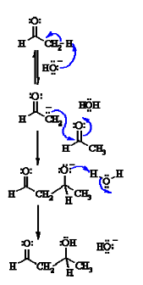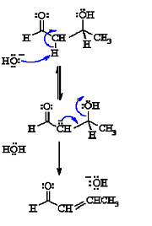
Dehydration generally occurs under slightly more vigorous conditions, such as higher temperature, than the condensation reaction. Thus at higher temperature in base the aldol reaction will go directly to the conjugated enone without any isolation of the aldol intermediate.

In the present case, the reaction—a mixed, or crossed aldol condensation involving an aromatic aldehyde—is referred to as a Claisen-Schmidt condensation. The Claisen-Schmidt condensation always involves dehydration of the product of the mixed addition to yield a product in which the double bond (produced during dehydration) is conjugated to both the aromatic ring and the carbonyl group. Because this aromatic aldehyde lacks α- hydrogens, only one product is formed, rather than a mixture of four different compounds, as long as the concentration of the second aldehyde is carefully controlled. In this experiment we will prepare the dibenzalacetone: 1,5-diphenyl-1,4-pentadien-3-one. The equilibrium is shifted toward the product because the compound precipitates from the reaction mixture as it is formed.
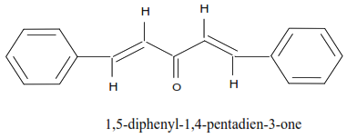
In this experiment, you will run an aldol condensation between an aldehyde and a ketone and then the product of the reaction precipitates out of solution and can be collected by filtration. The crude product is normally purified by recrystallization. Weigh your product and determine percent yield. What reactant is your percent yield based on? Determine the melting point and compare to the literature value. (Table 1)
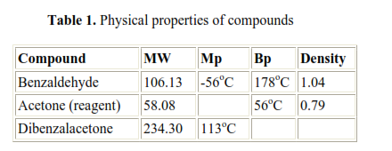
Safety Note

a) NaOH in aqueous ethanol is corrosive and particularly dangerous to the eyes. If contacted, remove with plenty of water.
b) Acetone is highly flammable.
c) Benzaldehyde is listed as moderately toxic (but contributes to the flavor of
almonds)

Experimental:

Chemicals:

Methanol, CH3OH
Acetone, CH3COCH3
10% NaOH
Benzaldehyde, C6H5-CHO
95% Ethanol, C2H5OH

Materials:

125 mL Erlenmeyer flask
25 mL graduated cylinder
thermometer
funnel
filter paper
ice bath

Procedure:

- Transfer 15mL of ethanol into a 125-mL Erlenmeyer flask and add 20mL of 10% NaOH to it. Using a thermometer, cool the solution to 20ºC.

- In a medium size tube, mix 2mL of benzaldehyde with 15 drops of acetone, and leave it at room temperature for 5 minutes. Then, add the mixture to the ethanol-NaOH solution in small portions and stir with magnetic stirrer (if available) for 30 minutes. Chill the solution in an ice-water bath. Collect the yellow crystals by suction filtration and hand-dry them by pressing them between dry paper towels.

- Determine the weight of the dibenzalacetone product, its melting point, and the percent yield. Return the product to your instructor.

EXP.2

Synthesis of p-Nitro acetanilide from Acetanilide
(Electrophilic Aromatic Substitution)

Purpose - The objectives of this experiment are to learn nitration of acetanilide as an electrophilic aromatic substitution reaction.
.
Introduction:

Electrophilic aromatic substitutions (EAS) generally occur, because of the high electron density of the aromatic ring, during EAS reactions electrophiles are attracted to the ring's Л system and protons serve as the leaving groups, Equation 1.

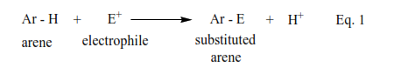
Generally, EAS reactions occur in three steps, Scheme I. During Step I, the electrophile is produced, Scheme 1.

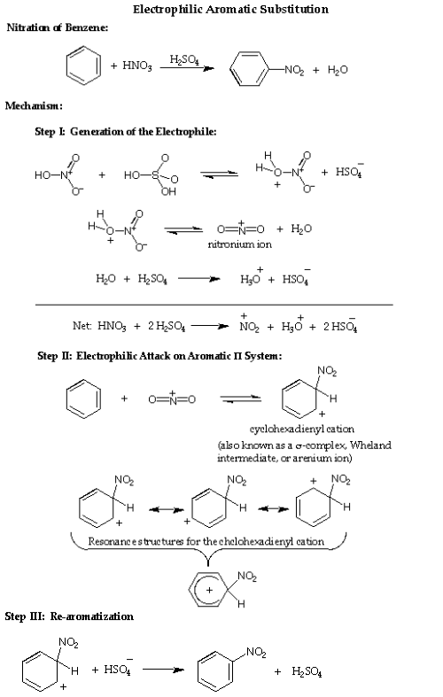

In this experiment you will put a nitro (—NO₂) group on a benzene ring, which already has an secondary amide group, attached to it (acetanalide). The actual electrophile in the reaction is the nitronium ion (NO₂⁺), which is generated in situ ("in the reaction mixture" HNO₃/H₂SO₄) using concentrated nitric acid and concentrated sulfuric acid.
Reaction:
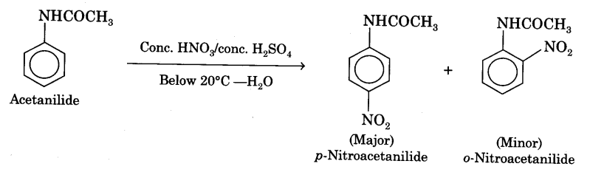
Precautions:
- During addition of nitrating mixture, the temperature of the reaction mixture should not rise above 10°C.
- Addition of fuming nitric acid should be done drop wise.
- Do not inhale the vapors of nitric acid as they are very corrosive in nature. Addition of nitrating mixture may preferably be done in a fume-cupboard.
Experimental:
Chemicals:
Glacial acetic acid (GAA)
Acetanilide
Con. H₂S0₄
Conc. HNO₃
Materials:
Conical flask (100 ml)
beaker (250 ml)
measuring cylinder (100 ml)
test-tube
filter-papers
Procedure:
- Take a 100 ml conical flask and add 5 g of powdered acetanilide in it. Add 5 ml of glacial acetic acid and stir the mixture by the use of glass-rod.
- Place 2 ml of fuming nitric acid in a clean test-tube and cool it in a freezing mixture (ice + salt) taken in a beaker. Carefully add drop by drop 2 ml of cone, sulphuric acid with constant shaking and cooling.
- Add the remaining 8 ml of cone. H2S04 drop by drop (with cooling under tap water) to the conical flask containing acetanilide and glacial acetic acid. Place the conical flask in a freezing mixture (Fig). Stir the contents and wait until the temperature becomes less than 5°C.
- To the cooled contents in the flask add nitrating mixture prepared in step (2) drop by drop with constant stirring. During addition temperature of the mixture should not rise above 10°C. This operation should take about 15 minutes (Fig).
- Remove the conical flask from the freezing mixture and allow it to stand for 30 minutes at room temperature.
- Pour the contents of the flask on the crushed ice taken in a beaker. Stir it and filter the crude product. Wash thoroughly with cold water to remove acid.
- Recrystallization of p-nitroacetanilide. Dissolve the crude product obtained above in about 20 ml of methylated spirit. Warm to get a clear solution. Filter while hot and cool the filtrate in ice. o-Nitroacetanilide goes in the filtrate while p-nitroacetanilide is obtained as colourless crystals on the filter paper. Wash the solid on the filter paper with cold water. Dry the solid, weigh it and record its yield.
Result:
Weight of p-nitroacetanilide is obtained =………g
Melting point of the compound is……….°C
Note: Approximate expected yield is 4g.
The melting point of p-nitroacetanilide is 214°C.

EXP.3
Synthesis of p-nitroaniline from aniline based on protection/deprotection of amine group

The nitration of aniline is difficult to carry out with nitrating mixture (a mixture of cone. H₂SO₄ ,and cone. HN0₃) since —NH₂ group gets oxidized which is not required. So the amino group is first protected by acylation to form acetanilide which is then nitrated to give p-nitroacetanilide as a major product and o-nitroacetanilide as a minor product. Recrystallization from ethanol readily removes the more soluble ortho-compound and the pure p-nitroacetanilide is obtained. The chemical equation can be written as:

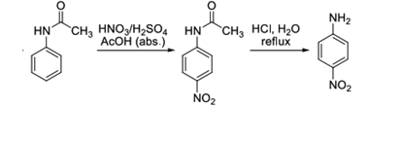
Deprotection of amine group procedure:

- In a 50 mL Erlenmeyer flask mix the moist, crude p-nitroacetanilide with 3 mL of water and 4 mL of concentrated hydrochloric acid. Reflux the mixture gently for 15–20 minutes. The material gradually dissolves and an orange-colored solution is formed.
- When the hydrolysis is completed add 6 mL of cold water and cool the mixture to room temperature. Crystals of the product may separate.
- Pour the p-nitroaniline hydrochloride slowly, stirring thoroughly, into a mixture of 4 mL of concentrated aqueous ammonia, 15 mL of water, and 5–6 g of chipped ice. The mixture must be distinctly alkaline at the time of the mixing; test with indicator papers, and add a little more ammonia if necessary.
- Collect the orange-yellow precipitate of p-nitroaniline with suction and wash it with cold water. Recrystallize the product from a large volume of hot water; about 30 mL of water will be required per gram of material.
- The yield is 0.5–0.8 g. Prepare a sample of the purified product.

EXP.4

Cross aldol condensation
Peparation of 1-(4-methoxyphenyl)-3-phenylprop-2-en-1-one

Introduction

Aldol condensations represent an important class of carbon ‐carbon bond formation
reactions both in nature and in synthetic chemistry. Compounds called chalcones
(or chalconoids) can be prepared by the cross aldol condensation of an aromatic ketone
and an aldehyde.

In this experiment 1-(4-methoxyphenyl)-3-phenylprop-2-en-1-one, obtained through a cross aldol condensation of 4-Methoxybenzaldehyde and Acetophenone, will be synthesized in a one pot reaction.

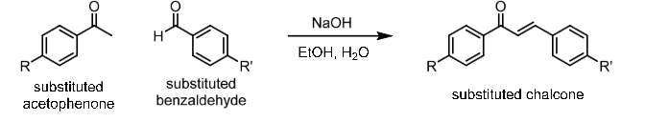

Experimental:

Chemicals:

Acetophenone
Anisaldehyde
50% NaOH
95% Ethanol, C2H5OH

Materials:

25 mL Round bottle flask
10 mL graduated cylinder
thermometer
funnel
filter paper
ice bath

Procedure

- Acetophenon (1mL) and anisaldehyde (1mL) were added to 5 mL 95%ethanol.
- Add 5 drops sodium hydroxide (50%) solution to mixture for 2 min.
- The mixture was irradiated by an ultrasonic generator in a water bath at 30-35 ºC for (25 min.) turbidity appeared in the mixture.
- Neutralized with 2N HCl. The solid product formed was filtered, washed with cold water and recrystallized by ethanol.

EXP.5

Canizzaro reaction

One of the notable organic reactions in chemistry is the Cannizzaro reaction, named after its discoverer, Stanislao Cannizzaro. It is limited to aldehydes lacking alpha hydrogen centers. It produces an alcohol and carboxylic acid at minimal amounts, accounting only 50% to the yield even under ideal conditions. It is a base-catalyzed reaction, which begins with the nucleophilic attack of OH⁻ on the carbonyl center. The resulting anion attacks another molecule of aldehyde, transferring a hydride ion. In the final step, the acid and alkoxide ions formed exchange a proton. All in all, the discovery of Cannizzaro has proven to be one of the most important reactions in synthetic organic chemistry

- Dissolve 1.0g of KOH in 1 mL distilled H₂O in a test tube.
- Weigh 200 mg of 4-chlorobenzaldehyde and transfer it to a 25 mL round bottle flask, add 0.5 mL of methanol and stir to dissolve the 4-chlorobenzaldehyde.
- Transfer 0.3 mL of the 50% aqueous KOH sol’n to the flask.
- Place the base of the 25 mL flask in a heating bath, preheated to ~75 degree celsius, and heat the reaction mixture with stirring for 1.5 hour.
- Remove the flask from the bath and cool the mixture to room temperature. Then, add 2.5 mL of water and transfer the mixture in a small separator funnel. Extract the aqueous mixture with 3 separate 1.0 mL portions of dichloromethane and collect the organic layer.
- Wash the combined dichloromethane extracts with two separate 0.5 mL portions of saturated aqueous sodium chloride. Also add several spatula tips of anhydrous sodium sulfate anhydrous to organic layer.
- Remove DCM in organic layer by using rotary evaporator. P-chlorobenzyl alcohol in organic layer should recrystallized in 3ml of 4% acetone in hexane.

EXP.6
Mechanochemical synthesis of racemic 1,1'-bi-2-naphthol and 2,3-diphenylquinoxaline

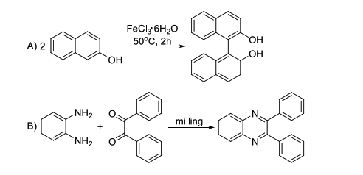

Experimental procedure:
Synthesis of racemic 1,1'-bi-2-naphthol
Place a mixture of 2-naphthol (1 g, 7 mmol) and iron(III) trichloride hexahydrate (3.8 g, 14 mmol) in a mortar, powder it thoroughly and transfer to a test tube. Heat the tube at 50 °C for 2 hours. Cool the reagents to room temperature, mix them with a diluted hydrochloric acid and filter with suction. Wash the solid on the sinter with diluted hydrochloric acid and water and dry it. Recrystallize the crude product from ethanol. Typical yield of the reaction is 0.95 g (95%).

Synthesis of 2,3-diphenylquinoxaline
Place a mixture of o-phenylenediamine (324 mg, 3 mmol) and benzil (630 mg, 3 mmol) in the ball mill and stir the reagents for 1 hour at room temperature.
Alternatively, powder the reagents in a mortar and transfer them into a beaker equipped with a magnetic stirrer bar. Stir the reagents for 1 hour. Typical yield of this reaction is 846 mg (100%).

Exp.7

Preparation of Benzoic Acid from Benzyl Chloride

Preparation of Benzoic Acid from Benzoyl chloride
In this reaction a side chain oxidation is performed. In order to achieve this benzyl chloride is mixed with sodium carbonate solution and is oxidized with potassium permanganate solution. The sodium salt of benzoic acid is formed; this is acidified with concentrated hydrochloric acid when benzoic acid crystallizes out. Preparation benzoic acid benzyl chloride
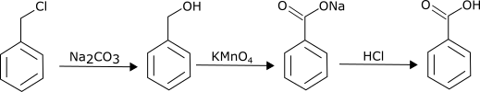Preparation of
Reagents
- Benzyl chloride 2 ml
- Anhydrous sodium carbonate 2 g in 20 ml of water
- Potassium permanganate 8 g in 80 ml water

Procedure:
About 2 ml of benzyl chloride is added to a solution of about 2 g rams of anhydrous sodium carbonate dissolved in 20 ml of distilled water. The mixture is taken in a round bottom flask. The round bottom flask is fitted with a water reflux condenser and heated. 4 grams of potassium permanganate in 80 ml of water is added in small quantities through the water condenser until a permanent pink color persists even after continuous boiling. It is boiled for about 1 hour. The mixture is not transferred to a beaker. About 4 grams of sodium sulfite are added to this mixture. Now add concentrated hydrochloric acid to this solution until the solution is acidic. The solution is cooled, precipitated benzoic acid is filtered and washed. The acid is recrystallized from boiling water.
The yield of benzoic acid is about 2 grams and the melting point is 1210C
Care should be taken while setting up the equipment’s, the hydrochloric acid used in converting the sodium salt of benzoic acid is concentrated, so extreme care should be taken while handling the chemicals and using them. Wear goggles, gloves and apron while performing the experiment. Use common sense while performing any lab activity and read your lab manual before doing any experiment.

