Toxicology worksheet (Lab-3)
Date---------- Names of the students:
Group--------

Name of the experiment:

Aim of the experiment:

Materials
1. Animal:
2. Drugs and agents:
3. Apparatus and instruments:

Procedure:

Results:

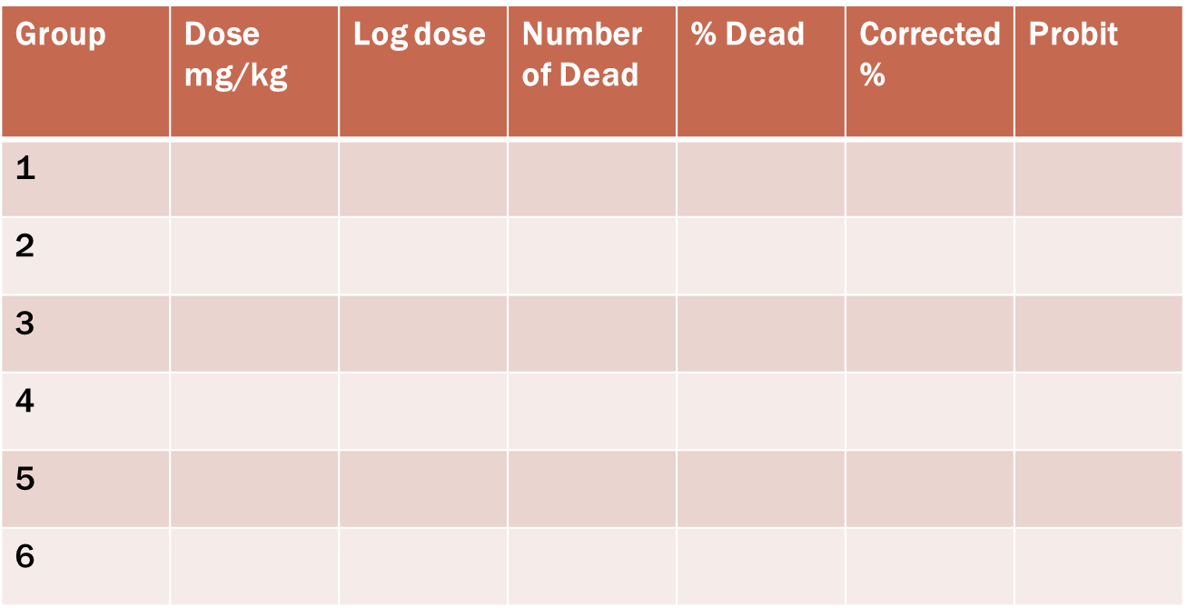
0/6
0.1
0.4
6/6
5/6
2/6
0/6
0/6
1
0.6
0.8
0.2

Discussions:

Conclusion:

