**Gout and Hyperuricemia**

Is the most common inflammatory joint disease in men and the most common inflammatory arthritis in older women. It is caused by deposition of monosodium urate crystals in joints and soft tissues following chronic hyperuricaemia. Chronic hyperuricaemia is associated with disorders of purine metabolism due to under excretion or over production of uric acid, the final metabolite of endogenous and dietary purine metabolism.

Gout is predominantly a disease of men with a male to female ratio of 3.6:1. In women, it tends to develop after menopause when levels of oestrogen, a known uricosuric, fall.

**Pathophysiology**

Uric acid is mainly a by-product from the breakdown of cellular nucleoproteins and purine nucleotides synthesised de novo with about a third coming from the breakdown of dietary purine intake. This is mainly present as monosodium urate due to the high concentration of sodium in the extra-cellular compartment. Human beings and higher primates lack the enzyme uricase that degrades uric acid to the highly soluble allantoin resulting in higher concentrations of urate close to the level of solubility. Monosodium urate has a solubility limit of 380 µmol/L; when the concentration exceeds 380 µmol/L, there is a risk of precipitation and the formation of monosodium urate crystals.

**Primary gout** is not a consequence of an acquired disorder, but is associated with rare inborn errors of metabolism and isolated renal tubular defects in the fractional clearance of uric acid.

**Secondary gout** is the consequence of the use of specific drugs or develops as a consequence of other disorders.

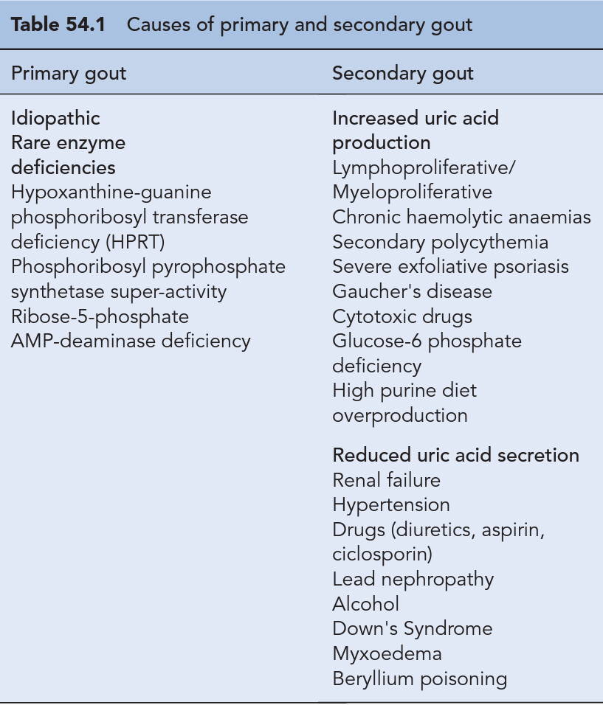

**Risk factors**

* **Genetics**
* **Renal disease**
* **comorbidties** for example obesity , dyslipidemia, glucose intolerance,hypertension,
* **Diet** (red meat, seafood consumption, soft drinks sweetened with sugar (not diet drinks) .The consumption of cherries, but no other fruits, has also been shown to decrease uric acid levels.
* **Alcohol consumption**
* **medication** ( Aspirin has a bimodal effect; low doses inhibit uric acid excretion and increase urate levels, while doses greater than 3 g/day are uricosuric. Alcohol, ciclosporin ,Cytotoxic chemotherapy because of increased cell breakdown; to overcome this, prophylactic treatment may be given with allopurinol, commencing 3 days before therapy.

Diuretics(both loops and thiazides) volume depletion and reduced renal

tubular secretion of uric acid.Ethambutol ,Levodopa ,Pyrazinamide,

Ribavarin and interferon, Teriparatide

**Presentation and diagnosis**

* An acute attack of gout has a rapid onset, with pain being maximal at 6–24 h of onset and spontaneously resolving within several days or weeks.
* The first attack usually affects a single joint in the lower limbs in 85–90% of cases, most commonly the first metatarsophalangeal joint (big toe)
* The affected joint is hot, red and swollen with shiny overlying skin. Even the touch of a sheet on the affected joint is too painful for the patient to bear. The patient may also have a fever, leucocytosis, raised erythrocyte sedimentation rate (ESR).
* Monosodium urate crystals preferentially form in cartilage and fibrous tissues where they are protected from contact with inflammatory mediators.
* patients will have normal uric acid concentrations during an acute attack of gout due to increased urinary urate excretion.
* The most appropriate time to measure serum urate for monitoring purposes is when the attack has completely resolved.
* The gold standard for the diagnosis of gout is the demonstration of urate crystals in synovial fluid or in a tophus by polarised light microscopy .Crystals may be found in fluid aspirated from non-inflamed joints, even in those joints which have not previously experienced an attack.

**Treatment**

* Management is not only directed at alleviating acute attacks and preventing future attacks, but also identifying and treating other co-morbid conditions such as hypertension and hyperlipidaemia.
* The Pharmacological measures should be combined with non-pharmacological measures such as weight loss, changes in diet, increased exercise and reduced alcohol consumption.

**Management of an acute attack**

* Drugs used in the management of an acute attack include NSAIDs, colchicine and corticosteroids. NSAIDs are the recommended first-line agents
* paracetamol and weak opiate analgesics, for example, codeine or dihydrocodeine may be added to the regimen to provide additional relief.
* Treatment should be continued until the attack is terminated, usually between 1 and 2 weeks. The affected joints should also be rested for 1–2 days and initially treated with ice which has a significant analgesic effect during an acute attack.
* Where loop and thiazide diuretics are being used for the management of hypertension alone, an alternative anti-hypertensive agent should be considered according to national guidance. **Losartan**, an angiotensin receptor blocker effective in hypertension, has been shown to have uricosuric properties and is a suitable agent in hypertensive patients with gout.
* patients with heart failure, diuretics are often essential and cannot be discontinued. Certain NSAIDs may be preferable in patients on diuretics with indometacin.
* Allopurinol should not be commenced during an acute attack as it may prolong or precipitate another attack.
* However, in patients already established on allopurinol therapy, allopurinol should always be continued during the attack.
* Aspirin at analgesic doses (600–2400 mg/day) should be avoided as it blocks urate secretion. The continuation or initiation of low-dose aspirin (75–150 mg/day) is recommended in patients with cardiac disease as the benefits outweigh the minimal effect on serum uric acid levels.
* Non-steroidalanti-inflammatorydrugs are first line treatment maximum doses of an NSAID should be commenced rapidly after the onset of an attack and then tapered 24 h after the complete resolution of symptoms.

**Colchicine**

It should be started as soon as possible after the onset of an attack. Although the mode of action of colchicine in gout is not fully understood, it is thought to arrest microtubule assembly in neutrophils and inhibit many cellular functions. Patients were given 1 mg of colchicine followed by 500 μcg every 2 h until the attack stopped or they felt too ill to continue taking colchicine.

A maximum of 6 mg should be given per course and treatment should not be repeated within 3 days. Common side effects associated with colchicine are abdominal cramps, nausea, vomiting, and rarely bone marrow suppression, neuropathy and myopathy. Side effects are more common in patients with hepatic or renal impairment.

**Corticosteroids**

Corticosteroids are usually considered where use of an NSAID or colchicine is contraindicated or in refractory cases. They may be given intravenously, intramuscularly or direct into a joint (intra-articular) when only one or two joints are affected. In patients with a monoarthritis, an intra-articular corticosteroid injection is highly effective in treating an attack. Common doses of intra-articular steroids are 80 mg of methylprednisolone acetate for a large joint such as a knee; 40 mg of methylprednisolone acetate or 40 mg of triamcinolone acetonide for a smaller joint such as a wrist or elbow.

Oral prednisolone 30 mg daily for 5 days has also been shown to be equally efficacious to indometacin 50 mg three times a day for 2 days or 25 mg three times a day for 3 days plus paracetamol and has fewer adverse events

**Interleukin-1inhibitors**Anakinra, an IL-1 receptor antagonist, has been shown to reduce the pain of gout and bring about complete resolution by day 3 in the majority of patients after a course of three 100-mg subcutaneous injections.

**Management of chronic gout**

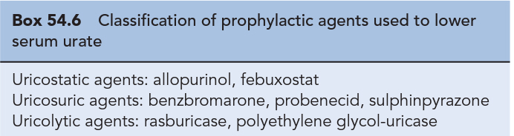Patients who suffer one or more acute attacks within 12 months of the first attack should normally be prescribed prophylactic urate-lowering therapy, The aim of prophylactic gout treatment is to maintain the serum urate level below the saturation point of monosodium urate (300 μmol/L).

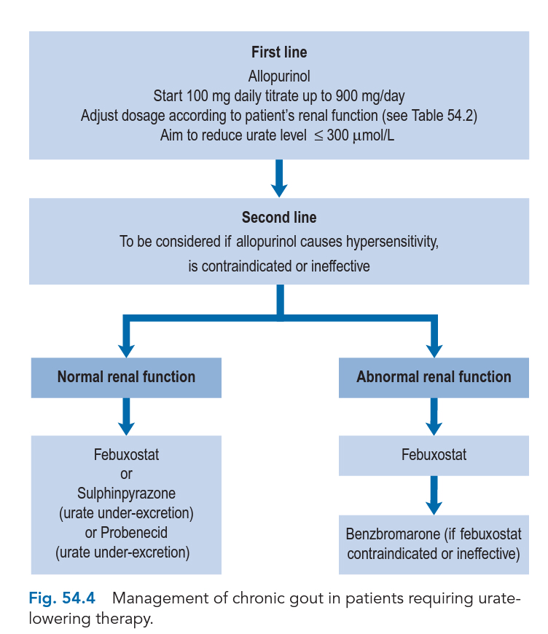

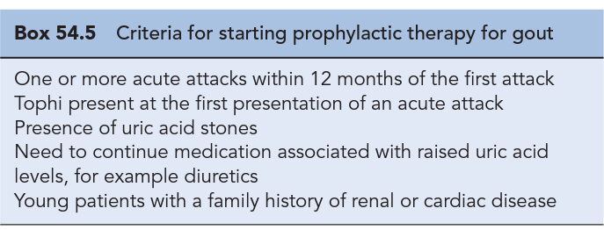

**Uricostatic agents** act on the enzyme xanthine oxidase. Blocking the action of this enzyme reduces the production of uric acid. Agents in this group include allopurinol and febuxostat.

**Allopurinol**

In patients with normal renal function, the starting dose is 100 mg/day; this is gradually increased in 100-mg increments every 2–3 weeks until the optimal serum urate level (<300 µmol/L) or the maximum dose is reached. The maximum recommended daily dose in patients with normal renal function is 900 mg/day. A decrease in serum urate will occur within a couple of days of introducing allopurinol therapy with a peak effect at 7–10 days. The dissolution of tophi may take up to 6–12 months with effective therapy. Adverse effects reported with allopurinol therapy include rash, fever, worsening renal failure, hepatotoxicity, vasculitis and even death. Azathioprine and mercaptopurine are metabolized by xanthine oxidase, co-administration of allopurinol reduces the metabolism of these two medicines leading to accumulation and toxicity. The dose of azathioprine or mercaptopurine should be reduced to approximately a quarter of the normal dose when co-prescribed with allopurinol.

**Febuxostat** is a more selective and potent inhibitor of xanthine oxidase than allopurinol and has no effect on other enzymes involved in purine or pyrimidine metabolism No dosage adjustment is necessary in patients with mild or moderate renal impairment; In patients with mild hepatic impairment, the dose should not exceed 80 mg daily; the use of febuxostat has not been studied in patients with severe hepatic impairment. Febuxostat should not be given to patients with ischaemic heart disease or congestive heart failure because of cardiovascular side effects. The most common adverse effects include respiratory infection, diarrhoea, headache and liver function abnormalities

**Uricosuric agents**

Uricosuric agents increase uric acid excretion primarily by inhibiting post-secretory tubular absorption of uric acid from filtered urate in the kidney. They are indicated as second-line agents in those who are urate under-excreters and are dependent on the patient having an adequate level of renal function. These agents should be avoided in patients with urate nephropathy or those who are over producers of uric acid due to the high risk of developing renal stones.

uricosuric agent are required to maintain an adequate fluid intake, and the need for alkalinisation of urine should be considered to prevent urate precipitation.

**Uricolytic drugs** convert uric acid to allantoin through the actions of the enzyme urate oxidase (uricase). Allantoin is more soluble than uric acid and readily excreted by the kidney. Uricolytics are indicated for hyperuricaemia associated with tumour lysis syndrome and are not indicated for other forms of hyperuricaemia.like Rasburicase