Irritable bowel syndrome
is defined as a chronic functional bowel disorder in which abdominal pain is associated with intermittent diarrhoea, sometimes alternating with constipation and a feeling of abdominal distension. In many the discomfort is associated with, or relieved by, defaecation. The cause is unknown. IBS can sometimes develop after a bout of gastroenteritis. It often seems to be triggered by stress, and many IBS sufferers have symptoms of anxiety and depression.

Significance of questions and answers
Age Because of the difficulties in diagnosis of abdominal pain in children, it is best to refer..It is most common in people between the ages of 20 and 30 and affects women more than men. If an older adult presents for the first time with no previous history of bowel problems,a referral should be made.
Symptoms abdominal pain , abdominal distension/bloating and disturbance of bowel habit.
Duration Patients may present when the first symptoms occur or may describe a pattern of symptoms, which has been going on for months or even years. If an older person is presenting for the first time, referral is most appropriate.

Previous history: A history of travel abroad and gastroenteritis sometimes appears to trigger an irritable bowel. Referral may be necessary to exclude an unresolved infection. Any history of previous bowel surgery would suggest a need for referral.

Aggravating factors
Stress, Caffeine, sweeteners sorbitol and fructose, milk and dairy products, chocolate, onions, garlic, chives and leeks.

When to refer
Children Older person with no previous history of IBS
Pregnant women
Blood in stools
Unexplained weight loss
Caution in patients aged over 55 years with changed bowel habit
Symptoms/signs of bowel obstruction
Unresponsive to appropriate treatment

Treatment timescale Symptoms should start to improve within 1 week.
Management
Antispasmodics: Smooth muscle relaxants alverine citrate, peppermint and mebeverine and the antimuscarinic hyoscine are used. They work by a direct effect on the smooth muscle of the gut, causing relaxation and thus reducing abdominal pain. The patient should see an improvement within a few days of starting treatment and should be asked to return to you in 1 week.
It is worth trying a different antispasmodic if the first has not worked. Side effects from antispasmodics are rare. Mebeverine and alverine have some selectivity for smooth intestinal muscle and have relatively few adverse effects, whereas antimuscarinics (anticholinergics) such as hyoscine butylbromide are poorly selective and are likely to cause antimuscarinic adverse effects (dry mouth, urinary symptoms, blurred vision, etc.). All antispasmodics are contraindicated in paralytic ileus, a serious condition that fortunately occurs only rarely.

Alverine citrate is given in a dose of 60–120mg(one or two capsules)up to three times a day. The drug should not be recommended for pregnant or breastfeeding women or for children.
Mebeverine hydrochloride is used at a dose of 135 mg three times a day. The dose should be taken 20 min before meals. The drug should not be recommended for pregnant or breastfeeding women, for children under 10 or for patients with porphyria.
Hyoscine butylbromide 10 mg tablets can be used in adults and children aged over 6. On starting treatment, adults should take one tablet three times a day, increasing if necessary to two tablets four times a day. The anticholinergic effects of hyoscine may intensify those of other anticholinergics by increasing anticholinergic load.
Bulking agents: Bran, which is an insoluble fibre, is no longer recommended in IBS. Oats are more soluble than wheat bran and can be better tolerated. Bulking agents such as ispaghula husk containing soluble fibre can help some patients. It may take a few weeks of experimentation to find the dose that suits the individual patient. Remind the patient to increase fluid intake to take account of the additional fibre.
Antidiarrhoeals: Use of OTC antidiarrhoeals such as loperamide is appropriate only on an occasional, short-term basis to reduce diarrhoea or urgency of defaecation.
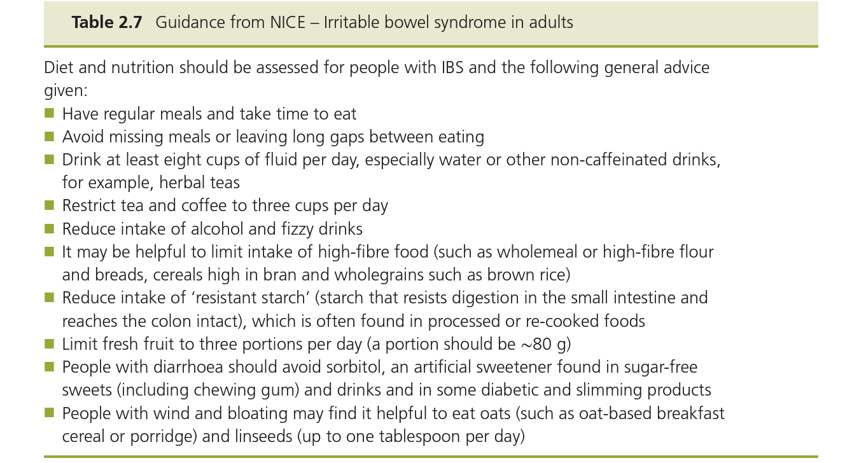
Exercise There is limited evidence that increased physical activity improves IBS, but it will increase overall health and may act as a distraction.

Complementary therapies Some patients find relaxation techniques helpful. Videos and audio tapes are available to teach complementary therapies. Others may benefit from traditional acupuncture, reflexology, aromatherapy or homoeopathy.

Haemorrhoids
Haemorrhoids (commonly known as piles) can produce symptoms of itching, burning, pain, swelling and discomfort in the perianal area and anal canal and rectal bleeding. They are swollen vascular cushions, which protrude into the anal canal (internal piles).They may swell so much that they hangdownoutside the anus (external piles).

Significance of questions and answers
Duration and previous history the pharmacist might consider treating haemorrhoids of up to 3 weeks’ duration. A recent examination by the doctor that has excluded serious symptoms would indicate that treatment of symptoms by the pharmacist would be appropriate.
Symptoms The term haemorrhoids includes internal and external piles, which can be further classified as (i) those that are confined to the anal canal and cannot be seen, (ii) those that prolapse through the anal sphincter on defaecation and then reduce by themselves or are pushed back through the sphincter after defaecation by the patient and (iii) those that remain persistently prolapsed and outside the anal canal. These three types are sometimes referred to as first, second and third degree, respectively.
Predisposing factors for haemorrhoids include diet, sedentary occupation and pregnancy, and there is thought to be a genetic element.

Pain: A severe sharp pain on defaecation may indicate the presence of an associated anal fissure, which may be accompanied by a sentinel pile (a small skin tag at the posterior margin of the anus) and requires referral. A fissure is a minute tear in the skin of the anal canal. It is usually caused by constipation and can often be managed conservatively by correcting this and using a local anaesthetic-containing cream or gel. Sometimes a vasodilatation ointment is prescribed, such as glyceryl trinitrate (GTN) rectal ointment, which causes anal muscle relaxation. In severe cases a minor operation is sometimes necessary.

Irritation: The most troublesome symptom for many patients is itching and irritation of the perianal area rather than pain. Persistent or recurrent irritation, which does not improve, is sometimes associated with rectal cancer and should be referred.

Bleeding: Blood may be deposited onto the stool from internal haemorrhoids as the stool passes through the anal canal. This fresh blood will appear bright red. It is typically described as being splashed around the toilet pan and may be seen on the surface of the stool or on the toilet paper. If blood is mixed with the stool, it will probably have come from higher up the GI tract and may be dark in colour (altered blood).
Constipation is a common causatory or exacerbatory factor in haemorrhoids. Straining at stool will occur. Insufficient dietary fibre and inadequate fluid intake may be involved,and the pharmacist should also consider the possibility of drug-induced constipation.
Bowel habit: A persisting change in bowel habit is an indication for referral.
Pregnancy
Pregnant women have a higher incidence of haemorrhoids than non-pregnant women. This is thought to be due to pressure on the vascular anal cushions due to the gravid uterus. Constipation in pregnancy is also a common problem because raised progesterone levels mean that the gut muscles tend to be more relaxed. Such constipation can exacerbate symptoms of haemorrhoids.
Other symptoms Symptomsofhaemorrhoidsremainlocaltotheanus.Theydonotcauseabdominal pain, abdominal distension or vomiting. Any of these more widespread symptoms suggest other problems and require referral.

When to refer
Duration of longer than 3 weeks
Presence of blood in the stools
Significant pain
Change in bowel habit (persisting alteration from normal bowel habit)
Suspected drug-induced constipation
Associated abdominal pain/vomiting
Malaise, fever or weight loss

Treatment timescale If symptoms have not improved after 1 week, patients should see their doctor.

Management
Local anaesthetics (e.g. benzocaine and lidocaine [lignocaine])
Local anaesthetics can help to reduce the pain and itching associated with haemorrhoids. There is a possibility that local anaesthetics may cause sensitisation, and their use is best limited to a maximum of 2 weeks.

Skin protectors Many antihaemorrhoidal products are bland soothing preparations containing skin protectors (e.g. zinc oxide and kaolin). White petroleum jelly can be used. Protecting agents form a barrier on the skin surface, helping to prevent irritation and loss of moisture from the skin.

Topical steroids :Ointment and suppositories containing hydrocortisone with skin protectors are available. The steroid reduces inflammation and swelling to give relief from itching and pain. The treatment should be used each morning and at night and after a bowel movement. The use of such products is restricted to those over 18. Treatment should not be used continuously for longer than 7 days.

Astringents :such as zinc oxide, hamamelis (witch hazel) and bismuth salts are included in many products designed for piles on the theoretical basis that they will cause precipitation of proteins when applied to mucous membranes or skin that is broken or damaged.
Antiseptics :These are among the ingredients of many antihaemorrhoidal products, including medicated toilet tissues. They do not have a specific action in the treatment of haemorrhoids. Resorcinol has antiseptic, antipruritic and exfoliative properties.
Counterirritants :such as menthol are sometimes included in antihaemorrhoidal products on the basis that their stimulation of nerve endings gives a sensation of cooling and tingling,which distracts from the sensation of discomfort.Menthol and phenol also have antipruritic actions.

Shark liver oil/live yeast :These agents are said to promote healing and tissue repair, but there is no scientific evidence to support such claims.

Laxatives The short-term use of a laxative to relieve constipation is advisable. Bulk laxatives make stools softer and easier to pass. A stimulant laxative (e.g. senna) could be supplied for 1 or 2 days to help deal with the immediate problem, while dietary fibre and fluids are being increased.
How to use OTC products
Ointments and creams can be used for internal and external haemorrhoids and should be applied in the morning, at night and after each bowel movement. An applicator is included in some packs of ointments and creams, and patients should be advised to take care in use to avoid any further damage to the perianal skin.
Suppositories can be recommended for internal haemorrhoids. After removing the foil or plastic packaging (patients have been known to try and insert them with the packaging left on),a suppository should be inserted in the morning, at night and after bowel movements. Insertion is easier if the patient is crouching or lying down.

