Treatment
In internal bleeding, researchers at western reserve university succeeded in lab tests from manufacturing nanopolymer that work as platelet. This synthetic platelet can be injected in the blood stream and reduces bleeding in this case [1].
From the most modern application of nanomedicine is Nano robot; it is a machine or tools inserted inside human body to treating tissues or replacing cells or something by a new one. They are in the range 0.1 to 10 micrometer. Nanorobots are used in diagnosing and treating cancer, removal kidney`s stone, clearing damaged cells in DNA series, and also in surgery by introducing nanorobot semi-autonomous or under control by a surgeon from vascular system or cavities of human body[6][7].
Nanoparticles-based therapeutics
In the alst three decades, therapeutic products companies produced drugs, that were used for clinical use, close to $5 billion. Since that time, therapeutics companies have been increasingly producing nanoparticles-based drugs. From the drugs that were produced recently are liposomes, polymer-products conjugates, and Micellular estradiol.
Google group noticed that there is a research project containing nanoparticles devices sent by blood to looking for tumors in a body. These nanoparticles devices (on a shape of disks) are hollowed by mouth and sent by blood to body parts looking for tumors. When these nanoparticles find tumor anywhere, they stick with them and send signals visible light or radio waves to a device worn on hand displaying there is a tumor and give place of the tumor and degree of it [8].

Diagnosis
Researchers developed a method to early detection of damaged kidneys. They used gold nanorods to detect the damage because protein generated by damaged kidney is to gold nanorods. When protein is attached to gold nanorods, their color will be changed. The method is cheap and fast [1].
Nanopore sensor was used at Osaka university to detect single virus particles with artificial intelligence. This method may give rapid detection for viruses. 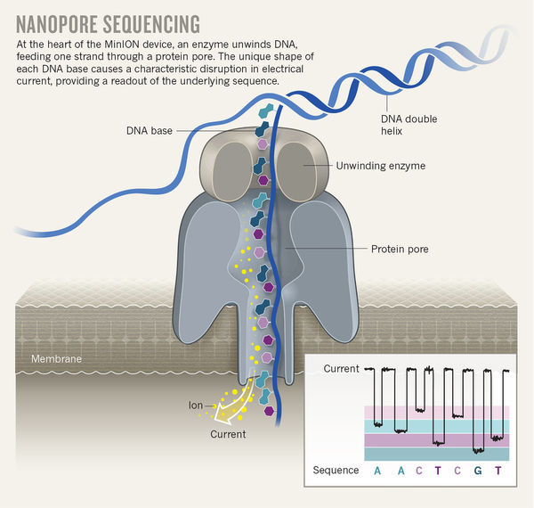
A method being developed to detect cancer cells in bloodstream by nanoparticles called nanoflares. Cancer cells contains genes. Nanoflares are injected in blood and shoot light when meet the genes of cancer cells.
Nanoflare
Nanosensors are being developing at Nagoya University in japan to detect bladder and prostate cancer in patient urine.
