pharmacognosyII Lec 3 Dr. Rasha eldalawy
Terpenoids
In general, terpenoids, may be defined as natural products whose structures are considered to be divided into several isoprene units; therefore, these compounds are invariably termed as isoprenoids.
Besides, this particular group of compounds is sometimes collectively referred to as the terpenes in relatively older texts.
Logically, the –oid suffix seems to be more acceptable and convincing, as it is in the same vein for steroids, alkaloids, flavonoids, etc., However, the-ene suffix must be solely confined to the unsaturated hydrocarbon belonging to this specific class of compounds.
- It has now been established experimentally that the isoprene units come into being through the biogenetic means starting from acetate via mevalonic acid.
- Each such unit essentially consists of five-carbons having two unsaturated bonds and possesses a branched chain.
The terpenoids usually have a number of such isoprene units joined together in a head to tail manner, as exemplified below:
Terpenoids are broadly classified on the basis of the number of isoprene units incorporated into a specific unsaturated hydrocarbon terpenoid molecule, as
- (a) Monoterpenoids: These are built up of two isoprene units and have the molecular formula C10H16;
- (b) Sesquiterpenoids: These are composed of three isoprene units and have the molecular formula C15H24;
- (c) Diterpenoids: These are comprised of four isoprene units and have the molecularformula C20H32;
- (d) Triterpenoids: These contain six isoprene units and have the molecular formula C30H48; and
- (e) Tetraterpenoids (Carotenoids): These are made up of eight isoprene units and have the molecular formula C40H64
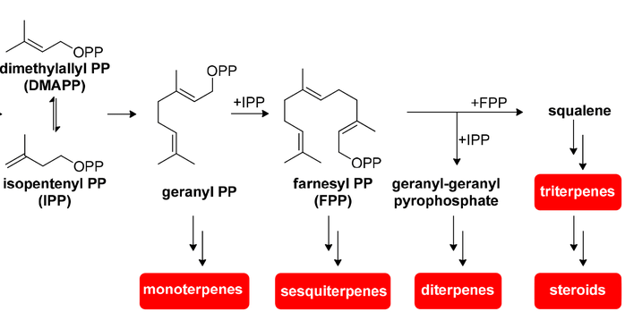

Sesquiterpenoid Lactones
Interestingly, another class of compounds essentially bearing such characteristic features as a methylene, lactone system; β- unsaturated carbonyls, and epoxides and obiviously chemically distinct from the sesquiterpenoids are collectively termed as sesquiterpenoid lactones.
The specific and vital biological nucleophilies e.g.; thiol and amino moieties present in the enzymes, help in the augmentation of faster and reactive approach to receptor sites by these sesquiterpenoid lactones.

Thus, the overall effect is evidenced by marked and pronounced biological activities, for instance: modified antimicrobial activity, enhanced antitumour properties.

Artemisinin
- It is obtained from the leaves and the closed, unexpanded flower heads of Artemisia annuna Linn., belonging to family Asteraceae.
- This particular herb has been used in the Chinese system of medicine exclusively for the treatment of malaria since more than one thousand years.
Uses:-
1. The drug and its derivatives are used as fast acting blood schizontocides in the control and management of malarial fever caused by plasmodium vivax strain.
2. These drugs are found to be active against both chloroquine resistant and chloroquine sensitive strains of Plasmodium falciparum.
3. These drugs are found to show extremely encouraging therapeutic effects specifically in the treatment of Cerebral malaria.
Biosynthesis of sesquiterpene
The starting unit of these compounds is farnesylpyrophosphate (FPP) which is produced by the reaction of geranyl pyrophosphate (GPP, the monoterpene precursor) with isopentylpyrophosphate (IPP)

Diterpenoids
Generally, diterpenoid represent a broad class of non-volatile C20 compounds that have been essentially obtained from geranyl pyrophosphate.
Ginkgolide–B
- Biological Source:- It is obtained from the root bark and leaves of Ginkgo biloba L., belonging to family Ginkgoaceae.
- Geographical Source:- It is cultivated in the south eastern United States. Then they are cultivated in China and Japan.
- It is a dioecious tree attaining a maximum height of 30 meters and has been cited in literatures as a living fossil that still survived unchanged in the region of eastern Asia since 200 million years.
- Ginkgolide-B is the most active member of the family significant therapeutic efficacy in the treatment of severs sepsis.
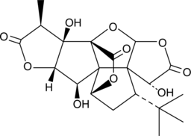

Uses
1. The standardized dehydrated acetone–water extract of the dried leaves equivalent to 6%terpenoids and 24% flavone glycosides is sold commercially in Europe as an approved drug to enhance blood fluidity and circulation
2. In USA it is sold as food supplement
Taxol
Alkaloidal terpene
Uses
1. Taxol is primarily employed in the treatment and management of metastatic carcinoma of the ovarian glands after the failure of follow-up chemotherapy.
2. It is also used in the treatment of breast cancer usually after the observed failure of combination chemotherapy for metastatic disease.
3. Because of its hydrophobic nature the injectable concentrate of taxol formulation meant for intravenous infusion is normally solubilized duly in poly-oxyethylated caster oil. However, before injection it should be appropriately diluted in normal saline or dextrose solution.

Triterpenoids
- Triperpenoids, generally are obtained by biogenesis from six isoprene units, they are found to share commonly the acyclic precursor squalene (C30).
- Based on the various possible modes, whereby ring closure in squalene takes place may ultimately give rise to a large number of triterpenoids having a variety of skeleton structures.
- In actual practice, more than 4000 naturally occurring triterpenoids have been isolated and identified, and over 40 varying skeleton types have been established.
- The triperpenoids may be categorized into two major groups, namely: the tetracyclic and the pentacyclic compounds: the former ones of the steroidal types with C-27 carbon atoms present in the skeleton while the latter are of the triterpenoid types with C-30 carbon atoms
Tetraterpenoid
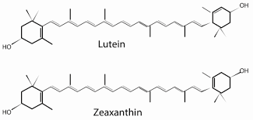

- Carotenoids are C40 isoprenoids which consist of eight isoprene units and can be divided in two major groups: carotene and xanthophylls.
- A terpene that does not obey the isoprene rule is called irregular terpene (carotene).
- Carotenes are linear or cyclized hydrocarbons such as lycopene, α-carotene and β-carotene.
- Xanthophylls are oxygenated derivatives (epoxy, keto or hydroxyl groups) of carotenes; for example: lutein, zeaxanthin
- An important branch-point in the biosynthesis of carotenoids lies in the cyclization of the linear lycopene at both terminal of the molecule yeild a bicyclic hydrocabon to yeild carotenes

