Lymphomas and Multiple Myeloma‎
I- Lymphomas
  - Lymphomas are a heterogeneous group of malignancies which characterized by transformation of normal immune cells ‎(B or T cells) ‎ that residing predominantly in lymphoid tissues.
- The disease can be classified on the basis of histological appearance‎(Differences in histology ‎ ) ‎ into two general ‎headings: Hodgkin’s lymphoma (HL) and non-Hodgkin’s lymphoma (NHL),
- HL is distinguished from NHL ‎by the presence of the pathognomonic Reed-Sternberg (RS) cell (large abnormal binucleate lymphocyte). ‎
- Lymphoma cells predominate in the lymph nodes; however, they can infiltrate other tissues, such as the bone ‎marrow, central nervous system (CNS), gastrointestinal (GI) tract, liver, skin, and spleen.
- Lymphomas are commoner than Leukemias.
- Because lymphoid tissue is in many parts of the body, Hodgkin disease can start almost anywhere. Most often it starts in lymph nodes in the upper part of the body. The most common sites are in the chest, in the neck, or under the arms.

- Hodgkin disease most often spreads through the lymph vessels in a stepwise fashion from lymph node to lymph node. Rarely, and late in the disease, it can invade the bloodstream and spread to other parts of the body, including the liver, lungs, and/or bone marrow.

HODGKIN LYMPHOMA
- Hodgkin lymphoma is a potentially curable lymphoma. There are five types of Hodgkin lymphoma classified by the World Health Organization:
nodular sclerosing, mixed cellularity, lymphocyte depleted, lymphocyte rich, and nodular lymphocyte-predominant.
PATHOPHYSIOLOGY
• B-cell transcriptional processes are disrupted during malignant transformation, preventing expression of B-cell surface markers and production of immunoglobulin messenger RNA which cause alterations in the normal apoptotic pathways favor cell survival and proliferation.
• Malignant Reed–Sternberg cells overexpress and upregulate nuclear factor kappa (factor-κ B) which is associated with cell proliferation and antiapoptotic signals.
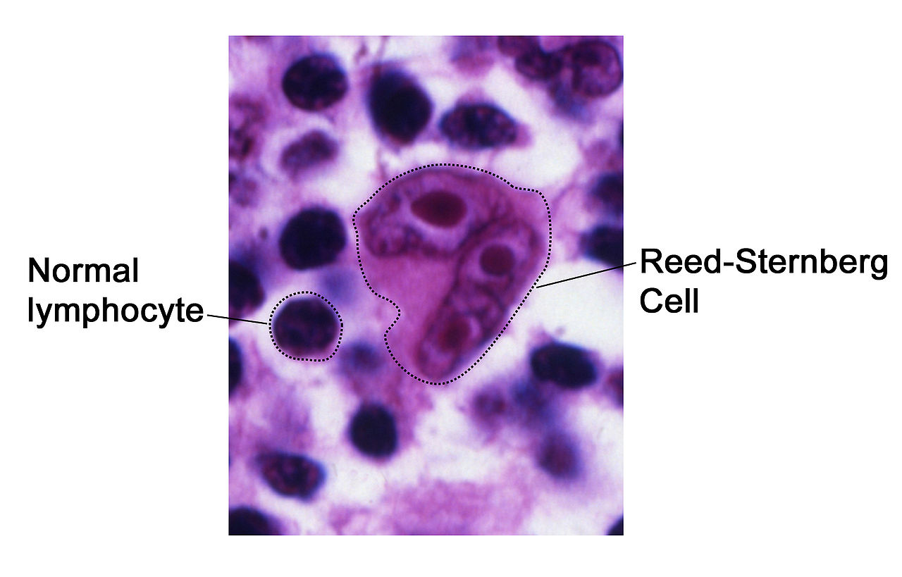
Infections with viral and bacterial pathogens up regulate nuclear factor kappa (factor-κ B). Epstein–Barr virus is found in many, but not all, HL tumors.

CLINICAL PRESENTATION

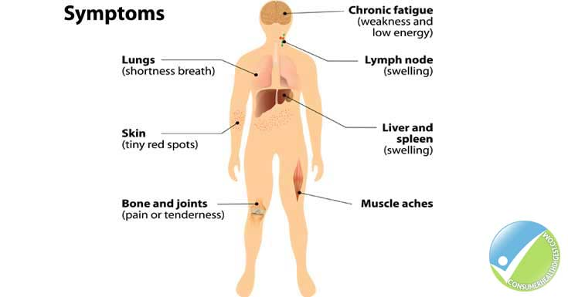
- Symptoms
- Lymphadenopathy, generally in the cervical, axillary, supraclavicular, or inguinal lymph nodes
- Splenomegaly
- Shortness of breath, dry cough, chest pressure (patients with mediastinal mass)
4- Gastrointestinal complications (e.g., nausea, vomiting, early satiety, constipation, and diarrhea)
5- Back, chest, or abdominal pain.
- Signs
1- Fever 2- Night sweats
3- Weight loss greater than 10% within last 6 months.
(These three are known collectively as B-symptoms.)

DIAGNOSIS AND STAGING
Diagnosis requires the presence of Reed–Sternberg cells in the lymph node biopsy.
Laboratory Tests
• LDH
• ESR
• Serum chemistries
• Complete blood cell count (CBC) studies for anemia, lymphopenia, neutrophilia, or eosinophilia
Other Diagnostic Tests
• Physical examination with careful attention to lymph node inspection
• Imaging: Chest x-ray, chest CT scan, abdominal/pelvic CTscan; may be used to confirm presence of active disease after treatment.
• Bone marrow biopsy
• Biopsy of suspected lymph node(s)—either open lymph node biopsy or core biopsy preferred over fine-needle aspiration.
Staging‎
• Prognosis predominantly depends on age and tumor stage;
- Patients older than 65to 70 years have a lower cure rate than younger patients.
- Patients with limited stage disease (stages I and II) have a 90% to 95% cure rate, whereas those with advanced disease (stages III and IV) have a 60% to 80% cure rate.
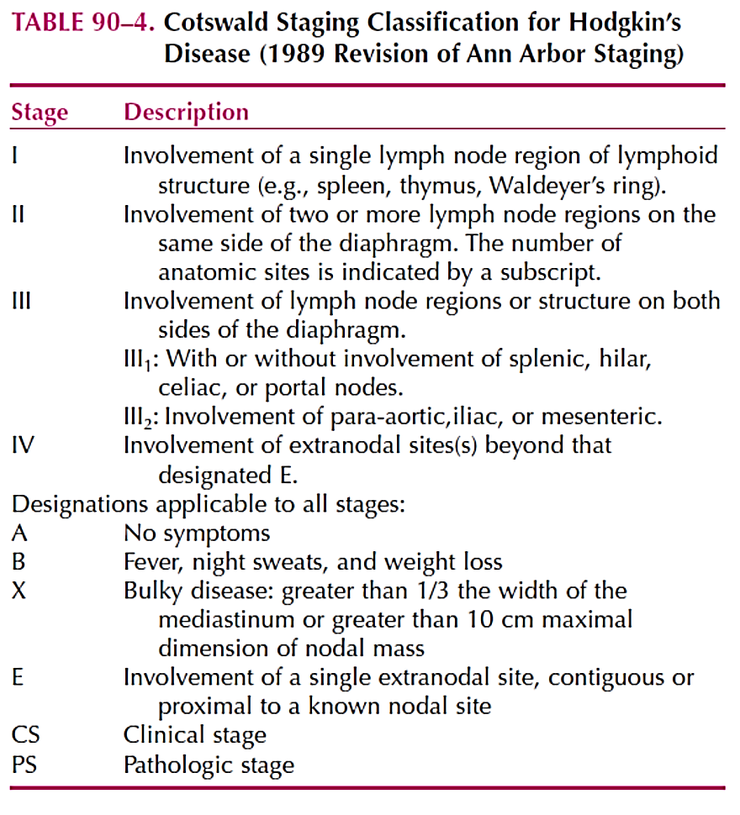

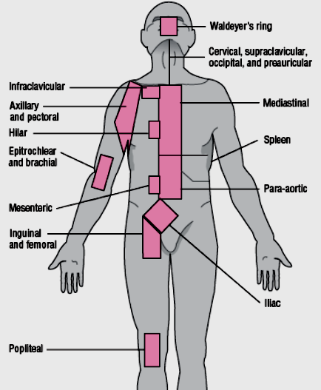
TREATMENT
• Goals of Treatment: The goal is to maximize curability while minimizing short- and long-term treatment-related complications.
- General treatment principles include the following:
- Radiation therapy
- Induction chemotherapy
- Salvage chemotherapy
- Hematopoietic stem cell transplantation
- The therapeutic role of surgery is limited, regardless of stage.
Radiation therapy (RT) is an integral part of treatment and can be used alone for select patients with early-stage disease, although most patients will receive chemotherapy and radiation.
- Involved-field radiation targets a single field of HL.
- Extended-field or subtotal nodal radiation targets the involved field and an uninvolved area.
- Total nodal radiation targets all areas.
• Patients with relapsed disease can be treated by salvage chemotherapy with or without radiationtherapy, or high-dose chemotherapy with stem cell support. 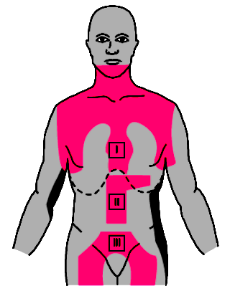
Figure 2=Radiation fields (shaded areas) commonly employed in Hodgkin’s disease
Initial Chemotherapy
- HL is highly responsive to treatment, even in advanced stages.
- Initial treatment may include radiation, combination chemotherapy, or ‎combined chemotherapy/ radiation. ‎
The following induction regimens are given as initial treatment for Hodgkin lymphoma:
- MOPP (mechlorethamine, vincristine, procarbazine, prednisone)
- ABVD (Adriamycin [doxorubicin], bleomycin, vinblastine, dacarbazine)
- Stanford V (doxorubicin, vinblastine, mustard, bleomycin, vincristine, etoposide, prednisone)
- BEACOPP (bleomycin, etoposide, doxorubicin, cyclophosphamide, vincristine, procarbazine, prednisone)
- The standard care is (ABVD) cycleswhich are given every 28 days; all patients should continue treatment for two cycles beyond documentation of complete remission
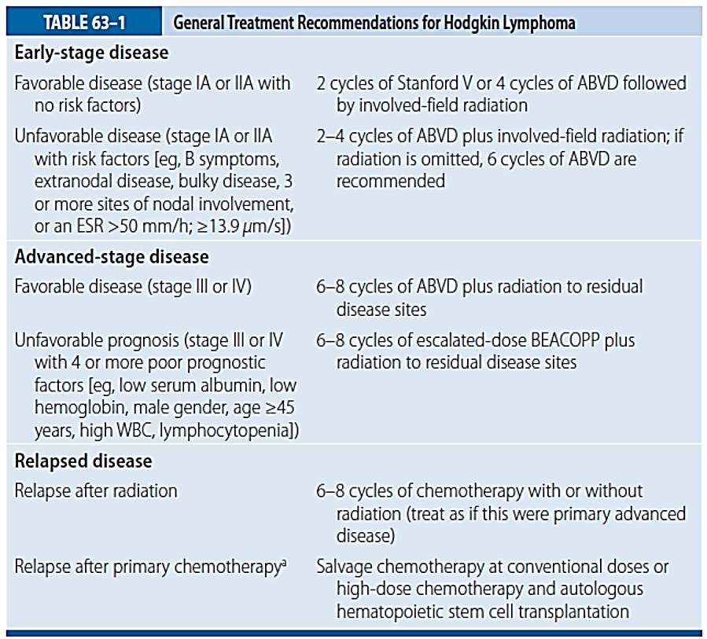
- Two to eight cycles of chemotherapy should be administered, depending on the stage of disease and the presence of risk factors.

ABVD, doxorubicin (Adriamycin), bleomycin, vinblastine, and dacarbazine; BEACOPP, bleomycin, etoposide, doxorubicin (Adriamycin), cyclophosphamide, vincristine (Oncovin), procarbazine, and prednisone; ESR, erythrocyte sedimentation rate; WBC, white blood cell count.
Salvage Chemotherapy
- Salvage therapy, also known as rescue therapy, is a form of therapy given after an ailment does not respond to standard therapy. The most common diseases that require salvage therapy are HIV and various tumors. The word is not clearly defined; it is used both to mean a second attempt and a final attempt.
- Salvage therapy drugs or drug combinations have, in general, much more severe side effects than the standard line of therapy. This is often true of a drug of last resort.
- When induction chemotherapy fails, or patients experience relapse, salvage chemotherapy is generally given. Salvage regimens incorporate drugs that are complementary to those that failed during induction therapy. Commonly used salvage regimens include the following:
- ICE (ifosfamide, carboplatin, etoposide)
- DHAP (cisplatin, cytarabine, prednisone)
- ESHAP (etoposide, methylprednisolone, cytarabine, cisplatin)
• Response to salvage therapy depends on the extent and site of recurrence, previous therapy, and duration of first remission. Choice of salvage therapy should be guided by response to initial therapy and a patient’s ability to tolerate therapy.
• Patients who relapse after an initial complete response can be treated with the same regimen, a non–cross-resistant regimen, RT, or high-dose chemotherapy and autologous hematopoietic stem cell transplantation (HSCT).
• Lack of complete remission after initial therapy or relapse within 1 year after completing initial therapy is associated with a poor prognosis. Patients with these prognostic factors are candidates for high-dose chemotherapy and HSCT.

NON-HODGKIN LYMPHOMA
Non-Hodgkin lymphoma (NHL) consists of a diverse group of malignant ‎tumors of the lymphoid tissues variously derived from the clonal expansion ‎of B cells, T cells, natural killer (NK) cells or precursors of these cells.‎
PATHOPHYSIOLOGY
Cytogenetic abnormalities involving translocations of antigen receptor genes are prevalent in NHL. These include T-cell receptor genes in T-cell lymphomas and immunoglobulin genes in B-cell lymphomas. This results in dysregulation of cell growth and proliferation, giving rise to the malignant clone of lymphocytes.
CLINICAL PRESENTATION
- Adenopathy which can be localized or generalized which is the most common symptom of non-Hodgkin lymphoma
- Adenopathy is a painless swelling in a lymph node, usually in the neck, armpit or groin. Mesenteric or GI involvement can cause nausea, vomiting, obstruction, abdominal pain, palpable abdominal mass, or GI bleeding.
- Bone marrow involvement can cause symptoms related to anemia, neutropenia, or thrombocytopenia.
- Forty percent of patients with NHL present with B symptoms (fever, drenching night sweats, and weight loss).
DIAGNOSIS AND STAGING
• Diagnosis is established by biopsy of an involved lymph node. Diagnostic workup of NHL is generally similar to that of HL.
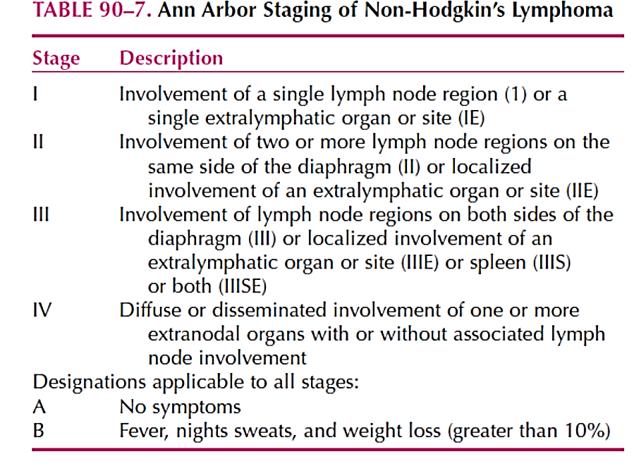
• NHL classification systems continue to evolve. Slow-growing or indolent lymphomas are favorable (untreated survival measured in years), whereas rapid-growing or aggressive lymphomas are unfavorable (untreated survival measured in weeks tomonths).

• Goals of Treatment: The goals are to relieve symptoms and, whenever possible, curethe patient of disease while minimizing the risk of serious toxicity.
General Principles
- Appropriate therapy for NHL depends on many factors, including patient age, histologic type, stage and site of disease, presence of adverse prognostic factors, and patient preference.
- Treatment is divided into two categories: limited disease (eg, localized disease; Ann Arbor stages I and II) and advanced disease (eg, Ann Arbor stage III or IV and stage II patients with poor prognostic features).
- Treatment options include RT, chemotherapy, and biologic agents. RT is used for remission induction with early stage, localized disease and, more commonly, as a palliative measure in advanced disease.
- Effective chemotherapy ranges from single-agent therapy for indolent lymphomas to aggressive, complex combination regimens for aggressive disease.

Indolent lymphomas (FOLLICULAR LYMPHOMA)
TREATMENT of LOCALIZED FOLLICULAR LYMPHOMA
• Options for stage I and II follicular lymphoma include loco-regional RT and immunotherapy(ie, rituximab) with or without chemotherapy or RT.
• Chemotherapy is not recommended,unless the patient has high-risk, stage II disease.
TREATMENT of ADVANCED FOLLICULAR LYMPHOMA
• Therapeutic options are diverse and include watchful waiting, RT, single-agenttherapy, combination chemotherapy, biologic therapy, radioimmunotherapy, and combined-modality therapy.
- Immediate aggressive therapy does not improve survival compared with conservative therapy (ie, watchful waiting followed by single-agent chemotherapy, rituximab, or RT, when treatment is needed).
• Oral alkylating agents chlorambucil or cyclophosphamide, used alone or in combination with prednisone, are the mainstay of treatment. These single agents are aseffective as combination regimens and produce minimal toxicity, but secondary acute leukemia is a concern.
Bendamustine is an IV alkylating agent approved for relapsed or refractory indolent NHL.
The most common chemotherapy regimen used with rituximab is the CHOP regimen
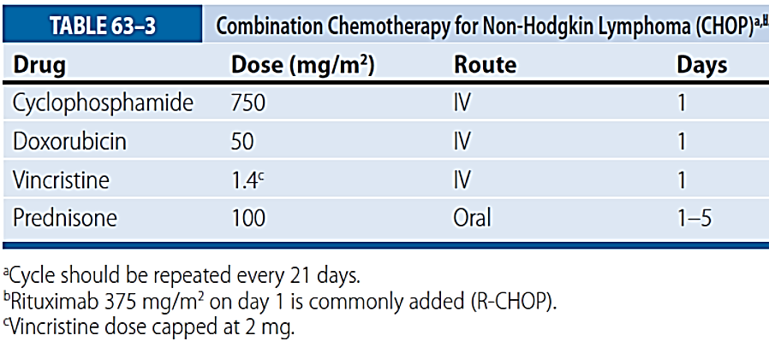

- Rituximab, a chimeric monoclonal antibody is one of the most widely used therapies for follicular lymphoma. It is approved for first-line therapy either alone or combined with chemotherapy and as maintenance therapy for patients with stable disease or with partial or complete response following induction chemotherapy.
• Radioimmunotherapy was initially used as salvage therapy and is being evaluated as first-line therapy in combination with CHOP.
• Radioimmunotherapy is generally well tolerated. Toxicities include infusion-relatedreactions, myelosuppression, and possibly myelodysplastic syndrome or acutemyelogenous leukemia. 131I-tositumomab can cause thyroid dysfunction.
Aggressive Lymphomas (Diffuse large B-cell lymphomas (DLBCLs)
- Aggressive and highly aggressive B-cell NHLs are potentially curable.‎
- ‎The standard treatment of patients with advanced disease (bulky stage II ‎or stage III or IV) is R-CHOP for six cycles.‎
- ‎ High-dose chemotherapy immediately followed by autologous ‎hematopoietic cell transplantation (HCT) should be considered for patients ‎who relapse after conventional chemotherapy.
- Salvage chemotherapy is ‎given before HCT to ensure the disease is sensitive to additional cytotoxic ‎therapy.‎
- ‎ Highly aggressive NHL (e.g., Lymphoblastic or Burkitt lymphoma) ‎progress rapidly and metastasize to the central nervous system. Regimens ‎similar to those for acute lymphoblastic leukemia (ALL) are used.‎
TREATMENT OF LOCALIZED DISEASE
- Diffuse large B-cell lymphomas (DLBCLs) are the most common ‎lymphoma in patients of all ages but most commonly seen in the seventh ‎decade. ‎
  - Patients with localized, nonbulky (<10 cm) stage I or II Diffuse large B-cell lymphoma (DLBCL) without B- symptoms are typically treated with rituximab, cyclophosphamide, doxorubicin, vincristine, and prednisone (R-CHOP) for three to six cycles with or without radiotherapy.
TREATMENT OF ADVANCED DISEASE
• Bulky stage II and stages III and IV lymphoma should be treated with R-CHOP or rituximab and CHOP-like chemotherapy until achieving complete response (usually four cycles). Two or more additional cycles should be given following complete response for a total of six to eight cycles. Maintenance therapy following a completeresponse does not improve survival.
• High-risk patients Consider high-dose chemotherapy with autologous HSCT who respond to standard chemotherapy and meet HSCT criteria.
- Commonly used salvage regimens include DHAP (dexamethasone, cytarabine, and cisplatin), ESHAP(etoposide, methylprednisolone, cytarabine, and cisplatin), and MINE (mesna,ifosfamide, mitoxantrone, and etoposide). None is clearly superior to the others. ICE (ifosfamide, carboplatin, and etoposide) appears to be better tolerated thancisplatin-containing regimens, especially in elderly adults.
• Rituximab is being evaluated in combination with many salvage regimens.
NON-HODGKIN LYMPHOMA IN ACQUIRED IMMUNODEFICIENCY
SYNDROME
• Patients with AIDS have more than a 100-fold increased risk of developing NHL,which is usually aggressive.
• Treatment of AIDS-related lymphoma is difficult because underlying immunodeficiencyincreases the risk of treatment-related myelosuppression.
• Standard combination regimens (eg, CHOP) yield disappointing results.
Newer approaches, including dose-adjusted EPOCH (etoposide, prednisone, vincristine,cyclophosphamide, and doxorubicin), appear promising.

