Degrees of Unsaturation (or IHD, Index of Hydrogen Deficiency)

Degrees of Unsaturation (Index of Hydrogen Deficiency): How the molecular formula of a compound can give helpful hints about its structure.
Today we’ll talk about a quick and useful calculation we can perform to obtain the number of [multiple bonds + rings] in an unknown structure merely by knowing the molecular formula. We call it the Index of Hydrogen Deficiency, or more commonly, just “Degrees of Unsaturation“.

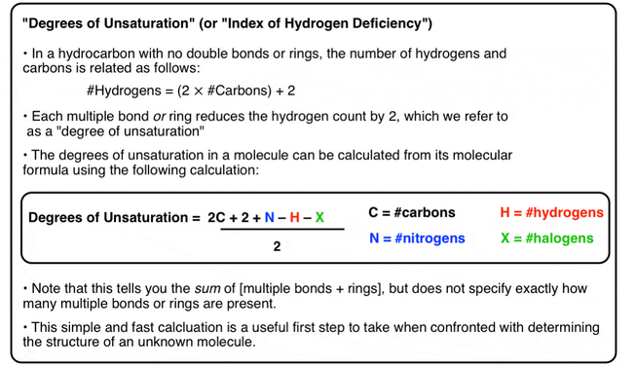
- What’s So Great About The IHD or DUS?
The best thing about the IHD is that it is an easy equation to use that gives you useful information about the structure of an unknown compound. It literally takes a minute to do. Calculating the degrees of unsaturation is THE first task I recommend doing when you are faced with determining the structure of an unknown compound with a known molecular formula.

Before we get going, see if you can apply the equation in the box above to find the degrees of unsaturation in this extremely well-known molecule whose formulae is given below.
- C₉H₈O₄
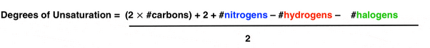
DUS or IHD = 2X9 + 2 + 0 – 8 – 0 / 2
= 18 + 2 -8/2
= 20-8 / 2
= 12/2 = 6

For A Hydrocarbon with No Rings or Double Bonds the Number of Hydrogens Is Equal to Twice the Number of Carbons, Plus 2.

The hydrocarbon is alkane and its molecular formula is:

C_{n}H_{2n+2}

_{Example}

A molecule like dodecane (C₁₂) we’d expect to see (12 x 2) + 2 = 26 hydrogens.

So, molecular formula for dodecane is

C₁₂H₂₆
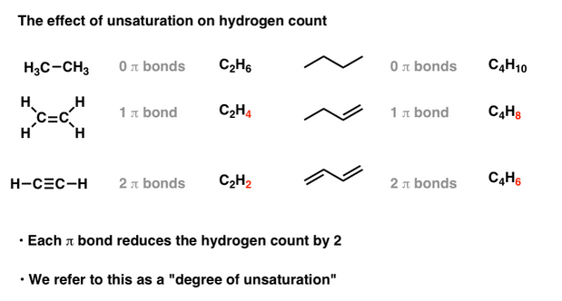

Each Double Bond or Ring Reduces the Hydrogen Count By 2.
You should be able to see that each multiple bond (π bond) the number of hydrogens in the formula decreases by two.
Hydrocarbons containing π bonds are often called “unsaturated” hydrocarbons.
Let’s turn our attention to cyclic compounds. Do you notice a similar effect?
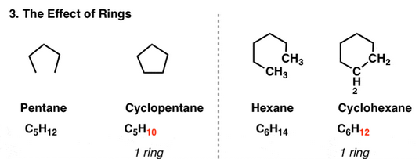
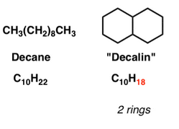
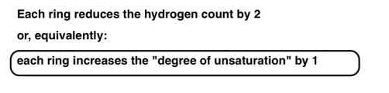

Each Ring or Double Bond Is Called A “Degree of Unsaturation”
Therefore, each ring introduces a “degree of unsaturation” into the molecule.
You might ask: what if we have a molecule with rings and multiple bonds? See for yourself.
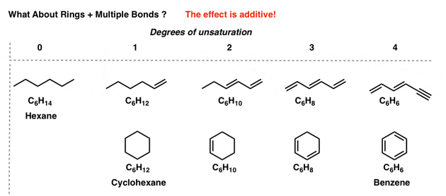
Note: For instance, thus the molecular formula C₆H₆ (4 degrees of unsaturation) is satisfied by molecules with
- 4 pi bonds [3 pi bonds and a ring (benzene)]

What About Molecules Containing Oxygen?
So far, so good. Let’s move on. What about molecules with oxygen?
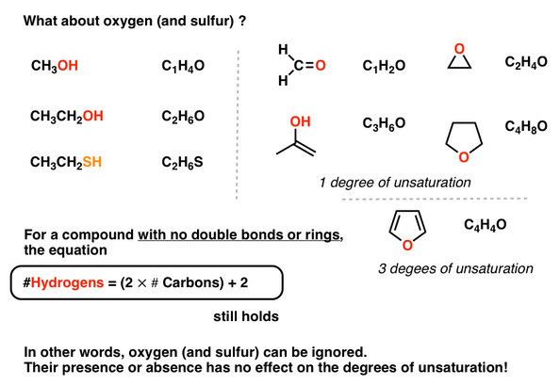

What About Halogens?

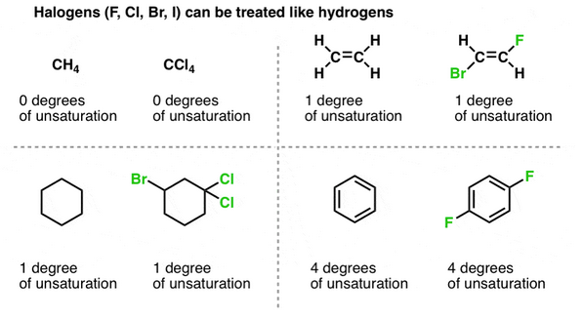

Examples
- C₉H₈O₄
- C₂₁H₃₀O₂
- C₁₇H₂₁NO₄
- C₁₁H₁₅NO₂
Let’s plug each of them into our formula. You should get:
- C₉H₈O₄ [6 degrees of unsaturation]
- C₂₁H₃₀O₂ [7 degrees of unsaturation]
- C₁₇H₂₁NO₄ [8 degrees of unsaturation]
- C₁₁H₁₅NO₂ [5 degrees of unsaturation]

