صيدلة سريرية
د. ضياء جبار
College of Pharmacy
Fourth year. Clinical Pharmacy
Endocrine disorders
Diabetes Mellitus Part I
Introduction
1-Diabetes mellitus (DM) is a group of metabolic disorders characterized by chronically elevated blood glucose (BG) and abnormal carbohydrate, fat, and protein metabolism.

2-Without effective treatment, DM can lead to acute complications such as diabetic ketoacidosis (DKA) and hyperosmolar hyperglycemic syndrome (HHS).

3-Chronic hyperglycemia can cause microvascular, macrovascular, and neuropathic complications.

Pathophysiology
1-Type 1 DM (5%–10% of cases) usually results from autoimmune destruction of pancreatic β-cells, leading to absolute deficiency of insulin.

2-It usually presents in children and adolescents but can occur at any age. The disorder is believed to be initiated by exposure to an unknown environmental trigger in a genetically susceptible individual.

3-The autoimmune process is mediated by macrophages and T lymphocytes with autoantibodies to β-cell antigens (e.g., islet cell antibody, insulin antibodies).

4-After the initial diagnosis, a period of transient remission called the “honeymoon” phase may occur, during which insulin doses can be reduced or withdrawn before continued β-cell destruction requires lifelong insulin replacement therapy.

6-Type 2 DM (90%–95% of cases) is characterized by multiple defects:
- Impaired insulin secretion: β-cell mass and function are both reduced, and β-cell failure is progressive.
- Reduced incretin effect: Normally, the gut incretin hormones glucagon-like peptide-1 (GLP-1) and glucose-dependent insulinotropic peptide (GIP) are released and stimulate insulin secretion in response to a meal. Patients with type 2 DM have a reduced incretin effect due to decreased concentrations of or resistance to the effects of incretin hormones.
- Insulin resistance: This is manifested by excessive hepatic glucose production, decreased skeletal muscle uptake of glucose, and increased lipolysis and free fatty acid production.
- Excess glucagon secretion: This occurs because type 2 DM patients fail to suppress glucagon in response to meals because of GLP-1 resistance/deficiency and insulin resistance/deficiency, which directly suppress glucagon.
- Sodium-glucose cotransporter-2 (SGLT-2) upregulation in the kidney: This increases reabsorption of glucose by proximal renal tubular cells, which further contributes to hyperglycemia.

7-Gestational diabetes (GDM) is DM that occurs in women during pregnancy.

8-Less common causes of DM (1%–2%) include maturity onset diabetes of the young (MODY), genetic syndromes (eg, Down syndrome), endocrine disorders (eg, acromegaly, Cushing syndrome), pancreatic exocrine dysfunction, infections, and medications (eg, glucocorticoids, thiazides, niacin, atypical antipsychotics).

9-Microvascular complications include retinopathy, neuropathy, and nephropathy.

10-Macrovascular complications include coronary heart disease (CHD), stroke, and peripheral vascular disease.

Clinical presentation
Type 1 Diabetes Mellitus
1-Patients often have symptoms in the days or weeks preceding the diagnosis. The most common initial symptoms are polyuria, polydipsia, polyphagia, weight loss, fatigue, and lethargy.

2-Individuals are often thin and are prone to develop DKA in the absence of an adequate insulin supply; many patients initially present with DKA.

3-Symptom onset can be triggered by infection, trauma, or psychological stress.

Type 2 Diabetes Mellitus
1-Most patients are asymptomatic or have only mild fatigue at the time of diagnosis. Many patients are incidentally found to have type 2 DM after routine laboratory testing (eg, plasma glucose or A1C) or development of complications (eg, myocardial infarction, stroke).

2-Because mild hyperglycemia may exist for years prior to the diagnosis, microvascular and macrovascular complications are often present at the time of diagnosis.

3-Most patients are overweight or obese with an elevated waist:hip ratio.

Diagnosis
1-Normal fasting (no caloric intake for at least 8 hours) plasma glucose (FPG) is 70–99 mg/dL. Impaired fasting glucose (IFG) is FPG 100–125 mg/dL.

2-Normal glucose tolerance based on a 2-hour post-load plasma glucose using the equivalent of 75 g anhydrous glucose dissolved in water (oral glucose tolerance test or OGTT) is <140 mg/dL. Impaired glucose tolerance (IGT) is OGTT 140–199 mg/dL.

3-Normal A1C is 4%–5.6%. Increased risk of DM (prediabetes) is A1C 5.7%–6.4%.

4-Criteria for diagnosis of DM include any one of the following:
1. A1C ≥6.5% 2. FPG ≥126 mg/dL 3. OGTT ≥200 mg/dL 4. Random plasma glucose ≥200 mg/dL with classic symptoms of hyperglycemia or hyperglycemic crisis.

5-In the absence of unequivocal hyperglycemia, a diagnosis using criteria 1 through 3 requires two abnormal test results from the same sample or in two separate test samples.

6-Prediabetes is a condition of abnormal BG that is not sufficiently high to meet the thresholds that define DM but often progresses to the diagnosis.

7-Screening for type 1 DM in asymptomatic children or adults is not recommended due to low disease prevalence and the acute onset of symptoms.

8-Screening for type 2 DM is recommended for asymptomatic adults who are overweight (BMI ≥25 kg/m²) and have at least one other risk factor for developing type 2 DM.

9-All adults, even those without risk factors, should be screened every 3 years starting at 45 years old. Children at risk for developing type 2 DM should undergo screening every 3 years starting at age 10 years.

10-Pregnant women should undergo risk assessment for GDM at the first prenatal visit; those with multiple risk factors for type 2 DM should be tested as soon as feasible. All women (even if the initial test was negative) should undergo testing at 24–28 weeks’ gestation.

Treatment
1-Goals of Treatment: The primary goal is to prevent or delay progression of long-term microvascular and macrovascular complications.

2-Additional goals are to alleviate symptoms of hyperglycemia, minimize hypoglycemia and other adverse effects, minimize treatment burden, and maintain quality of life.

3-General glycemic targets for most nonpregnant adults with DM are listed in Table-1.

Table-1: Glycemic Target Recommendations for Most Nonpregnant Adults with Diabetes

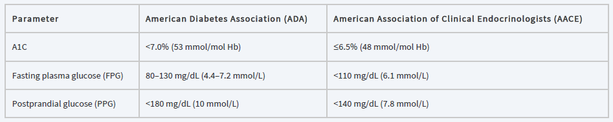

4-Glycemic targets should be individualized. More stringent or less stringent goals may be appropriate for some patients.

Nonpharmacologic Therapy
1-Medical nutrition therapy (MNT) involves an individually tailored nutrition plan. Implement a healthy meal plan that is moderate in calories and carbohydrates and low in saturated fat with all of the essential vitamins and minerals. Target an initial weight loss goal of at least 5% in all type 2 DM patients who are overweight or obese through calorie restriction.

2-Aerobic exercise can improve insulin sensitivity, modestly improve glycemic control, reduce cardiovascular (CV) risk, contribute to weight control, and improve well-being. Physical activity goals include at least 150 min/week of moderate intensity exercise spread over at least 3 days/week with no more than 2 days between activity. Resistance/strength training is recommended at least 2 times/week for patients without proliferative diabetic retinopathy.

3-Patients must be involved in decision making and have strong knowledge of the disease and associated complications.

Pharmacologic Therapy
Insulin
1-The main advantage of insulin over other antihyperglycemic agents is that it can achieve a wide range of glucose targets and the dose can be individualized based on glycemic levels.

2-Disadvantages include the risk of hypoglycemia, need for injections, weight gain, and treatment burden.

3-All commercial insulin preparations are produced using recombinant DNA technology.

4-Most insulin products are administered subcutaneously (SC) for chronic diabetes management, except for inhaled human insulin, which is a dry powder of regular insulin that is inhaled and absorbed through pulmonary tissue.

5-The most commonly used insulin concentration is 100 units/mL (U-100); more concentrated insulins (U-200, U-300, U-500) may be considered for patients requiring larger doses. U-500 regular insulin is reserved for patients with extreme insulin resistance and is usually given two or three times a day.

6-The pharmacokinetics of insulin products is characterized by their onset, peak, and duration of action (Table-2).

Table-2: Pharmacokinetics of Select Insulins Administered Subcutaneously
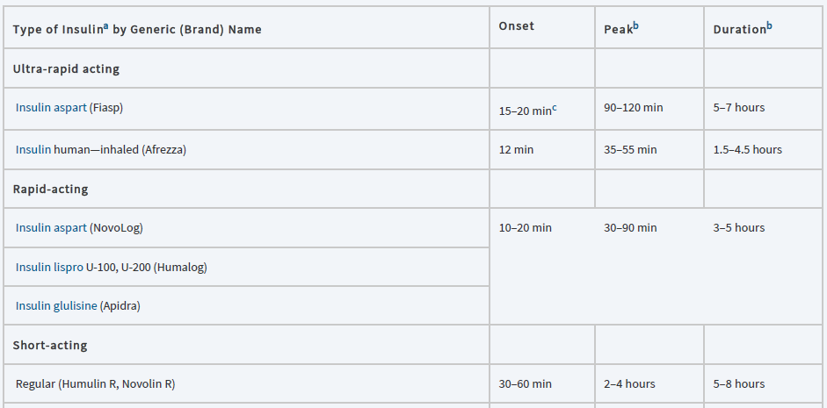
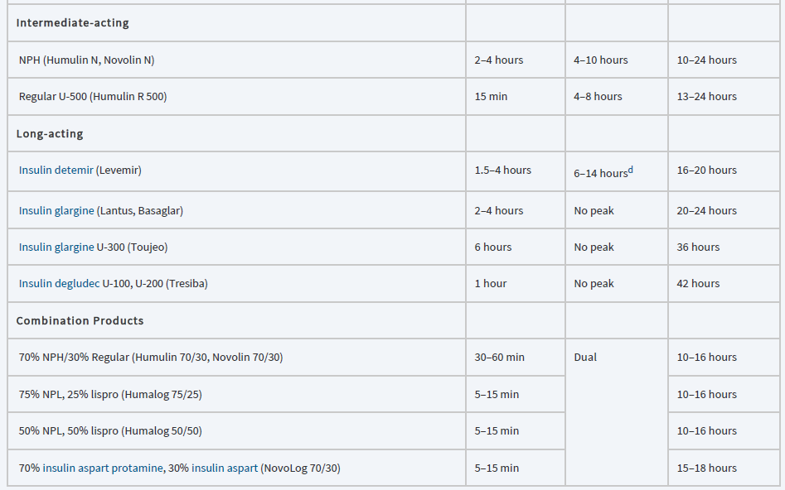

7-Basal insulin (or background insulin) refers to longer-acting insulins that regulate BG levels in between meals by suppressing hepatic glucose production and maintaining near-normal glycemic levels in the fasting state. Options include the following insulins:
- NPH is the least ideal product because it has a distinct peak and a duration of action much less than 24 hours and usually requires twice daily dosing.
- Detemir also has a peak and often lasts <24 hours; it can be given once daily in some patients but should be dosed twice daily at low doses.
- Glargine and degludec are longer acting-agents that have no peak and are given once daily.

8-All basal insulins can achieve similar A1C reductions if dosed and titrated properly, but the longer-acting products have a lower risk of hypoglycemia (particularly nocturnal hypoglycemia) and may result in less glucose variability. However, they are more expensive.

9-Bolus insulin refers to short- or rapid-acting insulins that cover meals (also called prandial insulin) or glycemic excursions (also called correction insulin).

10-Basal insulin is the preferred and most convenient initial insulin formulation for patients with type 2 DM, whereas patients with type 1 DM require a combination of basal and bolus insulin to achieve adequate glycemic control.

11-Bolus insulin options include:
- Aspart, lispro, and glulisine, the rapid-onset, short-duration insulins
- Inhaled human insulin and fast-acting insulin aspart (Fiasp®), the ultra-rapid onset insulins

12-Rapid-acting insulins offer a faster onset and shorter duration of action than regular insulin, and ultra-rapid acting insulins offer an even faster onset; this may more closely mimic prandial endogenous insulin release.

13-Rapid-acting insulins have a modestly lower risk of hypoglycemia than regular insulin.

14-Various premixed insulin products containing both a basal and a prandial component are also available for patients who require fewer injections or a simpler regimen (Table-2). However, these products are limited by fixed mixed formulations, which can make it challenging to tailor the dosing regimen.

15-The insulin dose must be individualized. In type 1 DM, the average daily requirement is 0.5–0.6 units/kg, with approximately 50% given as basal insulin and the remaining 50% dedicated to meal coverage.

16-During the honeymoon phase, requirements may fall to 0.1–0.4 units/kg. Higher doses are often needed during acute illness or with ketosis.

17-Hypoglycemia is the most common adverse effects of insulin therapy. Insulin also causes dose-dependent weight gain, which occurs predominantly in truncal fat.

18-Injection site reactions may include redness, pain, itching, urticaria, edema, and inflammation. SC administration can result in lipoatrophy or lipohypertrophy, which can be prevented by routinely rotating injection sites.

19-Inhaled human insulin can cause cough and upper respiratory infections, and it is contraindicated in chronic obstructive pulmonary disease and asthma due to bronchospasm risk.

20-Because inhaled insulin has been associated with a small decline in pulmonary function, patients should have spirometry tests performed at baseline, 6 months, and annually thereafter.

Biguanides
1-Metformin decreases hepatic glucose production and enhances insulin sensitivity in peripheral (muscle) tissues, allowing for increased glucose uptake into muscle cells.

2-Metformin is recommended as first-line pharmacotherapy in patients with type 2 DM (unless a contraindication or intolerability exists) due to extensive experience, high efficacy, minimal hypoglycemia risk, positive or neutral effects on weight, potential positive impact on CV risk, manageable side-effect profile, and low cost.

3-It does not cause weight gain and may lead to a modest (2–3 kg) weight loss.

4-It has a low risk of hypoglycemia because it does not directly increase pancreatic insulin secretion.

5-Metformin decreases plasma triglycerides and low-density lipoprotein cholesterol (LDL-C) by approximately 8%–15% and modestly increases high-density lipoprotein cholesterol (HDL-C) by 2%.

6-Metformin frequently causes GI side effects (diarrhea, abdominal discomfort, stomach upset); these effects are usually dose-dependent, transient, mild, and can be minimized with slow dose titration and taking metformin with or immediately after meals.

7-Extended-release metformin may lessen some of the GI side effects.

8-Metformin may cause a metallic taste and may lower vitamin B12 concentrations; B12 levels or methylmalonic acid should be measured annually or if a deficiency is suspected, with vitamin B12 supplementation given if indicated.

9-Lactic acidosis occurs rarely, usually in the setting of severe illness or acute kidney injury. The risk may increase in moderate-to-severe renal insufficiency or tissue hypoperfusion states such as acute heart failure (HF), excessive alcohol intake, and hepatic impairment. Because symptoms are often nonspecific, the diagnosis must be confirmed by laboratory measurement of high lactic acid levels and acidosis.

10-Metformin is renally excreted and accumulates in renal insufficiency; it is contraindicated in patients with eGFR <30 mL/min/1.73 m² and should be used with caution in patients with milder renal insufficiency.

11-Metformin initiation is not recommended in patients with eGFR 30–45 mL/min/1.73 m² but can be continued with increased renal function monitoring; a reduction of 50% of maximal dose may be warranted.

12-Due to the risk of acute renal failure with use of IV contrast dye, withhold metformin therapy starting the day of the procedure and resume it 2–3 days later if normal renal function has been documented.

13-Metformin can be used in combination with any other antihyperglycemic therapy and is often continued when insulin therapy is initiated.

14-The target metformin dose is 1000 mg twice daily or 2000 mg daily if the extended-release product is used. The minimal effective dose is 1000 mg/day.

Sulfonylureas
1-Sulfonylureas enhance insulin secretion by binding to the sulfonylurea receptor SUR1 on pancreatic β-cells.

2-First-generation agents (chlorpropamide, tolazamide, and tolbutamide) are lower in potency than second-generation drugs (glyburide, glipizide, and glimepiride), and are rarely used due to a higher risk of adverse effects.

3-All sulfonylureas are equally effective in lowering BG when given in equipotent doses.

4-Sulfonylureas are widely used because they have an extensive record of safety and effectiveness, are given orally, and are inexpensive. However, current treatment guidelines either discourage their use or suggest caution due to the risk of hypoglycemia and weight gain. In addition, tachyphylaxis to the insulin secretion effect occurs, leading to poor long-term durability of response in most patients.

5-The most common side effect is hypoglycemia. Patients who skip meals, exercise vigorously, or lose a substantial amount of weight are more prone to hypoglycemia.

6-Sulfonylureas with long durations of action and those with active metabolites should be used with extreme caution in older patients and those with renal insufficiency due to the high risk of hypoglycemia.

7-Weight gain is common (typically 1–2 kg). Patients with sulfa allergy rarely experience crossreactivity with sulfonylureas.

Thiazolidinediones (TZDs)
1-TZDs bind to the peroxisome proliferator activator receptor-γ (PPAR-γ) located primarily on fat and vascular cells, enhancing insulin sensitivity in muscle, liver, and fat tissues.

2-Maximum effects may not be seen until 3–4 months of therapy.

3-TZDs are considered second- or third-line agents and can be used in combination with metformin and other commonly prescribed medications for type 2 DM.

4-Pioglitazone decreases plasma triglycerides by 10%–20, whereas rosiglitazone may increase LDL-C by 5%–15%. Both drugs increase HDL-C, but the magnitude may be greater with pioglitazone.

5-Fluid retention may occur due to peripheral vasodilation and improved insulin sensitization in the kidney with increased sodium and water retention. This may result in peripheral edema (4%–5% of patients with monotherapy; 15% or more when combined with insulin), HF, hemodilution of hemoglobin and hematocrit, and weight gain.

6-TZDs are contraindicated in patients with New York Heart Association Class III or IV HF and should be used with caution in patients with Class I or II HF.

7-Weight gain is dose related and results from both fluid retention and fat accumulation; a gain of 4 kg is not uncommon, and higher gains may require drug discontinuation.

8-TZDs have also been associated with an increased fracture rate in the upper and lower limbs of postmenopausal women. An increased risk of bladder cancer is controversial.

Glucagon-like Peptide 1 Receptor Agonists (GLP1-RAs)
1-Dulaglutide, exenatide, exenatide XR, lixisenatide, liraglutide, and semaglutide stimulate insulin secretion and suppress inappropriately high postprandial glucagon secretion, decreasing hepatic glucose output. They also slow gastric emptying, increase satiety, and cause weight loss (average 1–3 kg).

2-Short-acting agents (exenatide, lixisenatide) predominantly lower postprandial glucose (PPG) levels, whereas long-acting agents (dulaglutide, liraglutide, exenatide XR, semaglutide) lower both FPG and PPG, but with larger effects on FPG.

3-Evidence suggests that liraglutide and semaglutide have the highest A1C and weight-lowering efficacy while exenatide and lixisenatide have the lowest.

4-Liraglutide and semaglutide have demonstrated CV benefits in clinical trials. Liraglutide is FDA approved to reduce the risk of major adverse CV events in adults with type 2 DM and established atherosclerotic cardiovascular disease (ASCVD).

5-GLP1-RAs are not currently recommended as first-line agents but can be used as monotherapy in patients who cannot tolerate or take first-line therapy.

6-They are recommended second-line agents for patients with established ASCVD or chronic kidney disease (CKD) and those with a compelling need to avoid hypoglycemia or to avoid weight gain or induce weight loss.

7-They can be used in combination with metformin, TZDs, sulfonylureas, SGLT-2 inhibitors, and basal insulin. They should not be used in combination with DPP-4 inhibitors due to similar mechanisms of action.

8-The GLP1-RAs are administered SC.

9-The most common adverse effects of GLP1-RAs are nausea, vomiting, and diarrhea. These effects are dose related, so dose titration is recommended. They usually occur early in the treatment course and are mild and transient but may require drug discontinuation in some patients. Instruct patients to eat slowly and stop eating when satiated or nausea may worsen and cause vomiting.

10-Injection site reactions and hypersensitivity reactions (including anaphylaxis and angioedema) have been reported.

11-Because GLP1-RAs enhance insulin secretion in response to food intake, the risk of hypoglycemia is low when combined with metformin, SGLT-2 inhibitors, or a TZD. However, hypoglycemia may occur when combined with a sulfonylurea or insulin.

Dipeptidyl Peptidase-4 (DPP-4) Inhibitors
1-Alogliptin, linagliptin, saxagliptin, and sitagliptin prolong the half-life of endogenously produced GLP-1 and GIP, thereby increasing glucose-dependent insulin secretion from the pancreas and reducing inappropriate postprandial glucagon secretion, resulting in lower glucose levels without an increase in hypoglycemia when used as monotherapy.

2-They do not alter gastric emptying, cause nausea, have significant effects on satiety, or cause weight gain/loss.

3-There are no clear differences in efficacy among agents in the class. DPP-4 inhibitors are considered second- or third-line therapy.

4-Advantages include once-daily dosing, oral administration, weight neutrality, low risk of hypoglycemia, and good tolerability. However, they have less A1C lowering efficacy than other second-line medication classes and are expensive.

5-Adverse effects are uncommon and include stuffy, runny nose; headache; and upper respiratory tract infections. The labeling of saxagliptin and alogliptin includes information about increased risk of hospitalizations for HF. The FDA has also issued a warning on the risk of severe joint pain with DPP-4 inhibitors.

6-Pancreatitis appears to be an established but rare safety concern.

Sodium-Glucose Cotransporter-2 Inhibitors
1-Canagliflozin, dapagliflozin, empagliflozin, and ertugliflozin reduce plasma glucose by preventing the kidneys from reabsorbing glucose back into the bloodstream, leading to increased glucose excretion in the urine.

2-SGLT-2 inhibitors lower both FPG and PPG . Renal impairment decreases the efficacy of SGLT-2 inhibitors.

3-SGLT-2 inhibitors are second-line agents that can be added to metformin or other second-line agents. They are not recommended as first-line agents but can be used as monotherapy in patients who cannot tolerate or take first-line therapy.

4-They are unlikely to cause hypoglycemia unless combined with medications such as sulfonylureas, meglitinides, or insulin.

5-Both empagliflozin and canagliflozin reduced major adverse CV events in large clinical trials, and empagliflozin is FDA approved to reduce the risk of CV death in adults with type 2 DM and established ASCVD.

6-The most common adverse effect is genital mycotic infections, which are more common in women and uncircumcised men. There is also a slightly increased risk of urinary tract infections. Polyuria, dehydration, dizziness, or hypotension may occur because of the osmotic diuresis effects.

7-Concomitant diuretic use may increase the risk of orthostatic hypotension and electrolyte abnormalities. Other potential safety concerns include ketoacidosis, amputations, fractures, and Fournier gangrene.

Reference
Joseph T. DiPiro, Robert L. Pharmacotherapy: A Pathophysiologic Approach,
11th Edition. 2021.

