College of Pharmacy
Fourth year. Clinical Pharmacy
Infectious Diseases
Tuberculosis
Introduction
1-Tuberculosis (TB) is a communicable infectious disease caused by Mycobacterium tuberculosis. It can produce silent, latent infection, as well as progressive, active disease.

2-Globally, 2 billion people are infected and roughly 1.5 million people die from TB each year.

Pathophysiology and etiology
1-M. tuberculosis is transmitted from person to person by coughing or other activities that cause the organism to be aerosolized. Close contacts of TB patients are most likely to become infected.

2-Human immunodeficiency virus (HIV) is the most important risk factor for progressing to active TB. An HIV-infected individual with TB infection is over 100-fold more likely to develop active disease than an HIV-seronegative patient.

3-Occasionally, a massive inoculum of organisms may be introduced into the bloodstream, causing widely disseminated disease and granuloma formation known as miliary TB.

Clinical presentation
1-Patients with TB typically present with cough, weight loss, fatigue, fever, and night sweats. Symptom onset may be gradual.

2-Frank hemoptysis usually occurs late in the course of disease but may present earlier.

3-Sputum smear is done to detect mycobacteria. Chest radiograph is also important.

4-Clinical features associated with extrapulmonary TB vary depending on the organ system(s) involved but typically consist of slowly progressive decline of organ function with low-grade fever and other constitutional symptoms.

5-Patients with HIV may have atypical presentation. HIV-positive patients are less likely to have positive skin tests, or fever. They have a higher incidence of extrapulmonary TB and are more likely to present with progressive primary disease.

6-The most widely used screening method for tuberculous infection is the tuberculin skin test, which uses purified protein derivative (PPD).

7-When active TB is suspected, attempts should be made to isolate M. tuberculosis from the infected site. Daily sputum collection over 3 consecutive days is recommended.

8-Tests to measure release of interferon-γ in the patient’s blood in response to TB antigens may provide quick and specific results for identifying M. tuberculosis.

Treatment
1-Goals of Treatment: (1) Rapid identification of a new TB case; (2) Initiation of specific anti-TB treatment; (3) Eradicating M. tuberculosis infection; (4) Achievement of a noninfectious state in the patient, thus ending isolation; (5) Preventing the development of resistance; (6) Adherence to the treatment regimen by the patient; and (7) Cure of the patient as quickly as possible (generally at least 6 months of treatment).

2-Drug treatment is the cornerstone of TB management. A minimum of two drugs, and generally three or four drugs, must be used simultaneously.

3-Directly observed therapy (DOT) by a healthcare worker is a cost-effective way to ensure completion of treatment and is considered the standard of care.

4-Drug treatment is continued for at least 6 months, and 18–24 months for cases of multidrug-resistant TB (MDR-TB).

5-Surgery may be needed to remove destroyed lung tissue, space-occupying lesions, and some extrapulmonary lesions.

Pharmacologic Therapy
Latent Infection
1-Chemoprophylaxis should be initiated in patients to reduce the risk of progression to active disease.

2-Isoniazid, 300 mg daily in adults, is the preferred treatment for latent TB, generally given for 9 months.

3-Rifampin, 600 mg daily for 4 months, can be used when isoniazid resistance is suspected or when the patient cannot tolerate isoniazid.

4-Rifabutin, 300 mg daily, may be substituted for rifampin for patients at high risk of drug interactions.

5-Pregnant women, alcoholics, and patients with poor diets who are treated with isoniazid should receive pyridoxine, 10–50 mg daily, to reduce the incidence of central nervous system (CNS) effects or peripheral neuropathies.

Treating Active Disease

1-Table 1 lists options for treatment of culture-positive pulmonary TB caused by drug-susceptible organisms.

2-The standard TB treatment regimen is isoniazid, rifampin, pyrazinamide, and ethambutol for 2 months, followed by isoniazid and rifampin for 4 months (a total of 6 months of treatment). Ethambutol can be stopped if susceptibility to isoniazid, rifampin, and pyrazinamide is shown.

3-Appropriate samples should be sent for culture and susceptibility testing prior to initiating therapy for all patients with active TB. The data should guide the initial drug selection for the new patient.

Table 1: Drug Regimens for Microbiologically Confirmed Pulmonary Tuberculosis Caused by Drug Susceptible Organisms
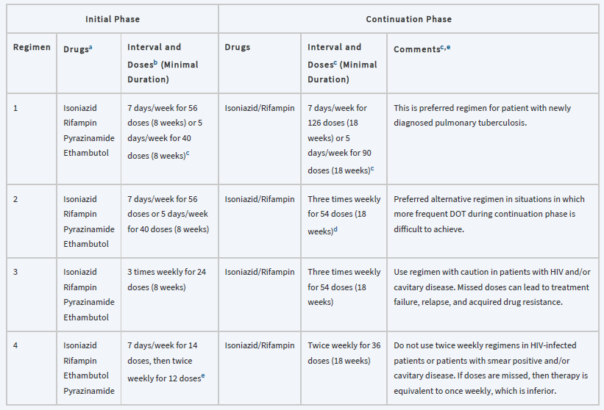
aOther combinations may be appropriate in certain circumstances.
bWhen DOT is used, drugs may be given 5 days/week and the necessary number of doses adjusted accordingly. Although there are no studies that compare 5 with 7 daily doses, extensive experience indicates this would be an effective practice. DOT should be used when drugs are administered <7 days/week.
cBased on expert opinion, patients with cavitation on initial chest radiograph and positive cultures at completion of 2 months of therapy should receive a 7-month (31-week) continuation phase.
dPyridoxine (vitamin B6), 25–50 mg/day, is given with INH to all persons at risk of neuropathy (eg, pregnant women; breastfeeding infants; persons with HIV; patients with diabetes, alcoholism, malnutrition, or chronic renal failure; or patients with advanced age). For patients with peripheral neuropathy, experts recommend increasing pyridoxine dose to 100 mg/day.
eAlternatively, some US tuberculosis control programs have administered intensive-phase regimens 5 days/week for 15 doses (3 weeks), then twice weekly for 12 doses.
DOT, directly observed therapy; EMB, ethambutol; HIV, human immunodeficiency virus; INH, isoniazid; PZA, pyrazinamide; RIF, rifampin.

4-If the patient is being evaluated for the retreatment of TB, it is imperative to know what drugs were used previously and for how long.

5-Patients who are slow to respond, those who remain culture positive at 2 months of treatment, those with cavitary lesions on chest radiograph, and HIV-positive patients should be treated for 9 months and for at least 6 months from the time they convert to smear and culture negativity.

Drug Resistance
1-If the organism is drug resistant, the aim is to introduce two or more active agents that the patient has not received previously. With MDR-TB, no standard regimen can be proposed.

2-It is critical to avoid monotherapy or adding only a single drug to a failing regimen.

3-Drug resistance should be suspected in the following situations:
- Patients who have received prior therapy for TB
- Patients from geographic areas with a high prevalence of resistance (South Africa, Mexico, Southeast Asia, the Baltic countries, and the former Soviet states)
- Patients who are homeless, institutionalized, IV drug abusers, and/or infected with HIV
- Patients who still have acid-fast bacilli–positive sputum smears after 2 months of therapy
- Patients who still have positive cultures after 2–4 months of therapy
- Patients who fail therapy or relapse after retreatment
- Patients known to be exposed to MDR-TB cases

Special Populations
Tuberculous Meningitis and Extrapulmonary Disease
1-In general, isoniazid, pyrazinamide, ethionamide, and cycloserine penetrate the cerebrospinal fluid readily.

2-Patients with CNS TB are often treated for longer periods (9–12 months).

3-Extrapulmonary TB of the soft tissues can be treated with conventional regimens. TB of the bone is typically treated for 9 months, occasionally with surgical debridement.

Children
1-TB in children may be treated with regimens similar to those used in adults, although some physicians still prefer to extend treatment to 9 months.

2-Pediatric doses of drugs should be used.

Pregnant Women
1-The usual treatment of pregnant women is isoniazid, rifampin, and ethambutol for 9 months.

2-Women with TB should be cautioned against becoming pregnant, as the disease poses a risk to the fetus as well as to the mother.

3-Isoniazid or ethambutol is relatively safe when used during pregnancy. Supplementation with B vitamins is particularly important during pregnancy.

4-Rifampin has been rarely associated with birth defects, but those seen are occasionally severe, including limb reduction and CNS lesions.

5-Pyrazinamide has not been studied in a large number of pregnant women, but anecdotal information suggests that it may be safe.

6-Ethionamide may be associated with premature delivery, congenital deformities, and Down syndrome when used during pregnancy, so it cannot be recommended in pregnancy.

7-Streptomycin has been associated with hearing impairment in the newborn, including complete deafness and must be reserved for critical situations where alternatives do not exist.

8-Cycloserine is not recommended during pregnancy. Fluoroquinolones should be avoided in pregnancy and during nursing.

Renal Failure
In nearly all patients, isoniazid and rifampin do not require dose modifications in renal failure. Pyrazinamide and ethambutol typically require a reduction in dosing frequency from daily to three times weekly.

Evaluation of therapeutic outcomes
1-The most serious problem with TB therapy is nonadherence to the prescribed regimen. The most effective way to ensure adherence is with DOT.

2-Patients who are AFB smear positive should have sputum samples sent for acid-fast bacilli stains every 1–2 weeks until two consecutive smears are negative.

3-Once on maintenance therapy, patients should have sputum cultures performed monthly until negative, which generally occurs over 2–3 months.

4-If sputum cultures continue to be positive after 2 months, drug susceptibility testing should be repeated, and serum drug concentrations should be checked.

5-Patients should have blood urea nitrogen, serum creatinine, aspartate transaminase or alanine transaminase, and a complete blood count determined at baseline and periodically, depending on the presence of other factors that may increase the likelihood of toxicity (advanced age, alcohol abuse, and possibly pregnancy).

6-Hepatotoxicity should be suspected in patients whose transaminases exceed five times the upper limit of normal or whose total bilirubin exceeds 3 mg/dL. At this point, the offending agent(s) should be discontinued and alternatives selected.

Reference
Joseph T. DiPiro, Robert L. Pharmacotherapy: A Pathophysiologic Approach,
11th Edition. 2021.

