|  |
| --- |
| Republic of Iraq  Ministry of Higher Education  and Scientific Research  Mustansiriyah University  College of Pharmacy |

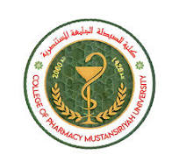

**Practical of Organic Chemistry ꟾꟾ**

**Second class / First semester**

**2023/ 2024**

**Lab 1. / Identification of Organic compounds**

**Done by:**

**Assistant Lecturer.** Hawazin Aziz Hamim

# Identification of Organic compounds

Identification of unknown or newly synthesized compounds is an important and necessary part of organic chemist work. Although, it is often possible to elucidate the compound structure based on its spectroscopic data (IR, NMR, MS). Many other information are important for the compound characterization, such as: elemental analysis, physical properties (solubility, color, odor, melting point, boiling point, etc. ...) and chemical reactions.

In this course, we will carry out several qualitative tests that allow us to identify functional groups such as carboxylic acids, alcohols, amines, alkanes, alkenes, and alkyl halides.

Each functional group has a particular set of chemical properties that it to be identified. Some of these properties can be demonstrated by observing solubility behavior, while others can be in chemical reactions that are accompanied by color changes, precipitation formation, or other visible changes.

Determination of Solubility Class

What is solubility?

Solubility is the extent to which a compound, called a solute, dissolves in a liquid, called a solvent.

Solubility is controlled by intermolecular forces that can be formed between the solute and the solvent (e.g. hydrogen bonding).

The rule that used to predict the solubility is "like dissolves like" and it is based on the polarity of the systems i.e. polar molecules dissolve in polar solvents (e.g. water, alcohols) and non-polar molecules in non-polar solvents (e.g. the hydrocarbon hexane).

Polar compounds: are compounds that can make hydrogen bond.

Non-polar compounds: are the compounds that cannot make hydrogen bonds.

Factors that effect on solubility include:

1. Molecular weight of compounds
2. Polarity

The aim of solubility test is:

1. To know the type of function group
2. To know the nature of compounds (like acid, base, neutral)
3. The polarity & the molecular weight of the compound. (Hydrocarbons are insoluble in water because of their non-polar nature, and if an unknown compound is partially soluble in water this indicates that a polar functional group is present). As the M.Wt. increases, the water solubility decreases (C ≤ 5 = water soluble).

For example: Benzoic acid is insoluble in water , but it is converted by 5% NaOH solution to sodium benzoate salt which is readily soluble in water.

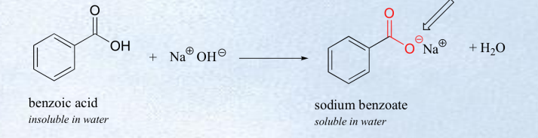

A-Miscible compounds: are a liquid compounds that are soluble in solvent.

B-Immiscible compounds: are a liquid compounds that are insoluble in solvent (2 phase system).

Q/How is make the solvent (NaOH 5%, NaHCO3, 5%, HC1 5%)?

(% Means gm/ml for solid substance or ml/ml for liquid substance).

* NaOH (5%): 5 gm of NaOH dissolved in (100 ml) of (H2O).

*NaHCO3: (5%): 5gm of NaHCO3, dissolved in (100ml) of H2O

*HCI (5%): 5ml of concentrated HCI in (95 ml) of H2O.

Solubility of solvents:

1. Water: - It can dissolve any compounds that have low (M. Wt) (less 5 carbon atoms) because the large molecule leads to break H-bond, salt and ionic compounds.
2. Ether: - It can dissolve any compounds that have high M. Wt (nonpolar compounds because it is nonpolar solvent).
3. Sodium Hydroxide NaOH (5%): - It can dissolve strong acid and weak acid compounds because it is a strong base.
4. Sodium Bicarbonate NaHCO3 (5%): -It can dissolve strong acid because it is weak base.
5. Hydrochloric acid HCl (5%): - It can dissolve base compounds because it is strong acid.
6. Concentrated Sulfuric acid H2SO4: - It can dissolve neutral compounds because it is a strong acid.

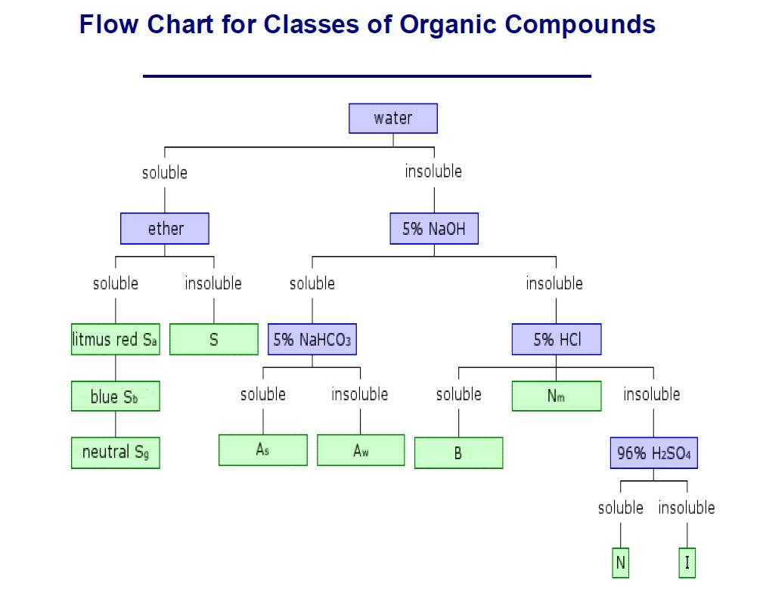

|  |  |  |
| --- | --- | --- |
|  | **Class** | **Functional Group Possibilities** |
| Sa | Aliphatic Carboxylic acids (≤5C). |
| Sb | Amines (≤6C). |
| Sg | Alcohols, aldehydes, ketones, esters, nitriles and amides (all ≤5C).    ,  ,  ,  ,  , |
| S | Ionic salts of organic acids and amines, poly hydroxylated compounds, polyfunctional compounds with hydrophilic functional groups.    , |
| As | Strong organic acids: carboxylic acids (>6C), phenols with electronwithdrawing groups (eg. NO2) in the ortho and/or para position(s).    ,  , |
| Aw | Weak organic acids: phenols, (all >5C), enols, amide, oximes, imides, sulfonamides (all >5C).    ,  ,  ,  , |
| B | Organic base: Aliphatic amines (≥8C) , aniline . |
| Nm | Miscellaneous neutral compounds containing N or S (>5C). |
| N | Alcohols, aldehydes, ketones, esters (>5C but <9C), ethers ,  alkenes , alkynes . |
| I | Saturated hydrocarbons (alkanes), haloalkanes, aryl halides, other deactivated aromatic compounds. |

**In which case we consider that the compounds are soluble in any solvent?**

* + If it dissolves to the extent of about 3% (0.1gm/3 ml or 0.2 ml/3 ml)
  + This is achieved by dissolving about 0.1 gm of solid or 0.2 ml (3-4 drops) of liquid organic compound in gradually increasing volumes of the solvent up to 3 ml (maximum allowed volume) with shaking. **Procedure:**

## 1. Water Solubility

Water is a polar solvent. It has the ability to form hydrogen bonding and can act either as an acid or a base. Therefore, it can dissolve:

1-Ionic compounds (salts).

2-Polar compounds “like dissolves like”.

3-Organic compounds with low molecular weight (less than 5 carbon atoms) such as alcohols, aldehydes, ketones, and carboxylic acids. Place 0.2 ml or 0.1 gm of compound in a small test tube, and add 3 mL of water in small portions. Shake test tube vigorously after the addition of each portion of solvent. If water soluble, go on to step 2; otherwise proceed to step 3.

## 2. Ether Solubility

Ether is a non-polar solvent. It cannot form hydrogen bonding. Therefore, it differs from water in that it cannot dissolve ionic compounds such as salts. It dissolves most water insoluble nonpolar compounds “like dissolves like”.

Place 0.2 ml or 0.1 gm of compound in a small test tube, and add 3 mL of diethyl ether in small portions. Shake test tube vigorously after the addition of each portion of solvent.

If the compound is both water and ether soluble, the acid-base properties of the compound should be determined with litmus:

litmus turns red - water soluble acidic compound (class Sa)



* litmus turns blue - water soluble basic compound (class Sb)

* litmus neutral - water soluble general compound (class Sg)

If the compound is not ether soluble it is a salt, amino acid, or contains many hydrophilic functionalities (class S) 4.

## 3. 5% NaOH Solubility

Water insoluble compounds must be tested first in 5% NaOH solution which is a strong basic solvent. It reacts with water insoluble compounds that are capable of donating protons such as strong & weak acids.

The stronger the acid, the weaker the base it can react.

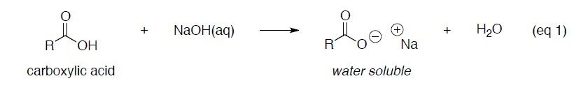

.

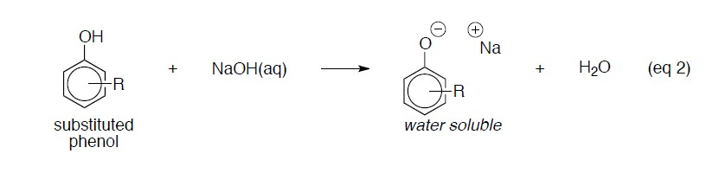

Place 0.2 ml or 0.1 gm of compound in a small test tube, and add 3 mL of NaOH solution in small portions. Shake test tube vigorously after the addition of each portion of solvent. If NaOH soluble, go on to step 4; otherwise proceed to step 5.

## 4. 5% NaHCO3 Solubility

Water insoluble compounds that dissolve in 5% NaOH solution must also be tested for solubility in 5% NaHCO3 solution. Therefore, for water insoluble acidic compounds NaOH solution considered as a detecting solvent where as NaHCO3  solution is called as a sub classifying solvent since it can react with strong acids only because it is a weak base.

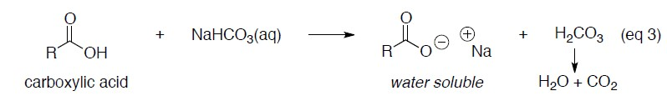

Place 0.2 ml or 0.1 gm of compound in a small test tube, and add 3 mL of NaHCO3 solution in small portions. Shake test tube vigorously after the addition of each portion of solvent. If NaHCO3 soluble, then it is a strong organic acid (class As). If not NaHCO3 soluble, then it is a weak organic acid (class Aw).

**As a result:**

1. If the compound is soluble in both bases. This indicates that the unknown is a strong acid “which can react with weak bases NaHCO3”

“protons are weakly attached & can be given easily”.

1. If the compound is soluble in 5% NaOH solution only. This indicates that the unknown is a weak acid.

## 5. 5% HCl Solubility

If the compound is insoluble in water & NaOH solution, this mean it is not an acidic compound but rather it may be a basic, neutral or inert compound. 5% HCl solution can dissolve basic compound such as amines (RNH2). If the compound is soluble in this solvent, then it may be primary, secondary, & tertiary amines (basic).

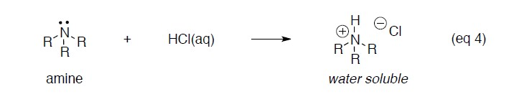

Place 0.2 ml or 0.1 gm of compound in a small test tube, and add 3 mL of HCl solution in small portions. Shake test tube vigorously after the addition of each portion of solvent.

If HCl soluble, then it is an organic base (class B). If not HCl soluble and (from elemental analysis) is found to contain nitrogen or sulfur, then it is a miscellaneous neutral compound (class Nm). If not HCl soluble, then go on to step 6.

## 6. Cold 96% Sulfuric acid H2SO4 Solubility

If the compound is insoluble in water, 5% NaOH solution & 5% HCl solution, solubility in cold concentrated H2SO4 should be tested.

If the compound is soluble in this acid it belongs to class N which includes, neutral compound such as high M.Wt. alcohols, aldehydes, ketones, esters & ethers (carbon atoms > 4) & unsaturated hydrocarbons. On the other hand, compound that are insoluble in cold conc. H2SO4 it is inert aliphatic (saturated) hydrocarbons, aromatic hydrocarbons, haloalkanes & aryl halides.

Place 3 mL of H2SO4 in a small test tube, and add 0.2 mL or 0.1 gm of compound. Shake test tube vigorously. If H2SO4 soluble, then it is a neutral compound (class N). If not H2SO4 soluble, then it is an inert compound (class I).

