College of Pharmacy
Communication Skills
Nonverbal Communication
Beyond words: the power of non-verbal communication
1-The most important thing in communication is hearing what isn’t said.
Peter Drucker
2-The body never lies.
Martha Graham
3-The pharmacist may learn more about the illness from the way the patient tells the story than from the story itself.

Background
1-Words are not the only way by which pharmacists communicate. Interpersonal
communication involves both verbal and nonverbal expression.

2- Nonverbal communication can be defined as a message or messages that are conveyed without using language.

3-This lecture describes the various components of nonverbal communication and discusses how it plays an important role in effective patient-centered communication.

Nonverbal versus Verbal Communication
1-The importance of nonverbal communication is underlined by the findings of behavioral scientists, who have reported that approximately 55% to 95% of all communication can be attributed to nonverbal sources ⁽¹⁾.

2-Various interpretations may present for the same nonverbal message and come
from the different social, cultural, and other background variables of the senders and receivers. However, within a given society, groups of nonverbal cues or “cue clusters” generally result in interpretations that are usually universally agreed upon.

3-When analyzing nonverbal communication, avoid focusing on just one cue. Look at all the nonverbal cues that you are receiving and use verbal communication to fully understand the meaning of the nonverbal behavior.

4-Nonverbal communications are unique for three reasons.
A-Verbal communication is discrete with clear endpoints – we know when the message has come to an end. In contrast, non-verbal communication is continuous – it goes on for as long as the communicators are in each other’s presence. We cannot stop communicating non-verbally– even when people are together in silence, the atmosphere is filled with messages.
So you are constantly providing “nonverbal messages” to those around you by your dress, facial expression, body movements, and other aspects of your appearance and behavior.

B-Nonverbal communication is difficult, if not impossible, to “fake” during an interpersonal interaction. Verbal communication is mostly under voluntary control whereas non-verbal communication operates beyond our conscious awareness.

C-Your nonverbal communication must be consistent with your verbal communication. This lack of congruence between your verbal and nonverbal messages may result in less than successful interpersonal communication.

Elements of Nonverbal Communication
Non-verbal communication can also be defined as all forms of human communication apart from purely the words used. Using this definition, the term non-verbal includes mainly:
1-Paralanguage (how something is said)
2-Body language
3-The physical environment (environmental nonverbal factors)

A-Paralanguage (how something is said)

The paralanguage includes the vocal characteristics as:

1-Tone: tone in particular can convey more meaning that actual words e.g.
Changes in the level and range of pitch convey information about the feeling of the person speaking.

"Thank you for asking question" said in a harsh voice contradict the words and indicate that is not meant. The same words in a warm tone show sincerity.

-The human voice communicates much to the receiver. This is especially true when the communication takes place over the telephone.

2-Speed: the speed of speaking must enable the listener to understand.

For good communication, the pharmacist should provide the clear message at a speed which give the patient time to think about what is being said. This will help the patient to understand and remember the message more easily.

3-Volume (how loudly we speak): many people speak with wide variation in volume, depending on the situation.

The volume must be adjusted to the circumstance and emphasize key words.

A-It may be necessary to speak more loudly to patients with hearing problems.
B- It may be necessary to speak less loudly to patients when we speak about an embarrassing subject.

B-Body language
The body language in turn, includes:

1-Eye contact:
the maintenance of eye contact during communication may indicate an interest in the subject in western cultures. However, Orientals tend to decrease eye contact during communication and will often look at the floor when speaking.

By maintaining eye contact with the patient, pharmacists are more likely to pick up nonverbal cues regarding whether the patient understands them. Many patients will say they understand something when they actually do not. Patients? facial expressions, such as a crinkled eyebrow, often reveal confusion, misunderstanding or uncertainty. These important cues are often missed by pharmacists when they do not take the time to maintain eye contact.
The amount of eye contact used should be in response to the patient. If the patient reacts uncomfortably to your direct eye contact, looking away occasionally may be a good idea (it is generally true that direct eye contact may have negative consequences in when we speak about an embarrassing subjects).

2-Facial expression:
the facial expression of pharmacist should be encouraging and welcoming. As well as pharmacist should be able to read the meaning of patient’s facial expression regarding the level of comprehension and receptiveness.

The 53 muscles of the face offer an almost infinite range of expression

Facial expression may send a message that you did not intend to transmit. This is especially damaging when your facial expressions are not consistent with your verbal expressions. For example, if you say, “Go ahead I am listening, tell me about it!” but your eyes are distracted by something else in the pharmacy, you may be communicating mixed messages.
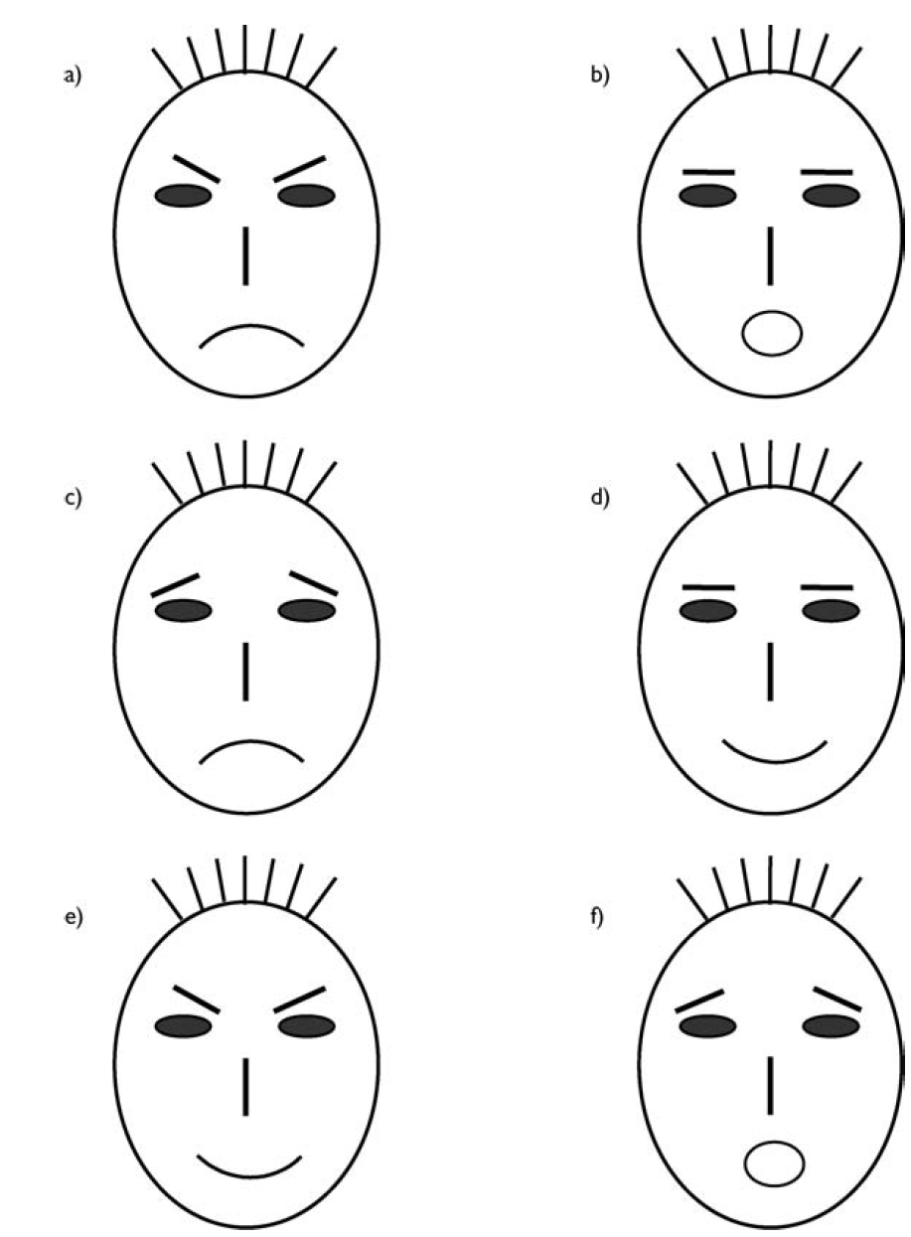
Figure six basic emotional expressions
Note: a = anger, b = fear, c = sadness, d = happiness, e = surprise, f = disgust
In these situations, people would tend to believe your facial expression and other nonverbal messages more than the verbal aspects of your communication.

The right word may be effective, but no word was ever as effective as a rightly timed pause.

Mark Twain

3-Body posture:
In addition to facial expression, body position can be somewhat distracting.
Most patients will judge your willingness to talk to them based on their perception of your body position. For example, a closed stance with folded arms or a body position that is slouched forward or tilted to one side may be communicating reluctance on your part to talk with them.
What nonverbal messages is the pharmacist sending? The patient?

leaning towards the person who is talking or sitting in a relaxed fashion, with a full-frontal appearance to the other person can encourage good communication.

A closed posture occurs when you have your arms folded in front of your chest, legs crossed at the knees, head facing downward, and eyes looking away from the patient. If you hold this posture during an interaction, the other person may respond in a similar noncommunicative manner or may break off the interaction altogether.

Communication from a closed posture may shorten or halt further productive interactions. Sometimes it is appropriate to use a closed posture, for example, when you want to limit the interaction with an overly talkative person.
1-A light, tender, sensitive touch is worth a ton of brawn.
Peter Thomson
2- Touch seems to be as essential as sunlight.
Diane Ackerman
3- Too often we underestimate the power of a touch, a smile, or a kind word all of which have the potential to turn a life around.
Leo Buscaglia.

4-Physical contact (touch):

Of all non-verbal behavior, touch is among the most powerful and the most problematic: powerful, because any intended physical contact between two human beings can have a considerable emotional impact; problematic, because it can be misinterpreted or experienced as a culturally offensive act [physical contact is governed by social and religious rules, which vary between cultures]. In some cultures, physical contact between adults in public is rare, even taboo.
In cultures where it is permitted, touch can be a compassionate and healing act which gives comfort and strength to those in pain or distress; touch can make contact between two people at a level beyond words.

The guiding hand on an elbow, the comforting touch on a shoulder, the reassuring holding of hands, picking up and hugging a distressed child – all so obvious, natural and humane.
[A sympathetic touch on an arm can say far more than any number of words].

5-Personal space (distance):
1-The distance between two interacting persons plays an important role in nonverbal communication. The structure and use of space, is a powerful nonverbal tool ⁽¹⁾.

2-Behavioral scientists have found that the quality of interactions can vary depending upon the distances between the communicators.

3- The distance should create some privacy (too far apart would cause talking that was audible to others), while at the same time, not creating discomfort. Our patients will give us nonverbal cues when we are standing too close.
[Patients usually indicate nonverbally whether they feel comfortable with the distance by either stepping backward or leaning forward].

4-In many cultures, 0.5-1 m is usually sufficiently close to allow friendly and meaningful communication. Preserve the most protected space (less than 0.5 m from their bodies) for others with whom they have close, intimate relationships.
When someone else enters into this space (intimate zone) during a conversation, people may experience anxiety and perhaps anger.

5-A crowded elevator is the best illustration of the need to maintain intimate space.
People in a crowded elevator will do almost anything (to the point of standing like statues) to avoid touching one another. If by chance two people in this situation do have bodily contact, they usually apologize, even though neither person had an opportunity to avoid the trespass of space.

6-The type of instructions that you need to give to the patient will also affect the distance. For sensitive issues, such as explaining the use of a rectal or vaginal medication, you may need to enter the patient’s private zone, especially if others are around.

6-Gesture:
Hand gestures in particular are useful when emphasizing a point or to help to describe something and can greatly enhance communication and improve understanding.

مثال ذلك تحريك اليد صعودا ونزولا عند قولنا للمريض رج الزجاجة قبل الاستعمال وهكذا الحال مع الكثير من التعليمات حيث يمكن تعزيز فهم وتذكر المريض للتعليمات بتعزيز الكلام بحركات اليد المنسجمة مع محتوى الكلام...
7-Clothing:
The clothing we choose to wear can communicate a great deal about us. Are the clothes in style? Are they ironed or wrinkled? Do the colors go together? How does the pharmacist distinguish him or herself from the rest of the staff in the pharmacy? Does the pharmacist wear a professional coat that indicating this is a pharmacist?

وأن من ابرز الأشياء التي تعطي (مظهر المهني ونقصد به الصيدلي ) هو ارتداء الصدرية في الصيدلية وهو جانب عنصر مهم من عناصر المظهر المهني ولكن ومع الأسف الشديد قلة من الزملاء الصيادلة من يلتزم به رغم التعليمات النقابية بهذا الخصوص...حتى إن صحفيا كتب مقالة في الصحيفة وعنونها (أين الصيدلي) اشتكى فيها من صعوبة تعرفه على الصيدلي في الصيدليات خصوصا إذا كان فيها أكثر من شخص والسبب واضح.

C-The physical environment (environmental nonverbal factors)

1-Never go to a doctor whose office plants have died.
Erma Bombeck
2-I was going to have cosmetic surgery when I noticed that the doctor’s office was full of portraits by Picasso.
Rita Rudner

There are many things in the environment which will have a some potentially very powerful impact. These are part of the broad category of non-verbal communication [communication beyond words].

Relationships with patients will be eased and enhanced, confidence and trust will be stimulated in an environment that is welcoming, comfortable and attractive.

Dirt, clutter, and general untidiness carry negative nonverbal messages. These messages influence patient perceptions about your professional role and your level of interest in serving your patients.

In the pharmacy, a host of physical, non-verbal elements send strong positive or negative messages (communicate) to patients, visitors and colleagues:

• Layout and arrangement of rooms or physical space.

• Tidiness and cleanliness.

• Comfort of seating.

• Temperature, humidity and freshness of atmosphere.

• Lighting levels, color schemes, decorative elements (such as plants and pictures).

•The visibility of library references books will enhance the professional image.

• Privacy: an area where the patient and pharmacist cannot be overheard is very important to ensure confidential communication and this may be only a corner in the pharmacy away from the customers’ cue. Privacy allows the pharmacist to give accurate and complete information and allow the patient to ask even potentially embarrassing or stupid questions.

[In some pharmacies (even in Iraq) there is a private consulting area. This may indicate to your patients that you are interested in counseling them in a private manner].

Many pharmacies sell many items that are not health-related. These may include, cosmetics, greeting cards, household items (e.g., paper towels, toilet paper, glass cleaners, etc.), candy, etc. Does selling these items confuse the patient about what the pharmacist’s primary intent is as a healthcare provider? Is the selling of these items consistent with the health image the pharmacist is trying to convey? Pharmacists may need to reconsider the items they sell and the effects of those items on the image conveyed.

D-Time-Consciousness:
Many patients are extremely time-conscious. Even a fifteen-minute wait, which is fairly common in many pharmacies, is viewed with impatience. Therefore, it is important to convey value in the wait in order to reduce this negative view of waiting. This may be done by either providing services worth waiting for (such as counseling) that most others don’t provide or provide as well, or this may be done through compassion and empathy.
Case Study 1
Patient: Fifteen minutes? Just to throw a few pills in a bottle? I just had to wait almost an hour and a half at the doctor’s office.
Pharmacist: I know that you have waited a long time today. I will get your medicine to you as quickly as I can. I do have two other patients ahead of you and I want to be accurate with everyone’s medicine. I do appreciate your patience.
Notice in this situation that the pharmacist acknowledges the patient’s complaint but does not take responsibility for the problem, nor does the pharmacist attempt to solve it. The pharmacist is caring and compassionate, but also not willing to engage the patient in a debate.

Mirroring
1-When two (or more) people are in some kind of harmony, their non-verbal behavior is often mirrored: they may be sitting in similar poses (may be one ankle resting on the knee, or an arm loose on the arm of a chair); they may move or make the same gesture at the same time.

2-Knowledge of this is also professionally important. If a patient is imitating your body posture, then you may assume that they are on at least a similar wavelength to you and amenable to some degree of open conversation. In order to demonstrate the same degree of openness to what a patient is saying, you can mirror their behavior.

3-A tense patient may be influenced unconsciously to relax and imitate you, by your adopting a relaxed body posture, but if their tension is mirrored in your posture, and you don’t recognize the imitation, then progress may not be easy.

Distracting Nonverbal Communication
1-One of the most distracting nonverbal elements is lack of eye contact. It is frustrating to talk to somebody who is not looking at you. Unfortunately, many pharmacists unconsciously do not look at patients when talking to them. Their
tendency is to look at the prescription, the prescription container, the computer
screen, or other objects while talking.

This behavior may indicate to patients that you are not totally confident about what you are saying or that you really do not care about speaking with them.
Not looking at the patient also limits your ability to assess whether the patient understands the information. In other words, lack of eye contact limits your ability to receive feedback from the patient about the messages that you are giving.

Good eye contact is also essential for effective listening. If you do not look at patients while they are talking, they may get the impression that you are not interested in what they are saying. Using good eye contact does not mean that you continually stare at patients, because that may make them feel uncomfortable as well. The key is that you spend most of the time looking at them.

2-Another potentially distracting nonverbal element is facial expression. This is especially damaging when your facial expressions are not consistent with your verbal expressions. For example, if you say, “Go ahead I am listening, tell me about it!” but your eyes are distracted by something else in the pharmacy, you may be communicating mixed messages. The patient hears you say that you are interested, but your nonverbal behavior communicates otherwise. In these situations, people would tend to believe your facial expression and other nonverbal messages more than the verbal aspects of your communication.

3-In addition to facial expression, body position can be somewhat distracting.
For example, a closed stance with folded arms or a body position that is slouched forward or tilted to one side may be communicating reluctance on your part to talk with patients.

4-Another potential distraction to communication may be your tone of voice. An inappropriate tone of voice may create an entirely different meaning from the one intended.

Detecting Nonverbal Cues in Others
1-Up to this point, this lecture has focused on your own nonverbal communication.
The following section examines nonverbal messages provided by others and describes how to better detect these messages.

2-Assessing the meaning behind the nonverbal messages of others is difficult, because we tend to interpret nonverbal cues based on our own personal backgrounds and experiences. We “filter” these messages based on our personal orientation and experiences. The meaning of the nonverbal messages that we receive may or may not be the meanings intended by the sender.

Case Study 2
During his first experience in a community pharmacy, a pharmacy student (John) was assigned the task of receiving new prescriptions from patients.
One day, Mr. Stevens approached the prescription counter to have his prescription for levodopa refilled. John, who did not realize that Mr. Stevens had Parkinson’s disease, noticed that his hands were shaking and commented, “I see you are a bit nervous today. What’s the matter?”

John observed a nonverbal message (rapid hand movement) from Mr. Stevens and assigned a wrong meaning to it. John should not have jumped to the conclusion based on just one nonverbal cue but should have noticed that Mr. Stevens’ head was also moving and that he walked with a shuffled gait characteristic of Parkinson’s disease.

3-Another example occurs when elderly patients move closer to you or may put a hand to their ears. What message might these nonverbal cues indicate? Possibly, they may indicate that they are having difficulty in hearing. You may also observe hearing aids, glasses, and other devices that may indicate possible communication difficulties.

Dealing with Sensitive Issues
1- It is interesting to note that a study found that embarrassment was the most common reason why consumers did not approach their health care provider.

2- A wide variety of embarrassing issues could exist within practice, including incontinence, sexual dysfunction, depression, menopause, hemorrhoids, contraception, and breast or prostate cancer.

3-As a pharmacist, you should be prepared to recognize situations that may be sensitive areas for patients. You should be comfortable discussing such matters in a nonthreatening way and in a nonverbal environment that conveys confidentiality and privacy.

Overcoming distracting nonverbal factors
1-As mentioned earlier, the first step in improving interpersonal communication is recognizing how you communicate with others. In the nonverbal area, this self-awareness involves being constantly aware of your nonverbal behavior.

2-Once you have discovered what aspects you need to change to become more
effective, the next step is a difficult one: finding strategies to overcome these distracting elements. Several suggestions have been already made about how specific nonverbal elements can be improved.

One thing that should be mentioned here is that potentially distracting behaviors can be overcome by using nonverbal elements that project different messages. For example, you may find that you naturally cross your arms while talking to others. You can overcome this nonverbal element by using other nonverbal elements, such as
smiling, using a friendly tone of voice, or moving closer to the patient. The total message received by the patient is the combination of all these nonverbal cues, both positive and negative, and not just one isolated component.

Another example is that if you have a soft voice and you sense that the patient cannot hear you, then you should lean toward the patient, or move the patient into a quieter section of the pharmacy.

[The key to this process is to first recognize distracting nonverbal elements and then try to overcome them].

Summary
Because nonverbal communication contributes significantly to the meanings of messages between pharmacists and others, it is important for you to keep the following in mind:

1-Certain nonverbal behaviors are universal; however, many are culturally specific.

2- Nonverbal behavior is more powerful than verbal. If the spoken word contradicts nonverbal behaviors, the observer will believe the nonverbal messages.

3-The practice environment have important effects on communication with patients.

References
1-Robert S. Beardsley, (ed.); Communication Skills in Pharmacy Practice, 5th edition. Copyright © 2008 Lippincott Williams & Wilkins.
2-Jonathan Silverman .Skills for Communicating with Patients. Third Edition. 2013.
3- Bruce Hugman. Healthcare Communication. Pharmaceutical Press 2009
4- Bruce Berger. Immediacy—Part 2 :Nonverbal Communication. US Pharmacist.
5- Heidi M. Anderson-Harper. A Handbook for Teaching Courses in Pharmacy Communications. Copyright 1994: American Association of Colleges of Pharmacy.

College of Pharmacy
Communication Skills.
Assertiveness

Overview
Assertive pharmacists take an active role in patient care.
1-These pharmacists initiate communication with patients rather than wait to be asked questions.
2-Assertive pharmacists also convey their views on the management of patient drug therapy to other health care professionals.
3-Finally, assertive pharmacists try to resolve conflicts with others in a direct manner but in a way that conveys respect for others.

Defining Assertiveness
What is assertiveness? Assertiveness is perhaps best understood by comparing it with two other response styles: passivity and aggression. These three styles of responding are described below.

A-Passive behavior
1-This response is designed to avoid conflict at all cost.
2-Passive or nonassertive persons will not say what they really think out of fear that others may not agree.
3-Passive individuals “hide” from people and wait for others to initiate conversation.
4-They put the needs or wants of other people above their own.
5-They worry about how others will respond to them and have a high need for approval.
6-Passive persons may see themselves as victims who are subject to the manipulation of others.
[It is this view that is damaging to their self-esteem]

B-Aggressive behavior
1-Aggressive people seek to "win" in conflict situations by dominating or intimidating others.
2-Aggressive persons promote their own points of view but are indifferent or hostile to the feelings, thoughts, or needs of others.
3-Such individuals are easily angered and have a low tolerance for frustration
3-Thus, aggressive individuals may "win" certain interpersonal battles in the short term, but their behavior often leads to negative long-term consequences.

[For example, patients who do not feel they are treated with respect in a community pharmacy may not return to that pharmacy and may tell friends about their negative experiences.
Employees who feel helpless and undervalued can damage the goals of their employer in a variety of indirect ways].

4-Aggressive approaches do not build trusting relationships, which is a key element in working with patients and others in professional practice.
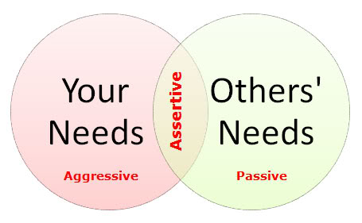

C-Assertive behavior
1-Assertive behavior is the direct expression of ideas, opinions, and desires. The intent of assertive behavior is to communicate in an atmosphere of trust. Conflicts that arise are faced and solutions of mutual accord are sought. Assertive individuals initiate communication in a way that conveys their concern and respect for others.
The goal of communication is to stand up for oneself and to solve interpersonal problems in ways that do not damage relationships. Assertiveness requires that you respect others as well as yourself.

2-Too often, our goals in communication are defined in terms of what we want others to do rather than what we will do. For example, we might say that we want physicians to appreciate the role of the pharmacist in patient care. Redefining this goal would have us focus on what specific things we can do to improve our working relationships with physicians. If we tell others our goals in providing a good pharmaceutical care services and show them by our behavior what we want to achieve, many will come to respect our position.

ويكون ذلك بممارسة الصيدلي لدوره العلمي بجوانبه المختلفة (كالتثقيف الدوائي للمرضى والاشتراك مع الطبيب (في المستشفى خصوصا) في اختيار الدواء المناسب للمريض وإبداء الآراء العلمية المستندة على قاعدة علمية رصينة في مختلف المسائل التي تواجهه في المستشفى والمساهمة في إيصال المعلومة الصحيحة للطبيب والاشتراك في الحلقات والندوات والمؤتمرات العلمية وغيرها كثير ...كل ذلك يجعل الطبيب وغيره يحترم ويقدر دور الصيدلي ....أما الاكتفاء بكتابة طلبية الأدوية وتوزيعها على المرضى ...ومن ثم نطلب من الطبيب تقدير واحترام دور الصيدلي...فلا يجدي نفعا)

3-Other example, you may wish that your boss, who tends to be very negative during evaluations of staff, was more supportive of your work. However, just hoping that he would be more positive in his evaluations will not resolve this issue. You must take active steps to change how you respond to his criticisms rather than waiting for his to change her approach
سيتم التعرف على كيفية التعامل مع الانتقاد لاحقا في المحاضرة

Theoretical Foundations
Usually, the people respond passively or aggressively because they have irrational beliefs that interfere with assertiveness. These beliefs involve:
1-Fear of rejection or anger from others and need for approval (everyone should like me and approve of what I do).
2-Over-concern for the needs and rights of others (I should always try to help others and be nice to them).
3-Perfectionist standards (I must be perfectly competent. If I am not, then I am a failure. Others must also be perfectly competent and deserve to be severely criticized if they are not.)

[In the passive person these beliefs create anxiety that leads the individual to try (unsuccessfully) to avoid the inevitable conflicts that arise in relationships.

In aggressive person these beliefs lead to angry, aggressive behavior, with frequent “blaming” of others for normal human failings].

Assertiveness Techniques
There are a number of communication techniques or strategies that are useful in responding to situations that tend to be conflict-ridden.

A-Providing feedback
Many times, you must tell people that you are upset by what they did. When you choose to convey negative feedback to others, use techniques to make the communication less threatening. Criteria for useful feedback include:

1-Feedback focuses on a person's behavior rather than personality.
2-The feedback must be specific rather than general. It focuses on behavior that has just occurred and avoids dragging in past behavior (e.g., "you always do------ ").

3-Feedback focuses on problem solving. The focus is on problem solving rather than turning the conflict into a “win/lose” situation that damages the relationship.

The entire focus should be on attacking problems or issues, not people or personalities.

For another example, rather than saying (you should not prescribed ciprofloxacin because Mr. Jones is taking theophylline and the two drugs interact)

But say (This patient cannot take ciprofloxacin because he is already taking theophylline and there is a serious drug interaction. I suggest we use co-trimoxazole))

تعمدني بنصحك في انفـراد .... وجنبني النصيحة في الجماعة
فإن النصح بين النـاس نـوع .... من التوبيخ لا أرضى استماعه
4-Feedback is provided in a private setting.

Feedback uses “I” statements that take the form “When you [do or say] _____, I feel ___.” For example, “When you are late for work, I feel frustrated” is less damaging than “You’re irresponsible. You don’t care about the patients who are waiting and the co-workers covering for you when you’re late.”

B-Inviting feedback from others
1-At the same time, we need to invite feedback from others about us in order to improve our interpersonal communication skills.

2-Your ability to encourage feedback from others (even when it is negative), to hear criticism or suggestions without anger, and to admit when you have made a mistake, encourage people to be honest in their communications with you.

3- For example, as a pharmacist, you should routinely assess patient satisfaction and invite feedback on your services. As a manager, you should let employees know that you welcome suggestions from them on how to improve pharmacy operations.

C-Setting Limits
1-If we have difficulty in saying "no" to any request, then we feel overwhelmed and, often, angry at others for "taking advantage" of us.

2-Saying "no" or setting limits may be particularly difficult if you believe that the other person must agree that you have a good reason for saying "no." Whether you give reasons or not does not change the fact that you have the right to make the decision on how you will spend personal time.

3-Remember: being assertive in setting limits does not mean that you stop saying "yes" to requests. You will no doubt continue to help others.

D-Making Requests
1-When we ask for what we want from others, we must trust that others will be able to respond to our requests in an assertive manner, including saying "no."

2-Thus, we must not overreact when someone turns down our request in an assertive way.

E-Being Persistent
1- Often when you said “no,” people will try to coax you into changing your mind. If you continue to repeat your decision calmly, you can be assertive without becoming aggressive and without giving in.

F-Ignoring provocations
1-You as a pharmacist may receive an aggressive comments (provocations) for example, from patients who are angry or feeling helpless or from other pharmacists who feel unfairly criticized.

2-Ignoring the aggressive comments of others and focusing exclusively on solving underlying problems can do much to keep conflict from escalating to the point that relationships are damaged.

G-Responding to criticism
For some of us, criticism is particularly devastating because we typically hold two common irrational beliefs:
(1) That we must be loved or approved of by virtually everyone we know, and
(2) That we must be completely competent in everything we do and never make mistakes.
Since such perfectionist standards are impossible to achieve, we are constantly faced with feelings of failure or unworthiness.

*************************************************************************
Now let’s examine a few typical situations in pharmacy practice and determine what might be the most assertive way to respond in relationships with patients, physicians, employees, employers, and colleagues.

Assertiveness and Patients
1-Certain activities distinguish assertive pharmacists from passive ones. For example, passive pharmacists seem to hide behind the counter, and generally avoid interaction with patients unless asked specific questions. In this way, passive pharmacists are able to avoid the potential conflicts inherent in dealing with people.

2-Assertive pharmacists come out from behind counters, introduce themselves to patients, provide information on medications, and assess the patient’s use of medications and problems with therapy.

3-Encouraging patients to be more assertive is also an important skill in improving your communication with them. Even normally assertive patients may experience enough anxiety in communication with pharmacists. You as a pharmacist may encourage patients to be more assertive by allowing them to ask questions about their therapy that they want to ask.

4-A particularly difficult situation that you will face in pharmacy practice is responding to an angry patient. While no one likes to hear criticism, there are ways of dealing with criticism in a rational, assertive manner.

A-When you hear criticism from patients, it is important to keep in mind that some (do not assume all) patient anger arises from frustrations about being ill (and the life stresses they are experiencing), and not from you.

B-When patients are reacting primarily to the stresses of being ill; it is most helpful for you to understand what it is like for them and to respond empathically. An empathic response when patients react with dismay at the cost of their medications will probably be more helpful than an attempt to justify the cost.
Saying, “You’re right. These medications are expensive. Are you worried about whether you can afford them?” shows that you understand the patient’s worry and allows you to assess whether the concern about cost is a real problem of inability to afford treatment or a way of expressing feelings of frustration.

C-Another skill that is useful in responding to patient criticism is to get patients to turn criticism into useful feedback. For example, if a patient tells you that your pharmacy does not seem to care about the customer, it is important to find out specifically what is causing the problem. Asking “What specifically is it that upsets you?” may give you feedback that would be useful in improving your pharmacy operation.

D-There will be times with angry patients where you will need to stand up for yourself. If a patient persists in aggressive behavior in spite of your efforts to focus on understanding and problem solving, you will want to set limits without becoming aggressive. You can calmly tell an angry patient “I want to hear your point of view, but, when you are ready to talk without yelling and swearing, I will listen.”

Assertiveness and Other Health Care Professionals
When problems in patient medication therapies arise, consultations with physicians or nurses are often required. If you have determined that you need to speak directly with the prescribing physician, you will be most effective if you are persistent with receptionists and nurses in your request. Messages transmitted through third parties may not be the most effective means of communication. Such persistence might sound something like this:

CASE STUDY 1
Pharmacist calling a receptionist in a physician's office
Pharmacist: This is Ameer Hasan, the pharmacist at AL-Yasameen Pharmacy. I'd like to speak to Dr. Ahmed Saleem please.
Receptionist: He's with a patient now. What is it you wish to speak to him about?
Pharmacist: I am concerned about Mr. Amjad's prescription for metformin. I will need to speak to Dr. Ahmed about it. Please have him call me as soon as he comes out from the patient examination.

Receptionist: It might be quicker if you tell me what the problem is. I could talk to Dr. Ahmed and get back to you.
Pharmacist: Thank you, hut in this case I would like to talk to Dr. Ahmed directly.
Receptionist: He's very busy today.
Pharmacist: 1 knows he has a busy schedule but I must speak with him as soon as possible. Please ask him to call.

1-The pharmacist (Ameer Hasan) in this communication was assertive. He showed respect for the receptionist and yet was persistent in stating his request. He did not argue about the issue of which method of communication was quicker. He calmly restated his request without anger or apology.

Now, let's say you have managed to get through to the physician. Compare the following introductory comments by a pharmacist:

A-Dr. Ahmed, this is the pharmacist at AL-Yasameen Pharmacy. I'm sorry to bother
you—I know you're busy—but I think there's a problem with Mr. Amjad's prescription for metformin.

B- Dr. Ahmed, this is Ameer Hasan, the pharmacist at AL-Yasameen Pharmacy. I'm calling about a problem Mr. Amjad is having with his prescription for metformin.

In (A), the pharmacist did not introduce himself, which makes him an anonymous rather than a professional with an individual identity. Also, in (A), he "apologizes" for calling, which makes him seem unassertive.

Here are several ways the pharmacist could precede:
A-Did you know that Mr. Amjad is still having diarrhea from the metformin?
Do you want to change his prescription?

B- I spoke with Mr. Amjad today. He reports that he continues to have diarrhea after three months on the medication. He is now reluctant to leave the house because of the diarrhea. The effect on his life is so serious that we may want to consider switching him to another drug like Glimepiride which is less likely to cause diarrhea.

Response (B) is better.
-The pharmacist is not putting the physician on the spot by asking him if he knew there was a problem.
-Instead, he presented the problem that concerned him and suggested alternative medications that could possibly resolve the problem (The focus is on problem solving rather than win the situation).

2-When identifying potential problems with a physician prescription:

A- You should be prepared to identify alternatives to try to resolve the problem. In order to do this with confidence, you should have checked references before making the phone call or sending the written communication. This will increase your effectiveness in making a recommendation.

B-Once you are sure of your facts; you must be persistent in pushing for a therapeutic change that is required.

C-Be sure that you should use the medical terms and speak to the physician as a fellow health professional.

D-Focus on the goal you share with the physician, which is to help the patient.

E-Physicians may not accept recommendations and may, in fact, seem ungrateful to some of your interventions and you may not receive feedback that your efforts have been successful. Perhaps the next prescription the physician writes will show a change, even though the initial response to you indicated that a change would not be made.

F-It is important to keep in mind that consulting with physicians if problems arise or asking questions if something seems to be a problem must be done in spite of what the physician’s reaction might be. To fail to consult a physician because of anticipated resistance reduces your professional role significantly.

6-While pharmacists seem to fear that physicians will not respond positively to therapeutic recommendations; the research evidence suggests just the opposite. Research indicates that, when pharmacists make suggestions to physicians for important therapeutic changes in a patient’s drug treatment, in the vast majority of cases, pharmacist recommendations are accepted and implemented by physicians.

7-When patient safety is compromised, it is the professional responsibility of the assertive pharmacist to persist in trying to prevent or resolve problems. More than one-half of health care workers in one study reported seeing colleagues making mistakes, yet less than 10% reported saying anything about what they observed.

Assertiveness and Employees
Please consider the following situation. The manager of a hospital outpatient pharmacy has observed lately that one of the pharmacists has been creating problems.
The manager’s major concern is that the pharmacist is sometimes rude and abrupt with patients. Today, the manager overhears the pharmacist respond with obvious annoyance to a patient who expressed confusion about how to take her medication.
The manager decides to talk privately with the pharmacist and provide feedback about his behaviour.

CASE STUDY 6.2

Manager speaking with staff pharmacist
Manager: I overheard your conversation with Mrs. Raymond this afternoon when you became impatient with her for not understanding instructions. I was upset because I didn’t think you treated her with respect. I want you to treat patients with courtesy and not get so impatient and judgmental with them.
Pharmacist: Well, she wouldn’t pay attention when I was explaining the directions. I just got fed up.
Manager: I know that patients can be irritating, but I want you to treat them with respect.
Pharmacist: Well, we were so busy then that I just didn’t have time to explain the directions slowly.
Manager: I know you were feeling rushed today, but even then, I want you to be more courteous.
Pharmacist: Well, it would certainly be easier to take time to be nice if you’d get
enough pharmacists in here to cover the workload.
Manager: Those things may be true, but right now I want to resolve the problem in the way you communicate with patients when you are irritated or hurried. I want you to agree to treat patients with respect, regardless of how busy we get. Will you do that?
Pharmacist: That’s easier said than done.
Manager: Will you do it?

1-Pharmacy managers are responsible not only for how they communicate with patients, but also how other pharmacists and support personnel treat patients. They must make clear to all employees what is expected in the way of patient care.

2-In the previous scene, the pharmacy manager used a number of assertive techniques in his conversation with the pharmacist.

A-The pharmacy manager used appropriate feedback techniques. He told the pharmacist what he had observed about a specific behaviour and what he wanted changed without attacking the pharmacist as a person. The manager did not label the pharmacist as being rude. Focusing feedback on what a person does is much less destructive than making personal judgments about him as a person. Such feedback also lets him know exactly what must be changed to improve his performance

B- He calmly repeated these expectations in spite of the pharmacist’s excuses. He would not let himself be dragged off the point.

C-He did not become anger when the pharmacist attacked his performance as a manager (Ignoring provocations). He might also have said, “I would like to discuss any ideas you might have about improved the training of techs another time, but right now I want to talk about the way you counsel patients.” This would have let the pharmacist know that he was willing to listen to specific, constructive suggestions but not before the current problem was resolved.

D-The manager discussed the situation privately and soon after the incident occurred. He made “I” statements to provide feedback and define expectations, including “I overheard your conversation,” “I was upset,” and “I want you to treat patients with courtesy.” Because of these “I” statements, the communication was less damaging to the relationship than if the manager had labelled or judged the pharmacist as a person (“You are rude” or “You were rude”) or if he had over-generalized based on what he observed (“You always ……………… when we get busy here”). Dealing with the problem immediately was also much more effective than waiting until the problem had become so serious that more drastic action was required.

Many of the same guidelines that are useful in giving negative feedback apply as well to praise. A personal statement, such as telling a pharmacist, “I really appreciate your willingness to stay late tonight to help out” is more meaningful than a general statement (e.g., “You’re a good pharmacist”).

In addition, if positive feedback is an ongoing part of the relationship rather than something that only gets written on job performance evaluation forms, it is more effective. Too often, employees feel that the only time they get any feedback from their bosses is when they have done something wrong, which makes it much harder to accept the negative comments.

Finally, your willingness to accept even negative feedback from employees (if it is constructive) can create an atmosphere of mutual respect. In the example above, the pharmacy manager conveyed both an assertive and empathic message when he said, “I know you were feeling rushed today, but even then, I want you to be more courteous.” He let the pharmacist know that he understood the feelings of frustration and at the same time insisted that certain standards be met in patient care.

Assertiveness and Employers
1-It is necessary to be assertive not only with your employees, but with your supervisors as well. We may be faced with a situation where we receive a negative evaluation or criticism of our performance by a supervisor.

2-For some of us, our first response to criticism is to counterattack. The attitude is, “So what if I did make a mistake……………..”. In contrast to these aggressive responses, for more passive individuals, the initial response to criticism is to apologize excessively, and give excuses. Neither a passive nor aggressive response fosters problem solving.

3- Even when you agree with the judgments made by someone criticizing you and think you were wrong, you must separate the foolish or careless thing you did from yourself as a person.

The following are five responses that are helpful in various types of situations where criticism is levied.

1-Getting Useful Feedback
If the criticism is vague, it is necessary first to find out exactly what happened that led to the criticism. Therefore, before reacting to any problem that may be present, first be certain that you understand the exact nature of the problem. If a patient says that people in your pharmacy don't care about customers, find out exactly what happened that was upsetting and led to this conclusion. In order to know how to improve your service, you must have specific feedback that points out what changes might be indicated.

2-Agreeing With Criticism
If you consider the criticism you receive to be valid, the most straightforward response is to acknowledge the mistake.
In any case, avoid "Yes, but. . ." responses that try to excuse behavior but lead to increased annoyance on the part of the other person. “Yes, I am late for work a lot, but the traffic is so bad" usually leads to an escalation of the conflict ("You'll just have to leave home earlier!"). If you made a mistake or were wrong, acknowledge that.
When you acknowledge mistakes and apologize for them, people have difficulty maintaining their anger.
However, if you continue to make the same mistakes, the apologies will seem manipulative since you have not taken steps to prevent the problem from reoccurring.

3-Disagreeing With Criticism
If you consider criticism unfair or unreasonable, it is important to state your disagreement and tell why. For example, you came in late to work this morning and your boss is anger. During his attack, he says, "You're always late……………….."
It is important to say to him: "You're right, I was late this morning, and for that I apologize. But it is not true that I am always late. I know I was late one day last month but that is the only other time I can recall being late in the two years I have worked here.
Not speaking against something you consider to be an injustice or untruth leads to loss of self-esteem.

4-Fogging
Fogging involves acknowledging the truth or possible truths in what people tell you about yourself while ignoring completely any judgments they might have implied by what they said.
أي إننا نعترف بصحة الفعل أو التصرف لكننا لا نوافقهم في الاستنتاجات أو الأحكام التي بنوها استنادا عليه
إذا مَحَاسِنيَ اللاّتي أُدِلُّ بِهَا كانَتْ ذُنُوبي فقُلْ لي كَيفَ أعتَذرُ

CASE STUDY 6.3

Supervisor: You spent a lot of time talking with that patient about a simple drug.
Pharmacist: You're right. I did.
Supervisor: The other pharmacists spent much less time than you when talking about this simple drug.
Pharmacist: You're probably right. They may not spend as much time as I do on patient education about the drugs.

Such a response allows you to look at truths about your behavior without accepting the implied criticisms. A fogging response differs from agreeing with the criticism. Agreeing
with criticism includes acknowledging that you were wrong.

5-Delaying a response
If the criticism takes you by surprise and you are confused about how to respond, give yourself time to think about the problem before responding. Few conflict situations call for an immediate response. If you are too surprised or upset to think clearly about what you want to say, then delay a response. Tell the person: "I want time to think about what you've told me, and then I'd like to sit down with you and try to clear up this problem.

Assertiveness and Colleagues
The techniques for assertiveness with employers can also help you be more assertive with your colleagues.
For example, a pharmacist who works with you in the hospital calls and asks you to serve as chairman of a new committee. You are interested in the committee but are not sure you have the time to chair it. Which of the following responses would you choose?

A-"Well, I'd really like to. I don't know. I think I could if it doesn't take too much
time."
B-"Why don't you ask Jim? He'd be good. If you can't find anyone else, maybe I
could do it."
C-"I've given enough time to this organization. Everyone always comes to me.
Let someone else do some work for a change."
D-"I'm interested in the committee, but I'm not sure I have time. Let me think
about it tonight and I'll call you in the morning with my decision."

Response (d) seems most honest and assertive.
[We typically feel that we must respond immediately to situations that arise. Often the best response is to delay a response. It gives you time to decide what it is you really want to do].
When you are facing a decision or when you are embroiled in a conflict, it is often best to say, “I want time to think. I’ll get back to you.” It is, of course, essential that you do get back to that person when you say you will and resolve the issue.

Response (a) is a wishy-washy “yes.” The problem with such a response is that you may say “yes” but never take responsibility for your decision. The “yes” response, in this situation, was given because you found it difficult to say “no.”

Response (b) suggests that, if no one else will do it, you will feel that you must do it. You feel responsible for solving the president’s problem by identifying someone to chair the committee. If he cannot find someone else, you will then feel obligated.

The response (c) is an aggressive response.

Let’s now imagine a situation where the colleague tries to coax you into changing your “no” response to a “yes” response to his request to chair the committee.

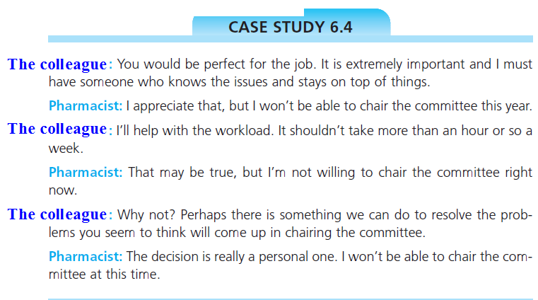

In this instance, the pharmacist calmly repeated his "no" response without despite the other pharmacist's efforts to coax him into changing his mind. If the pharmacist had chosen to do so, he might have given an explanation for his decision, but he is not "obliged" to do so.

The danger for passive people in giving an explanation is that they seem to believe that the others must agree that the decision is "justified" before they feel they have the right to say "no."
أي إن عملية تبرير قرارهم للآخرين وإقناعهم به (برفض الطلب مثلا) تكون لديهم أهم وأولى من حقهم باتخاذ قرار الرفض

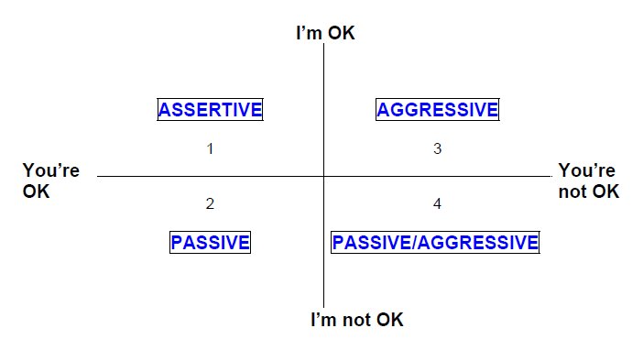Summary
Quadrant 1
If I am ok and you are ok, then I am being assertive. When you are being assertive, people like you and respect you because you accept others in spite of their faults. You will have confidence, self esteem even though you are not perfect.

Quadrant 2
If I am not OK, but you are OK, then I am being passive. When you are being passive, the other person may benefit. However, your viewpoint will be ignored, and people won’t respect you. This can then affect your performance at work.

Quadrant 3
If I am OK but you are not OK, then I am being aggressive. Aggressive people have a tendency to behave in a superior manner. They tend to dismiss people and thus, people do not trust them. Using aggressive behaviour leads to under performance in others in the longer term.

