**HOME WORK NO. 1**

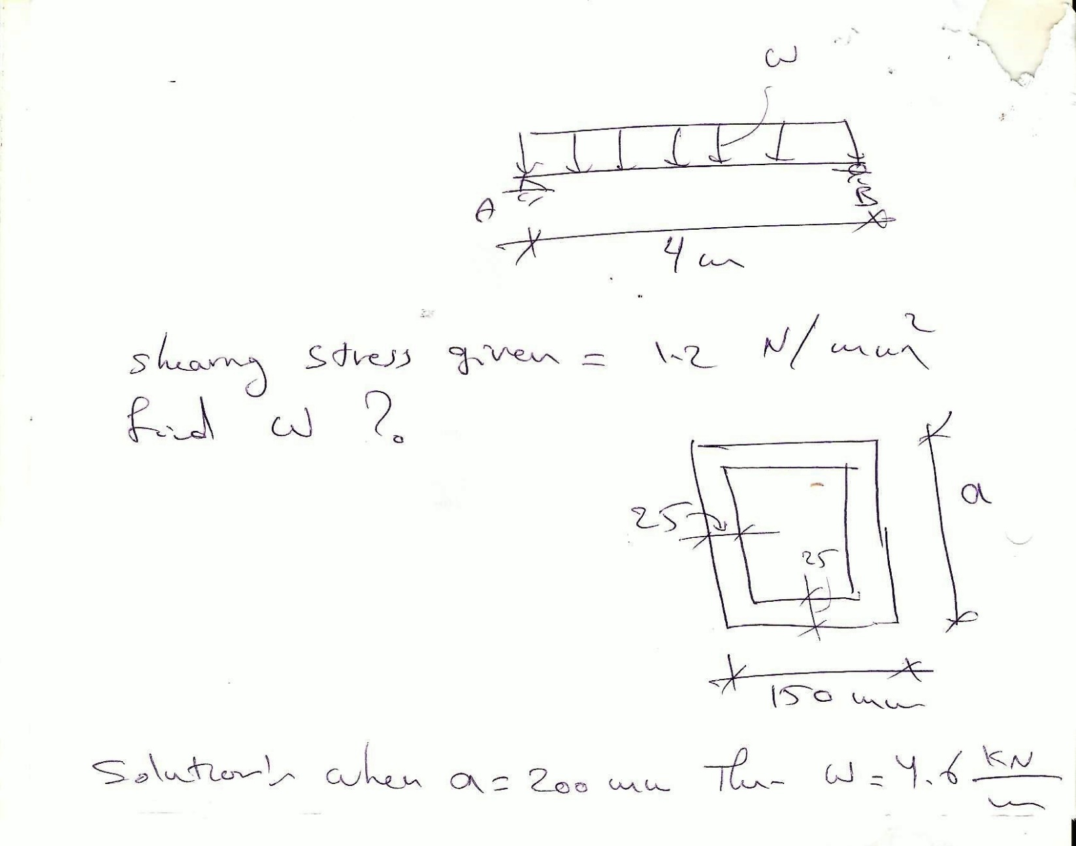

**HOME WORK NO. 2**

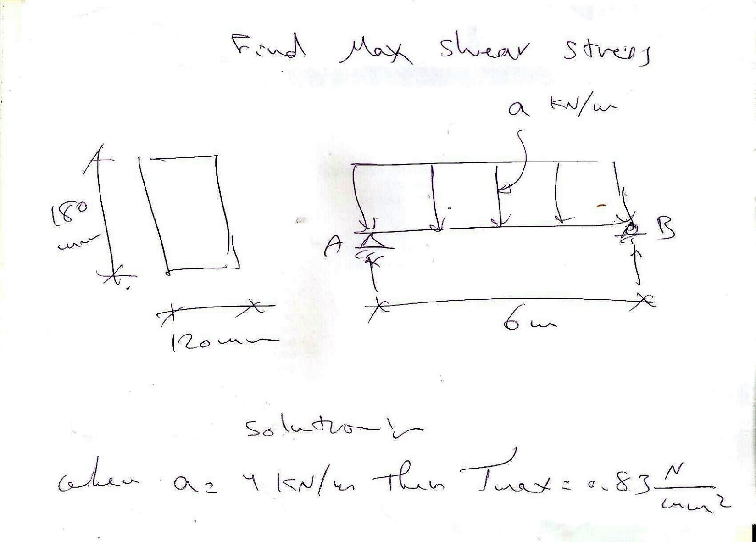

**HOME WORK NO. 3**

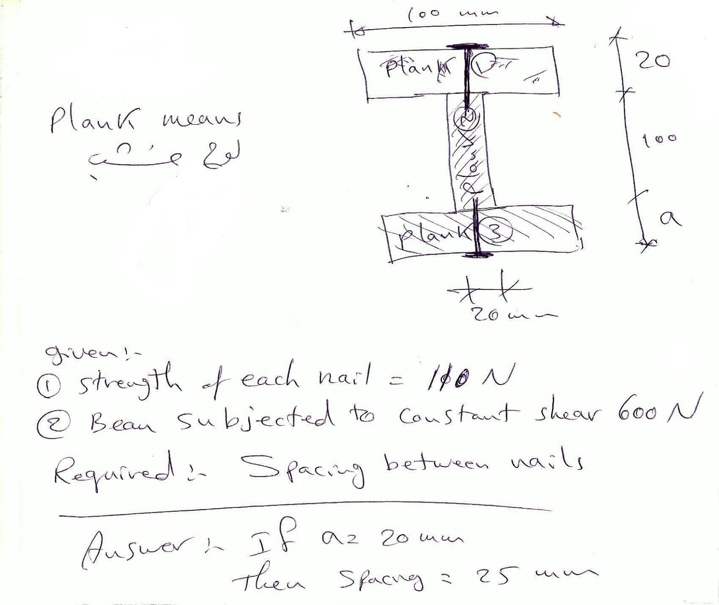

**HOME WORK NO. 4**

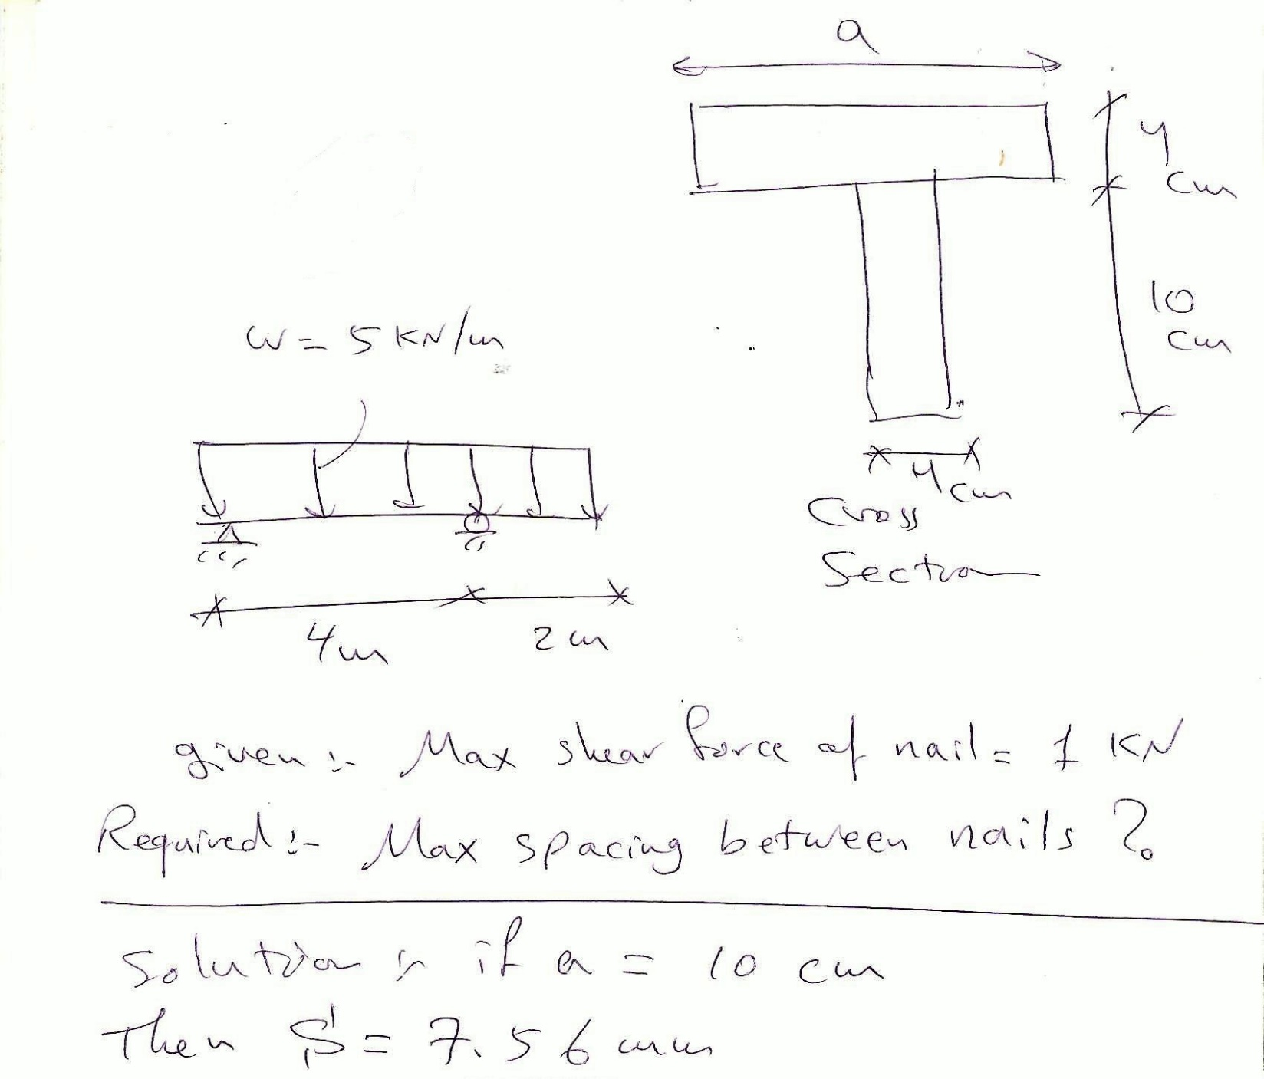

**HOME WORK NO. 5**

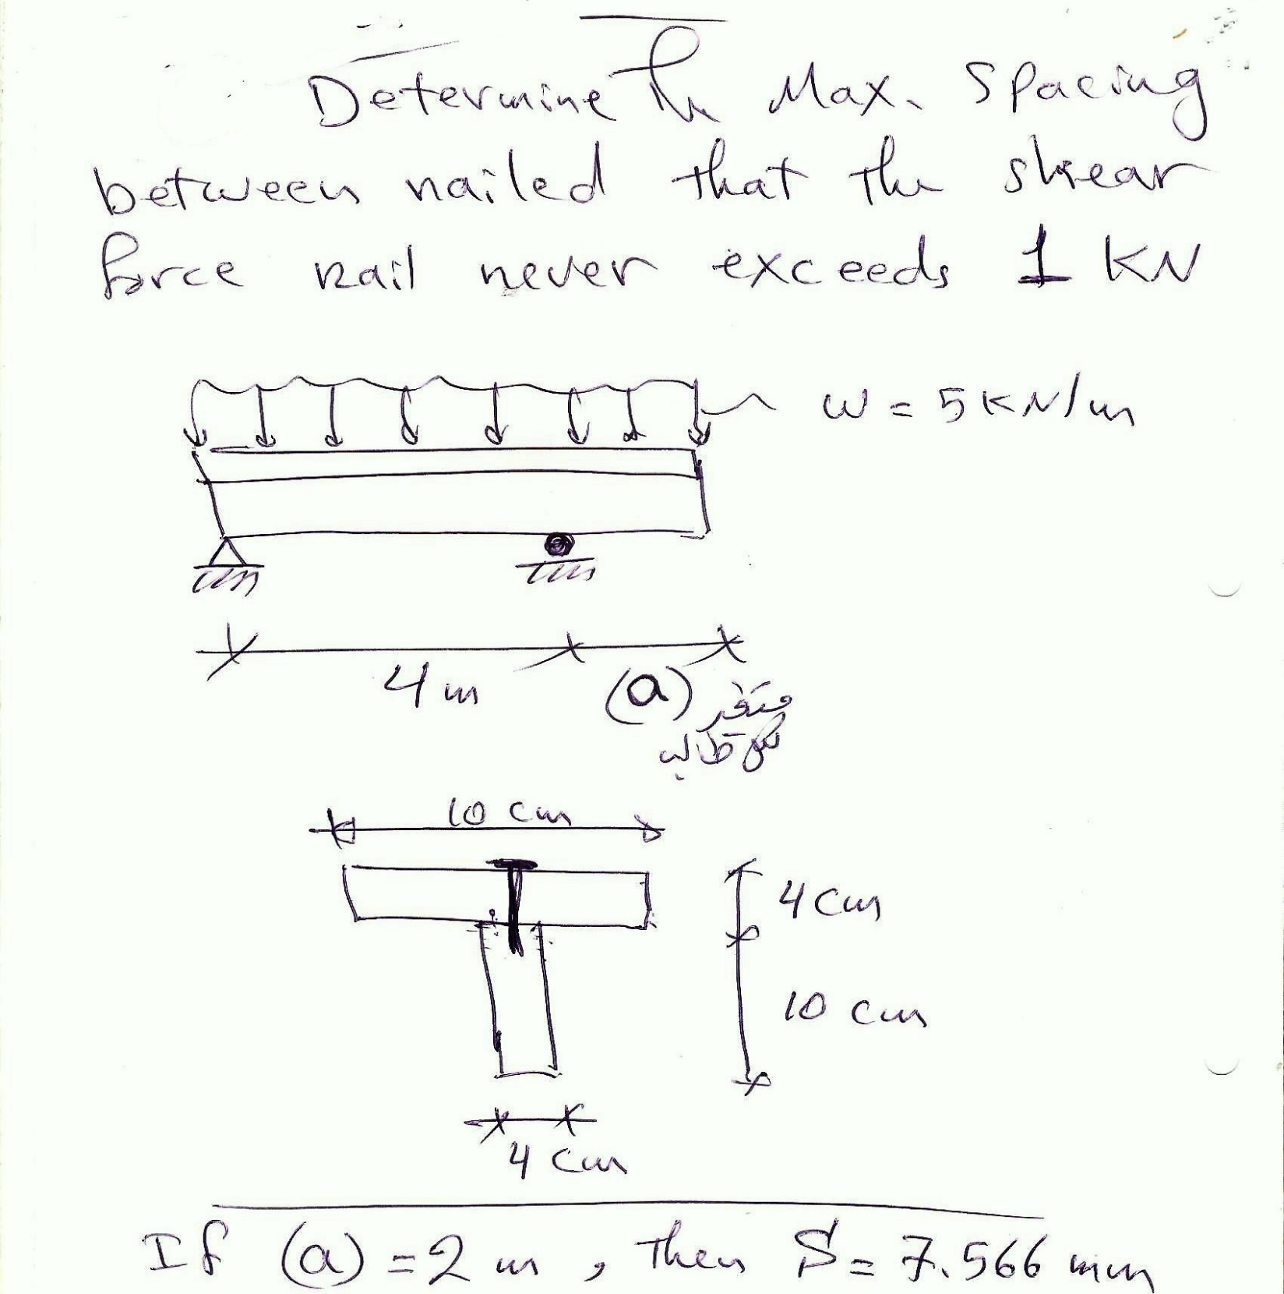

**HOME WORK NO. 6**

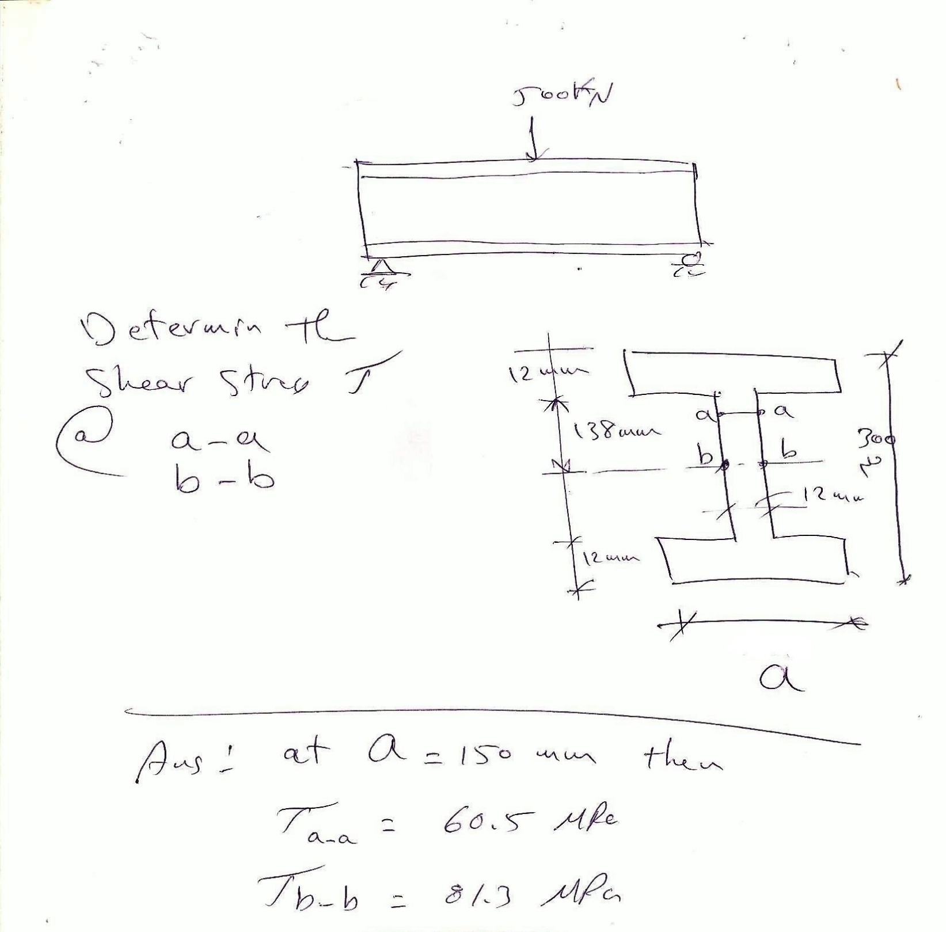

**HOME WORK NO. 7**

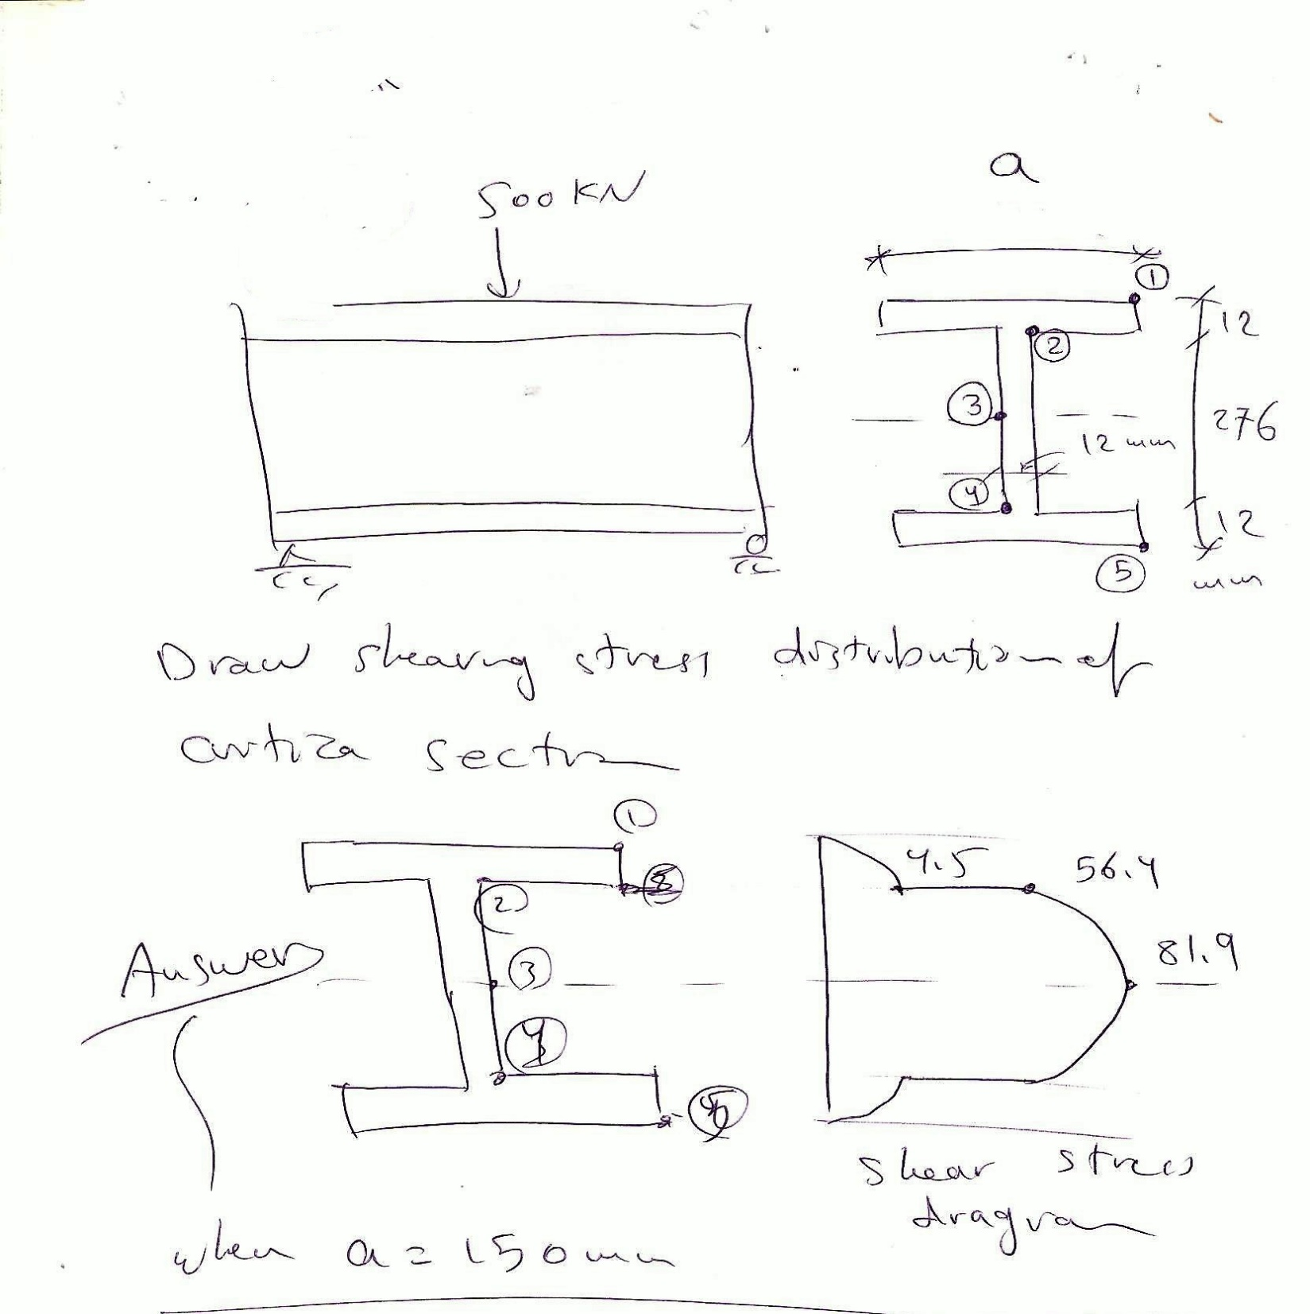

**HOME WORK NO. 8**

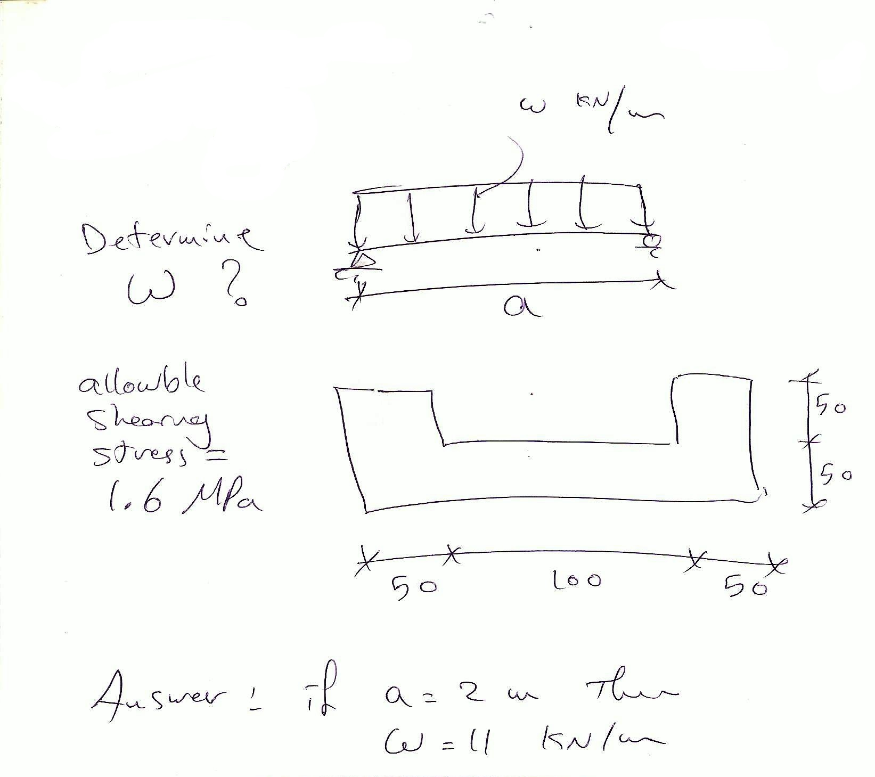

**HOME WORK NO. 9**

