Distillation
A chemical process where a mixture made of two or more liquids (called "components") with different boiling points can be separated from each other. The mixture is heated until one of the components boils (turns to a vapor). The vapor is then fed into a condenser, which cools the vapour and changes it back into a liquid that is called distillate'. What remains in the original container is called the "residue". A fractionating column (that is a distillation column with more than two outlets) can be used to improve the separation. An oil refinery uses fractional distillation to purify crude oil so that it can become useful and can be used for various things.
This has been used for a long time, to distil alcohol and produce distilled beverages. Distillation is a commonly used operation in many industries.
Distillation can be done anywhere, whether it's in a house or a laboratory, but in most countries it is illegal to distil alcohol without a license. Illegally distilled alcoholic drinks are called moonshine.^{[1]}
Sometimes the desalination of water is done by "distillation". This is a different process that separate a liquid (water) from solids (salts). Alcohol distillation or petroleum distillation is used to separate two or more liquids.

is a process of separating the component or substances from a liquid mixture by selective evaporation and condensation. Distillation may result in essentially complete separation (nearly pure components), or it may be a partial separation that increases the concentration of selected components of the mixture. In either case the process exploits differences in the volatility of the mixture's components. In industrial chemistry, distillation is a unit operation of practically universal importance, but it is a physical separation process and not a chemical reaction.
Commercially, distillation has many applications. For example:
- In the fossil fuel industry distillation is a major class of operation in obtaining materials from crude oil for fuels and for chemical feed stocks.
- Distillation permits separation of air into its components — notably oxygen, nitrogen, and argon — for industrial use.
- In the field of industrial chemistry, large ranges of crude liquid products of chemical synthesis are distilled to separate them, either from other products, or from impurities, or from unreacted starting materials.
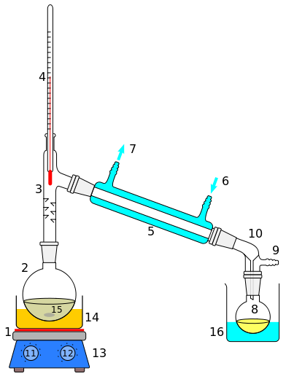
- Distillation of fermented products produces distilled beverages with a high alcohol content, or separates out other fermentation products of commercial value.

Laboratory display of distillation: 1: A source of heat 2: Still pot 3: Still head 4: Thermometer/Boiling point temperature 5: Condenser 6: Cooling water in 7: Cooling water out 8: Distillate/receiving flask 9: Vacuum/gas inlet 10: Still receiver 11: Heat control 12: Stirrer speed control 13: Stirrer/heat plate 14: Heating (Oil/sand) bath 15: Stirring means e.g. (shown), boiling chips or mechanical stirrer 16: Cooling bath.

Applications of distillation
The application of distillation can roughly be divided in four groups: laboratory scale, industrial distillation, distillation of herbs for perfumery and medicinals (herbal distillate), and food processing. The latter two are distinctively different from the former two in that in the processing of beverages and herbs, the distillation is not used as a true purification method but more to transfer all volatiles from the source materials to the distillate.
The main difference between laboratory scale distillation and industrial distillation is that laboratory scale distillation is often performed batch-wise, whereas industrial distillation often occurs continuously. In batch distillation, the composition of the source material, the vapors of the distilling compounds and the distillate change during the distillation. In batch distillation, a still is charged (supplied) with a batch of feed mixture, which is then separated into its component fractions which are collected sequentially from most volatile to less volatile, with the bottoms (remaining least or non-volatile fraction) removed at the end. The still can then be recharged and the process repeated.
In continuous distillation, the source materials, vapors, and distillate are kept at a constant composition by carefully replenishing the source material and removing fractions from both vapor and liquid in the system. This results in a better control of the separation process.

Batch distillation

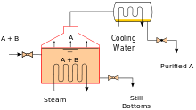
A batch still showing the separation of A and B.
Heating an ideal mixture of two volatile substances A and B (with A having the higher volatility, or lower boiling point) in a batch distillation setup (such as in an apparatus depicted in the opening figure) until the mixture is boiling results in a vapor above the liquid which contains a mixture of A and B. The ratio between A and B in the vapor will be different from the ratio in the liquid: the ratio in the liquid will be determined by how the original mixture was prepared, while the ratio in the vapor will be enriched in the more volatile compound, A (due to Raoult's Law, see above). The vapor goes through the condenser and is removed from the system. This in turn means that the ratio of compounds in the remaining liquid is now different from the initial ratio (i.e., more enriched in B than the starting liquid).
The result is that the ratio in the liquid mixture is changing, becoming richer in component B. This causes the boiling point of the mixture to rise, which in turn results in a rise in the temperature in the vapor, which results in a changing ratio of A : B in the gas phase (as distillation continues, there is an increasing proportion of B in the gas phase). This results in a slowly changing ratio A : B in the distillate.
If the difference in vapor pressure between the two components A and B is large (generally expressed as the difference in boiling points), the mixture in the beginning of the distillation is highly enriched in component A, and when component A has distilled off, the boiling liquid is enriched in component B.

Continuous distillation
Main article: Continuous distillation
Continuous distillation is an ongoing distillation in which a liquid mixture is continuously (without interruption) fed into the process and separated fractions are removed continuously as output streams occur over time during the operation. Continuous distillation produces a minimum of two output fractions, including at least one volatile distillate fraction, which has boiled and been separately captured as a vapor, and then condensed to a liquid. There is always a bottoms (or residue) fraction, which is the least volatile residue that has not been separately captured as a condensed vapor.
Continuous distillation differs from batch distillation in the respect that concentrations should not change over time. Continuous distillation can be run at a steady state for an arbitrary amount of time. For any source material of specific composition, the main variables that affect the purity of products in continuous distillation are the reflux ratio and the number of theoretical equilibrium stages, in practice determined by the number of trays or the height of packing. Reflux is a flow from the condenser back to the column, which generates a recycle that allows a better separation with a given number of trays. Equilibrium stages are ideal steps where compositions achieve vapor–liquid equilibrium, repeating the separation process and allowing better separation given a reflux ratio. A column with a high reflux ratio may have fewer stages, but it refluxes a large amount of liquid, giving a wide column with a large holdup. Conversely, a column with a low reflux ratio must have a large number of stages, thus requiring a taller column.

General improvements
Both batch and continuous distillations can be improved by making use of a fractionating column on top of the distillation flask. The column improves separation by providing a larger surface area for the vapor and condensate to come into contact. This helps it remain at equilibrium for as long as possible. The column can even consist of small subsystems ('trays' or 'dishes') which all contain an enriched, boiling liquid mixture, all with their own vapor–liquid equilibrium.

Industrial distillation
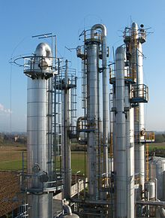
Typical industrial distillation towers
Large scale industrial distillation applications include both batch and continuous fractional, vacuum, azeotropic, extractive, and steam distillation. The most widely used industrial applications of continuous, steady-state fractional distillation are in petroleum refineries, petrochemical and chemical plants and natural gas processing plants.
To control and optimize such industrial distillation, a standardized laboratory method, ASTM D86, is established. This test method extends to the atmospheric distillation of petroleum products using a laboratory batch distillation unit to quantitatively determine the boiling range characteristics of petroleum products.
Industrial distillation^{[20][30]} is typically performed in large, vertical cylindrical columns known as distillation towers or distillation columns with diameters ranging from about 65 centimeters to 16 meters and heights ranging from about 6 meters to 90 meters or more. When the process feed has a diverse composition, as in distilling crude oil, liquid outlets at intervals up the column allow for the withdrawal of different fractions or products having different boiling points or boiling ranges. The "lightest" products (those with the lowest boiling point) exit from the top of the columns and the "heaviest" products (those with the highest boiling point) exit from the bottom of the column and are often called the bottoms.
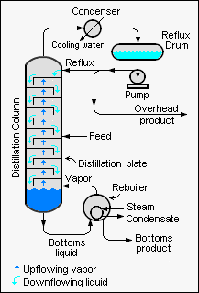
Diagram of a typical industrial distillation tower
Industrial towers use reflux to achieve a more complete separation of products. Reflux refers to the portion of the condensed overhead liquid product from a distillation or fractionation tower that is returned to the upper part of the tower as shown in the schematic diagram of a typical, large-scale industrial distillation tower. Inside the tower, the downflowing reflux liquid provides cooling and condensation of the upflowing vapors thereby increasing the efficiency of the distillation tower. The more reflux that is provided for a given number of theoretical plates, the better the tower's separation of lower boiling materials from higher boiling materials. Alternatively, the more reflux that is provided for a given desired separation, the fewer the number of theoretical plates required. Chemical engineers must choose what combination of reflux rate and number of plates is both economically and physically feasible for the products purified in the distillation column.
Such industrial fractionating towers are also used in cryogenic air separation, producing liquid oxygen, liquid nitrogen, and high purity argon. Distillation of chlorosilanes also enables the production of high-purity silicon for use as a semiconductor.
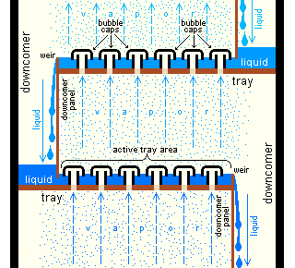
Section of an industrial distillation tower showing detail of trays with bubble caps
Design and operation of a distillation tower depends on the feed and desired products. Given a simple, binary component feed, analytical methods such as the McCabe–Thiele method^{[20][31]} or the Fenske equation^{[20]} can be used. For a multi-component feed, simulation models are used both for design and operation. Moreover, the efficiencies of the vapor–liquid contact devices (referred to as "plates" or "trays") used in distillation towers are typically lower than that of a theoretical 100% efficient equilibrium stage. Hence, a distillation tower needs more trays than the number of theoretical vapor–liquid equilibrium stages. A variety of models have been postulated to estimate tray efficiencies.
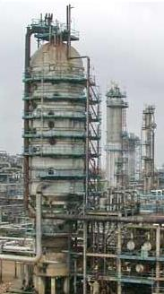
In modern industrial uses, a packing material is used in the column instead of trays when low pressure drops across the column are required. Other factors that favor packing are: vacuum systems, smaller diameter columns, corrosive systems, systems prone to foaming, systems requiring low liquid holdup, and batch distillation. Conversely, factors that favor plate columns are: presence of solids in feed, high liquid rates, large column diameters, complex columns, columns with wide feed composition variation, columns with a chemical reaction, absorption columns, columns limited by foundation weight tolerance, low liquid rate, large turn-down ratio and those processes subject to process surges.

Large-scale, industrial vacuum distillation column

