1.2.2 Types of Attacks
Al-Mustanseriya University Class: Third Year
Engineering College Subject: Ciphering & Data Security
Computer and Software Engineering Dep. Lecture -2-

Passive Attacks
Passive attacks are in the nature of eavesdropping on, or monitoring of, transmissions. The goal of the opponent is to obtain information that is being transmitted. Two types of passive attacks are release of message contents and traffic analysis.
The release of message contents is easily understood (Figure 1.3a). A telephone conversation, an electronic mail message, and a transferred file may contain sensitive or confidential information. We would like to prevent an opponent from learning the contents of these transmissions.
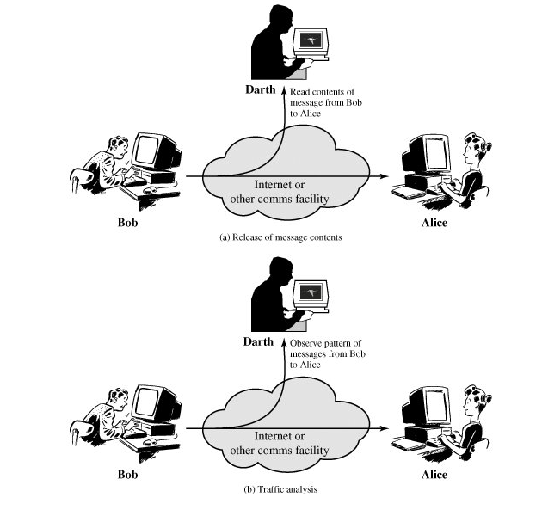

Figure 1-3. Passive Attacks

A second type of passive attack, traffic analysis, is subtler (Figure 1.3b). Suppose that we had a way of masking the contents of messages or other information traffic so that opponents, even if they captured the message, could not extract the information from the message. The common technique for masking contents is encryption. If we had encryption protection in place, an opponent might still be able to observe the pattern of these messages. The opponent could determine the location and identity of communicating hosts and could observe the frequency and length of messages being exchanged. This information might be useful in guessing the nature of the communication that was taking place.
Passive attacks are very difficult to detect because they do not involve any alteration of the data. Typically, the message traffic is sent and received in an apparently normal fashion and neither the sender nor receiver is aware that a third party has read the messages or observed the traffic pattern. However, it is feasible to prevent the success of these attacks, usually by means of encryption. Thus, the emphasis in dealing with passive attacks is on prevention rather than detection.

Active Attacks
Active attacks involve some modification of the data stream or the creation of a false stream and can be subdivided into four categories: masquerade, replay, modification of messages, and denial of service.
A masquerade takes place when one entity pretends to be a different entity (Figure 1.4a). A masquerade attack usually includes one of the other forms of active attack. For example, authentication sequences can be captured and replayed after a valid authentication sequence has taken place, thus enabling an authorized entity with few privileges to obtain extra privileges by impersonating an entity that has those privileges.
Replay involves the passive capture of a data unit and its subsequent retransmission to produce an unauthorized effect (Figure 1.4b).
Modification of messages simply means that some portion of a legitimate message is altered, or that messages are delayed or reordered, to produce an unauthorized effect (Figure 1.4c). For example, a message meaning "Allow John Smith to read confidential file accounts" is modified to mean "Allow Fred Brown to read confidential file accounts."

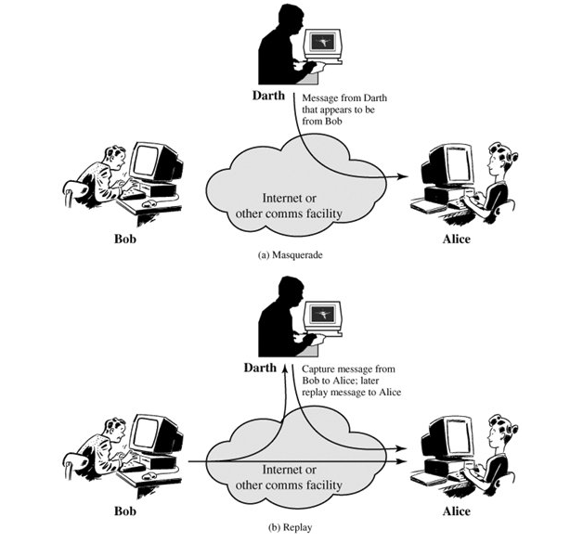

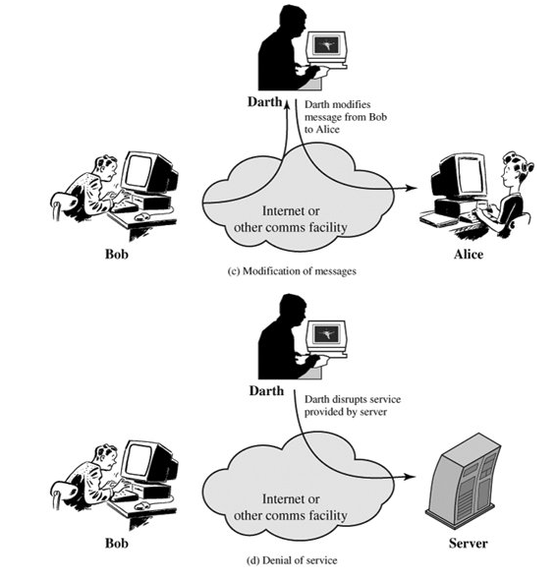

Figure 1-4. Active Attacks

The denial of service prevents or inhibits the normal use or management of communications facilities (Figure 1.4d). This attack may have a specific target; for example, an entity may suppress all messages directed to a particular destination (e.g., the security audit service). Another form of service denial is the disruption of an entire network, either by disabling the network or by overloading it with messages so as to degrade performance.
Active attacks present the opposite characteristics of passive attacks. Whereas passive attacks are difficult to detect, measures are available to prevent their success. On the other hand, it is quite difficult to prevent active attacks absolutely, because of the wide variety of potential physical, software, and network vulnerabilities. Instead, the goal is to detect active attacks and to recover from any disruption or delays caused by them. If the detection has a deterrent effect, it may also contribute to prevention.

1.3 Security Services

Authentication
The authentication service is concerned with assuring that a communication is authentic. In the case of a single message, such as a warning or alarm signal, the function of the authentication service is to assure the recipient that the message is from the source that it claims to be from. In the case of an ongoing interaction, such as the connection of a terminal to a host, two aspects are involved. First, at the time of connection initiation, the service assures that the two entities are authentic, that is, that each is the entity that it claims to be. Second, the service must assure that the connection is not interfered with in such a way that a third party can masquerade as one of the two legitimate parties for the purposes of unauthorized transmission or reception.
Two specific authentication services are:
- Peer entity authentication: Provides for the corroboration of the identity of a peer entity in an association. It is provided for use at the establishment of, or at times during the data transfer phase of, a connection. It attempts to provide confidence that an entity is not performing either a masquerade or an unauthorized replay of a previous connection.
- Data origin authentication: Provides for the corroboration of the source of a data unit. It does not provide protection against the duplication or modification of data units. This type of service supports applications like electronic mail where there are no prior interactions between the communicating entities.

Access Control
In the context of network security, access control is the ability to limit and control the access to host systems and applications via communications links. To achieve this, each entity trying to gain access must first be identified, or authenticated, so that access rights can be tailored to the individual.

Data Confidentiality
Confidentiality is the protection of transmitted data from passive attacks. With respect to the content of a data transmission, several levels of protection can be identified. The broadest service protects all user data transmitted between two users over a period of time. For example, when a TCP connection is set up between two systems, this broad protection prevents the release of any user data transmitted over the TCP connection. Narrower forms of this service can also be defined, including the protection of a single message or even specific fields within a message. These refinements are less useful than the broad approach and may even be more complex and expensive to implement.
The other aspect of confidentiality is the protection of traffic flow from analysis. This requires that an attacker not be able to observe the source and destination, frequency, length, or other characteristics of the traffic on a communications facility.

Data Integrity
As with confidentiality, integrity can apply to a stream of messages, a single message, or selected fields within a message. Again, the most useful and straightforward approach is total stream protection.
A connection-oriented integrity service, one that deals with a stream of messages, assures that messages are received as sent, with no duplication, insertion, modification, reordering, or replays. The destruction of data is also covered under this service. Thus, the connection-oriented integrity service addresses both message stream modification and denial of service. On the other hand, a connectionless integrity service, one that deals with individual messages without regard to any larger context, generally provides protection against message modification only.
We can make a distinction between the service with and without recovery. Because the integrity service relates to active attacks, we are concerned with detection rather than prevention. If a violation of integrity is detected, then the service may simply report this violation, and some other portion of software or human intervention is required to recover from the violation. Alternatively, there are mechanisms available to recover from the loss of integrity of data, as we will review subsequently. The incorporation of automated recovery mechanisms is, in general, the more attractive alternative.

Nonrepudiation
Nonrepudiation prevents either sender or receiver from denying a transmitted message. Thus, when a message is sent, the receiver can prove that the alleged sender in fact sent the message. Similarly, when a message is received, the sender can prove that the alleged receiver in fact received the message.

Availability Service
Availability is the property of a system or a system resource being accessible and usable upon demand by an authorized system entity, according to performance specifications for the system (i.e., a system is available if it provides services according to the system design whenever users request them). A variety of attacks can result in the loss of or reduction in availability. Some of these attacks are amenable to automated countermeasures, such as authentication and encryption, whereas others require some sort of physical action to prevent or recover from loss of availability of elements of a distributed system.
An availability service is one that protects a system to ensure its availability. This service addresses the security concerns raised by denial-of-service attacks. It depends on proper management and control of system resources and thus depends on access control service and other security services.

