Phase Change and Applications
Chapter One
Introduction
1.1 The importance of phase change processes:
Matter exists in nature in three distinct phases namely; solid, liquid and gaseous. The change of phase between these states is accompanied by transfer of considerable amount of heat called (latent heat). The change of phase also occurs at an approximately constant temperature. Processes involving change of phase have found a large number of applications in engineering a technology. The major applications can be listed as follows:-
a- Refrigeration:- this application adopts the change of phase between liquid and gaseous phase. If certain liquids (refrigerants) with low evaporation temperature (below water freezing point at atmospheric pressure = 0ºC) are left to vaporize or boils at its boiling point, it extracts the heat required for the change of phase from any neighboring region causing its temperature to drop towards the boiling point of the refrigerant. The neighboring region could be the freezer of a domestic refrigerator or the air passing across cooling coil in air conditioning system.
b- Air Conditioning:- most air conditioning systems depend on refrigeration cycles to cool the air that is propelled to the air conditioned spaces. Furthermore, the phase change of water – carried by air – between its liquid and gaseous states, plays important role in some air conditioning processes like humidification and evaporative cooling. The science that deals with the properties of air-water mixture and the processes related to that is called (psychrometry).
c- Distillation:- it is an important process in many scientific and industrial applications. Distillation means the separation of a liquid from a mixture of several liquids or pollutants having higher boiling points by evaporating this liquid and re-condensing it in another container. The condensed liquid will be pure from unwanted pollutants. Distillation is used in desalinating sea water, in oil refineries and many food industries.
d- Thermal Storage:- storing surplus heat in materials undergoing change of phase is the most effective means of thermal storage. It is generally adopted between solid and liquid states. All materials absorb considerable amount of heat in melting and release is during solidification.
e- Boiling:- boiling occurs inside the boilers of power plants, industrial boilers, refrigeration evaporators and emergency cooling systems inside nuclear reactors.
f- Condensation:- condensation is encountered in power plants condensers, distillations systems and refrigeration condensers.
1.2 Sensible and Latent heat:
The sensible heat is the energy transferred between two mediums or bodies of different temperatures. Or it can be defined as the heat transferred to a body causing an increase in its temperature.
The latent heat is the energy transferred to a medium causing a change in its phase rather than an increase in temperature. That is why it is called "latent" or internal. Latent heat can reverse its direction when the phase is returned to its initial phase before the transfer of heat. As an example of latent heat interaction is the melting of wax. When heat is transferred to a solid wax its temperature starts to increase. Sensible heat is transferred to the wax at this stage. The temperature keeps increasing until reaching the melting point. The wax temperature remains approximately constant at the melting point any heat transferred to wax at this stage is latent causing it to melt. When wax is left to cool down the heat reverses its direction and transfers out of the wax to the environment and the wax re-solidifies.
Ex. 1.1: a cup contains 100 g of water at 25ºC. If an ice cube of 10 g at -6ºC is added to water and left to melt completely then calculate:-
a) Sensible heat in Joules.
b) Latent heat in Joules.
c) Water temperature at the end of melting.
Assume negligible thermal losses to the environment.
( Latent heat of ice melting q_{L} = 334 kJ/kg , Ice specific heat C_{p,ice (-6 C)} = 2.027 kJ/kg )
( C_{pw} = 4.178 kJ/kg ºC )

Sol.
Q_{S,ice} = m_{ice} C_{p,ice} (T₁ – T₂) = 0.01 * 2.027 * 6 = 0.12162 kJ
Q_{L} = m_{ice} q_{L} = 0.01*334 = 3.34 kJ
Q_{total,ice} = 3.34 + 0.12162 = 3.46162 kJ = Q_{S,water}
Q_{S,water} = m_{water} C_{pw} (T₁ – T₂)
3.46162 = 0.1 * 4.178 * ( 25 – T₂ )
T₂ = 16.714 ºC ( temperature of the liquid 100 g water)
T_{2,final} = (100/110)*(16.714+273) + (10/110)*(0+273)
T_{2,final} = 288.194 K = 15.194 ºC

Ex. 1.2: Compare the amounts of latent and sensible heat required to convert one kg of ice at -20 ºC to superheated vapor at 120 ºC. What is the time required for that if an electric heater of 3000 W is employed?
Sol.
Q_{S,ice} = m C_{p,ice} ( T₂ – T₁ ) = 1 * 1.943 * 20 = 38.86 kJ
Q_{Solid,L} = m q_{L} = 1*334 = 334 kJ
Q_{S,water} = m C_{pw} ( T₂ – T₁ ) = 1 * 4.178 * 100 = 417.8 kJ
Q_{Vapor,L} = m h_{fg} = 1 * 2258.02 = 2258.02 kJ
Q_{S,vapor} = m C_{p,vapor} ( T₂ – T₁ ) = m ( h₂ – h₁ ) = 1 ( 2716.6 – 2676.2 ) = 40.4 kJ
Q_{total} = Q_{S,ice} + Q_{Solid,L} + Q_{S,water} + Q_{Vapor,L} + Q_{S,vapor} = 3089.08 kJ
Q_{total} = Power * time
3089.08 = 3 * time
Time = 1029 sec = 17 minutes

1.3 Some Important Definitions:
Quality (x): It is defined as the ratio of vapor mass to the total mass in a certain volume of vapor-liquid mixture. Therefore when x=1 then the volume entirely contains vapor.
$$x=\frac{m_{vapor}}{m_{vapor}+m_{liquid}}$$
Moisture content (MC): It is defined as the ratio of liquid mass to the total mass is a certain volume of vapor-liquid mixture, therefore:-
$$MC=1-x$$
Void fraction (α): It is defined as the ratio of the volume occupied by a vapor or gas to the total volume of the mixture under consideration. Its definition is valid not only for single substance materials (like quality) but also for heterogeneous mixtures of several constituents like water and air.
$$α=\frac{V_{vapor}}{V_{vapor}+V_{liquid}}$$
Relative Humidity (Φ): It is defined as the ratio of the mole fraction of water vapor in moist air to mole fraction of water vapor in saturated air at the same temperature and pressure. From perfect gas relationships another expression for Φ is:
$$Φ=\frac{existing partial pressure of water vapor}{saturation pressure of pure water at same temperature}$$
Humidity Ratio (W): It is defined as the mass of water interspersed in each kilogram of dry air. If perfect gas relation (PV=MRT) is used then the following definition appears if ( R_{air}=287 J/kg K and R_{water vapor}=461.5 J/kg K):
$$W=0.622\frac{P_{s}}{P_{atm}-P_{s}}$$
Melting Ratio (MR): It is defined as the ratio of the liquid mass that is melted to the total mass of the liquid-solid mixture occupying a certain volume.
$$MR=\frac{m_{liquid}}{m_{liquid}+m_{solid}}$$

1.4 Phase Diagrams:
Phase diagrams are important plots that represent the relation between the three phases for a certain material. The plot is constructed between temperature and pressure at certain specific volume which passes through the critical point.
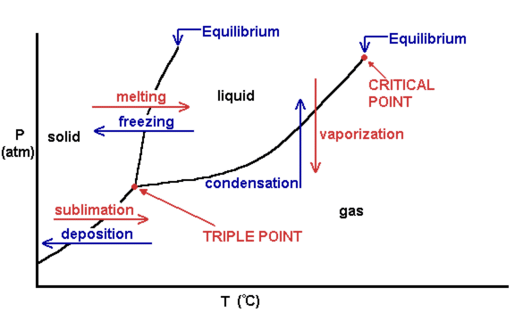
Fig. (1.1): Phase change diagram of a material that contracts on freezing.

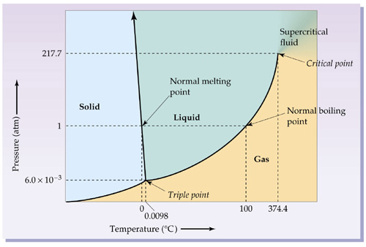
Fig. (1.2): Phase change diagram of a material that expands on freezing (water).
Ex. 1.3: A mixture of steam-water at a pressure of 200 kPa enters a heat exchanger at 0.85 quality and leaves at 0.65 quality. If the condenser tube is surrounded by 20kg of solid paraffin wax at 40 ºC then find the wax melting ratio after 1 minutes if water mass flow rate is 0.07 kg/s and the wax melting temperature is 50 ºC. How long will it take for the wax to melt completely for the same water conditions? Use the following data:- [ h_{fu,wax}=150 kJ/kg, c_{ps,wax}=2.15 kJ/kg ºC ].
Sol.
Q_{water}=mh_{fg}(x₁ – x₂)=0.07*2201.9*.2=30.8266 kW
Q_{water,60 sec}=30.8266*60=1849.596 kJ
Q_{wax}=Q_{sen}+Q_{lat}
Q_{sen}=M*c_{ps,wax}*(T₂ – T₁) = 20 * 2.15 * 10 = 430 kJ
Q_{left} = 1849.596 – 430 = 1419.596 kJ
Q_{lat} = M_{wax} * h_{fu,wax} = 20 * 150 = 3000 kJ
MR = Q_{left} / Q_{lat} = 1419.596 / 3000 =0.4732
time₂ = ( 3000 – 1419.596 ) / 30.8266 = 51.26 sec
So the total time = 60 + 51.26 = 111.26 sec

