The momentum equation
It is defined as the product of the mass and the velocity of a moving body. Thus since velocity is vector quantity , the momentum of a body changes if either the magnitude or direction of its velocity changes. A net force must be applied to a body to change its momentum. This momentum principle can also be applied to a fluid moving through an arbitrary passageway, as shown in fig.1
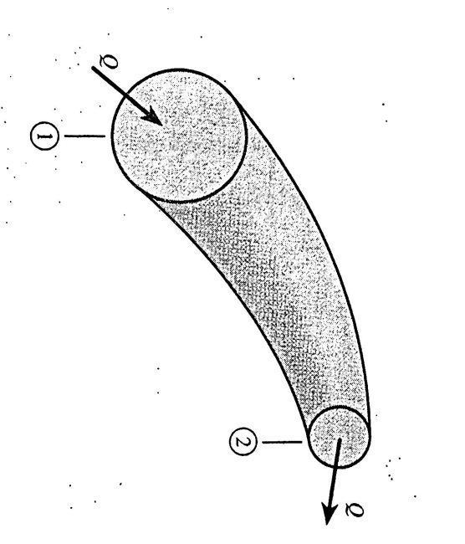
Fig.1
The mass m of fluid within the passageway is equal to the product of the mass flow rate ǷQ and the time interval Δt:
m= (ǷQ) Δt
F=m*a=(ǷQ) Δt*a
F=(ǷQ) Δt*$\frac{∆v}{∆t}$
F=ǷQ(v2-v1)
F_{x}=ǷQ(v_{2x}-v_{1x})
F_{y}=ǷQ(v_{2y}-v_{1y})
F_{z}=ǷQ(v_{2z}-v_{1z})
In fig.2, a free jet of fluid of cross section area A enters a fixed turning vane, since the direction of the jet velocity is changed, the jet exerts a force F on the van and the van is held in place via a support mechanism that allows the van to exert an equal force but opposite on the jet.
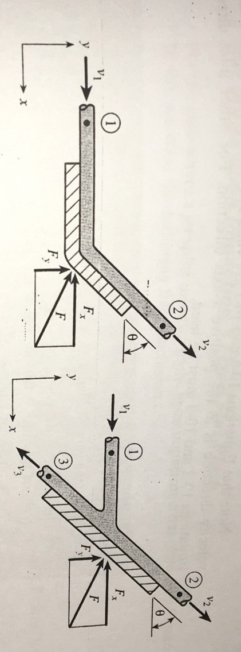
Fig.2
To obtain x and y components of force F :
F_{x}=ǷQ(v_{2x}-v_{1x})= ǷQ(v cos ϴ-v)
F_{x}= - ǷQv (1-cos ϴ)
F_{y}=ǷQ(v_{2y}-v_{1y})= ǷQ(v sin ϴ-0)
F=$\sqrt{F _{X} ^{2 _{ }}+F _{Y} ^{2}}$

Examples:
Ex1: for the turning vane of fig.2, the following data are given: Jet velocity=10m/s, volume of flow=0.05m³/s, ϴ=45◦. Find the total force acting on the vane?
F_{x}= - ǷQv (1-cos ϴ)
=-1000*0.05*10(1-cos 45)= -147 N
F_{y}= ǷQ(v sin ϴ)
1000*0.05*10 sin 45=354 N
F=$\sqrt{F _{X} ^{2 _{ }}+F _{Y} ^{2}}$= 383 N.

Ex2:
For the system in fig.3, a jet of oil Sg=0.9, flows at a rate of 100 gpm from a horizontal nozzle having a 1 in dia., if the plate is inclined from the horizontal by an angle 45, fine the total force acting on the plate and floe rate up and down the surface of the plate?
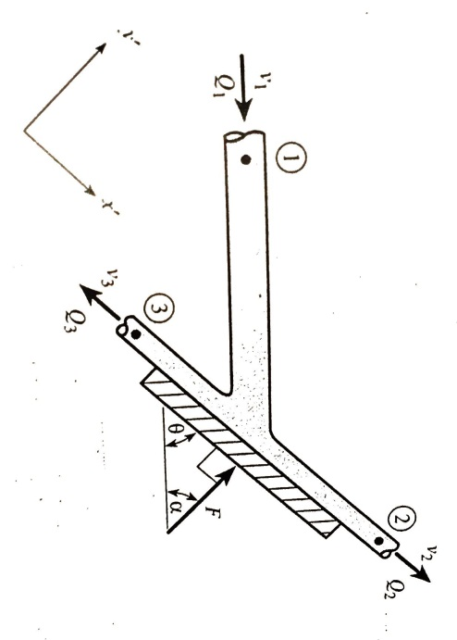
Fig.3
F= ǷQ(v sin ϴ)
Ƿ=Ƿwater* Sg oil=1.49 slugs/ft³*0.9=1.75 slugs/ft³
V=Q1/A1=$\frac{100*231*1*1}{\frac{π}{4}*1*1728*60}$
V=$\frac{0.223}{0.00545}$= 40.9 ft/s
F=1.75*0.223*40.9*sin 45=11.3lb
B:
Q2=$\frac{1+\cos{45}}{2}Q1$=85.4 gpm
Q3=$\frac{1-\cos{45 }}{2}*Q1$=14.6 gpm

Flows through bends and nozzles in pipeline:
Fig.4, shows a pipeline containing a reducer type bend , here there is a change in velocity direction and magnitude due to reduction in pipe diameter, and tere is a change in pressure, from fig4,:
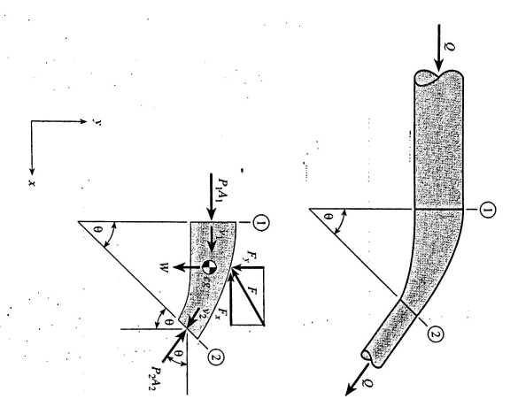
fig.4

P1A1- P2A2 cos ϴ -Fx =ǷQ(v2cos ϴ- v1)
P1A1 sin ϴ- W –Fy= ǷQ(-v2sin ϴ)

Ex3:A nozzle with an exit diameter of 1 in is attached to the end of 4 in dia. Horizontal pipi. (fig.5) water flows through the pipe and nozzle at a flow rate of 200 gpm, if the nozzle jet exits into the atmosphere , find the force exerted on the nozzle due to the water on the inside and the atmosphere air on the outside?
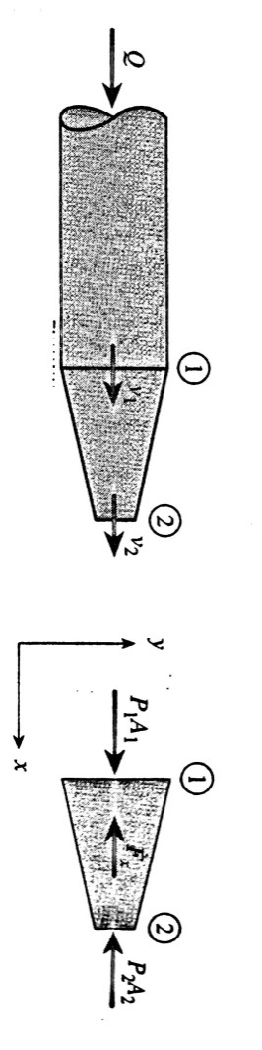
Fig.5
P1A1-P2A2-Fx=ǷQ(v2-v1)
Q1=Q2=200*231*$\frac{1}{1728}$ $\frac{1}{60}$=0.446 ft³/s
V1=Q1/A1=$\frac{0.446}{π/4(\frac{4}{12}) ^{2}}$=5.11 ft/s
V2=Q2/A2=$\frac{0.446}{π/4(\frac{1}{12}) ^{2}}$=81.8 ft/s
To find P1 Z₁+$\frac{v _{1} ^{2}}{2g}+\frac{P _{1}}{γ}$ = Z₂ +$\frac{v{ _{2}}^{2}}{2g}+\frac{P _{2}}{γ}$
0+$\frac{5.11 ^{2}}{2*32.2}+\frac{P _{1}}{62.4}$ = 0+$\frac{81.8}{232.2}+0$
P1=6460 lb/ft²
P1 in momentum equation: 6460*$\frac{π}{4}(\frac{4}{12}) ^{2}$-0-Fx=1.94 *0.446*(81.8-5.11)
Fx=431 lb
Ex4: Oil (Sg=0.9) flows at rate of 0.05 m³/s through 100 mm dia (fig.5). horizontal 90 elbow connected in a pipeline as shown in fig.6 , if the pressure at sec. 1 is 200 kpa gage, find the fluid force acting on the elbow?
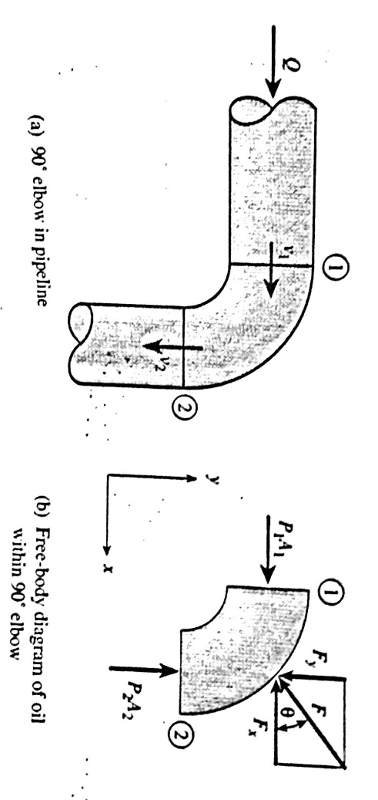
Fig.6
P1A1-Fx=ǷQ(0-v1)=-ǷQv1
P2A2-Fy=ǷQ(-v2-0)=-ǷQv2
V1=v2=Q/A=$\frac{0.05}{\frac{π}{4}*0.1}$=6.37 m/s
Z₁+$\frac{v _{1} ^{2}}{2g}+\frac{P _{1}}{γ}$ = Z₂ +$\frac{v{ _{2}}^{2}}{2g}+\frac{P _{2}}{γ}$
Then 200000 *π/4-Fx= -1000*0.05*6.37
1570 –Fx=- 319 Fx=1889 N
1570-Fy=-319N Fy= 1889 N
F=$\sqrt{1889 _{ } ^{2 _{ }}+1889 ^{2}}$= 2671 N.

