Series, parallel and network pipe system
The two basic categories of fluid piping system are series and parallel.
Series pipe system:
In series pipe system (fig.1), there is only one path of fluid to take from the beginning to the end. Thus the flow rates through all components are equal and the total pressure drop across the entire system equals the summation of pressure drops across each component.

Fig.1
The total head loss across the system can be as follows:
H_{L tot.}$=∑f\frac{L}{D}\frac{v ^{2}}{2g}+\sum{K\frac{v ^{2}}{2g}}$
Q_{T} = Q1= Q2=Q3---
Three different types of problems are involved in series piping system:
1-For a given flow rate and pipe dia., determine the pressure drop.
2-For a given pressure drop across any component and given pipe dia., determine the flow rate.
3-For a given flow rate and given pressure drop, determine the pipe dia.
Parallel pipe system:
In parallel pipe system (fig.2), the fluid has more than one path to take, the total flow entering a junction equals the sum of the branch flows leaving the junction. Thus the continuity equation becomes:
Q_{T =} Q₁ + Q₂
_{Δ}P1=ΔP2 =P_{in} + P_{out}
Fig.2
Pipes Network (Hardy-Cross method):
This method consist of assuming a distribution of flow in network in such a way that principle of continuity is satisfied at each junction. A correction to these assumed flow is then computed successively for each pipe loop in the network until the correction is reduced to an acceptable value.
Correction factor is :
ΔQ =$\frac{-\sum{hf}}{1.85(\sum{hf/Q)}}$
˂ 0.2 m³/min or $± 3 l/s$

Examples
Example 1: Water (ν= 1.1*10⁻⁵ ft²/s) is pumped from one tank to another at rate 0.25 ft³/s, the pipe has a length of 300 ft and dia.2 in, if the pump has an efficiency of 80%, find the horsepower that must be delivered by an electric motor to drive the pump?
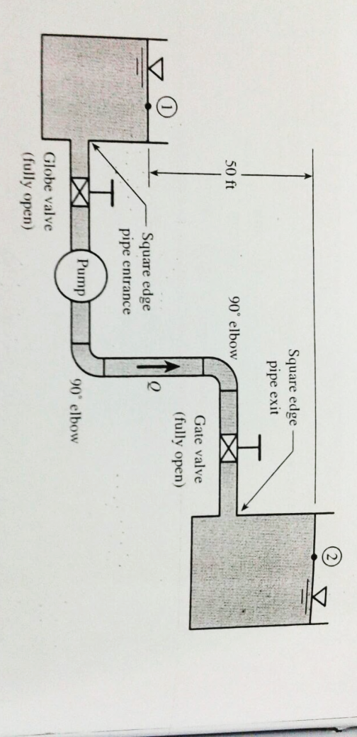
Fig.3

Energy eq. between 1 –2
Z₁+$\frac{v _{1} ^{2}}{2g}+\frac{P _{1}}{γ}$ ₊ Hp - $f\frac{L}{D}\frac{v^{2}}{2g}+K _{L}\frac{v ^{2}}{2g}$ = Z₂ +$\frac{v{ _{2}}^{2}}{2g}+\frac{P _{2}}{γ}$
Z₁+$\frac{v _{1} ^{2}}{2g}+\frac{P _{1}}{γ}$ ₊ Hp - $H _{L}$ = Z₂ +$\frac{v{ _{2}}^{2}}{2g}+\frac{P _{2}}{γ}$
P1=P2=0
V1=V2=0
H_{p}=(Z₂-Z₁)+H_{L}
H_{L}=$∑f\frac{L}{D}\frac{v ^{2}}{2g}+\sum{K\frac{v ^{2}}{2g}}$
H_{p}=(Z₂-Z₁)+ $∑f\frac{L}{D}\frac{v ^{2}}{2g}+\sum{K\frac{v ^{2}}{2g}}$
V=$\frac{Q}{A}$ =$\frac{0.25}{\frac{π}{4}(\frac{2}{12 }) ^{2}}$=11.5 ft/s
R_{e}= $\frac{v D}{ν}$ =$\frac{11.5*2/12}{1.1*10 ^{-5}}$ = 1.74*10⁵
The flow is turbulent table , ε= 0.00085 and the relative roughness is
$\frac{ε}{D}$= $\frac{0.00085}{2/12}$ = 0.0051
From moody diagram f=0.031
Then ∑K=0.5+10+(2*0.75)+0.91+1=13.19
H_{p}=50 + $\left(0.031\frac{300}{\frac{2}{12}}+ 13.19\right)*\frac{11.5 ^{2}}{2*32.2}$ = 191 ft
H_{p} =$\frac{γ H Q}{550}=\frac{62.4*0.25*191}{550}$ = 5.42 hp HP= $\frac{5.42}{0.8}$= 6.77 hp
Example 2: Determine the flow rate of water from the large reservoir (fig.4), ν= 1.21*10⁻⁵ ft²/s, pipe long = 75 ft and dia.= 2 in, ε=0.00085 ft?
Fig.4
Z₁+$\frac{v _{1} ^{2}}{2g}+\frac{P _{1}}{γ}$ ₋₋HL = Z₂ +$\frac{v{ _{2}}^{2}}{2g}+\frac{P _{2}}{γ}$
P1=P2=0 , v1=0
H_{L}=$∑f\frac{L}{D}\frac{v ^{2}}{2g}+\sum{K\frac{v ^{2}}{2g}}$
∑K= 0.5+2(0.75)+10=12
H_{L}+$\frac{v ^{2}}{2g}$ + (Z₂-Z₁) =0
f($\frac{L}{D}$ +∑K+1)$\frac{v ^{2}}{2g}$ +(Z₂-Z₁)=0
(f$\frac{75}{2/12}$ +12+1) $\frac{v ^{2}}{2*32.2}$ -50=0
(450 f +13) v² -3220=0
V=$\sqrt{\frac{3220}{450 f+13}}$
Assume f=0.03 thus v=11ft/s
R_{e}=$\frac{VD}{v}$ =1.52*10⁵
$\frac{ε}{D}$ = 0.00085/(2/12) =0.0051 so f= 0.03 (correct )
V=10.2 ft/s, R=1.41*10⁵, f=0.03, v=11ft/s, Re=1.52*10⁵
Q=Av= $\frac{π}{4}$($\frac{2 ^{ }}{12}) ^{2}$ *11= 0.24 ft³/s

Example3:
Lubricating oil enters junction A @ flow rate 100 gpm, (γ=57 lb/ft³, ν=1*10⁻³ ft/s). The loss coefficient K of each branch is 10, inlet and outlet pipe diameter @ junctions A & Bare equals, thus v_{A}=v_{B}, if the diameter of pipelines 1 & 2 is 1 in. find the flow rate in each pipeline and pressure drop (P_{A}-P_{B}) across the branch network?
fig.5
Q₁=Q₂=50 gpm
The pressure drop across the pipe 1 equals the pressure drop across pipe 2
So pipe 1 becomes a series pipeline.
The equivalent length of the pipe 1 is equal to:
L_{TOTAL}=30+30+20+20+2($\frac{KD}{f}) _{tee}+\frac{KD}{f} _{bearing}+2(\frac{KD}{f}) _{elbow}$
V=$\frac{Q}{A}$=$\frac{50*231*1*1}{\frac{π}{4}*\frac{1}{12}*1728*60}$=20.4 ft/s
Re= $\frac{VD}{v}$=$\frac{20.4*1}{1*10 ^{-5}*12}$=1700 (laminar flow)
F=64/Re=64/1700=0.0376
L_{total} =100+2($\frac{1.5*1}{0.0376*12})+\frac{10*1}{0.0376*12}+2(\frac{0.75*1}{0.0376*12})$
=132.2 ft
To find the head loss
H_{L A TO B}=H_{L PIPE 1}=H_{L PIPE 2}=f$\frac{Lv ^{2}}{D2g}$= 0.0376*$\frac{132.2}{1/12}*\frac{20.4 ^{2}}{2*32.2}$=385 ft of oil
To find pressure drop
Fig.4
Z₁+$\frac{v _{1} ^{2}}{2g}+\frac{P _{1}}{γ}$ ₋₋HL = Z₂ +$\frac{v{ _{2}}^{2}}{2g}+\frac{P _{2}}{γ}$
Z_{A}=Z_{B} , v_{A}=v_{B}
ΔP_{A TO B}=PA-PB=γ H _{L TO B}=21900 lb/ft²=152 psi
Example 4: Network pipeline (Hardy-Cross method):
Find floe rate for each pipe in network (fig.6)using Hardy-cross method, the length of AB, BD, CD,AC and BC are 2000 ft, 1500ft, 2000 ft, 1500 ft and 2500 ft respectively, all pipes have diameter of 6 in ,the friction factor for each pipe is 0.022?
Fig.6 .pipe network
Loop 1
Pipe | Q ft³/s | V=Q/A | f | L | Hf=f*L/D*v²/2g | hf/Q
AB | -1.5 | 7.6 | 0.022 | 2000 | -78.9 | 52.6
BC | -0.25 | 1.3 | 0.022 | 2500 | -2.89 | 11.5
AC | +0.5 | 2.5 | 0.022 | 1500 | +6.4 | 12.8
∑ |  |  |  |  | -75.39 | 76.91

ΔQ =$\frac{-\sum{hf}}{1.85(\sum{hf/Q)}}$ = $\frac{-(75.39}{1.85( 76.91)}$ = 0.5 ft³/s = 0.015 m³/s =15 L/s˃ 3 L/s
not. Ok
Pipe | AB | BC | AC
Corrected flows | -1 | 0.25 | +1
Loop 2
Pipe | Q ft³/s | V=Q/A | f | L | Hf=f*L/D*v²/2g | hf/Q
BC | +0.25 | 1.3 | 0.022 | 2000 | +2.89 | 11.5
CD | +0.25 | 1.3 | 0.022 | 2000 | +2.31 | 9.24
BD | -0.25 | 1.3 | 0.022 | 1500 | -1.73 | 6.92
∑ |  |  |  |  | +3.47 | 27.66

ΔQ =$\frac{-\sum{hf}}{1.85(\sum{hf/Q)}}$ = $\frac{-(3.47)}{1.85( 27.66)}$ = 0.06 ft³/s = 0.002 m³/s = 2 L/s˂ 3 L/s O.K
Pipe | BC | CD | BD
Corrected flows | +0.25 | 0.25 | -0.25

Example 6:
A network in which Q and hf refer to discharge and pressure drops respectively, subscripts 1, 2, 3, 4, and 5 designate respective values in pipe lengths AC, BC, CD, DA, AC, subscripts A B C & D designate discharges entering or leaving the junction points ABC& D respectively, by sticking the values given in the figure find the following discharges: Q_{B}, Q₂, Q₄ & Q₅ and pressure drops hf4, hf5?
Fig.7
D) Q_{D} = Q₃ + Q₄
100= 40+ Q₄ = 60
A) Q₄ = Q_{A}+ Q₁ + Q₅
60=20 + 30+ Q₅ = 10
C)Q₃ + Q₅ +Q₂ =30
Q₂ = 30 – 40 – 10 = -20
.B) Q₁ + Q₂ = Q_{B}
30+ 20= Q_{B} =50
∑ hf=0
@ ABC hf1- hf2 – hf5=0
60 – 40 – hf 5=0 hf 5 =20
Circuit ACD : hf4+ hf5 – hf3 =0
hf4 + 20 -120=0 hf4=100

Branched pipeline
Fig.8 Branched pipes
When three or more pipes meet at a junction then the following basics principles apply:
1-The continuity equation must be obeyed, the total flow into the junction must equal total flow out of the junction.
2-At any one point there can only be one value of head.
3- Darcyꞌs equation must be satisfied for each pipe.
Example 5:
The water level A & B in two reservoir are 104.5 m and 100 m, above datum , a pipe joins each to a common point D where pressure is 9.8 KN /m² gage, and height 83.4 above datum. Another pipe connects D to another tank. What will be the height of water level in C assuming the same values of f , and friction coefficient =0.0075, dia. of AD, BD, CD are 300, 450, and 600 mm , L=240, 270 and 300 m?
D (pressure head)=$\frac{p _{D}}{γ}$ = $\frac{98.1}{9.8}$ = 10 m
Piezometer head at D = 83.5+10= 93.5 m
Head loss between A & D =104.5 – 93.5 =11 m
= = = B& D = 100 -93.5 =6.5 m
Using Darcy Weisbach equation D ….. 11=$\frac{4 f L v ^{2} _{AD}}{D*2*g}$
=$\frac{4*0.0075*240*v ^{2}}{0.3*2*9.8}$ =3m
BD…….6.5=$\frac{4*0.0075*27*v ^{2}}{0.45*2*9.8}$ = 2.66 m/s=v BD
Q1+Q2=Q3
Q_{CD}= $\frac{π}{4}$ (D² * V+$\frac{π}{4}$ D² V=$\frac{π}{4}$ (0.3² * 3)+$\frac{π}{4}$ (0.45² *2.66) =0.635 m³/s
V_{CD} = Q/A =$\frac{0.635}{\frac{π}{4}*0.6 ^{2}}$ = 2.24 m/s
Head loss in CD = $\frac{4 f L v ^{2} _{AD}}{D*2*g}$=$\frac{4 0.0075* 300* 2.24 ^{2} _{ }}{0.6*2*9.8}$ = 3.84 m
C = 93.5 – 3.84 =89.66 m

