## New approach to

## Polymerization

## and Structure

(2)

Dr. Raouf Mahmood

Polymers consist of large molecules, i.e. macromolecules. According to the basic IUPAC (International Union of Pure and Applied Chemistry) definition [Metanomski, 1991]:

‘A polymer is a substance composed of molecules characterised by the multiple repetition of one or more species of atoms or groups of atoms (constitutional repeating units) linked to each other in amounts sufficient to provide a set of properties that do not vary markedly with the addition of one or a few of the constitutional repeating units’.

The word **polymer** originates from the Greek words ‘poly’ meaning many and ‘mer’ meaning part. It was the Swedish chemist Jöns Jacob Berzelius (1832) who suggested the term polymer for any compound with a molar mass that was a multiple of the molar mass of another compound with the same elemental composition. Figure 1.1 shows the structure of polypropylene, an industrially important polymer. The constitutional repeating units, which are also called simply "repeating units", are linked by covalent bonds, and the atoms of the repeating unit are also linked by covalent bonds. A molecule with only a few constitutional repeating units is called an **oligomer**. The physical properties of an oligomer vary with the addition or removal of one or a few constitutional repeating units to or from its molecules. A **monomer** is the substance that the polymer is made from, which in the case of polypropylene is propylene (propene) (Fig. 1.1). The process that converts a monomer to a polymer is called **polymerisation**.

|  |  |
| --- | --- |
| Figs-Chapter 1 M:Fig. 1.1 | Figs-Chapter 1 M:Fig. 1.2 |
| Figure 1.1. The structure of monomer and polymer (polypropylene). The constitutional repeating unit is shown between the brackets. | Figure 1.2. Anisotropic nature of polymer crystals. Approximate moduli for polyethylene parallel (*E*c) and transverse (*E*t) to the chain axis are shown. |

The polymers dealt with in this lecture are exclusively carbon-based organic polymers. Other common elements in the organic polymers are hydrogen, oxygen, nitrogen, sulphur and silicon. The **covalent bonds** that link the atoms of the polymer chains are very strong with dissociation (separation) separation energies between 300 and 500 kJ mol-1. The intermolecular bonds, sometimes denoted secondary bonds, are much weaker with dissociation energies of a few to 50 kJ mol-1. To assess the stability of primary and secondary bonds, these energies may be compared with the thermal energy, i.e. *RT*, where *R* is the gas constant and *T* is the absolute temperature given in kelvin. The thermal energy is approximately 2.5 kJ mol-1 at 300 K and approximately 4 kJ mol-1 at 500 K.

The large difference in dissociation energy and bond force constant (‘stiffness’) between the covalent bonds and the weak secondary intermolecular bonds is of great importance for the properties. The identity of the molecules, i.e. the entities linked by covalent bonds, is largely preserved during melting, while the secondary bonds are broken. There are many examples of polymers that degrade early at low temperatures but where the degradation involves only a few of the existing primary bonds. Melting involves mainly the rupture and partial re-establishment of a great many secondary bonds.

Polymer crystals show very direction-dependent (anisotropic) properties. The Young’s modulus of a polyethylene single crystal at room temperature is approximately 300 GPa in the chain axis direction and only 3 GPa in the transverse directions (Fig. 1.2). This considerable difference in modulus is due to the presence of two types of bonds connecting the different atoms in the crystals: strong and stiff bonds along the chain axis and weak and soft secondary bonds acting in the transverse directions (Fig. 1.2). A whole range of other properties, e.g. the refractive index, also shows strong directional dependence. The orientation of the polymer molecules in a material is enormously important. The Young's modulus of a given polymer can be changed by a factor of one hundred by changing the degree of chain orientation.

**Classification of Polymers**

There are several ways of classification of polymers based on some special

considerations:

**A- Classification Based on Source Under**: this type of classification, there are

three sub categories.

**1. Natural polymers:** These polymers are found in nature , example plants and

animals. Examples are proteins, cellulose, starch, resins and rubber.

**2. Semi-synthetic polymers**: The polymers obtained by simple chemical

treatment of natural polymers to change their physical properties like Starch,

silicones

**3. Synthetic polymers:** The fibres obtained by polymerisation of simple

chemical molecules in laboratory are synthetic polymers, ex.. Nylon,

polyethene, polystyrene, synthetic rubber, PVC, Teflon…. etc..

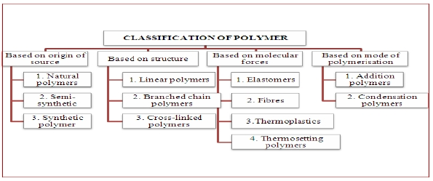

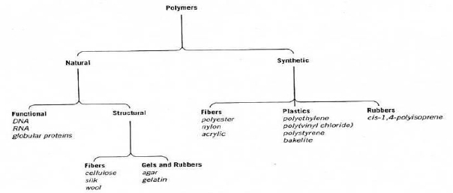

**Classification of Polymers**

**B- Classification Based on the structure of polymers :**

There are three different types based on the structure of the polymers.

**1. Linear polymers on Structure**

· In these polymers monomers are linked with each other and form a long

straight chain.

· These chains has no any side chains, ex. Polyethene, PVC, Nylons, polyesters

etc.

· Their molecules are closely packed and have high density, tensile strength.

These are represented as:

**2. Branched chain polymers**

· They have a straight long chain with different side chains.

·Their molecules are irregularly packed hence they have low density, tensile

strength and melting point, ex… polypropylene , amylopectin and glycogen.:

**3. Crosslinked or Network polymers**

· Those polymers in which two linear chains are joined together by covalent

bonds and it have three dimensional.

• Degree of crosslinking is a number of junction point per unit volume.

• Polymers crosslinking are hard, rigid .and brittle due to their network

structure.

• Polymers Crosslinked do not dissolve in solvents because all the polymer

chains are covalently tied together, but they can absorb solvents.

Ex. Bakelite, melamine, formaldehyde resins, vulcanised rubber etc. These

polymers are depicted as follows:

**C- Classification Based on Mode of Polymerisation**

Polymers can also be classified on the basis of mode of polymerisation into two

sub groups:

**1. Addition polymers**:

The addition polymers are formed by the repeated addition of monomer

molecules possessing double or triple bonds, The polymers formed by the

addition of monomers repeatedly without removal of by products are called

addition polymers. e.g., the formation of polythene from ethene and

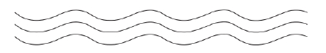



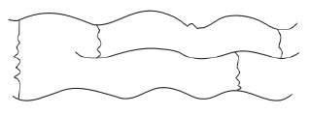

**Classification of Polymers**

polypropene from propene. However, the addition polymers formed by the

polymerisation of a single monomeric species are known as homopolymers.

**2. Condensation polymers :**

They are formed by the combination of two monomers by removal of small

molecules like water, alcohol or NH3.ex.. Nylon 6, 6, Nylon 6, etc. For

example, nylon 6, 6 is formed by the condensation of hexamethylene diamine

with adipic acid.

**D- Classification Based on Molecular Forces**

Mechanical properties of polymers like tensile strength, toughness, elasticity

depends upon intermolecular forces like van-der waals forces and hydrogen

bonding. On the basis of these forces they are classified as

**1. Elastomers**

These are rubber – like solids with elastic properties. In these elastomeric

polymers, the polymer chains are held together by the weakest intermolecular

forces. These weak binding forces permit the polymer to be stretched. A few

‘crosslinks’ are introduced in between the chains, which help the polymer to

retract to its original position after the force is released as in vulcanised rubber.

The examples are buna-S, buna-N, neoprene, etc.

**2. Fibres**

Fibres are the thread forming solids which possess high tensile strength and

high modulus. These characteristics can be attributed to the strong

intermolecular forces like hydrogen bonding. These strong forces also lead to

close packing of chains and thus impart crystalline nature. used in textile

industries The examples are polyamides (nylon 6, 6), polyesters (terylene), etc.



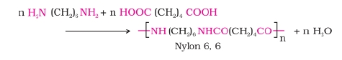

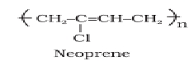

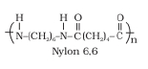

**Classification of Polymers**

**3. Thermoplastic polymers**

· These are the polymers having intermolecular forces between elastomers and

fibres.

· They are those polymers which can be softened on heating and hardened on

cooling room temperature.

· They may be linear or branched chain polymers.

· these polymer can be recycled many times. Ex , Polythene, polyesterne, PVC.

**4-Thermosetting polymers**

· This polymer is hard and infusible on heating.

· These are not soft on heating under pressure and they are not remoluded.

· These polymers are cross linked or heavily branched molecules

• These polymers we cannot reused or recycle .

Ex. Some common examples are bakelite, urea-formaldelyde resins, etc.

**E-Classification Based On the basis of types of Monomers**:

**1-Homopolyme:** A polymer containing a single type of repeat unit is called a

homopolymers e.g., polystyrene

**2-Hetropolymer (Copolymer):** if a polymer is made up two different

monomers then it is called copolymer, e.g., butadiene –styrene rubber

**F-Classification Based on the Basis of Morphology:**

Polymers can be classified into two classes on the basis of morphology:

**1-Crystalline polymers:** invariably don’t form perfect crystalline materials but

instead are semi crystalline with both crystalline and amorphous regions. The

crystalline phase of such polymers are characterized by their melting

temperature (Tm )

**2-Amorphous Polymers**: Characterized by their glass transition temperature

(Tg), the temperature at which they transform abruptly from the glass state

(hard) to the rubbery state (soft). This transition corresponds to the onset of

chain motion.

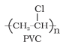

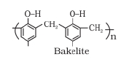

**Classification of Polymers**

**G-Classification Based On the basis of End Use:**

polymers can divided into three classes:

**1-Rubbers:** They are dimensionally unstable. These polymers are characterized

by long-range elasticity. The rubbery polymers are characterized by low

molecular cohesion. Their mechanical properties are poor. Their tensile strength

ranges between 300-1000 psi.

**2-Plastics:** these are much stronger than rubbers. They exhibit tensile strength

ranges between 4000-13000 psi. some plastics are hard, stiff and dimensionally

stable and some are soft and flexible.

**3-Fibres:** they are the strongest of the three different types of polymers. They

exhibit tensile strength which ranges between 20000-150000 psi.

**Bonding in Polymers:**

Various types of bonding may exist in polymeric material. These types and

dissociation energy are:

• Primary covalent

• Hydrogen bonding

• Dipole interaction

• Van der vals forces

• Ionic

50-200 kcal/mol - strong

3-7 kcal/mol - weak

1.5-3 kcal/mol - weak

0.5-2 kcal/mol - weak

10-20 kcal/mol - weak

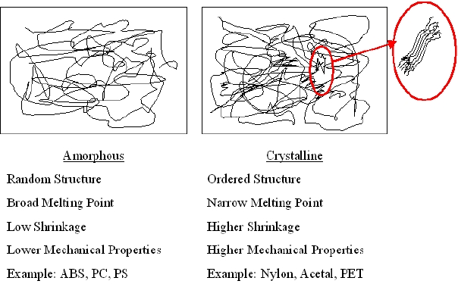

**Intermolecular forces in polymers**

The covalent bonds

Organic polymers are based on **carbon** (always), **hydrogen** (almost always) and occasionally oxygen, nitrogen, sulphur, halogens, and a few other elements. These atoms are in the case of polymers connected by covalent bonds. A covalent bond is a chemical bond formed when two atoms share a pair of electrons. Primary bond is an often-used synonymous expression to covalent bond. The electronic structure of the elements determines the characteristics of their covalent bonds to other atoms. Figure 1.3 shows schematically the electronic structures of the aforementioned elements. Electrons located in different electron shells surround the positively charged nucleus. The number of electrons is equal to the number of protons in the nucleus of an uncharged atom. Both theory and experiment indicate that the electronic structures of the rare gases (e.g. helium, neon and argon) are especially stable; these atoms are said to contain ‘filled shells’. The way in which the other elements forms covalent bonds can be understood by their wish to attain filled-shell conditions. The first shell holds only 2 electrons, whereas the second shell holds 8 electrons. The third can hold 18 electrons, but a very stable configuration is reached when a shell of 8 electrons is filled (argon structure). Hydrogen needs only 2 electrons to fill its outermost shell. This can be achieved by forming a covalent bond between two hydrogen atoms (Fig. 1.4). The two hydrogen atoms share an electron pair and simulate in this respect the helium configuration with a filled outer shell. Carbon has 4 electrons in the outermost shell (valence electrons) and it wishes to attain filled shell conditions, 8 valence electrons. Forming covalent bonds with four hydrogen atoms, as is shown in Fig. 1.4, simulates the electronic structure of neon. The covalent bonds are very strong and the atoms are not readily separated. Let us take a look at a few other important elements. Nitrogen has 5 valence electrons and therefore binds three other atoms as in ammonia (NH3) to attain filled shell conditions. Oxygen has 6 valence electrons and forms two covalent bonds with the two hydrogen atoms in water (H2O) to attain the neon structure.

Figs-Chapter 1 M:Fig. 1.3

Figure1.3. Electronic structures of common elements in organic polymers.

Figs-Chapter 1 M:Fig. 1.4

Figure1.4. Formation of covalent bonds: H2 and CH4.

Secondary bonds

The interaction between atoms of different molecules (often denoted secondary bonds) is very important for the properties and the physical behaviour of polymers. The secondary bonds can be divided into several categories and they are much weaker than the covalent bonds, a few kJ mol-1 for London dispersion forces to ~50 kJ mol-1for hydrogen bonds.

We need first to define a few concepts that are important for the further discussion. The first concept is dipole moment. Two atoms linked with a covalent bond (it can be a single, double or triple bond) share a number of electrons. The atom with the greater electronegativity attracts the electrons more and it will become negatively charged (-*q*; note that *q* is smaller than the charge of one electron). The other atom, which is more electropositive, will become positively charged (+*q*). Note that the charges are equal but that they have different signs. The electronegativity of an element can be judged from its position in the periodic table: it increases when going from left to right in the periodic table and it decreases when going downwards in the periodic table. The dipole moment (u) is simply the product of the charge and the distance (l) between the charges, i.e. u=*q*l. The dipole moment is thus a vector.

Symmetrical molecules like methane have dipole moments that point from the carbon atom to the four hydrogen atoms (Fig. 1.9). The vector sum of the four vectors is zero and hence methane is a non-polar molecule. Water has two strong dipoles, the vector sum is not zero (Fig. 1.9) and it is therefore a polar molecule. Polyethylene is an example of a non-polar polymer. Each methylene unit has a weak dipole moment perpendicular to the chain axis (Fig. 1.9). The net dipole moment is, however, zero for two adjacent methylene groups. Poly(vinyl chloride) is a polar polymer because of its strong C-Cl dipole moment and the lack of symmetry.

Figs-Chapter 1 M:Fig. 1.9

Figure1.9. Drawings of molecules (methane, water and a repeating unit of polyethylene) showing their net dipole moments (arrows)

Polarisation is another important phenomenon. All atoms and molecules polarise when they are exposed to an electric field. Non-polar molecules polarise by the displacement of the electronic clouds relative to the positively charged nuclei under the influence of the electric field. This leads to an induced dipole moment (uind), which is given by:

 (1.1)

where α is the polarisability and E is the electric field strength. Molecules that are charged or have dipoles will induce dipoles in otherwise non-polar molecules.

The interaction between two ions with charges *Q*1 and *Q*2, although not particularly relevant for organic polymers, is described by the Coulomb law:

 (1.2)

where *U* is the energy, *r* is the distance between the charges, *ɛ*0 is the dielectric permittivity in vacuum and *ɛ* is the dielectric constant of the surrounding medium. The coulomb forces (*f*=∂*U*/∂*r*) extend over long distances; these forces decay with respect to *r*-2.

The interaction between two permanent dipoles can be calculated on the basis of the Coulomb law. It is important to note that both attractive and repulsive forces result from the interaction and that the energy-distance relationship differs from the Coulomb law. The energy also depends on the angles between the r vector and the two dipole moment vectors (*θ*1, *θ*2) and between the two dipole moments (*φ*).

Finally, there is another type of force which acts between all atoms and molecules, even the neutral atoms like the rare gases and hydrocarbons. These forces have been given many different names: dispersion forces, London forces, charge-fluctuation forces and induced-dipole-induced-dipole forces. Dispersion forces make a very important contribution to the total van der Waals force, which is thus the sum of the dispersion forces and the forces originating from interactions between two permanent dipoles, and between permanent and induced dipoles. Dispersion forces are quantum mechanical in origin, but they can be explained more intuitively by simple electrostatics. The electrons in an atom (e.g. helium) are moving around their nucleus. At any given time, there will be a small dipole moment (this will average out to zero over a longer time period), which will generate a small electric field that will in turn induce a dipole moment in a nearby atom. The interaction between these two temporary dipoles gives rise to an attractive force between the two atoms.

Hydrogen bonds are exceptionally strong intermolecular bonds. They are developed between hydrogen covalently bound to a strongly electronegative atom (e.g. O, N, F and Cl) and an electronegative atom of similar type. It is now accepted that the hydrogen bond is mostly a strong electrostatic interaction. The strength of the hydrogen bond is between 10 and 50 kJ mol-1, which is greater by an order of magnitude than the van der Waals bonds but smaller than the strength of the covalent bonds. Hydrogen bonds are very important for biological systems.