Polymerization Reactions

(4)
Dr. Raouf Mahmood

Polymerization Reactions
The chemical reaction in which high molecular mass molecules are formed from monomers is known as polymerization. There are two basic types of polymerization, chain-reaction (or addition) and step-reaction (or condensation) polymerization.
Step – growth (reaction) Polymerization (condensation):
A step-growth polymerization is a stepwise reaction between bi-functional or multifunctional monomers in which a high-molecular-weight polymer is formed after a large number of steps. Many naturally and synthetic polymers are produced by step-growth polymerization including polyesters, polyethers, urethanes, epoxies, and polyamides. This polymerization method typically produces polymers of lower molecular weight than chain reactions and requires higher temperatures to occur.
Unlike addition polymerization, step-wise reactions involve two different types of di-functional monomers or end groups that react with one another, forming a chain. Condensation polymerization also produces a small molecular by-product (water, HCl, etc.). Below is an example of the formation of Nylon 66, a common polymeric clothing material, involving one each of two monomers, hexamethylene diamine and adipic acid, reacting to form a dimer of Nylon 66.
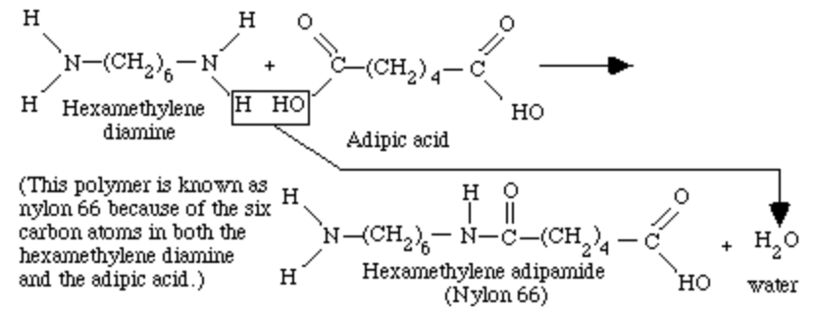
At this point, the polymer could grow in either direction by bonding to another molecule of hexamethylene diamine or adipic acid, or to another dimer. As the chain grows, the short chain molecules are called oligomers. This reaction process can, theoretically, continue until no further monomers and reactive end groups are available. The process, however, is relatively slow and can take up to several hours or days. Typically this process breeds linear chains that are strung out without any cross-linking or branching, unless a tri-functional monomer is added.
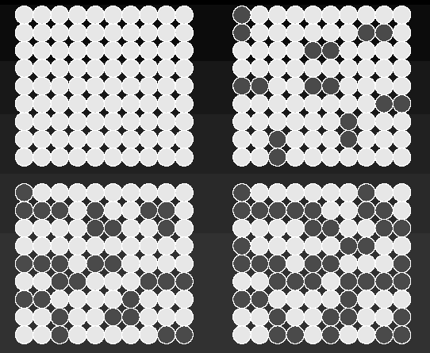 | Here we have a lattice of monomer molecules (light grey). There is no need to activate a site: temperature or a catalyst enables the reaction.  All the time, at various places, one monomer adds to another forming a dimer. Dimers can add monomers, making trimers, or two dimers can add, making a tetramer. And so the process goes on.  During this type of polymerization, we have a mass of partly grown polymer chains, .all of which are combining to make bigger molecules.

Chain-Reaction (growth) Polymerization (Addition by free radicals):
One of the most common types of polymer reactions is chain-reaction (addition) polymerization. This type of polymerization is a three step process involving two chemical units. The first, known simply as a monomer, can be regarded as one link in a polymer chain. It initially exists as simple units. In nearly all cases, the monomers have at least one carbon-carbon double bond. Ethylene is one example of a monomer used to make a common polymer.
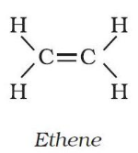
The other chemical reactant is a catalyst. In chain-reaction polymerization, the catalyst can be free-radical peroxide added in relatively low concentrations. A free-radical is a chemical component that contains a free electron that forms a covalent bond with an electron on another molecule. The formation of a free radical from organic peroxide is shown below:
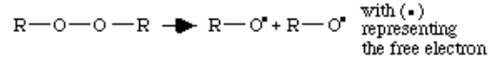
In this chemical reaction, two free radicals have been formed from the one molecule of R₂O₂. Now that all the chemical components have been identified, we can begin to look at the polymerization process.
Step 1: Initiation
The first step in the chain-reaction polymerization process, initiation, occurs when the free-radical catalyst reacts with a double bonded carbon monomer, beginning the polymer chain. The double carbon bond breaks apart, the monomer bonds to the free radical, and the free electron is transferred to the outside carbon atom in this reaction.
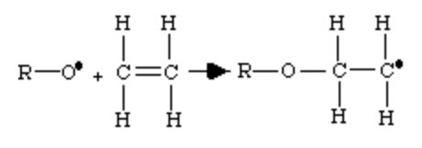
Step 2: Propagation
The next step in the process, propagation, is a repetitive operation in which the physical chain of the polymer is formed. The double bond of successive monomers is opened up when the monomer is reacted to the reactive polymer chain. The free electron is successively passed down the line of the chain to the outside carbon atom.
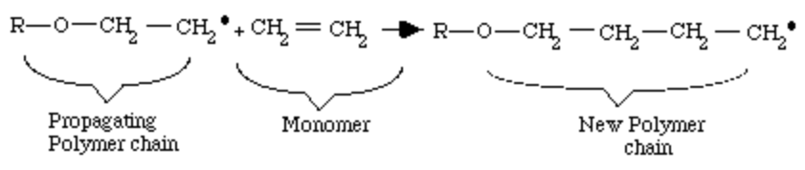
This reaction is able to occur continuously because the energy in the chemical system is lowered as the chain grows. Thermodynamically speaking, the sum of the energies of the polymer is less than the sum of the energies of the individual monomers. Simply put, the single bounds in the polymeric chain are more stable than the double bonds of the monomer.
Step 3: Termination
Termination occurs when another free radical (R-O.), left over from the original splitting of the organic peroxide, meets the end of the growing chain. This free-radical terminates the chain by linking with the last CH₂. component of the polymer chain. This reaction produces a complete polymer chain. Termination can also occur when two unfinished chains bond together. Both termination types are diagrammed below. Other types of termination are also possible.
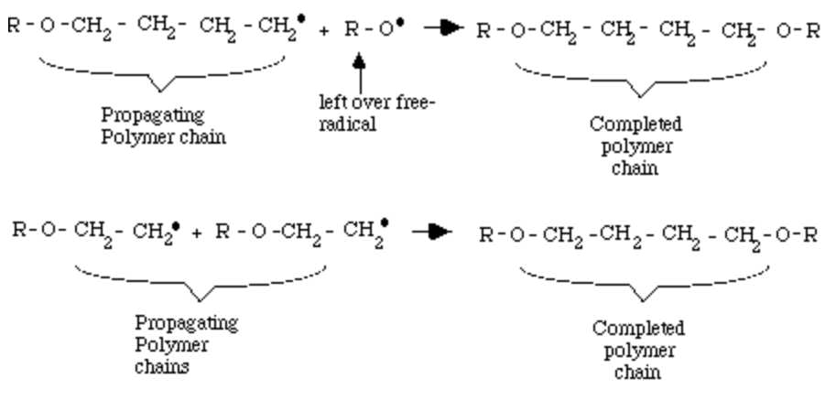

This exothermic reaction occurs extremely fast, forming individual chains of polyethylene often in less than 0.1 second. The polymers created have relatively high molecular weights. It is not unusual for branches or cross-links with other chains to occur along the main chain.
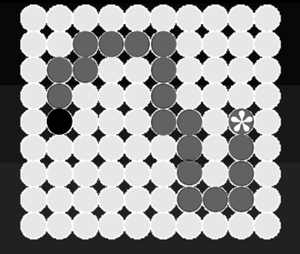 | Here we have a lattice of monomer molecules (light grey). A site is activated (by a chemical initiator, by radiation, or whatever) – this is the very dark grey circle.  This then adds monomer after monomer to the chain (dark grey), while the activity (star) is transferred to the end of the growing chain.  Some kind of process deactivates the growing end, and then we have a polymer molecule in solution in the monomer.  The characteristic of this type of polymerization is that it gives complete chains in solution in monomer.

STEP-GROWTH POLYMERIZATION

VERSUS

Chain-Growth POLYMERIZATION

Step-Growth ( Condensation) | Chain-Growth(Addition by free radicals)
All molecules present (monomer, oligomer, polymer) can react with any other molecule. | During propagation, only monomers react to the “active site” at the end of the growing chain.
Monomers exist throughout the reaction, but large quantities of monomers are consumed early in the reaction. | Monomers exist throughout the reaction; its concentration decreases steadily with time.
There is no termination step and the end groups of the oligomers and polymers are reactive throughout the polymerization process. | There are two distinctive mechanisms during polymerization; these are initiation and propagation. In most cases there is also a termination step.
The reaction proceeds rapidly at the beginning but the molecular weight increases only slowly and high MW's are only attained at the end of the process  by long oligomers reacting with each-other. | The reaction speed depends on the concentration of initiator (and co-initiator) and high-molecular weight polymers form throughout the duration of the reaction.
Long reaction times are needed for the synthesis of long (high molecular weight) polymers. | Long reaction times have high degrees of conversion but do not affect (much) the (average) molecular weight.
Molecular species of any length (oligomers) exist throughout the reaction, with the length distribution broadening and shifting to higher MW with increasing reaction time. | The mixture contains primarily monomers and polymers, and only small amounts of growing polymer chains;

