Programmable Logic

Devices

Programmable Logic Devices

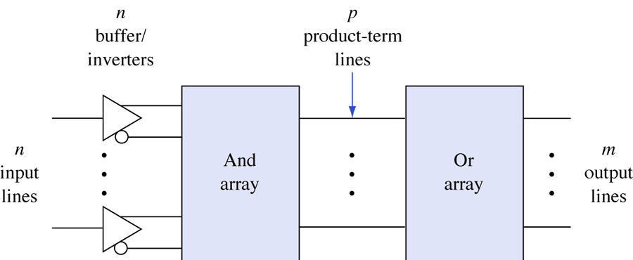

**Fig. (1) General structure of PLDs**

**Programmable Logic Device (PLD)**: is an integrated circuit with internal logic gates and/or connections that can in some way be changed by a programming process

* Examples:

PROM

Programmable Logic Array (PLA)

Programmable Array Logic (PAL) device

Complex Programmable Logic Device (CPLD)

Field-Programmable Gate Array (FPGA)

* A PLD’s function is not fixed and can be programmed to perform different functions.

75

**Types of PLDs:**

|  |  |  |
| --- | --- | --- |
| **OR-array** | **And-array** | **Device** |
| Programmable | Fixed | PROM |
| Programmable | programmable | FPLA |
| Fixed | programmable | PAL |
| - | programmable | FPGA |
| Fixed | Fixed | PLA |

FPLA= Field PLA

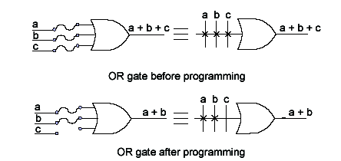

76

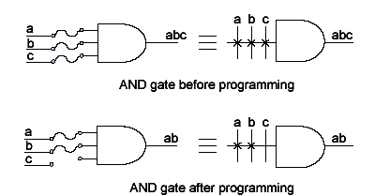

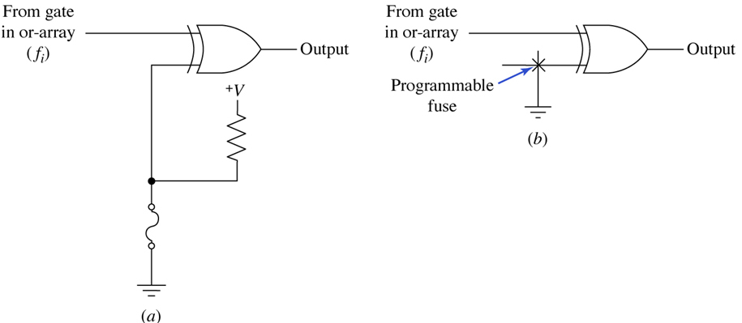

**Fig. (2)**

**a) Circuit diagram (b) Symbolic representation**

77

**PLA (Programmable Logic Array):**

The combinational circuit do not use all the minterms every time. Occasionally, they have don't care conditions. Don't care condition when implemented with a PROM becomes an address input that will never occur. The result is that not all the bit patterns available in the PROM are used, which may be considered a waste of available equipment.

For cases where the number of don't care conditions is excessive, it is more economical to use a second type of LSI component called a Programmable Logic Array (PLA). A PLA is similar to a PROM in concept; however it does not provide full decoding of the variables and does not generates all the min. terms as in the PROM. The PLA replaces decoder by group of AND gates, each of which can be programmed to generate a product term of the input variables. In PLA, both AND and OR gates have fuses at the inputs, therefore in PLA both AND and OR gates are programmable. Fig.(3) shows the block diagram of PLA. It consists of n-inputs, output buffer with m outputs, m product terms, m sum terms, input and output buffers. The product terms constitute a group of m AND gates and the sum terms constitute a group of m OR gates, called OR matrix. Fuses are inserted between all n-inputs and their complement values to each of the AND gates. Fuses are also provided between the outputs of the AND gates and the inputs of the OR gates. The third set of fuses in the output inverters allows the output function to be generated either in the AND-OR form or in the AND-OR-INVERT form. When inverter is bypassed by link we get AND -OR implementation. To get AND -OR- INVERTER implementation inverter link has to be disconnected.

78

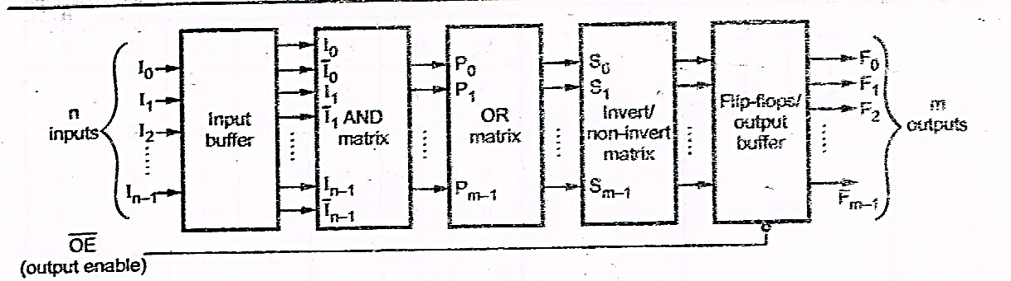

**Fig.(3) Block diagram of a PLA**

**Input Buffer:**

Input buffers are provided in the PLA to limit loading of the sources that drive the inputs. They also provide inverted and non-inverted form of inputs at its output. Figure (4) shows two ways of representing input buffer for single input.

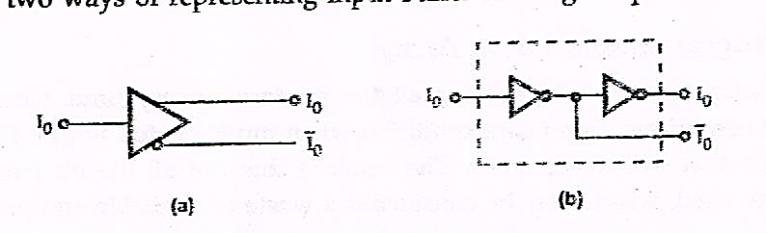

**Fig. (4) Input buffer for single input line**

**Output Buffer:**

The driving capacity of PLA is increased by providing buffers at the output. They are usually TTL compatible. Figure (5) shows the tri-state, TTL compatible output buffer. The output buffer may provide totem-pole, open collector or tri-state output.

79

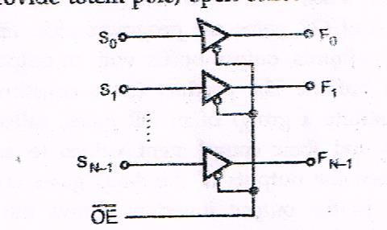

**Fig.(5) Output buffers**

**Output through Flip-Flops:**

For the implementation of sequential circuits we need memory elements, flip-flops and combinational circuitry for deriving the flip-flop inputs. To satisfy both the needs some PLAs are provided with flip-flop at each output, as shown in the Fig. (6).

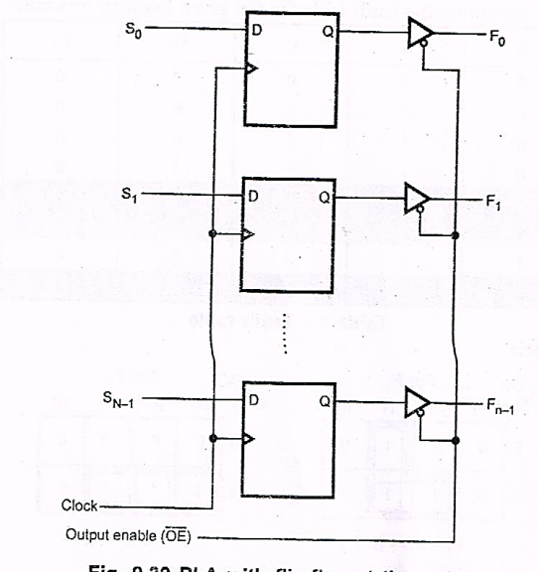

**Fig. (6) PLA with flip-flop at the output**

80

**Implementation of Combination Logic Circuit using PLA:**

Like ROM, PLA can be mask-programmable or field-programmable. With a mask-programmable PLA, the user must submit a PLA program table to the manufacturer. This table is used by the vendor to produce a user-made PLA that has the required internal paths between inputs and outputs. A second type of PLA available is called a field-programmable logic array or FPLA. The FPLA can be programmed by the user by means of certain recommended procedures. FPLAs can be programmed with commercially available programmer units.

As mentioned earlier, user has to submit PLA program table to the manufacturers to get the user-made PLA. Let us study how to determine PLA program table with the help of example.

**Example1:** A combinational circuit is defined by the functions :

$$F_{1}=\sum{m\left(3,5,7\right)}$$

$$F_{2}=\sum{m\left(4,5,7\right)}$$

Implement the circuit with a PLA having 3 inputs, 3 product terms and two outputs.

**Solution** : Let us determine the truth table for the given Boolean functions

81

**Table (1): Truth table**

|  |  |  |  |  |
| --- | --- | --- | --- | --- |
| A | B | C | F1 | F2 |
| 0 | 0 | 0 | 0 | 0 |
| 0 | 0 | 1 | 0 | 0 |
| 0 | 1 | 0 | 0 | 0 |
| 0 | 1 | 1 | 1 | 0 |
| 1 | 0 | 0 | 0 | 1 |
| 1 | 0 | 1 | 1 | 1 |
| 1 | 1 | 0 | 0 | 0 |
| 1 | 1 | 1 | 1 | 1 |

**K-map simplification**

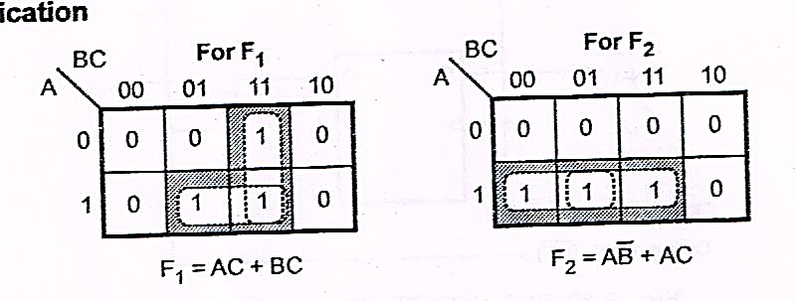

**Fig. (7)**

**Table (2): PLA program table**

|  |  |  |  |  |  |  |
| --- | --- | --- | --- | --- | --- | --- |
| **Product term** | **Inputs** | | | **Outputs** | |  |
|  | **A** | **B** | **C** | **F1** | **F2** |
| **1** | **1** | **-** | **1** | **1** | **1** |
| **2** | **-** | **1** | **1** | **1** | **-** |
| **3** | **1** | **0** | **-** | **-** | **1** |
|  | | | | **T** | **T** |
| **T/C** |

82

From the truth table, the Boolean functions are simplified, as shown in the Figure. The simplified functions in sum of products are obtained from the maps are :

$$F_{1}=AC+BC$$

$$F_{2}=A\overline{B}+ AC$$

Therefore, there are three distinct product terms : AC, BC and A $\overline{B}$, and two sum terms. The PLA program table shown in Table 2 consists of three columns specifying product terms, inputs and outputs. The first column gives the lists of product terms numerically. The second column specifies the required paths between inputs and AND gates. The third column specifies the required paths between the AND gates and the OR gates. Under each output variable, we write a T (for true) if the output inverter is to be bypassed, and C (for complement) if the function is to be complemented with the output inverter. The product terms listed on the left of first column are not the part of PLA program table they are included for reference only.

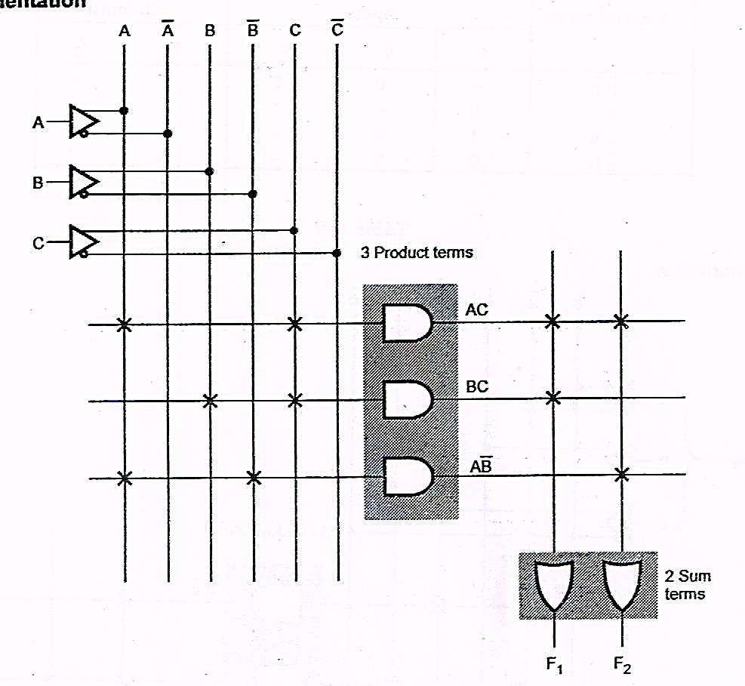

**Fig. (8)**

83

**Example 2 :** Illustrate how a PLA can be used for combinational logic design with reference to the functions :

$$f_{1}\left(a,b,c\right)=\sum{m\left(0,1,3,4\right)}$$

$$f_{2}\left(a,b,c\right)=\sum{m\left(1,2,3,4,5\right)}$$

Realize the same assuming, that a 3×4×2 PLA is available.

**Solution: K-map simplification**

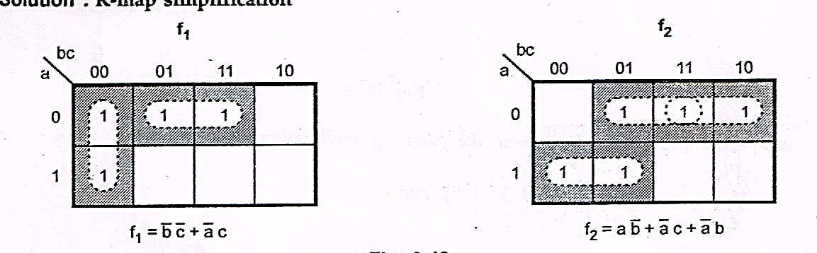

**Fig. (9)**

**Table (3)**

|  |  |  |  |  |  |
| --- | --- | --- | --- | --- | --- |
| **Product terms** | **Inputs** | | | **Outputs** | |
| **A** | **b** | **c** | F1 | F2 |
|  | — | 0 | 0 | 1 | **-** |
| **c** | 0 | **-** | 1 | 1 | 1 |
| **a $\overline{b}$** | 1 | 0 | **-** | **-** | 1 |
| $\overline{a}$**b** | 0 | **1** | - | - | 1 |
|  | | | | **T** | **T** |

84

**Implementation**

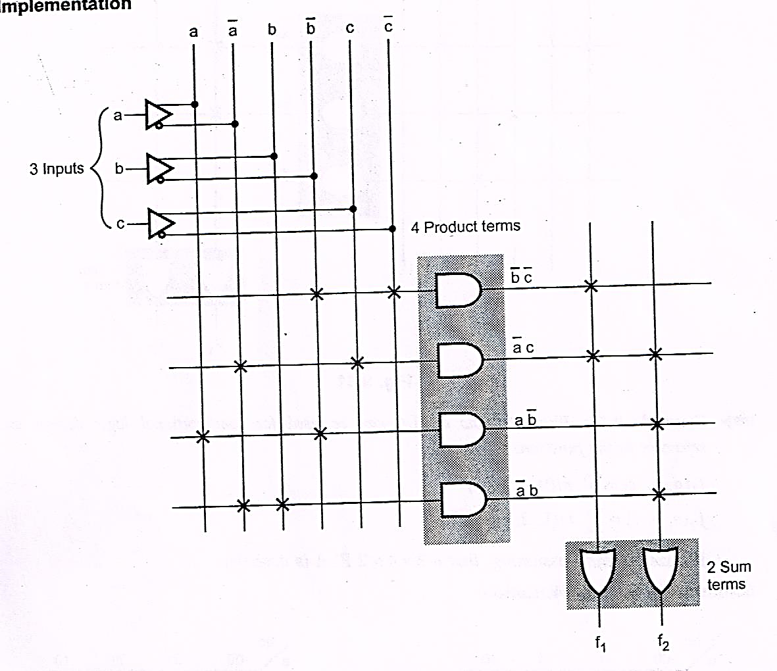

**Fig. (10**)

**Example3:** Implement the following multi Boolean function using  **3×4×2** PLA PLD.

$$f_{1}\left(a_{2},a_{1},a_{0}\right)=\sum{m\left(0,1,3,5\right)and}$$

$$f_{2}\left(a_{2},a_{1},a_{0}\right)=\sum{m\left(3,5,7\right)}$$

**Solution** : Let us simplify the functions using K-maps.

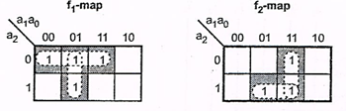

**Fig. (11)**

85

$$f_{1}={\overline{a}}_{2}{\overline{a}}_{1}+{\overline{a}}_{2}a_{0}+{\overline{a}}_{1}a_{0}$$

$$f_{2}=a_{2}a_{0}+a_{1}a_{0}$$

To implement functions f1 and f2 we require 3×5×2 PLA and we have to implement them using 3×4×2 PLA. Therefore, we have to examine product terms by grouping 0s instead of 1. That is product terms for complement of a function.

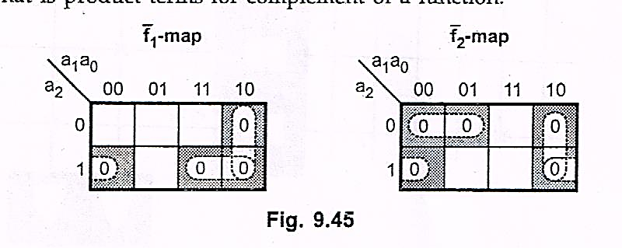

**Fig. (12)**

$${\overline{f}}_{1}=a_{2}{\overline{a}}_{0}+a_{1}{\overline{a}}_{0}+a_{2}a_{1}$$

$${\overline{f}}_{2}={\overline{a}}_{2}{\overline{a}}_{1}+a_{1}{\overline{a}}_{0}+a_{2}{\overline{a}}_{0}$$

Looking at function outputs we can realize that product terms $a_{2}{\overline{a}}_{0}$ and $a_{1}{\overline{a}}_{0}$ are common in both functions. Therefore, we need only 4 product terms and functions can be implemented using a 3× 4 × 2 PLA as shown in Table (4) and Fig. (13).

**Table (4)**

|  |  |  |  |  |  |
| --- | --- | --- | --- | --- | --- |
| **Product terms** | **Inputs** | | | **Outputs** | |
| $$a_{2}$$ | $$a_{1}$$ | $$a_{0}$$ | $$f_{1}$$ | $$f_{2}$$ |
| $$a_{2}{\overline{a}}_{0}$$ | 1 | - | 0 | 1 | 1 |
| $$a_{1}{\overline{a}}_{0}$$ | - | 1 | 0 | 1 | 1 |
| $$a_{2}a_{1}$$ | 1 | 1 | - | 1 |  |
| $${\overline{a}}_{2}{\overline{a}}_{1}$$ | 0 | 0 | - | - | 1 |
|  | | | | **C** | **C** |

86

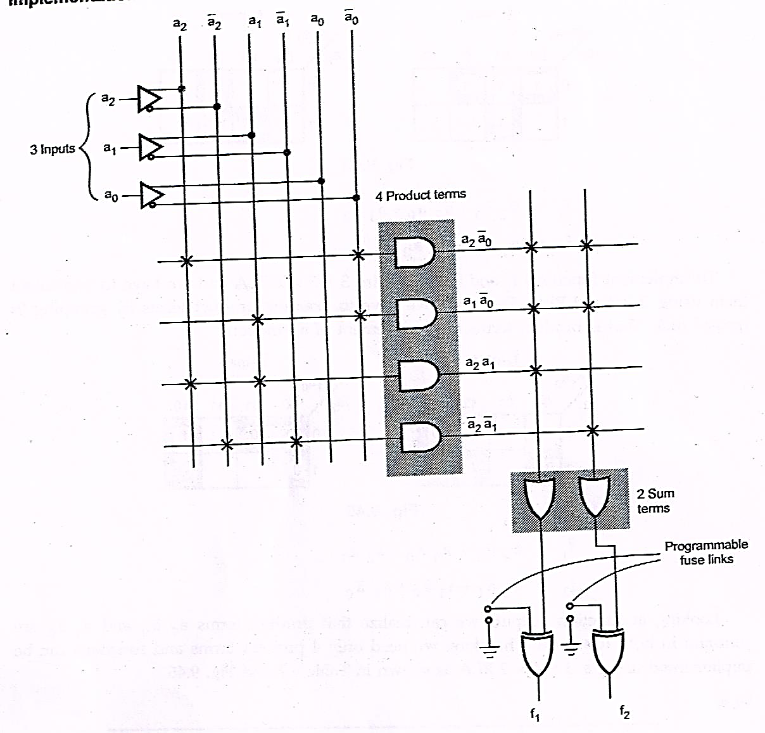 **Fig. (13)**

As shown in the Fig. (13) exclusive-OR gate is programmed to invert the function to get the desired function outputs.

**Example 4 :** Design a BCD to Excess-3 code converter and implement using suitable PLA.

**Solution :** Let us derive the truth table of BCD to Excess-3 converter as shown in Table (5).

87

Table (5) Truth table for BCD to Excess- 3 code converter

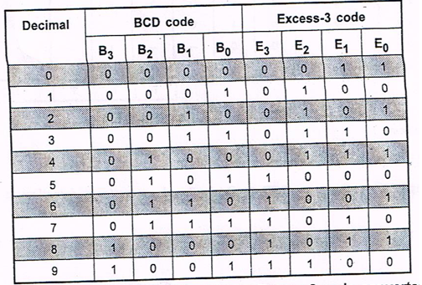

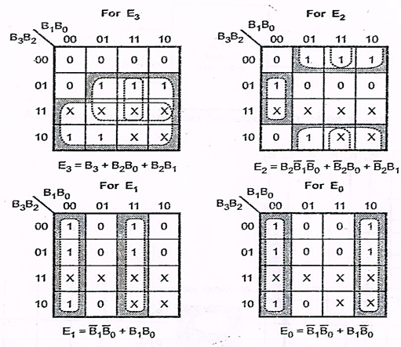

88

**Table (6)**

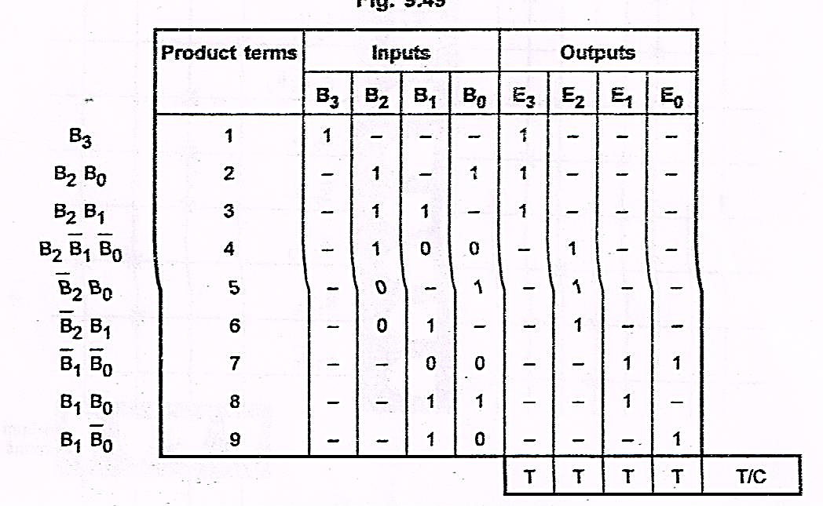

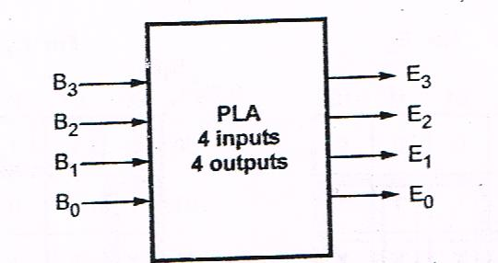

**Fig.(14): BCD to Excess-3 code converter using PLA**

**Implementation**

89

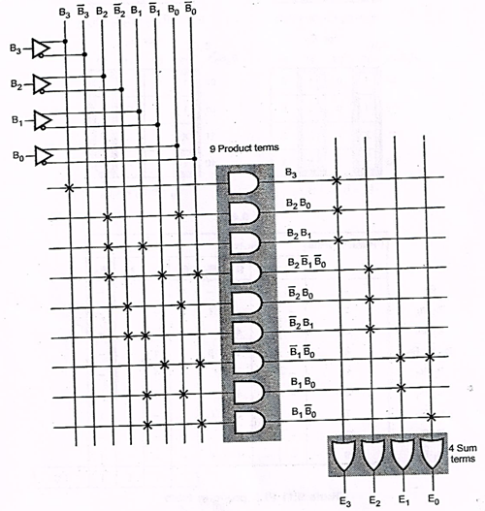

**Fig. (15)**

**Example 5 : A combinational circuit is defined by the function**

$$F_{1}\left(A,B,C\right)=\sum{m\left(1,3,5\right), { F}_{2}=\sum{m \left(2,4,5\right)}}$$

Implement the circuit with PLA

**Solution:** Let us determine truth table for the given Boolean function.

90

**Table (7): Truth table**

|  |  |  |  |  |
| --- | --- | --- | --- | --- |
| **A** | **B** | **C** | **F1** | **F2** |
| **0** | **0** | **0** | **0** | **0** |
| **0** | **0** | **1** | **1** | **0** |
| **0** | **1** | **0** | **0** | **1** |
| **0** | **1** | **1** | **1** | **0** |
| **1** | **0** | **0** | **0** | **1** |
| **1** | **0** | **1** | **1** | **1** |
| **1** | **1** | **0** | **0** | **0** |
| **1** | **1** | **1** | **0** | **0** |

**Table (8): PLA program table**

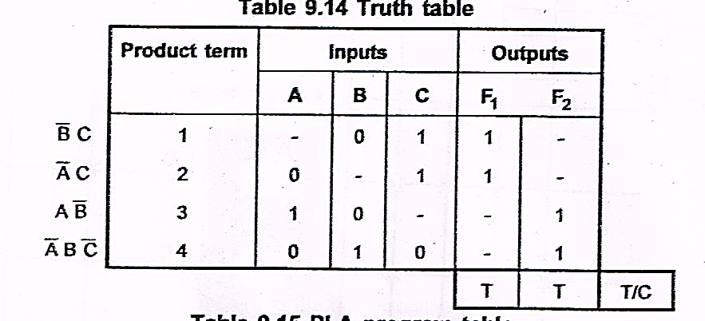

**K-map simplification**

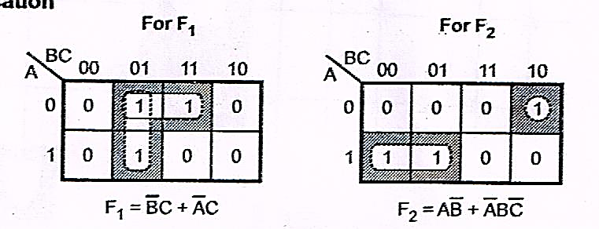

91

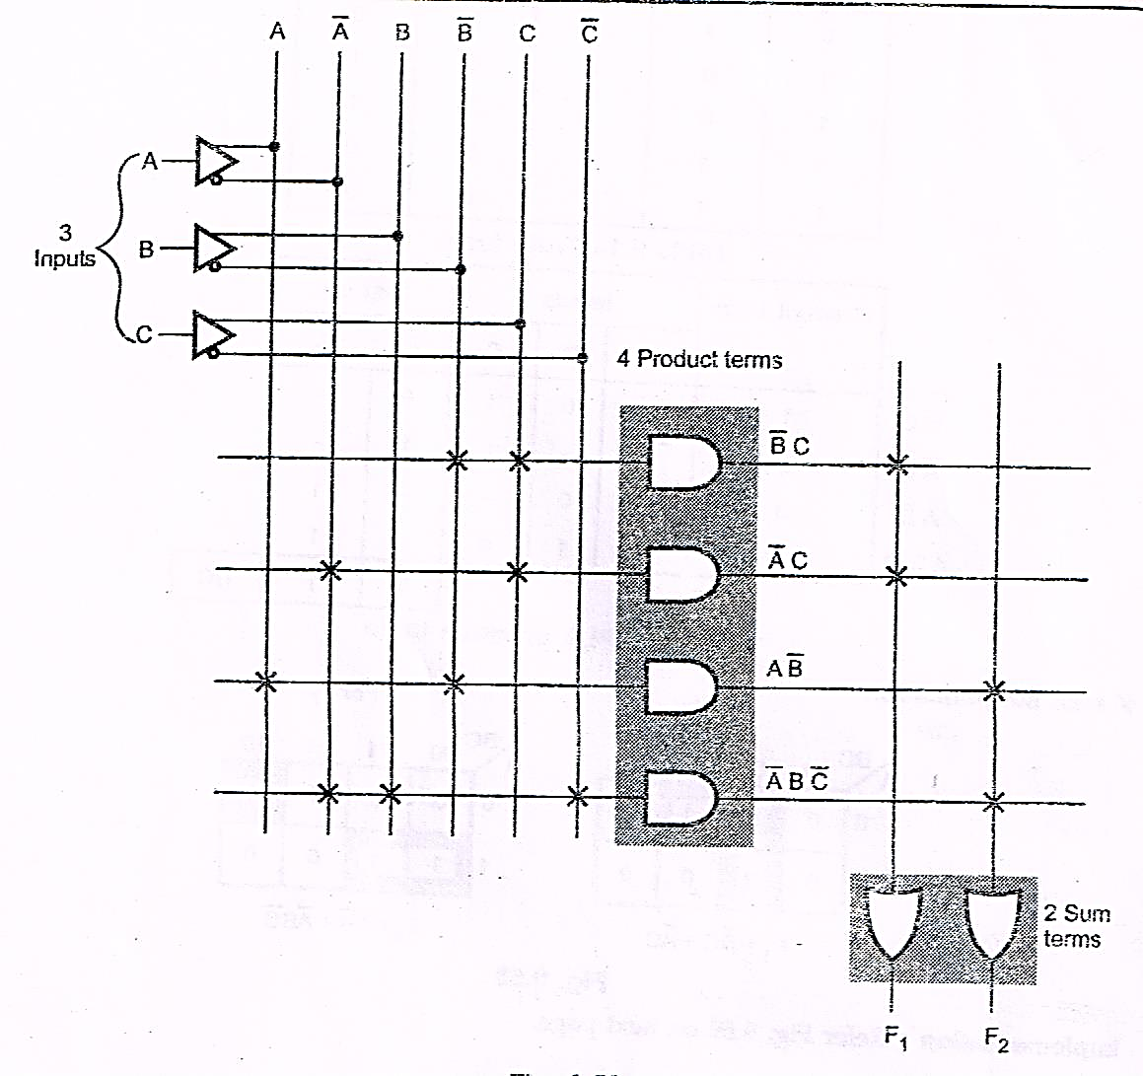

**Fig. (16)**

**Example 6**:

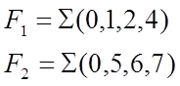

**Solution:**



92

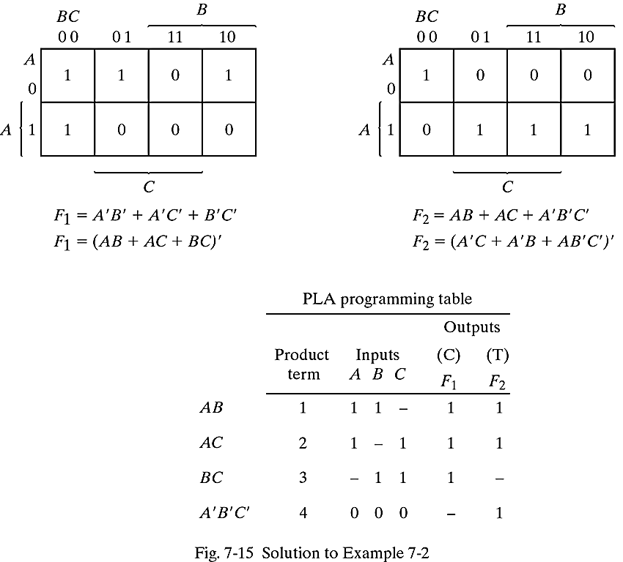

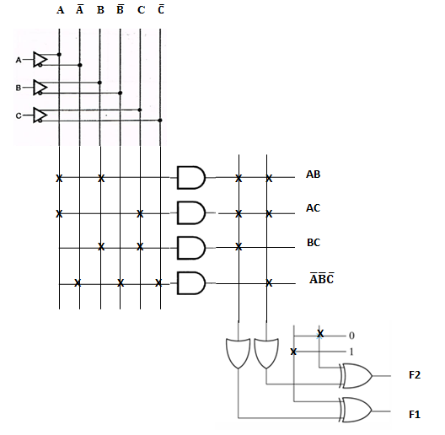

**Fig. (17)**

93

**Programmable Array Logic (PAL):**

The programmable array logic (PAL) is a logic device with fixed OR array and a programmable AND array. It is user ‘friendly 🡪 PAL’: easier to program but not as flexible as PLA.

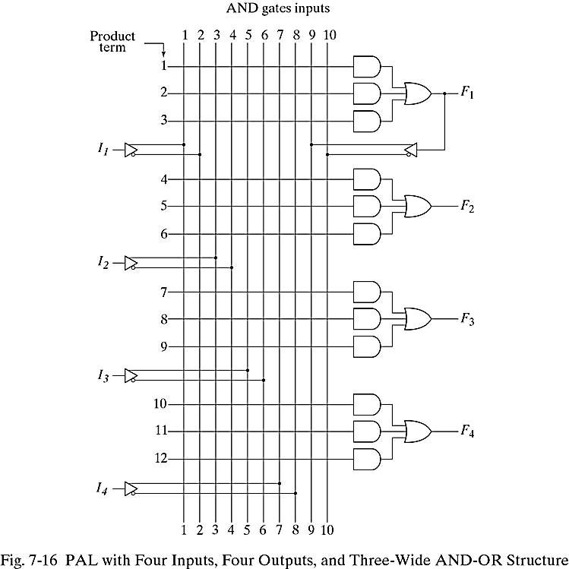

**Example 7:**

What are the equations for F1 through F4.

F1 = $\overline{C}$ + $\overline{A}\overline{B}$

F2 = $\overline{A}B\overline{C}$ + AC + A $\overline{B}$

F3 = AD + BD + F1

F4 = AB + CD + $\overline{F1}$

94

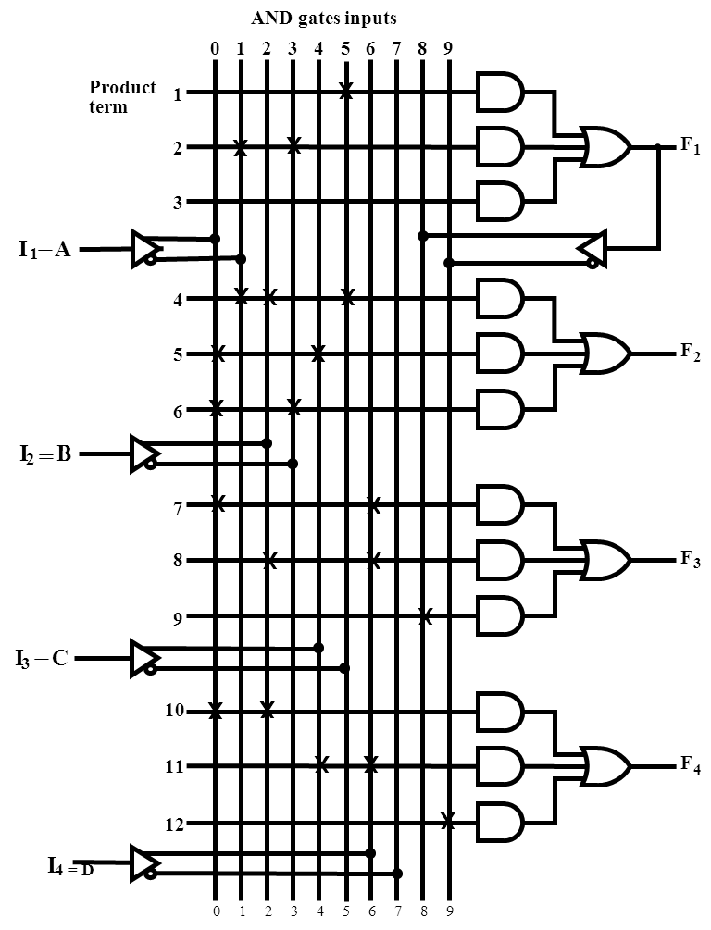

**Example 8:**

4 inputs/4 outputs with fixed 3-input OR gates

W = A B $\overline{C}$ + $\overline{A}$ $\overline{B}$ C $\overline{D}$

X =?

Y =?

Z =?

95

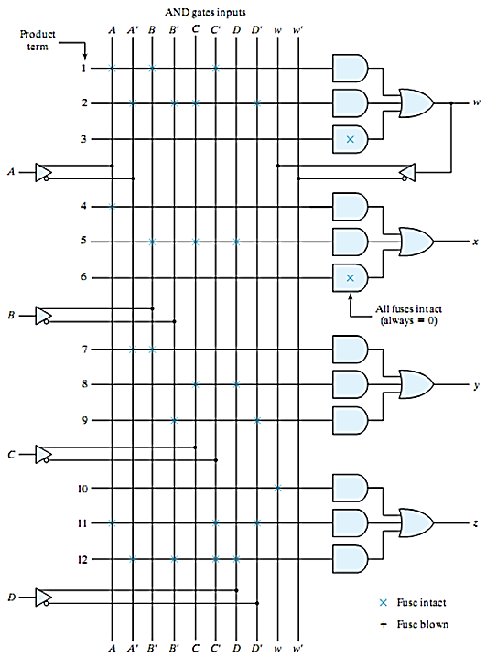

**Example 9:** Using a PAL of the structure showing in Fig. implements the following Boolean function.

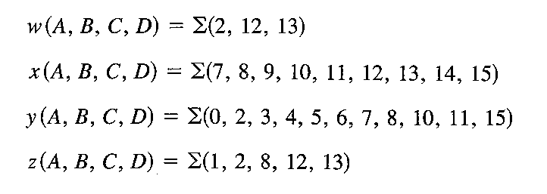

96

**Solution:**

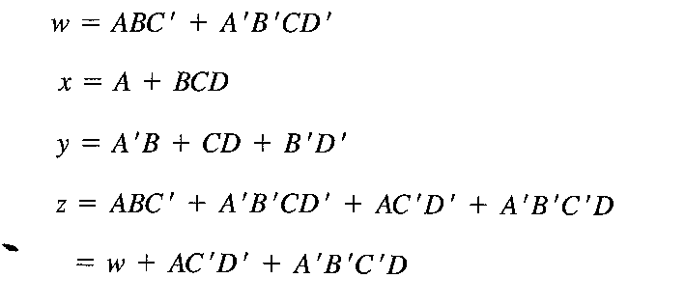

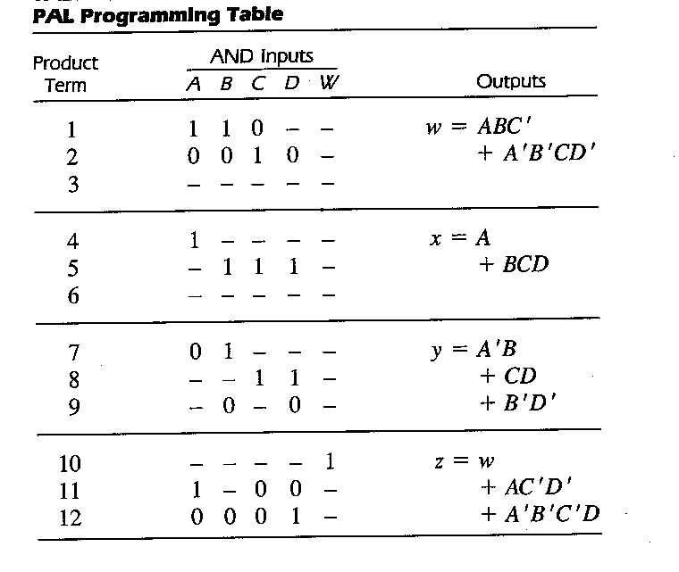

97

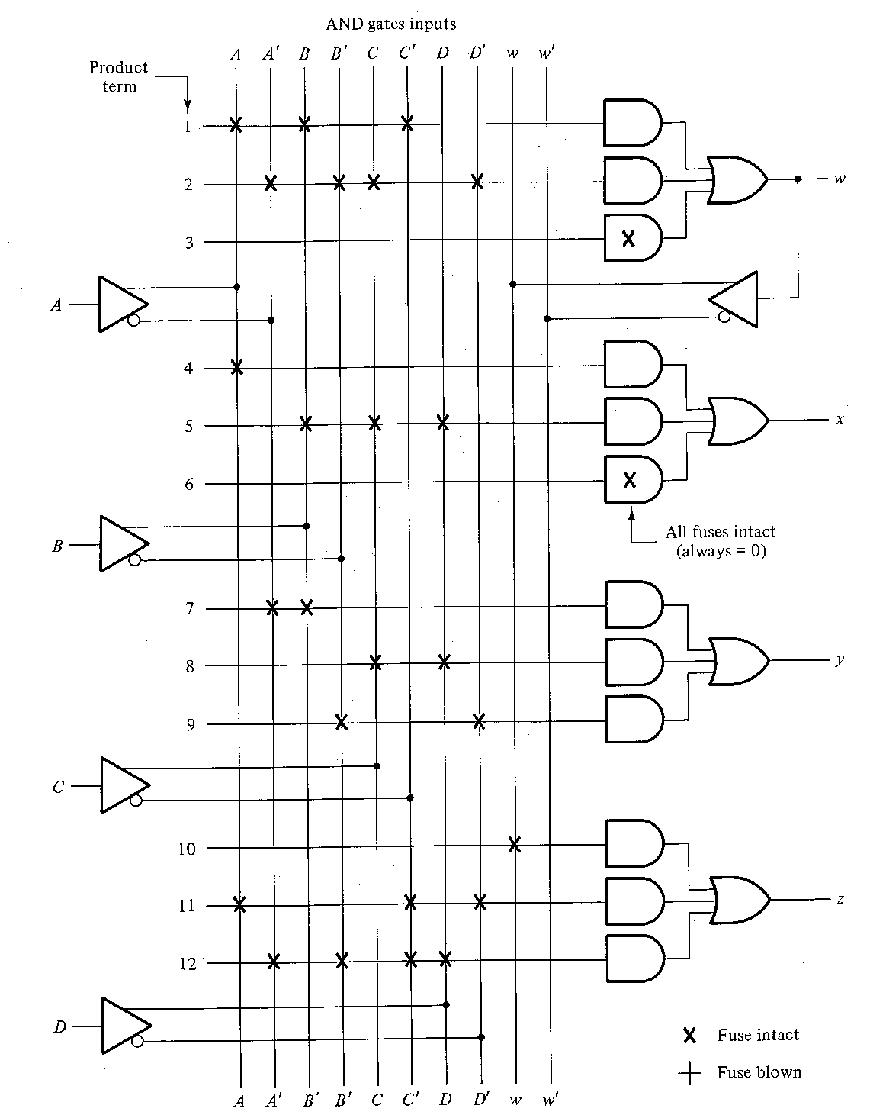

**************************************************************

98