Chapter Four
Waterproofing Insulation

Waterproofing
All buildings need insulation from moisture, rain, groundwater and surface water because the dampness causes in damage of the construction materials and releases undesired smells with the breeding of insects and mice and bring diseases. The walls that exposed to the rain without sufficient amount of sunlight are more susceptible to dampness.

Effect of Dampness
- Damage of building materials and elements of the house.
- Efflorescence of the walls, floor and ceiling.
- Damaging the paint.
- The failure in the timber used and wooden décor.
- Corrosion of metallic parts.
- Proliferation of fungi and unhealthy situation for users in the building.

Causes of Dampness
1. Rain water: The rain water has the ability to penetrate the roof of the building, especially for poor surfaces and absence of gutters. Rain could penetrate the windows in absence of overhangs.
2. Surface water: This means river, sea or pond. The water mixes with the soil close to the building and forming a clay then moisture seeps to the foundations or inside through the capillary action.
3. Underground water: The accumulated water under the earth's surface could be transmitted through the pores of the soil by the capillary action and ascend to the foundations or inside hence damage the structural materials used in the building. It could even overflowing into the building.
4. Condensation: It is noticed in winter days a layer of dew formed on the window or even wall, and this phenomenon is called "condensation". The accumulated moisture on windows, walls, ceiling and floor seeps into the parts of the house after a period of time and leads to the fragility of construction materials and the appearance of rust, mildew and odors.
5. Poor sewage drainage: When wastewater gathers under the building and it was hard to flow downstream because of some restrictions then dampness could be occurred in the nearby elements of the building.
6. Modern construction: The walls newly constructed remain in the wet state for a certain period.

Capillary action: It is the ability of water to transport through the small pores of the material with the help of the forces of adhesion and cohesion. The capillary action occurs in porous materials like sponge, brick, concrete and many construction materials.

Types of Waterproofing Insulators
The purpose of waterproofing materials is to prevent the water as well as the moisture and keep it away from building elements. In order to choose the appropriate isolator of humidity it must take into account the nature of the ground (concrete, stone, clay, metal) as well as the climate (dry, wet). The method is characterized by the development of the insulation layer or membrane resists water pressure and using materials to prevent leakage of water or moisture into building elements.

The main types of waterproofing materials are:

- Bitumen: It is a black material made from the rest of the distillation of crude oil. Bitumen is very common in waterproofing isolation because of its cheapness compared to the other insulating materials in addition to its flexibility and resistance to the proliferation of fungi and insects. Bitumen is available in drums where it should be heated to about 80 degrees to melt. The most famous types are:
- Liquid of bitumen which is used to fill the cracks in the concrete or roof tiles. Sometime, adhesive is added to the resin components and it is called "mastic". Bitumen could be used as paint (1-2 mm) for the foundations and walls that are in a direct contact with the soil.
- Solid of bitumen (asphalt) which is used for paving of the street after mixing with sand and stones.
- Flancoat: a waterproofing material of bitumen used for coating surfaces of concrete in contact with the soil to prevent the dampness. It is effective and easy to use and does not need any mixing with any compound. It does not need to melt, where a brush or a roll is used to paint the surfaces. Often, it is available in black, but there are many other colors.
- Bitumen rolls: These layers have the excellent isolating and waterproofing capability. They are made of bitumen and sometimes covered by a reflective metallic sheet to reflect the heat. The bitumen layer commonly used to insulate the ceiling or walls and it is available in (3, 4 and 5 mm) thickness.

- Acrylic: It is a water resistant material and frequently used for waterproofing of the building roof and the floor of swimming pool. This material is composed of polyester fibers submerged in a liquid resin of polyacrylonitrile, where the required surface should be painted (many layers) and exposed to air to dry quickly and becomes a flexible insulating layer. This substance has a high susceptibility adhesion to various building materials. It is long-life and environment-friendly material.

- Waterproofing liquid: This liquid is made from the mixing of paraffin's wax with volatile oil. The waterproofing liquid is used to spray or paint the required surfaces.

- Epoxy: A polymeric material sticky and has rapid solidification used to process the holes and cracks.

- Cement: In case of free of impurities, cement could be a good resistant insulator. Cement is available as:
- Portland cement: the increasing of the amount of cement in cement-sand mixture increases the resistance.
- White cement: it is used to fill the separations in marble tiles for bathrooms and balconies.

- Sheets or layers: Surfaces could by isolated using many layers like:
- Polyethylene membrane: Polyethylene is a flexible material that resists moisture and is often found in a very thin layer.
- Rubber sheets
- Extruded polystyrene (XPS) layers.
- Layers of Mass Loaded Vinyl (MLV).
- Nylon: It can be used between different parts of the building or between the layers of insulators, as well as to cover the foundations.
- Metallic sheets: slabs, roofs and walls could be covered by a tiny layer of metallic sheet such as copper and aluminum plates. These metals are commonly used to make water storages.

- Fiberglass: It is a hard kind that results from mixing the glasswool with the epoxy. It is characterized by high resistance to the water therefore used in tank construction. Glasswool could be also mixed for the purposes of strengthening bitumen waterproofing layer.

- Shingle: These tiles have good isolation and used to cover the inclined surfaces and remove the accumulated water. A shingle is made of durable material like brick, stone or composite material and has a beautiful appearance.

- Asbestos: It is ceiling panels characterized by light weight and resistance to water, heat, fire, acids and fungi. The asbestos panel is often used in roofing but it is prohibited recently due to its harmful effect to the body health and environment.

- Rocks: Such as marble and granite. They are characterized by hard surfaces so a high resistance to the water. Marble is commonly used as floor tiles in kitchens and bathrooms. These rocks could be used to make the statues.

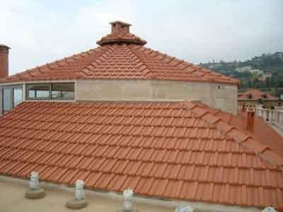
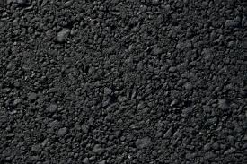
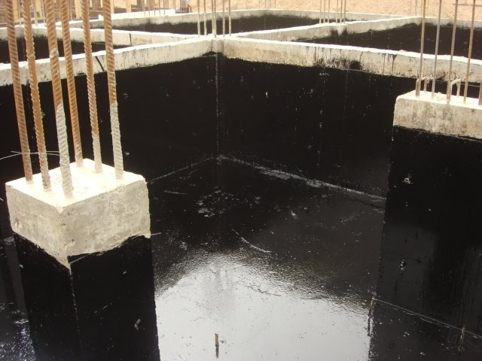
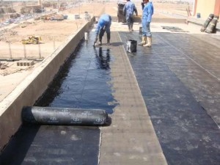
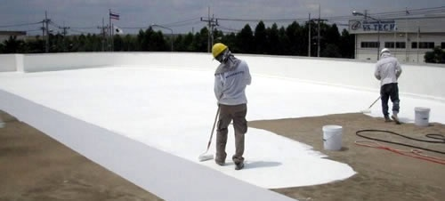
Asphalt Bitumen paint Shingles
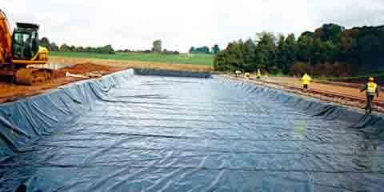
Acrylic
Bitumen rolls Polyethylene membrane
Practical Waterproofing Treatments

A. Waterproofing of foundation
1. Paint foundation surface using bitumen paints to prevent water transport and to provide adhesion between the concrete and insulation layer.
2. Paste a layer of tarpaulin to protect the foundation from direct contact with water.
3. Put a layer of thermal insulator.
4. Fill the neighboring land to the foundation by stones to resist the permeability of the water as much as possible (see the figure below).

B. Waterproofing of walls
1. Paint wall surface using bitumen paints to prevent water transport and to provide adhesion between the wall and insulation layer.
2. Paste a layer of tarpaulin, to protect the walls from direct contact with water, starting from the underground to prevent dampness path to the top.
3. Put a layer of thermal insulator.
4. Finishing works by a layer of mortar or marble.

C. Waterproofing of roof
1. After the casting of concrete, surface should be cleaned and the cracks should be treated carefully using grout or epoxy.
2. Provide appropriate inclination towards the gutters and treating the cumulative area by a layer of cement.
3. Paint concrete surfaces using bitumen paints to provide adhesion between the concrete and the insulation layer.
4. Put a layer of waterproofing material.
5. Put a layer of thermal insulating material.
6. Put a layer of soil and then covering with impervious tiles or insulating membrane such as acrylic.

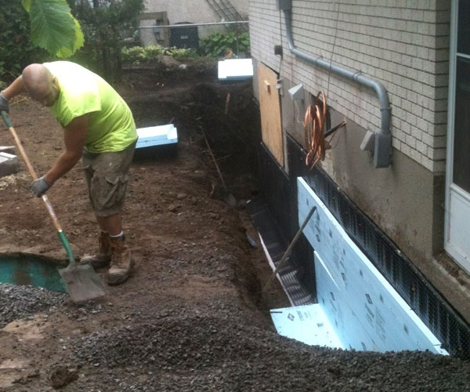

Engineering Calculation in Water Transport

Permeability: It is a measure of the ability of a porous material to allow liquids to pass through it; hence it is the inversion of the resistance. The unit of permeability is Darcy (D).
1 Darcy ≈ 10⁻¹² m²

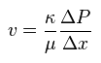
Velocity of the liquid in a permeable material is given by:

Where:
υ = flow velocity through the medium (m/s)
k = coefficient of permeability of the medium (m²)
μ = dynamic viscosity of the fluid (Pa·s)
∆P =Applied pressure difference (Pa)
∆x = thickness of the bed of the porous medium (m)
The following table shows some values of water permeability in a range of materials.
Unconsolidated Sand & Gravel | Well Sorted Gravel |  | Well Sorted Sand or Sand & Gravel |  |  | Very Fine Sand, Silt, Loess, Loam
Unconsolidated Clay & Organic |  |  |  |  | Peat |  | Layered Clay |  |  | Unweathered Clay
Consolidated Rocks | Highly Fractured Rocks |  |  |  | Oil Reservoir Rocks |  |  | Fresh Sandstone |  | Fresh Limestone, Concrete |  | Fresh Granite
κ (milliDarcy) | 10⁸ | 10⁷ | 10⁶ | 10⁵ | 10000 | 1000 | 100 | 10 | 1 | 0.1 | 0.01 | 0.001 | 0.0001
Strength | Pervious |  |  |  | Semi-Pervious |  |  |  | Impervious

Example: A swimming pool of 60 m² has a concrete floor of 10 cm thickness and exposed to 20 kPa pressure difference of water. Determine the discharge of water across the concrete. (μ of water = 0.001 Pa.s) (k of concrete = 0.01 miliDarcy). What will be the difference if granite is used (k of granite = 0.001 miliDarcy).

Solution
- In case of concrete
= (0.01 x 10⁻³ x 10⁻¹²/0.001) (20000/0.1) = 0.2 x 10⁻⁸ m/s

Q = υ x A = 0.2 x 10⁻⁸ x 60 = 12 x 10⁻⁸ m³/s

- In case of granite

υ = (0.001 x 10⁻³ x 10⁻¹²/0.001) (20000/0.1) = 0.02 x 10⁻⁸ m/s

Q = υ x A = 0.02 x 10⁻⁸ x 60 = 1.2 x 10⁻⁸ m³/s

Sorption: It is the tendency of water to rise into porous materials by capillary action. Thus, no water pressure is required. The quantity of water absorbed into the material by capillary action is given by:
$V=A S \sqrt{t}$
Where
V = accumulated volume by absorption (m³)
A = wetted area (m²)
S = Sorptivity ($m/\sqrt{min}$)
t= time (min)

The following table shows some values of water sorptivity in a range of materials
Material | S ($mm/\sqrt{min}$)
Stone | 0.15
Concrete | 0.2
Block | 0.5
Brick | 1.1
Cement | 1.5
Gypsum | 3.5
Soil | 40

Example: Brick wall (S=1.1$mm/\sqrt{min}$) of 5 m width, 3 m high and 25 cm thickness is attached to underground water. What would be the dampness level for a period of one month, if the water touches 10 cm of the foundation height. What is the difference if impervious brick (S=0.1 $mm/\sqrt{min}$) has been used.

Solution:
$V=A S \sqrt{t}$ = (5 x0.1) x 1.1 x 10⁻³ x $\sqrt{30 x 24 x 60}$ = 0.114 m³
Water rise = V / A = 0.114 / (5x0.25) = 0.091 m
It means that the water will rise approximately 9 cm after a month.

For the case of impervious brick it is less than 1 cm monthly. Check it!!

