Chapter Five
Radiation Insulation

Introduction
It is known that various electromagnetic waves and particles emitted from radioactive sources have direct and indirect effects on living organisms, where many symptoms could be happened when expose to radiation more than allowed. Workers in nuclear facilities and X-ray labs exposed to the risk of external, which affects the face, hands or internal exposure due to the entry of radioactive particles into the body through breathing and food. To avoid the radiation risk in this area it is necessary to know the nature of radiation and methods of isolating and comply with the instructions for the prevention of it as mentioned in this chapter.

Radiation
Radiation is energy released in the form of electromagnetic waves has many forms, such as light, ultraviolet and infrared or small particles from radioactive materials like alpha, beta and gamma. The source of this radiation is universe, sun, nuclear reactors, industrial and laboratory applications. Some substances found in the earth are also characterized by radiation. There is a little radioactivity within the body. Electromagnetic waves consist of photons; shortest waves are gamma rays while the longest are radio waves.

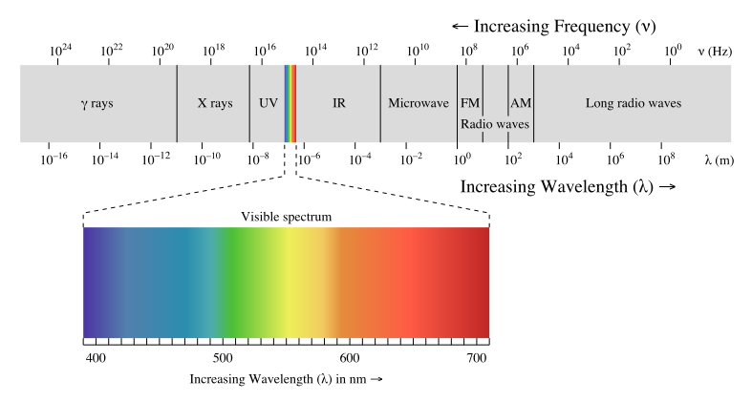

Classification of Radiation
Radiation could be classified according to its dangerous as following:

1. Non-Ionizing Radiation: Examples of this radiation light, infrared, ultraviolet and radio waves. This type of radiation is safe usually.

2. Ionizing Radiation: Such as cosmic rays, gamma rays, alpha particles and beta particles. It is dangerous because of its ability of ionizing.

Non-Ionizing Radiation
The sources of these rays are sun or industrial applications. These rays are not inherently dangerous, but when prolonged exposure to it has caused cases of discomfort or headaches queasiness or dryness of hair and sometimes minor skin burns. Clothes, sunglasses and shading protect us from these rays.

Types of Non-Ionizing Radiation
1. Light (the visible spectrum): It is a very useful radiation. It provides the light and control many biological functions such as: strengthen of bone tissue, maintain the blood pressure, diabetes level, cholesterol level and psychological comfortable. It has a big role in the growth of plants by photosynthesis.
2. Infrared: It is very useful which provide the warmth and used for many applications like: night vision, short-range wireless communications and remote sensing.
3. Ultraviolet: It is a useful radiation except one band of it. These rays help to provide the body with vitamin (D). There are many application of UV like: water and medical sterilization, reducing the yellowing with newborns. The long exposure to UV harms the skin and the eye. It is worth to refer that that these rays are the cause of damaging plastics and insulating polymeric materials because of their ability to disconnect the chemical bonds.
4. Radio waves: Such as the broadcasting of radio, television, telecommunications and microwave wavelengths. Despite the benefits of these rays in the transfer of information, they have some harmful effects on humans, especially on the nervous side and the senses.

Ionizing Radiation
It includes rays or particles come from the sun, the universe or radioactive elements (such as radium, uranium, plutonium and thorium, iodine, potassium, zircon, phosphor and radon). The radiation that is emitted from these sources could ionize the medium, which means detaching the electrons from atoms.

Radioactivity
Most of the chemical elements have the same number of neutrons and protons in the nucleus. In some elements the number of neutrons is greater than the number of protons, so that be unstable and called radioactive isotopes. These isotopes emit small particles from the nuclei such as alpha particles, beta particles and gamma rays. Over time, these elements are transformed into other elements less weight and have various chemical and physical characteristics. The emitted particles and rays are considered as ionizing radiation. The characteristics of radioactive isotopes depend on the type of radiation emitted, energy of radiation and its half-life.

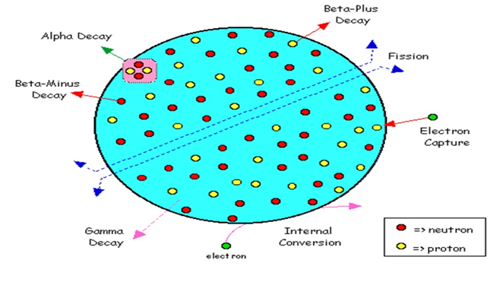
Half-Life: It is the time needed to disintegrate half of atoms of a radioactive element, hence reducing the activity by half. For example, the half-life of (iodine -131) is 8 days while the half-life of (radium -226) is 1600 years.
The disintegration of the radioactive isotope
Types of Ionizing Radiation
1. Alpha particles: alpha particle is emitted from the nucleus during the decay. It consists of two protons and two neutrons (it is similar to the nucleus of the helium atom) so it has positive electrical charges. These particles lose energy quickly as soon as leaving the radioactive element. Hence, the penetration of alpha particles to the skin is weak. And it could be blocked by a thick paper. The risk of alpha particles appeared when enter to the internal parts of the body by berthing eating or wounding.
2. Beta particles: These particles are emitted from the nucleus during the decay. It is noticing, during the breakdown of neutrons, that beta particles may be produced either as electrons (negative charge) or as positrons (positive charge), or in sometimes whole neutrons are emitted to the outside. Beta particles have more penetration force than that of alpha particles, and some beta particles can penetrate the skin and cause damage to it. It also causes harmful effects if entered to the body. Beta radiation could be blocked by a piece of wood or a layer of aluminum (10-20 mm).
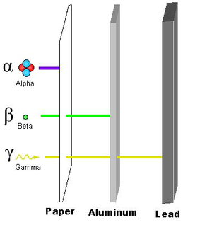
3. Gamma rays: This type of radiation represents the energy generated by the disintegration that is occurred within the nucleus. The emission of alpha and beta particles pushes the nucleus to the stability phase, hence emits energy (photons) out in the form of gamma rays. there is a kind of gamma rays called annihilation radiation which is produced from the combination of electrons and positrons. this radiation is one of the most dangerous types of radiation and has very high penetrating force, where it can easily penetrates the human body and absorbed by the tissues. It could be blocked by a barrier of concrete or a layer of lead (4-12 mm).

Shielding for some types of radiation
X-rays: These rays are similar to gamma rays in terms of features but differ in the source, where X-rays emitted from the outside of nucleus (transportation of electrons between the energy levels), while gamma rays are emitted from the inside of nucleus. Penetration force and permeability of these rays are less than that of gamma rays, where it could be blocked by a thin layer of lead (1-3 mm).

Cosmic rays: These are high-energy particles coming from the space. Mostly, this radiation is dissipated through the upper layers of the atmosphere, but a few percent in. This dangerous radiation could be blocked by a layer of composite materials or chemical compounds.

Risks of Ionizing Radiation
The ionizing radiation could ionize the medium, which means detaching the electrons from atoms. The Ionizing of the constituent elements of the biological material of the recipient's body causes the increase or decrease in the size of the cell or fragmentation, hence the formation of toxic compounds that may move to other parts of the body, leading to serious damage. These effects are appeared either early or later in the form of symptoms or disease like cancerous diseases in addition to the hereditary effects of genetic influences. Workers in radiation facilities may get internal or external exposure. Internal exposure to ionizing radiation occurs when inhaling or swallowing radionuclides or entry into the bloodstream. External exposure occurs when radioactive materials attached to the skin. The type of damage is inflicted by the amount of radiation dose to the body according to the level of exposure threshold is exceeded. Usually the risks of radiation are: skin redness, burns, hair loss, syndrome of radiation, bleeding, infertility and cancer in some cases.
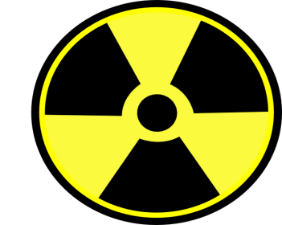

Warning sign for ionizing radiation
Radiation Measuring
Radiation intensity is measured in a unit called Sievert, denoted as (Sv) and consists of 100 Rem. Human may expose to a dose of radiation that is measured using an instrument called radiation meter, as shown in the figure, which often works within the limits (0.1 - 200 μSv/h).

Radiation meter

Means to minimize the risk of radiation
Person who is working in the field of radiation may be exposed to a dose of radiation varying depending on the nature of the work. The commitment to the following aspects is very important to reduce the risk of radiation.

1) Time of Exposing
Radiation is less dangerous in the case of reducing the exposure time (time spent by the person beside the radiation source). The maximum exposure limit allowed to the human is (0.05 Sv/yr) according to the recommendations of international councils such as (ICRP) and (USNRC). In order to calculate the amount that is permitted to those working in the field of radiation, the exposure limit is divided by the total working time. Hence, for 8 hours and 360 days, the allowed limit is 17 μSv/h.
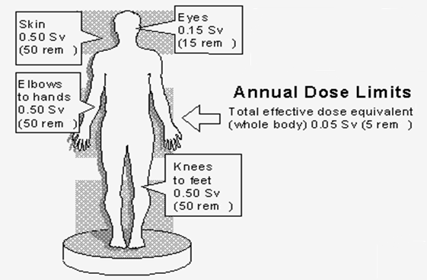

Exposure limits

2) Exposure Distance
The increasing of distance far from the radiation source will reduce the intensity of the radiation (inverse relationship) according to the inverse-square law as following:

I₁ L₁² = I₂ L₂²

Where:
I = Intensity of radiation
L= distance away from the source

3) Shielding
Radiation could be reduced using barriers consisting of metals or materials have the ability to either absorb the radiation and convert it to heat or reflect it. For each type of radiation there is appropriate barrier setting to according to the intensity and the energy of radiation.

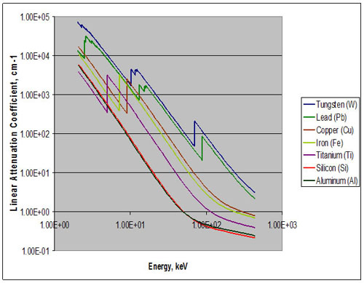
Linear Attenuation Coefficient: It represents the value of material susceptibility to reduce the radiation. It is symbolized by the letter (μ) and has the unit (cm⁻¹). The value of linear attenuation coefficient of a material depends on the energy of the radiation passing which is measured in (eV) unit, as shown in the figure.

The value of linear attenuation coefficient of some materials

More values for many different elements could be found in the link below.
http://physics.nist.gov/PhysRefData/XrayMassCoef/tab3.html

The following table shows the value of the linear attenuation coefficient for some materials.
Linear attenuation coefficient in (cm⁻¹) for a range of gamma-ray energies

Material | Energy (keV)
 | 100 | 200 | 500
Carbon | 0.335 | 0.274 | 0.196
Aluminum | 0.435 | 0.324 | 0.227
Iron | 2.72 | 1.09 | 0.655
Copper | 3.8 | 1.309 | 0.73
Lead | 59.7 | 10.15 | 1.64

Half Value Layer: It is the thickness of the material that satisfies half reduction of radiation (ie, attenuated by 50 percent). It is measured in centimeters and symbolized as (HVL). The following table shows some HVL for some elements.

HVL in (cm) for a range of gamma-ray energies

Material | Energy (keV)
 | 100 | 200 | 500
Carbon | 2.07 | 2.53 | 3.54
Aluminum | 1.59 | 2.14 | 3.05
Iron | 0.26 | 0.64 | 1.06
Copper | 0.18 | 0.53 | 0.95
Lead | 0.012 | 0.068 | 0.42

Calculation of radiation attenuation
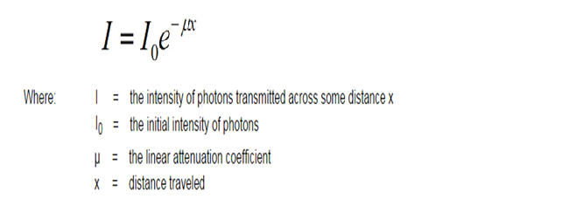
Beer-Lambert Law could be used to calculate the amount of attenuated radiation (gamma rays and rays) the existence of the barrier from the relationship:

Homework: Prove that the relationship between half value layer and linear attenuation coefficient is:
HVL = 0.693 / μ

Ex. (1): The intensity of 500 keV gamma-rays has measured at a zone and it was 25 μSv/h. What would be the intensity after using a shield of 8 mm lead. (μ=1.64 cm⁻¹)
Solution:
= 25 exp (-1.64*0.8) = 6.73 μSv/h

Since the intensity is less than 17 μSv/h then sounds good.

Ex. (2): Three materials: aluminum (8 cm), iron (4 cm) and lead (0.4 cm) have exposed to 18 μSv/h at 200 keV. Determine the best shield.
Solution:

Material | μ (cm⁻¹) | Thickness (cm) | I (μSv/h)
Aluminum | 0.324 | 8 | 1.35
Iron | 1.09 | 4 | 0.23
Lead | 10.15 | 0.4 | 0.31

In this case, iron has the minimum attenuation, so it is the best shield.

Ex. (3): What thickness of copper is required to reduce the radiation intensity by 10%. Assume 200 keV.
Solution:
From HVL table for copper at 200 keV: HVL = 0.53 cm
HVL means reduction by 50% so,

% | X
50 | 0.53
10 | ?

X = 10 * 0.53 / 50 = 0.106 cm

Ex. (4): In the x-ray lab, a source of 60 keV radiates 1000 μSv (0.5 m beside the focal spot). What is the radiation intensity behind monitoring glass shielded by 1 mm tungsten (μ=58.5 cm⁻¹) at 2 m far from the source.
Solution:
I₁ L₁² = I₂ L₂²
1000 (0.5)² = I₂ (2)² I₂ = 62.5 μSv radiation at 2 m
= 62.5 exp (-58.5*0.1) = 0.18 μSv radiation behind the shield
Application of Radiation Insulation

1. Nuclear power plants
The main part of the nuclear plant is the reactor which contains the units of nuclear fuel (uranium, thorium, plutonium or iodine). Since there are series of nuclear fissions, hence the reactor is surrounded by a thick wall of steel (25 cm) to retain high vapor pressure and to prevent radiation leakage (particle) to the outside. It should also cover surfaces in direct contact with the nuclear explosions by a layer made of highly absorbent material to neutrons, such as cadmium alloy. The energy emitted (photon) is absorbed by the water which encloses the reactor. This energy leads to boil the water which is taken to the turbine to generate electricity.

2. Radioactive waste
It means the remnants of nuclear plants or it is related to chemical anti-armor weapons. The problem of disposal of radioactive waste emerged several decades ago, it was found that these materials remain effective and radiate particles that could be absorbed by nearby plants and insects and then transmitted to humans and infect the internal parts. Overall, there are several ways to keep the danger of these substances, including:
a. Storing in plastic barrels into the ground and in the desert areas.
b. Storing in concrete tanks surrounded by salt or gypsum.

3. X-ray lab
In hospitals, it should pay some attention to the X-ray lab. It should have a private room to capture X-ray and does not contain windows. If the walls were built of brick or concrete, it would be sufficient to protect, but if there is an internal separator, then it should be isolated by a layer of lead (2 mm) and that includes door and control window. X-ray tube should be placed at least half a meter far from the body.

4. Airplanes
Recently, the external parts of the aircraft are replaced by composite materials in order to reduce weight and cost. This procedure increases the risk of radiation because the attenuation coefficient of polymeric material is very weak. To process this problem, a deposition of a thin layer of lead is required, or intercalation small grains of absorbent materials (such as bromine) within the composite material.

5. Spacecrafts
Spacecraft is exposed to high-energy gamma rays, cosmic rays and particles. So, it should use accurate shielding materials. External shells are covered by alloys of high z-materials such as: lead, tungsten, gold, vanadium and titanium. For the inner layers, usually use materials with high hydrogen such as lithium-hydride. In addition to the prevention of radiation, shields must enclose some magnetic parts made of ferromagnetic materials such as (iron, nickel and cobalt). This provides a magnetic field protects against solar hurricanes and cosmic rays.

Advanced techniques in shielding
The use of composite materials technology in radiation barriers is common because of the economic and qualitative benefits. The following table shows some composite materials used in radiation shields and their applications.

Material | Description of composite | Density (g/cm³) | Application
Pb6 | Anhydride (polymer+Pb+W+Ti) | 5.6 | Nuclear
Jxa | Polyamide (polyamer+Pb+W+Gd) | 3.4 | Nuclear
GFRP | Glass fibers | 2 | Airplane
P100+Br | Graphite-epoxy intercalated by bromine | 1.7 | Airplane
Kevlar or Vectra | hydrogenous using liquid-crystal polymer (LCO) | 1.6 | Airplane, spacecraft
Nomex or Aramid | Aramid polymers | 1.5 | Airplane, spacecraft
Interlayer | Polyamide without any dense absorber elements | 1.4 | Radioactive waste
Dibutyl Sebacate | Organic ester | 0.9 | X-ray lab

