Chapter Seven
Fireproofing Insulation

Introduction to Fireproofing
Most fatal fires occur when people are asleep in their homes, or aboard their offices. Residential fires may occur due to cooking, smoking, electrical shocks, or gas leakage. It could kill many people every day as smoke can lull a person into a deep slumber. Practical Fireproofing building can help prevent such tragedies by using materials that are relatively fire-resistant. Fire-retardant materials should not be confused with fire resistant materials. Whilst a fire resistant material is one that is designed to resist burning and withstand heat, fire retardant materials are designed to burn slowly. The key is to construct a building in which a fire would take effect slowly, allowing the occupants plenty of time to escape.
Examples of fireproofing materials

Types of Fireproofing Materials
Fireproofing material could be classified according to its strength, functionality, and availability to:

1. Fire-resistant materials (used in building parts)
- Glass wool and rock wool
- Gypsum boards
- Asbestos
- Perlite boards
- Proplex Sheets
- Calcium silicate
- Brick
- Concrete
- Intumescent paint
- Glass
- MgO Panels

2. Fire-retardant materials (used in textiles manufacturing)
- PBI
- Aramids
- Coated nylon
- Carbon foam
- Polyhydroquinone - dimidazopyridine
- Melamine
- Modacrylic
- Wool
- Leather

Application of Fireproofing
Fireproofing materials could be applied in:
- Walls, timber battens, wooden door and windows.
- Metallic structure.
- Electrical switches, cable trays and control joints.
- Plastic pipes.
- Air-conditioning ducts and service penetrations.

Construction
Concrete and Gypsum are good examples of fireproofing material in construction and they are designed specifically to be fire resistant. Recently, many incorporated chemical additives may be used such as fiberglass that makes the board more dimensionally stable when it is exposed to high heat.
Metallic structure
Intumescent coatings are using to coat steel structure where it reacts under the influence of fire and swell to many times their original thickness, producing an insulating layer that protects from the effects of the fire. This is clearly evident in new airports, shopping malls, hotels, sports stadiums, etc. Intumescent material is generally accomplished with three components: mineral acid catalyst (typically ammonium polyphosphate, APP), carbon (typically pentaerythritol or dipentaerythritol), and blowing agent (typically melamine).
Electrical switches
Fire Protect Putty Pads have been developed to maintain the acoustic integrity and fire resistance of plasterboard partitions, where plastic electric socket boxes have been fitted. They also make a significant contribution to the reduction of air leakage and reduce infiltration load, thus energy costs and carbon emissions.

Contemporary Ways of Fireproofing
Recently, many fireproofing mixtures and solution have been used and it is available and affordable commercially. Fireproofing spray is primarily used to protect rigid structural elements including columns, beams, metal beams, and some steel joists from the effects of heat generated during a fire. The technical name for applied fireproofing spray is Sprayed Fire-Resistive Material (SFRM). It is used as part of a building’s passive fireproofing strategy. Spray applied fireproofing has thermal and acoustical properties and controls condensation.
Passive fire protection products, such as fireproofing, is used to delay (or even prevent) the failure of steel and concrete structures that are exposed to the high temperatures found during a fire. They do this by thermally insulating the structural members to keep them below the temperatures that cause failure.
Fire spray may also provide acoustical treatment and thermal insulation for large areas where the structural members and metal columns are left exposed. Spray applied fireproofing is not suitable for surfaces exposed to moisture or high humidity levels. The moisture and humidity will deteriorate the products. In addition, the moisture may cause mold growth.
SFRM is composed of cement or gypsum and often contains other materials like mineral wool, quartz, perlite, or vermiculite. The gypsum or cement makes up the majority of the solution and is selected because it hardens as it dries. The other materials are used to help lighten the solution or to add air as in insulator. Chemical hardeners are sometimes used to either speed up hardening or to make the final fireproofing harder than normal. Applied fireproofing is available as a wet or dry spray formula. The fireproofing is generally delivered as a dry powder in bag, which is then mixed with water in the field. Proper lung and eye protection is required during mixing and application.
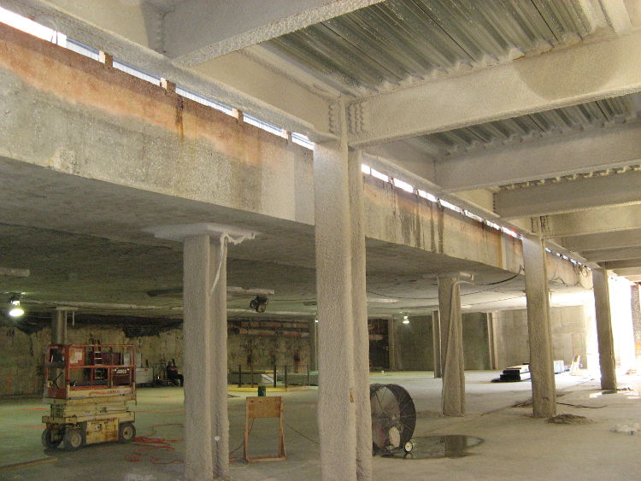
The following image shows a typical spray applied fireproofing on steel columns and beams.
Application of fireproofing spray

