Capillary pressure
Relative permeability and capillary pressure defined capillary pressure as the difference in pressure across the interface between two phases. Similarly, it has been defined as the pressure differential between two immiscible fluid phases occupying the same pores caused by interfacial tension between the two phases that must be overcome to initiate flow.

Capillary pressure equation
With Laplace’s equation, the capillary pressure P_{cow} between adjacent oil and water phases can be related to the principal radii of curvature R₁ and R₂ of the shared interface and the interfacial tension σ_{ow} for the oil/water interface:
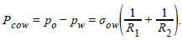....................(1)
The relationship between capillary pressure and fluid saturation could be computed in principle, but this is rarely attempted except for very idealized models of porous media..

Capillary pressure behavior
Fig. 1 shows a sketch of a typical capillary pressure relationship for gas invading a porous medium that is initially saturated with water; the gas/water capillary pressure is defined as P_{cgw}=p_{g}-p_{w}. For this example, water is the wetting phase, and gas is the nonwetting phase. As shown in Figs. 2 and 3, a wetting phase spreads out on the solid, and a nonwetting phase does not. Wettability of a solid with respect to two phases is characterized by the contact angle. Popular terminology for saturation changes in porous media reflects wettability:
- "Drainage" refers to the decreasing saturation of a wetting phase
- "Imbibition" refers to the increasing wetting-phase saturation
Thus, the capillary pressure relationship in Fig. 1 is for drainage—specifically primary drainage, meaning that the wetting phase (water) is decreasing from an initial value of 100%.
- 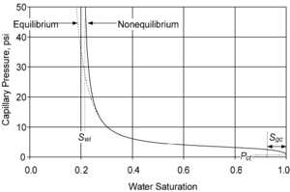
Fig. 1 – A typical capillary pressure relationship for primary drainage of water with invasion of gas. Water is the wetting phase.
- 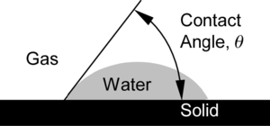
Fig. 2 - Water = wetting phase. A drop of water spreading on a solid, with a contact angle less than 90°.
- 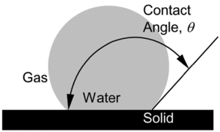
Fig. 3 – Water = nonwetting phase. A drop of water resting on a solid, with a contact angle greater than 90°.
Gas does not penetrate the medium in Fig. 1 until the capillary pressure exceeds the threshold pressure P_{ct}, which depends on the size and shape of the pores and the wettability of the sample. As capillary pressure increases beyond this value, the saturation of the water continues to decrease. It is generally believed that the gas cannot flow until its *saturation is greater than a critical level S_{gc}, which is often 5 to 15% of the total pore volume. If gas is not mobile below S_{gc}, then the capillary pressure relationship between S_{w} = 1–S_{gc} and S_{w} = 1 in Fig. 1 is fictitious, as suggested by Muskat^{[1]}—a detail largely ignored in later literature.
Below S_{w} = 1– S_{gc}, the capillary pressure increases with decreasing water saturation, with water saturation approaching an irreducible level S_{wi} at very high capillary pressures. Morrow and Melrose^{[2]} argue that capillary pressure measurements have not reached equilibrium if the capillary pressure trend asymptotically approaches an irreducible water saturation. As the water saturation decreases during a measurement, the capacity for flow of water rapidly diminishes, so the time needed for equilibration often increases beyond practical limitations. Hence, a difference develops between the measured relationship and the hypothetical equilibrium relationship, as shown in Fig. 1.

Wettability of porous material
As shown in Figs. 4 and 5, the wettability of the porous material is an important factor in the shape of capillary pressure relationships. Wettabilities of reservoir systems are categorized by a variety of names. Some systems are strongly water-wet, while others are oil-wet or neutrally wet. Spotty (or "dalmation") wettability and mixed wettability describe systems with nonuniform wetting properties, in which portions of the solid surface are wet by one phase, and other portions are wet by the other phase. Mixed wettability, as proposed by Salathiel,^{[3]} describes a nonuniform wetting condition that developed through a process of contact of oil with the solid surface. Salathiel hypothesized that the initial trapping of oil in a reservoir is a primary drainage process, as water (the wetting phase) is displaced by nonwetting oil. Then, those portions of the pore structure that experience intimate contact with the oil phase become coated with hydrocarbon compounds and change to oil-wet.
The drainage and imbibition terminology for saturation changes breaks down when applied to reservoirs with nonuniform wettability. Rather than using drainage and imbibition to refer to the decreasing and increasing saturation of the wetting phase, some engineers define these terms to mean decreasing and increasing water saturation, even if water is not the wetting phase for all surfaces.
Treiber et al.^{[4]} reported a study of wettabilities of 55 oil reservoirs. Twenty-five of the reservoirs were carbonate, and the others were silicic (28 sandstone, 1 conglomerate, and 1 chert). To characterize wettability, they used the following ranges for the oil/water/solid contact angle as measured through the water phase:
0 to 75° = water-wet 75 to 105° = intermediate-wet 105 to 180° = oil-wet

Wettability
The wettability moves from strongly water-wet at the top of the legend to strongly oil-wet at the bottom. With increasing oil wetness, the capillary pressure shifts upward, reflecting the increased pressure needed to push water into the pore spaces of the specimen.
- When strongly water-wet, S_{or} is approximately 14%.
- When intermediate-wet, S_{or} rises to approximately 35%.
- When strongly oil-wet, S_{or} returns to approximately 15%.

Nomenclature
p_{o} | = | pressure in the oil phase, m/Lt ², psi
p_{w} | = | pressure in the water phase, m/Lt ², psi
P_{cow} | = | capillary pressure between oil and water phases, m/Lt², psi
R₁, R₂ | = | principal radii of curvature, L
σ_{ow} | = | oil/water interfacial tension, m/t ², dyne/cm

References

• Muskat, M. 1949. Calculation of Initial Fluid Distributions in Oil Reservoirs. Trans. of AIME 179 (1): 119-127. http://dx.doi.org/10.2118/949119-G
• • Morrow, N.R. and Melrose, J.C. 1991. Application of Capillary Pressure Measurements to the Determination of Connate Water Saturation. In Interfacial Phenomena in Petroleum Recovery, 257-287, ed. N.R. Morrow. New York City: Marcel Dekker Inc
• • Salathiel, R.A. 1973. Oil Recovery by Surface Film Drainage in Mixed-Wettability Rocks. J Pet Technol 25 (10): 1216–1224. SPE-4104-PA. http://dx.doi.org/10.2118/4104-PA
• • Treiber, L.E. and Owens, W.W. 1972. A Laboratory Evaluation of the Wettability of Fifty Oil-Producing Reservoirs. SPE J. 12 (6): 531–540. SPE-3526-PA. http://dx.doi.org/10.2118/3526-PA
• • Morrow, N.R., Cram, P.J., and McCaffery, F.G. 1973. Displacement Studies in Dolomite with Wettability Control by Octanoic Acid. SPE J. 13 (4): 221–232. SPE-3993-PA. http://dx.doi.org/10.2118/3993-PA
• • Bethel, F.T. and Calhoun, J.C. 1953. Capillary Desaturation in Unconsolidated Beads. J Pet Technol 5 (8): 197-202. SPE-953197-G. http://dx.doi.org/10.2118/953197-G
• • Morrow, N.R. 1970. Irreducible wetting-phase saturations in porous media. Chem. Eng. Sci. 25 (11): 1799–1818. http://dx.doi.org/10.1016/0009-2509(70)80070-7
• • Chatzis, I., Morrow, N.R., and Lim, H.T. 1983. Magnitude and Detailed Structure of Residual Oil Saturation. SPE J. 23 (2): 311–326. SPE-10681-PA. http://dx.doi.org/10.2118/10681-PA
- • Jerauld, G.R. and Rathmell, J.J. 1997. Wettability and Relative Permeability of Prudhoe Bay: A Case Study In Mixed-Wet Reservoirs. SPE Res Eng 12 (1): 58–65. SPE-28576-PA. http://dx.doi.org/10.2118/28576-PA

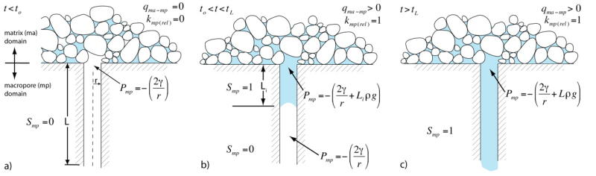

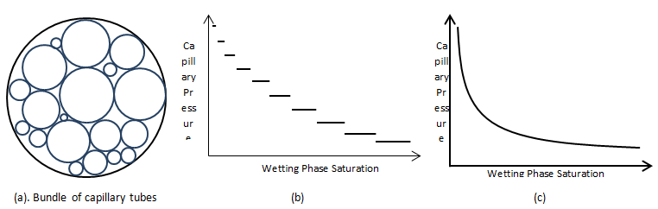

Comparison Between Capillary Pressure and Relative Permeability
Similarities and analogs between capillary pressure and relative permeability curves for a two phase system is shown in Figure 2-83.
Reservoir wettability is determined by complex interface boundary conditions acting within the pore space of sedimentary rocks. These conditions have a dominant effect on interface movement and associated oil displacement. Wettability is a significant issue in multiphase flow problems ranging from oil migration from source rocks to such enhanced recovery processes as alkaline flooding or alternate injection of CO2 and water.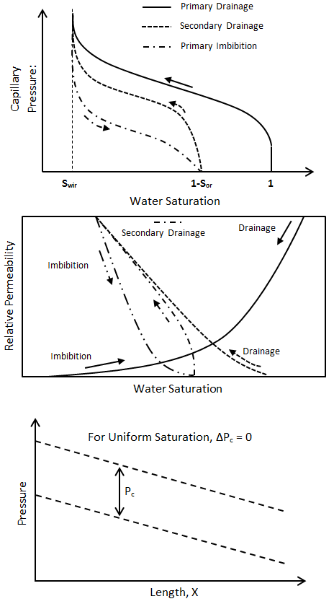
Figure 2-83: Comparison Between Capillary Pressure and Relative Permeability Curves

Fluid Distribution in Two Phase Flow
There are several important points regarding the distribution of fluids in porous media under two-phase flow condition. The wetting phase seeks to maintain its continuum in the network of pore space involving the relatively small pore throats connecting pore bodies. While the non-wetting phase seeks to maintain a continuum in a pore network involving the large pore throats. As the non-wetting phase saturation increases, the wetting phase is “trapped” in the pore spaces accessible through relatively small pore throats. However, as the non-wetting phase saturation decreases, k_{rnw} decreases (i.e. imbibition displacement) the wetting phase imbibes into relatively small pore throats and pore bodies in a hierarchical manner. This results in the non-wetting phase being trapped in the relatively large pore bodies and large pore throats connecting trapped oil in pore bodies. Also, in a water-wet formation at S*_{or} conditions, only water is flowing and k_{ro}(S*_{or}) is equal to zero. However, if the formation is oil-wet, at S*_{or} conditions, k_{ro}(S*_{or}) is very small (10⁻²) but never becomes zero because of wetting “film” flow. Additionally, if the IFT is very small, there is a significant change in the relative permeability characteristics.
Phase behaviour
describes the phase or phases in which a mass of fluid exists at given conditions of pressure, volume and temperature (PVT) 4. PHASE BEHAVIOUR OF HYDROCARBONS When fluids are produced from a subsurface reservoir to the surface both temperature and pressure are reduced
Natural gas and crude oil are naturally occurring hydrocarbon mixtures that are found underground and at elevated conditions of pressure and temperature. They are generally referred to as petroleum fluids. Petroleum fluids are principally made up of hydrocarbons; but few non-hydrocarbon components may be present such as nitrogen, carbon dioxide and hydrogen sulfide.
We make no mistake when we refer to Natural Gas and Petroleum Engineers as Fluid Engineers. This is, engineers that deal with fluids to make a living. Moreover, we specialize in two special fluids whose importance to the society cannot be overstated--indeed, humankind rely on natural gas and crude oil as the premier source of energy that keeps the society operative. As a consequence, we may very well be titled as Hydrocarbon Fluid Engineers. That is everything we are basically about. At every stage of the oil business, a Hydrocarbon Fluid engineer is required. This is, reservoir analyses, drilling operation, production operation, processing, among others, reveal the wide spectrum of areas where an engineer with expertise on hydrocarbon fluids is fundamental.
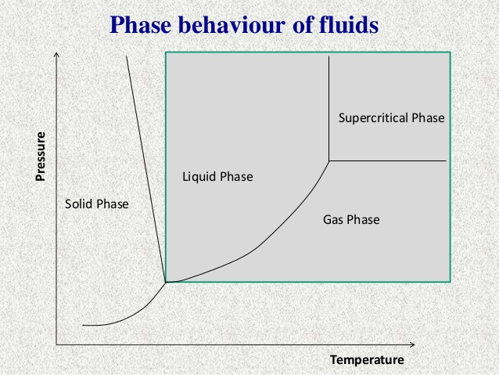
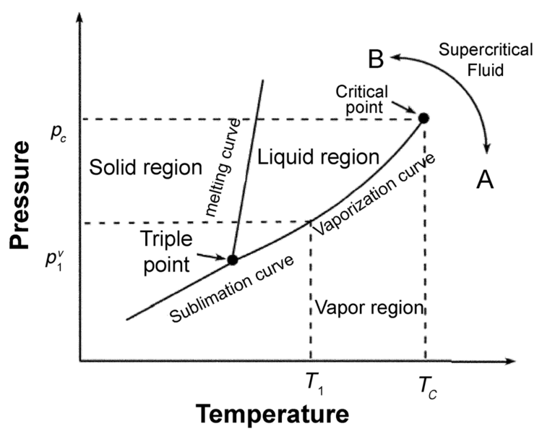
Phase behavior for pure fluids
Pressure depletion
The method of producing a gas reservoir that is not associated with a water drive. Gas is removed and reservoir pressure declines until all the recoverable gas has been expelled.
The loss or decline in reservoir pressure resulting from pressure drawdown during the production of gas or oil. Also known as pressure depletion.
Increased infill drilling in low permeability gas reservoirs has made it important to understand the fracture geometry evolution within or near the drainage area of older offset producers. The offset producers with induced hydraulic fractures create a pressure depleted zone with pressure gradient from the drainage boundary to the fracture surface. The intensity and the extent of this depleted area is controlled by the cumulative production, pore-volume, hydrocarbon saturation, effective permeability and the original reservoir or pore pressure. Such pore pressure depletion causes stress gradients in the drainage area of the producers with higher stresses near the drainage boundary and lower stresses around the fracture surface in the producer. The fracture initiated from an offset well close to this drained envelope is preferentially extended towards the depleted zone due to reduced closure stress in that direction. This effect is extensively studied and proven with actual tiltmeter measurements in the shallow Diatomite formation in the Lost Hills field in California by Wright et al. Theoretical preview of different mechanisms responsible for fracture geometry evolution associated with effective stress changes are widely studied and presented in the literature. Such sensitivity of pore pressure depletion to the fracture geometry evolution is the premise to this present work.

Water flooding recovery
A method of secondary recovery whereby water is pumped into reservoir rock to force out oil that has ceased to flow under its own pressure.
In the oil industry, waterflooding or water injection is where water is injected into the oil field, usually to increase pressure and thereby stimulate production. Water injection wells can be found both on- and offshore, to increase oil recovery from an existing reservoir.
Water flooding was first practiced for pressure maintenance after primary depletion and has since become the most widely adopted improved-oil-recovery (IOR) technique. It is now commonly applied at the outset of reservoir development. The reservoir-connate-water composition usually differs significantly from the composition of water available for injection. Parametric laboratory studies of crude-oil recovery showed that, for connate and injected brines of the same or different composition, waterflood recoveries could differ substantially depending on brine composition. However, laboratory tests designed to predict waterflood performance usually have not incorporated the difference in connate and injected brines.
Water Injection Methods
The water used for water injection is usually some sort of brine, but it can also be made up of other sources that are treated. For example, in some reservoirs water is produced with the hydrocarbons, removed from the production and re-injected into the formation.
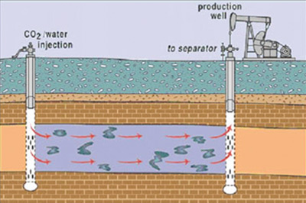
It is important that the water being injected works within the formation. Filtration and processing of the water that will be injected are sometimes necessary to ensure that no materials clog the well pores and that bacteria is not permitted to grow. In an effort to reduce any corrosion within the reservoir, oxygen is often removed from the water, as well.
While production wells can be converted into injection wells, water-injection wells are also drilled specifically for this purpose. Water is then pumped into the reservoir, or gravity can help to push the liquid into the formation. This solution positions water tanks on hills or somewhere above the well, and the water simply is fed into the wellbore.
There are a number of techniques for determining where the water-injection wells should be drilled, as well as established patterns for water-injection wells in relation to production wells. One popular pattern, called the five-spot pattern, involves drilling four water-injection wells in a square around a production well. This is repeated around each production well on the reservoir, resulting in four production wells surrounding each water-injection well, as well.
Other drilling techniques include the seven-spot pattern, which has six water-injection wells surrounding a production well, and the inverted seven-spot pattern, which describes six production wells surrounding one water-injection well.
Also, wells can be drilled in line patterns, rather than spot patterns, where a direct line or staggered line of production wells is followed by a similar line of water-injection wells, and so on. In an edge waterflood, water-injection wells are drilled along the outside borders of the field, and water is injected, with production flowing toward the production wells in the center of the reservoir.

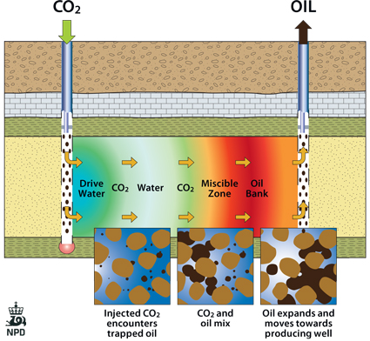

Break through technologies
A description of reservoir conditions under which a fluid, previously isolated or separated from production, gains access to a producing wellbore. The term is most commonly applied to water or gas breakthrough, where the water or gas injected to maintain reservoir pressure via injection wells breaks through to one or more of the producing wells.

