**Fundamental Traffic Flow Concept**

**1. Overview**

Traffic flow theory involves the development of mathematical relationships among the primary elements of a traffic stream: flow, density, and speed. These relationships help the traffic engineer in planning, designing, and evaluating the effectiveness of implementing traffic engineering measures on a highway system.

So traffic flow theory relies on three entities to describe the operations of a transportation system element: speed, flow, and density.

**1.** The average speed of the traffic stream is a fairly intuitive measure that describes how fast or slow, on average, traffic moves on a segment of roadway, and is typically measured in miles per hour (mph) or kilometers per hour (km/h). Traffic flow theory further distinguishes between time mean speed (TMS) and space mean speed (SMS) as described in the following, with the latter being the preferred and correct term to describe operations on a roadway segment.

**2.** The traffic flow is a measure of throughput through the system element, and is typically measured in vehicles per hour (veh/h), or sometimes vehicles per hour per lane of travel (veh/h per lane). The traffic flow is closely tied to the demand on the segment, as well as its capacity, which may impact and limit the throughput if demand exceeds that capacity.

**3.** Finally, density is a measure of how many vehicles are found on a given length of roadway segment, and is typically expressed in vehicles per mile per lane (veh/mi per lane) or vehicles per kilometer per lane (veh/km per lane).

Time Headway

Time headway (h) is the difference between the time the front of a vehicle arrives at a point on the highway and the time the front of the next vehicle arrives at that same point. Time headway is usually expressed in seconds.

Space Headways

Space headway (d) is the distance between the front of a vehicle and the front of the following vehicle and is usually expressed in feet.

Any of these measures can be calculated from the fundamental relationship of traffic flow, as follows:

* Speed (u)
  + Rate of motion (mph)
* Density (k)
  + Rate of traffic over distance (vpm)
* Volume (V)
  + Amount of traffic (vph)
* Flow (q)
  + Rate of traffic (vph); equivalent hourly rate



Each can also be observed and quantified in the field, with the measurement of speeds and flow rates often being much simpler than direct measurements of density. Therefore, density is often calculated from speed and flow, rather than being measured directly.

**1.2 Speed Density Relationship**

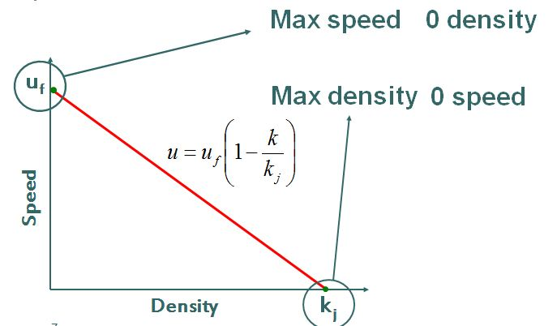



**1.3 Flow- Density Relationship**



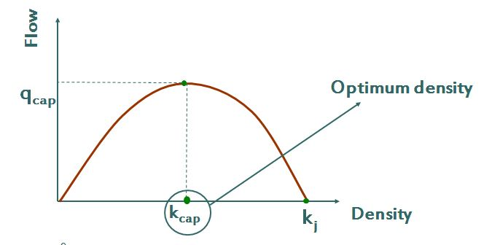

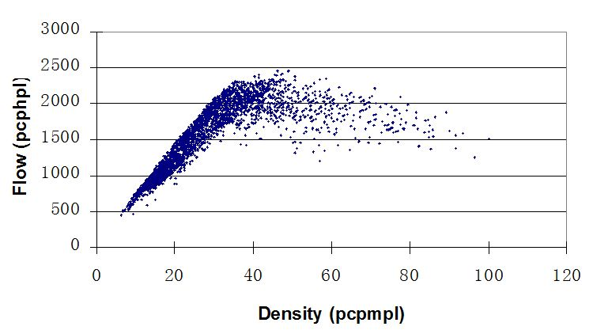

**Flow – density (and speed)**

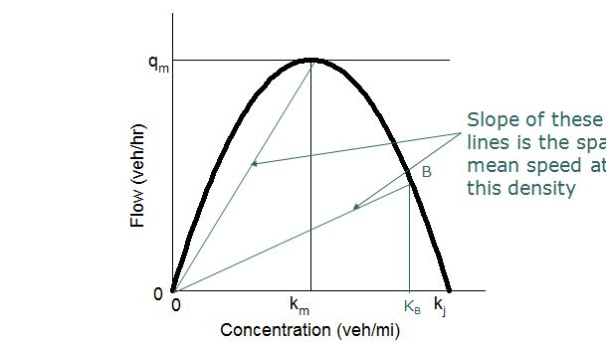

**1.4 Speed-Flow Relationship**



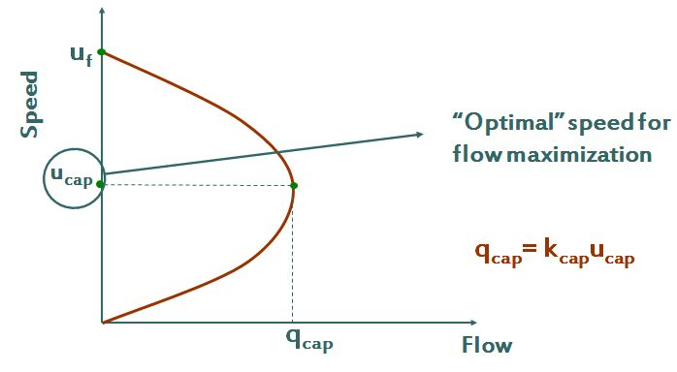



**2. Time Mean Speed versus Space Mean Speed**

In traffic operations, two different definitions exist for the measurement of speed: time mean speed (TMS) and space mean speed (SMS). In most HCM methodologies, the SMS is the correct metric to, for example, describe the average speed over a freeway segment. However, field studies often measure speeds at a point (through sensors, radar speed measurements, etc.), and the commonly used arithmetic average of those speed observations yields the TMS, not SMS. In other words, field studies often average speeds over time, while HCM methods require the speeds to be averaged over space. The TMS is generally slightly larger than the SMS, although the difference is typically on the order of 2% or less.

The time mean speed is defined as the arithmetic average speed of vehicles passing through a point, and is calculated using Eq. (1):

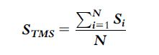

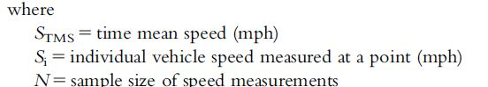

The space mean speed (SMS) can be calculated using a straight average of speeds, only if speeds were measured over a segment. For example, if the analyst has access to a record of individual vehicle travel times and converts those to individual speeds by dividing the segment length by these travel times, then an average of the resulting speeds yields the space mean speed. This can also be achieved by first summing the individual travel times ti, and factoring out the segment length, L, as is shown in Eq. (2):

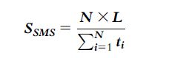

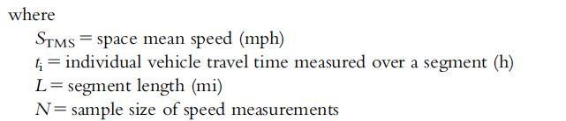

Alternatively, the space mean speed can be calculated directly from point measurements of vehicles passing through a point by using the harmonic mean (as opposed to the arithmetic mean) as shown in Eq. (3):

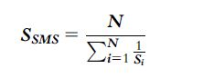

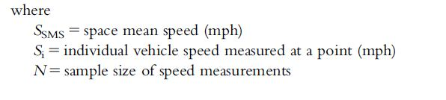

In traffic operation applications, analysts generally use the space mean speed. Depending on whether speed measurements are available as point speeds, or in the form of segment speeds (from travel times), the analyst should therefore use Eq. (3) and Eq. (2), respectively.

**Example 1**

A speed study collected speeds from nine vehicles at a fixed point as follows:

35 mph, 40 mph, 32 mph, 41 mph, 38 mph, 37 mph, 40 mph, 36 mph, and 39 mph.

Calculate the time mean speed and space mean speed. Also, assuming these vehicle speeds are fixed over a 1/2-mile segment, calculate the corresponding travel times and show that the space mean speed calculated from these travel times matches the point estimate.

Solution:

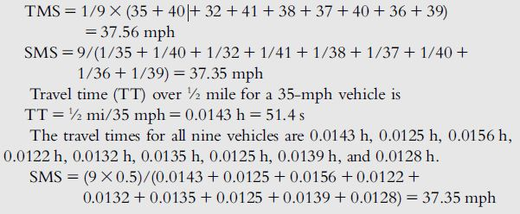

**3. Macro versus Micro Characteristics of Traffic**

The concepts of speed, flow, and density are key macroscopic characteristics of the traffic stream. They are immensely useful when describing the aggregated performance of a number of vehicles (say over a 15-min period), and follow useful relationships that allow for making predictions of future and changing traffic states. However, it is important to consider the microscopic characteristics of individual vehicles or better drivers, as well as the relationship between the individual driver and the aggregated speed-flow-density characteristics of the traffic stream.

A principal microscopic characteristic of traffic is the time headway, which is defined as the time between successive vehicles traveling through a fixed point. It is measured as the time between when the front bumper (or other fixed element) of vehicle 1 passes through a point until the front bumper of vehicle 2 (same element) passes through that same point.

The minimum headway between vehicles on an arterial street has been shown through research to be approximately 2 s. In other words, it takes a minimum of 2 s per vehicle to pass through a fixed point on an arterial street. Summing 2 s per vehicle to a full hour of observation, yields the relationship:

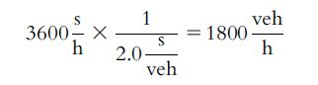

The resulting 1800 veh/h is the maximum number of vehicles that can pass through a point in one hour, provided there are no interruptions such as traffic signals. For traffic signals, the resulting flow rate is also referred to as the saturation flow rate, which is equivalent to the maximum flow rate per hour of continuous green, and will emerge as a key parameter in describing and analyzing the capacity of a signalized intersection. In other words, the maximum (saturation) flow rate is equal to the inverse of the minimum (saturation) headway between vehicles.

For arterial streets, the saturation headway is around 2 s (varying between about 1.9 s and 2.1 s depending on driver aggressiveness), resulting in a saturation flow rate of 1800 veh/h (or a range from 1900 to around 1700 veh/h). For basic freeway segments, the minimum headway can be as low as 1.5 s, which yields the freeway capacity of (3600 s/h)/ (1.5 s/veh) 52400 veh/h as described in Table 1 below.

**Table 1 Typical capacities of highway systems**

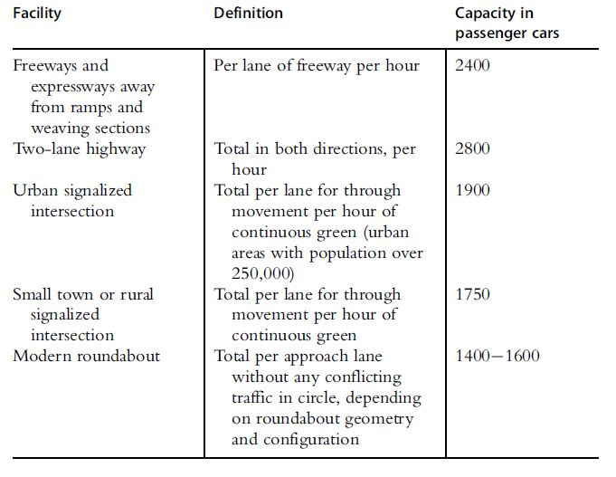

Any characteristics that may increase the minimum headway including curvature (e.g., left and right turn at signals or travel through a roundabout), grade, lane widths, or frictional effects from weather, work zones, or incidents will thus reduce the saturation flow rate or capacity of the transportation system element. To measure the capacity of a system element, one could thus measure the aggregated throughput over 15 min or 1 h, or one could measure the saturation headways, and then convert to the hourly flow rates.

Another critical microscopic traffic parameter is the spacing between vehicles, which is the distance between two vehicles when traveling at some headway and prevailing speed. If the headway is the time between successive vehicles passing a fixed point, the spacing is the distance between those two vehicles, obtained conceptually from taking a photograph of the two vehicles and measuring the distance between them (or technically from front bumper to front bumper). The spacing can be calculated by multiplying the headway by the vehicle speed. For example, a 50-mph arterial with a minimum headway of 2 s/veh results in a spacing at that speed of:

Capture.JPG

With increasing vehicle speed, the spacing also increases, provided the headway stays constant. One simple way to rationalize why the capacity of a freeway is higher than that of an arterial street (i.e., why the minimum headway for a freeway is lower than the minimum headway for an arterial) is to look at spacing. Figure 1 below illustrates that the aforementioned spacing for a 50-mph arterial and a headway of 2 s is essentially the same as the spacing for a 70-mph freeway with a headway of 1.5 s (146.7 ft/veh compared to 154.0 ft/veh).

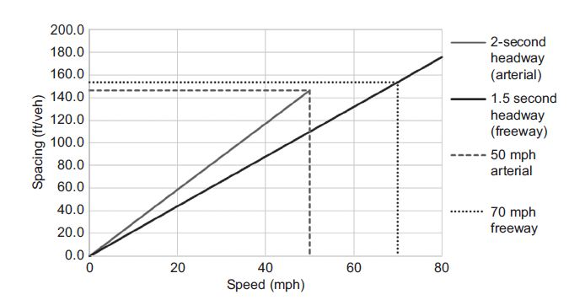

**Figure 1.** Illustration of spacing versus speed for arterials and freeways.

While this oversimplifies the explanation (e.g., driver reaction times and visual abilities are impacted by speed), it nonetheless illustrates how important it is to understand the relationship between micro and macro characteristics of the traffic stream. Flow rate (F) is the inverse of headway (h); spacing (x) is the product of headway (h) and speed (S); and density (D) can be estimated from the inverse of the spacing (s) of vehicles. A summary of these relationships, corresponding equations, and associated units is shown in Table 2.

**Table 2**. Summary of Macro and Micro Relationships.

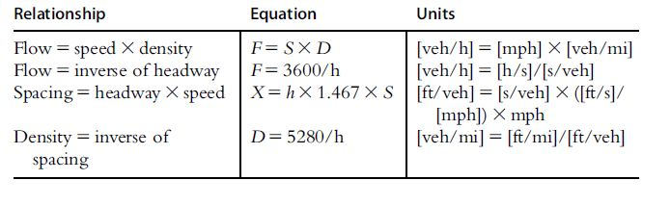

**4.** **Time-Space Diagram**

Time space diagram is a convenient tool in understanding the movement of vehicles. It shows the trajectory of vehicles in the form of a two dimensional plot. Time space diagram can be plotted for a single vehicle as well as multiple vehicles.

**Single vehicle**

Taking one vehicle at a time, analysis can be carried out on the position of the vehicle with respect to time. This analysis will generate a graph which gives the relation of its position on a road stretch relative to time. This plot thus will be between distance x and time t and x will be a functions the position of the vehicle for every t along the road stretch. This graphical representation of x(t) in a (t, x) plane is a curve which is called as a trajectory.

The trajectory provide an intuitive, clear, and complete summary of vehicular motion in one dimension.

In figure 2(a), the distance x goes on increasing with respect to the origin as time progresses. The vehicle is moving at a smooth condition along the road way. In figure 2(b), the vehicle at first moves with a smooth pace after reaching a position reverses its direction of movement. In figure 2(c), the vehicle in between becomes stationary and maintains the same position.

From the figure, steeply increasing section of x(t) denote a rapidly advancing vehicle and horizontal portions of x(t) denote a stopped vehicle while shallow sections show a slow-moving vehicle. A straight line denotes constant speed motion and curving sections denote accelerated motion; and if the curve is concave downwards it denotes acceleration. But a curve which is convex upwards denotes deceleration.

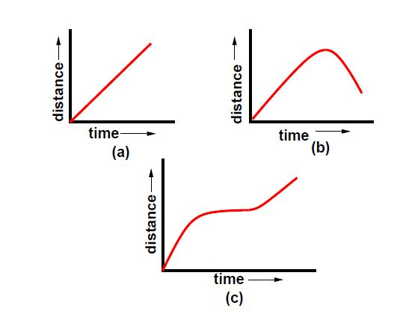

**Figure 2:** Time space diagram for a single vehicle.

**Multiple Vehicles**

Time-space diagram can also be used to determine the fundamental parameters of traffic flow like speed, density and volume. It can also be used to find the derived characteristics like space headway and time headway. Figure 3 shows the time-space diagram for a set of vehicles traveling at constant speed. Density, by definition is the number of vehicles per unit length. From the figure, an observer looking into the stream can count 4 vehicles passing the stretch of road between x1 and x2 at time t. Hence, the density is given as:

Capture.JPG

We can also find volume from this time-space diagram. As per the definition, volume is the number of vehicles counted for a particular interval of time. From the figure 22.3 we can see that 6 vehicles are present between the time t1 and t2. Therefore, the volume q is given as:

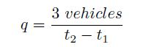

Again the averages taken at a specific location (i.e., time ranging over an interval) are called time means and those taken at an instant over a space interval are termed as space means.

Another related definition which can be given based on the time-space diagram is the headway. Space headway is defined as the distance between corresponding points of two successive vehicles at any given time. Thus, the vertical gap between any two consecutive lines represents space headway. The reciprocal of density otherwise gives the space headway between vehicles at that time.

Similarly, time headway is defined as the time difference between any two successive vehicles when they cross a given point. Thus, the horizontal gap between the vehicles represented by the lines gives the time headway. The reciprocal of flow gives the average time headway between vehicles at that point.

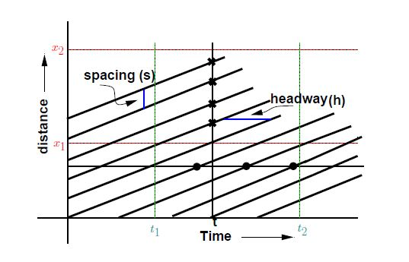

**Figure 3**: Time space diagram for many vehicles.

**Problem**

Show the trajectory of a vehicle moving along a road with constant speed, approaches an intersection, slows down, stop for a while, then takes a U-turn and travel back with original speed.

**Problem**

If an observer standing beside a road noted that the vehicles are passing him every 3 seconds. If so what is the flow rate.

**Problem**

An observer standing beside a road starts counting vehicle passing him from 4pm to 4:20pm and he counts about 580 vehicles. What is the average time headway.