Traffic Engineering
Pedestrian Flow Theory

Key differences between car traffic and pedestrian traffic
Aspect Dimensionality Direction Multiple Contact Interaction Rules
Cars Movement in one dimension Single direction flow No physical contact strongly affect interactions
Pedestrians Movement in two dimensions directional flow Physical contact drives dynamics
Subconscious drives behavior

Pedestrian Data collections
Many traditional observation techniques are not suitable for pedestrian flow observation (inductive loops, pneumatic tubes)

examples of ped data collection
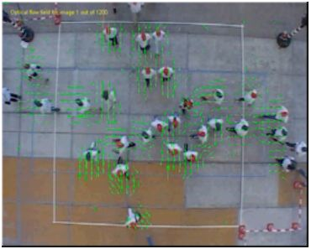
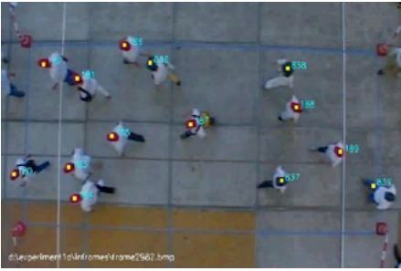

Pedestrian Flow Characteristics
1. Flow
2. Density
3. Speed
Microscopic flow variables
•Pedestrian trajectories describe position of a pedestrians as a function of t
• Example taken from TUD pedestrian experiments
• Projection of 2D movement onto main direction of motion yields regular trajectories in which overtaking / passing etc can be identified.
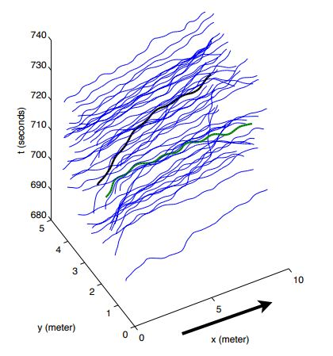
Passing maneuver in xt-plane
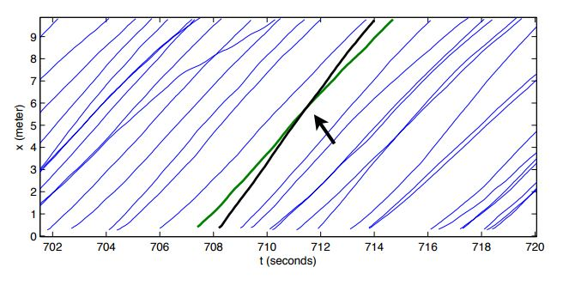

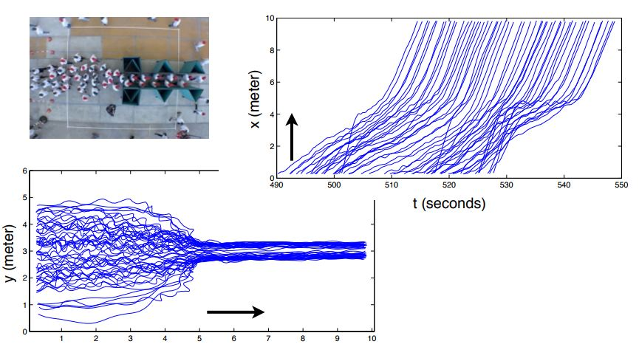

Density:
Is an instantaneous variable describing number of pedestrians in an area per unit area (P/m2).

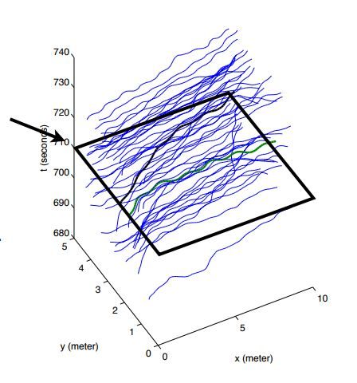

Flow: can be defined in relation to a cross section (a line in two-dimensional space).

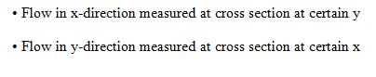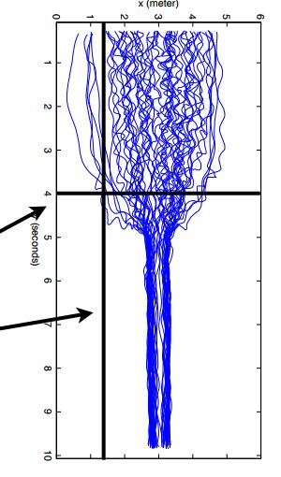

• Flow at a location (x,y) thus has direction

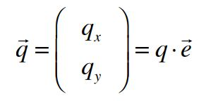

Service Levels Identification

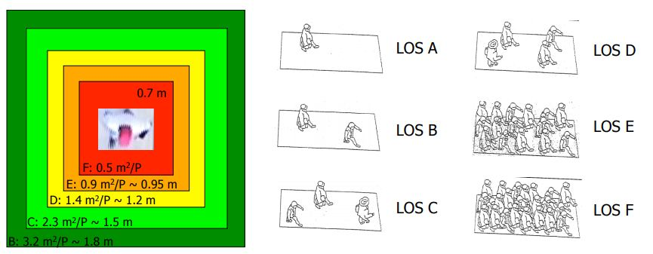

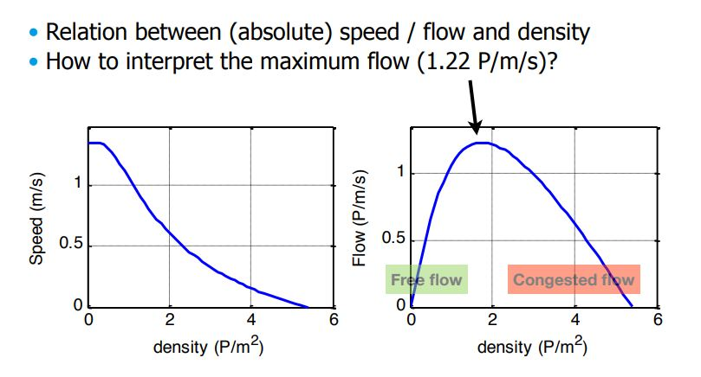

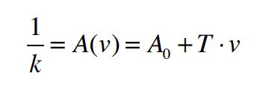

Factors affecting the FD

• Flow composition
- Age, gender,
- Walking purpose (e.g. leisure, commuting, shopping)
• Walking infrastructure
- Surface inclination
- Stairs
• Environment
- Temperature,
- weather conditions.

Impact of gender and age

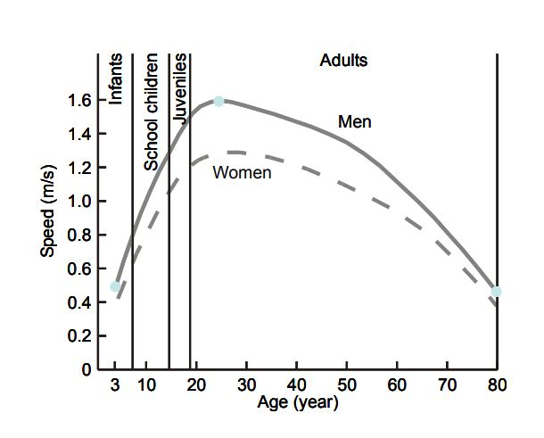

Fundamental diagram Hajj

Measured flow-density relation at Jamarat bridge

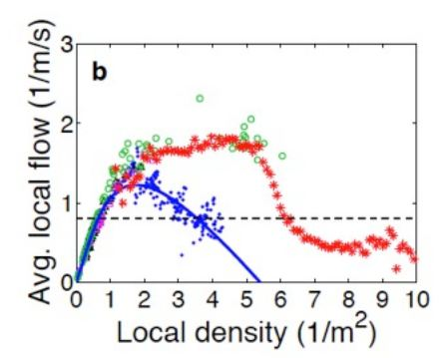

Pedestrian crowds

Existence of new ‘turbulent’ traffic state:
• Dynamics of flow are governed by physical interactions.
• Density is extremely high (8-10 P/m2).
• Pedestrians move uncontrolled in multiple directions.
• Pressure on pedestrians can be very high, situation is very dangerous.

