- Hardness
Hardness is a measure of how resistant solid matter is to various kinds of permanent shape change when a compressive force is applied. Some materials (e.g. metals) are harder than others (e.g. plastics). Macroscopic hardness is generally characterized by strong intermolecular bonds, but the behavior of solid materials under force is complex; therefore, there are different measurements of hardness: scratch hardness, indentation hardness, and rebound hardness.
Hardness is dependent on : ductility, elastic stiffness, plasticity, strain, strength, toughness, viscoelasticity, and viscosity.
- Measuring hardness
There are three main types of hardness measurements: scratch, indentation, and rebound. Within each of these classes of measurement there are individual measurement scales. For practical reasons conversion tables are used to convert between one scale and another.

Scratch hardness
Scratch hardness is the measure of how resistant a sample is to fracture or permanent plastic deformation due to friction from a sharp object. The principle is that an object made of a harder material will scratch an object made of a softer material. When testing coatings, scratch hardness refers to the force necessary to cut through the film to the substrate.
In order to use it a weight of known mass is added to the scale arm at one of the graduated markings, the tool is then drawn across the test surface. The use of the weight and markings allows a known pressure to be applied without the need for complicated machinery.
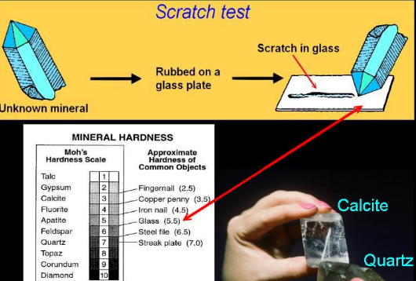
The Mohs scale of mineral hardness is a qualitative ordinal scale characterizing scratch resistance of various minerals through the ability of harder material to scratch softer material. Created in 1812 by German geologist and mineralogist Friedrich Mohs, it is one of several definitions of hardness in materials science such as concrete .

Indentation hardness
Indentation hardness measures the resistance of a sample to material deformation due to a constant compression load from a sharp object; they are primarily used in engineering and metallurgy fields. The tests work on the basic premise of measuring the critical dimensions of an indentation left by a specifically dimensioned and loaded indenter.

Macro indentation tests
The term "macro indentation" is applied to tests with a larger test load, such as 1 kgf or more. There are various macro indentation tests, including:
- Vickers hardness test (HV), which has one of the widest scales
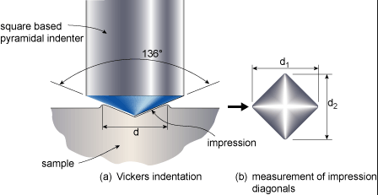
- Brinell hardness test (HB)
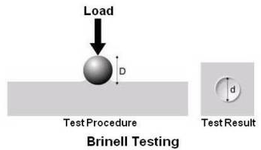
- Knoop hardness test (HK), for measurement over small areas
- Janka hardness test, for woodThe Janka Side Hardness test measures the force required to press an 11.28mm (0.444 inch) steel ball to half its diameter cross-grain into a block of wood. This force is recorded in both pounds-force (lbf) and kilo-Newtons (kN).
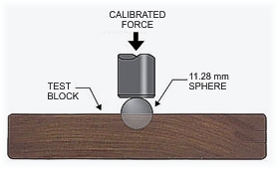
- Meyer hardness test
- Rockwell hardness test (HR), principally used in the USA
Shore hardness test, for polymers , rubbers and elastomers :Durometer is one of several measures of the hardness of a material.Higher numbers indicate harder materials; lower numbers indicate softer materials.Durometer is typically used as a measure hardness in polymers, elastomers, and rubbers, The A scale is for softer ones, while the D scale is for harder ones.

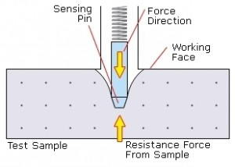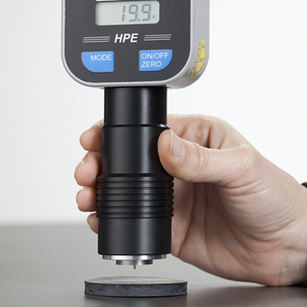

- Barcol hardness test, for composite materials.
The Barcol hardness test characterizes the indentation hardness of materials through the depth of penetration of an indentor, loaded on a material sample and compared to the penetration in a reference material. The method is most often used for composite materials such as reinforced thermosetting resins or to determine how much a resin or plastic has cured.

Hardness comparison table
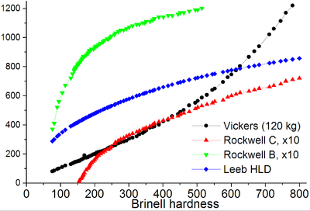
- Microindentation tests
The term "microhardness" has been widely employed in the literature to describe the hardness testing of materials with low applied loads. A more precise term is "microindentation hardness testing." In microindentation hardness testing, a diamond indenter of specific geometry is impressed into the surface of the test specimen using a known applied force (commonly called a "load" or "test load") of 1 to 1000 gf. Microindentation tests typically have forces of 2 N (roughly 200 gf) and produce indentations of about 50 μm. Due to their specificity, microhardness testing can be used to observe changes in hardness on the microscopic scale. Unfortunately, it is difficult to standardize microhardness measurements; it has been found that the microhardness of almost any material is higher than its macrohardness. Additionally, microhardness values vary with load and work-hardening effects of materials. The two most commonly used microhardness tests are tests that also can be applied with heavier loads as macroindentation tests:
- Vickers hardness test (HV)
- Knoop hardness test (HK)

Rebound hardness
Rebound hardness, also known as dynamic hardness, measures the height of the "bounce" of a diamond-tipped hammer dropped from a fixed height onto a material. This type of hardness is related to elasticity. The device used to take this measurement is known as a scleroscope ,Two scales that measures rebound hardness are the Leeb rebound hardness test and Bennett hardness scale.

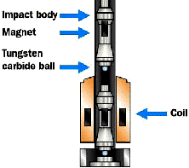

Materials and hardness :
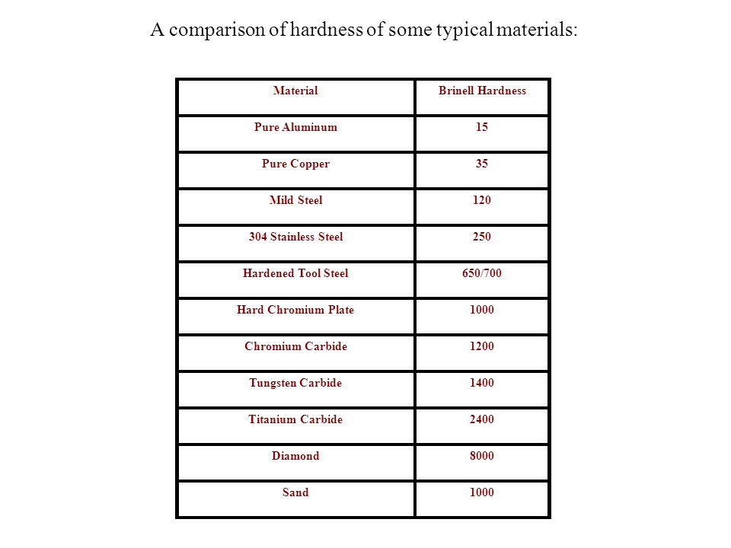
Relation between hardness and strength
For many materials , relationship between ultimate strength and Brinell hardness number is roughly linear :
For steel :
σ_{ult}= 3.4 HB (MPa)
For Cast Iron
σ_{ult}= 1.58 HB (MPa)

Measuring Concrete Hardness
As we all know “concrete gets hard”, but how is that measured and what does that mean to you when installing polymer coatings or systems?
The two most common tests are:
- Rebound Test Hammer Method
The rebound hammer method, also commonly referred to the Schmidt Hammer is a test to check the impact strength of a concrete substrate. This hammer has a piston that is engaged easily by the user, then when pushed on to the concrete “fires”. The scale on the hammer then produces a reading in PSI (pounds per square inch) of the tested area. Low readings could signify faulty strength concrete or hollow spots. These need to be addressed prior to doing any surface prep.
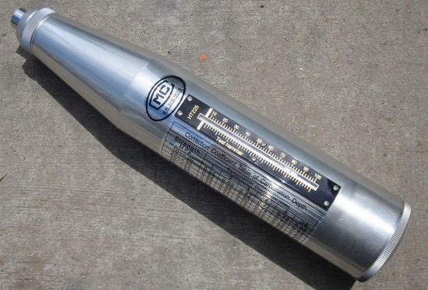
2. MoHS (Measure of Hardness Scale) Scratch Test
This test is more common today, especially with the large amount of concrete polishing that is being done.

Vibration
Any motion that repeats itself after an interval of time is called vibration or oscillation. The swinging of a pendulum and the motion of a plucked string are typical examples of vibration. The theory of vibration deals with the study of oscillatory motions of bodies and the forces associated with them.
A vibratory system, in general, includes a means for storing potential energy (spring or elasticity), a means for storing kinetic energy (mass or inertia), and a means by which energy is gradually lost (damper).

The vibration of a system involves the transfer of its potential energy to kinetic energy and of kinetic energy to potential energy, alternately. If the system is damped, some energy is dissipated in each cycle of vibration and must be replaced by an external source if a state of steady vibration is to be maintained.
Classification of Vibration
Vibration can be classified in several ways. Some of the important classifications are as follow:
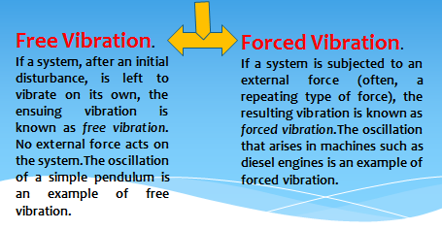

Failures by Vibration
If the frequency of the external force coincides with one of the natural frequencies of the system, a condition known as resonance occurs, and the system undergoes dangerously large oscillations. Failures of such structures as buildings, bridges, turbines, and airplane wings have been associated with the occurrence of resonance.
Case study
In April 1831, a brigade of soldiers marched in step across England's Broughton Suspension Bridge. According to accounts of the time, the bridge broke apart beneath the soldiers, throwing dozens of men into the water.
After this happened, the British Army reportedly sent new orders: Soldiers crossing a long bridge must "break stride," or not march in unison, to stop such a situation from occurring again.
Structures like bridges and buildings, although they appear to be solid and immovable, have a natural frequency of vibration within them. A force that's applied to an object at the same frequency as the object's natural frequency will amplify the vibration of the object in an occurrence called mechanical resonance.
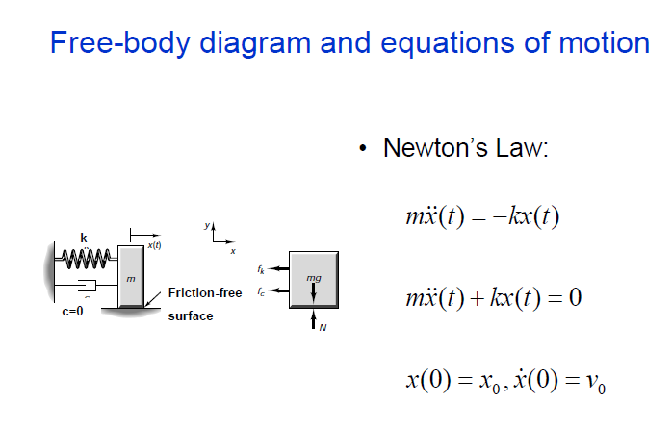
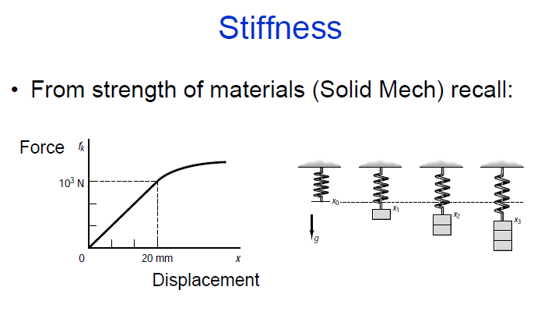
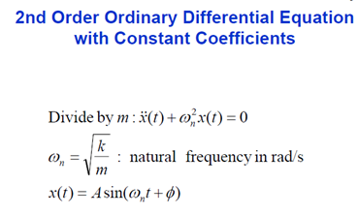
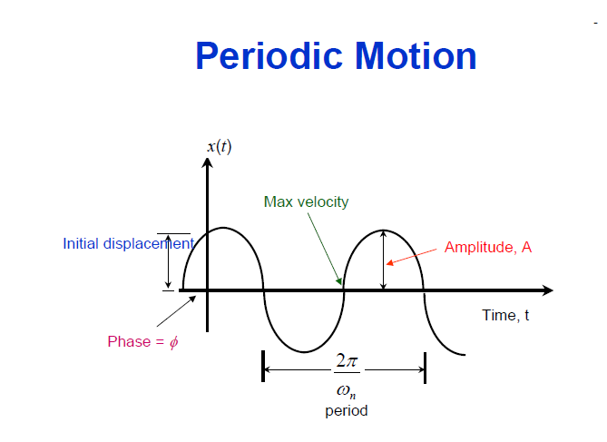

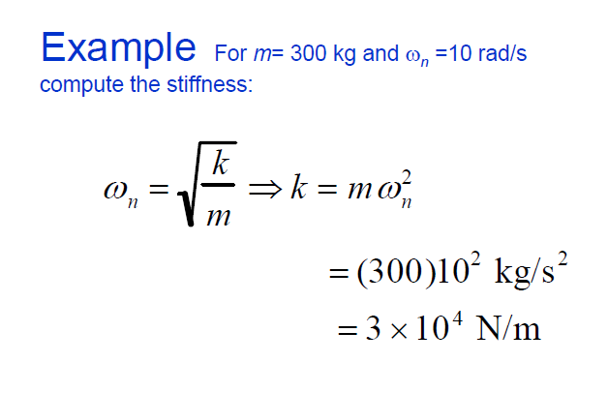
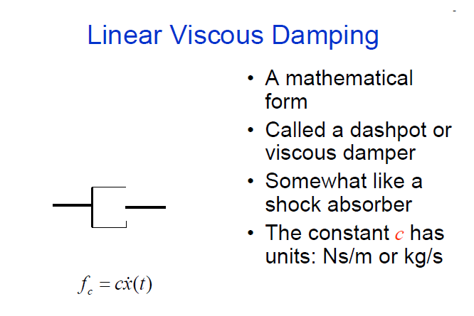
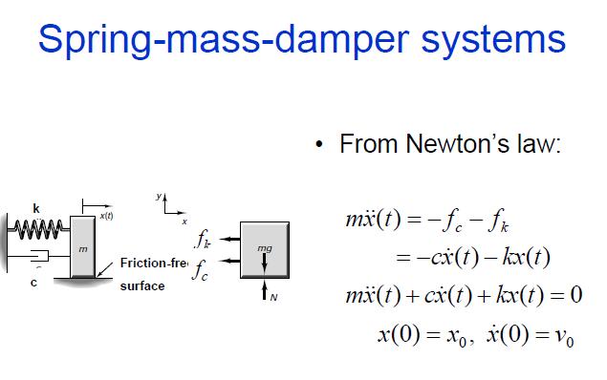
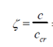
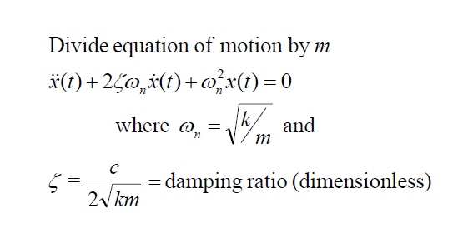

Continue

