**Q)** Dr. Munjed Al Muderis  was famous Professor in [orthopaedic](https://en.wikipedia.org/wiki/Orthopedic_surgery" \o "Orthopedic surgery) surgery. Al Muderis developed the new generation of implant, osseointegration [prosthetic limb](https://en.wikipedia.org/wiki/Prosthesis) (OPL) . In this method , Traditional and rigid socket based technology is now replaced with a surgery that inserts a [titanium](https://en.wikipedia.org/wiki/Titanium) implant into the bone.. the figure ( Q) is represent the new method , What are the most dangerous case in the three figures (a , b and c ) and Determine the maximum stress at **point F** for this case . Note : Weight of total body is **80 kg.**

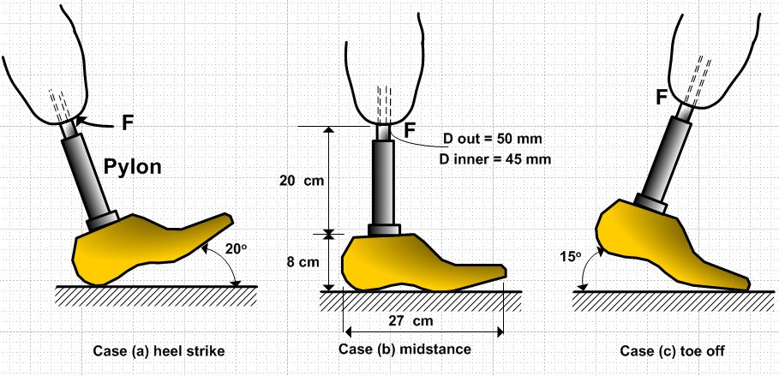

**Functionally graded materials (FGMs)**

Function graded materials are the advanced materials with varying properties in dimensions . These are made of two or more constituent phases with continuous and smoothly varying composition in preferred directions. The properties of material depend on the spatial position in the structure of material. These materials are gaining attention for biomedical application as biomaterials owing to flexibility in properties as desired.

Living tissues like bones and teeth are characterized as functionally graded material from nature. To replace these tissues, FGM serve an ideal compatible material . FGM has find wide range of application in dental and orthopedic applications for teeth and bone replacement. This paper review the biomedical applications of FGM as biomaterial for knee implant and dental implant.

**Types of Functionally Graded Materials**

At the inception of the development of the functionally graded materials, the concept was to remove the sharp interface that existed in the traditional composite material, and to replace it with the gradually changing interface, which was translated into the changing chemical composition of this composite at this interface region.

The porosity gradient functionally graded material is another type of FGM, in which the porosity in the material is made to change with the change in the spatial position in the bulk material. The shape and size of the pore are designed and varied, according to the required properties of the Functionally graded material.

1. **Compositional gradient FGM , 2- Microstructural gradient FGM and 3- porosity gradient FGM**



**FGM** has found wide range of application in orthopedic and dental for bone and

Teeth replacement although the knee joint may look like a simple joint, it is one of the most complex synovial joint in the body. It is a combination of articulations between the femur and patella and between the femoral condyles and tibial plateaus. Since in humans the knee supports nearly the whole weight of the body, it is the joint most vulnerable to both acute injury and the development of osteoarthritis. The total knee replacement (TKR) is now firmly established as a clinically efficacious modality for the relief of extreme pain associated with rheumatoid arthritis or trauma at the knee joint. A typical replacement joint consists of a tibial base plate or tray

Functional gradation is one characteristic feature of living tissue. Bio-inspired materials open new approaches for manufacturing implants for bone replacement. Different routes for new implant materials are presented using the principle of functional gradation. An artificial biomaterial for knee joint replacement has been developed by building a graded structure consisting of ultra-high molecular weight polyethylene (UHMWPE) fibre reinforced high-density polyethylene combined with a surface of UHMWPE. The ingrowth behaviour of titanium implants into hard tissue can be improved by depositing a graded biopolymer coating of fibronectin, collagen types I and III with a gradation, derived from the mechanisms occurring during healing in vivo. Functionally graded porous hydroxyapatite (HAP) ceramics can be produced using alternative routes, e.g. sintering of laminated structures of HAP tapes filled with polymer spheres or combining biodegradable polyesters such as polylactide, polylactide-co-glycolide and polyglycolide, with carbonated nanocrystalline hydroxyapatite. HAP–collagen I scaffolds are an appropriate material for in vitro growth of bone. The scaffold has to be functionally graded in order to create an optimised mechanical behaviour as well as the intended improvement of the cell ingrowth..

A variety of biomaterials and bio ceramics were investigated for FGM dental implants such as Ti/HA ,titanium/cobalt (Ti/Co), Ti/ZrO , titanium/ silica (Ti/SiO2), andTiN/HA.

**Smart materials** are designed materials that have one or more properties that can be significantly changed in a controlled fashion by external stimuli, such as [stress](https://en.wikipedia.org/wiki/Stress_(physics)), [temperature](https://en.wikipedia.org/wiki/Temperature), moisture, [pH](https://en.wikipedia.org/wiki/PH), [electric](https://en.wikipedia.org/wiki/Electric_field) or [magnetic](https://en.wikipedia.org/wiki/Magnetic_field) fields.

There are a number of types of smart material, some of which are already common. Some examples are as following:

1. [Piezoelectric](https://en.wikipedia.org/wiki/Piezoelectricity) materials are materials that produce a voltage when stress is applied. Since this effect also applies in the reverse manner, a voltage across the sample will produce stress within the sample. Suitably designed structures made from these materials can therefore be made that bend, expand or contract when a voltage is applied.
2. [Shape-memory alloys](https://en.wikipedia.org/wiki/Shape-memory_alloy) and [shape-memory polymers](https://en.wikipedia.org/wiki/Shape-memory_polymer) are materials in which large deformation can be induced and recovered through temperature changes or stress changes ([pseudoelasticity](https://en.wikipedia.org/wiki/Pseudoelasticity" \o "Pseudoelasticity)). The shape memory effect results due to respectively martensitic phase change and induced elasticity at higher temperatures.
3. [Magnetic shape memory](https://en.wikipedia.org/wiki/Magnetic_shape_memory) alloys are materials that change their shape in response to a significant change in the magnetic field.
4. [pH-sensitive polymers](https://en.wikipedia.org/wiki/PH-sensitive_polymers) are materials that change in volume when the pH of the surrounding medium changes.
5. [Temperature-responsive polymers](https://en.wikipedia.org/wiki/Temperature-responsive_polymers) are materials which undergo changes upon temperature.
6. [Halochromic](https://en.wikipedia.org/wiki/Halochromism) materials are commonly used materials that change their colour as a result of changing acidity. One suggested application is for paints that can change colour to indicate [corrosion](https://en.wikipedia.org/wiki/Corrosion) in the metal underneath them.
7. [Photomechanical materials](https://en.wikipedia.org/wiki/Photomechanical_effect) change shape under exposure to light.
8. [Polycaprolactone](https://en.wikipedia.org/wiki/Polycaprolactone) (polymorph) can be molded by immersion in hot water.
9. [Self-healing materials](https://en.wikipedia.org/wiki/Self-healing_material) have the intrinsic ability to repair damage due to normal usage, thus expanding the material's lifetime.
10. [Dielectric elastomers](https://en.wikipedia.org/wiki/Dielectric_elastomers) (DEs) are smart material systems which produce large strains (up to 300%) under the influence of an external electric field.
11. [Thermoelectric materials](https://en.wikipedia.org/wiki/Thermoelectric_materials) are used to build devices that [convert temperature differences into electricity and vice versa](https://en.wikipedia.org/wiki/Thermoelectric_effect).

**Shape Memory Alloys :**

Metals are characterized by physical and mechanical qualities such as tensile strength, malleability and conductivity. In the case of shape memory alloys, one can add the anthropomorphic qualities of memory and trainability. Shape memory alloys (SMA) exhibit what is called the shape memory effect. Shape memory effect (SME) is a unique effect of returning to an original geometry after a large inelastic deformation (near 10%) , that means SMA is able to remember and recover its original shape, after it has been deformed by heating over its transformation temperature.

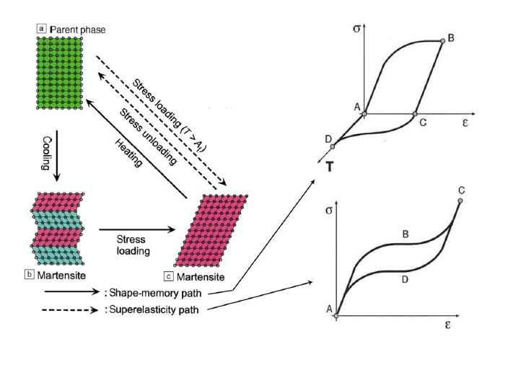

Fig. 1: Shape memory effect of SMAs

**Types of Shape Memory Alloys :**

Many alloys displaying the shape memory effect (SME) have been found and considerable effort is still being made to discover new materials. In recent years, the shape memory effect has been observed in many binary and ternary alloy systems.

These include AgCd, AuCd9 ,CuAlNi , CuAuZn, CuSn, CuZn. CuZnAl, CuZnGa. CuZnSi, CuSn, NiAl, FePt, FePd, MnCu and NiTi. Of these, only NiTi, CuZnAl and CuAlNi and their combinations with minute quantities of other elements are presently of commercial importance and have gained a wide acceptance in applications due to their better mechanical properties. Ni-Ti is the most widely used shape memory alloys for medical applications, The main Cu-based alloys are Cu-Al-Ni and Cu-Zn-Al alloys , Cu-based alloys have been used as an excellent alternative because they offer a wide range of transformation temperatures up to 200°C, a large superelastic effect, small thermal hysteresis and high damping coefficient. Cu-Al-Ni SMAs have been used in a wide range of applications, especially when the high temperatures are required. This is attributed to their high thermal stability and high transformation temperatures.

**Application Shape Memory Alloys** :

SMAs have found applications in many areas due to their high power density, solid state actuation, high damping capacity, durability and fatigue resistance. Accordingly, their use gives new possibilities of introduction to the market of innovative commercial products based on their particular characteristics, these characteristics of SMAs can be used for a number of applications according to the mechanism of these application there are three mechanism it’s like free recovery applications as blood-clot filters and stent in catheter ( medical application ) , constrained recovery applications as hydraulic couplings, force actuators as fire safety valves, proportional control as fluid flow control valve . Super elastic applications as eyeglass frames and guide wires for steering catheters into vessels in the body , damping applications, figure (2) shows some of SMAs products .

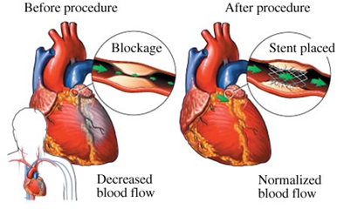

Fig. 2 : stent Shape memory alloys application

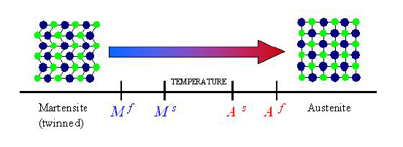

Fig. 3 : Phase transformation temperature

**Shape Memory Effect (SME) :**

The shape memory effect (SME) refers to the ability of the material, initially deformed in its low-temperature phase (martensite), to recover its original shape upon heating to its high-temperature phase (austenite or parent phase), i.e. if a macroscopic deformation is applied when the material is in the martensitic state, and then the temperature is raised, the plastic strain will recover upon heating and the material will return to its original shape. Upon cooling in the absence of an applied load, the crystal structure changes from austenite to martensite. The phase transition from austenite to martensite is termed the forward transformation. The transformation results in the formation of several martensitic variants, some of variants occur such that the average macroscopic shape change is negligible, resulting in twinned martensite. When the material is heated from the martensitic phase, the crystal structure transforms back to austenite, and this transition is called reverse transformation, during which there is no associated shape change.

**Nanotechnology** is enabling technology that deals with nano-meter sized objects. It is expected that nanotechnology will be developed at several levels: materials, devices and systems. The Nano materials level is the most advanced at present, both in scientific knowledge and in commercial applications. A decade ago, nanoparticles were studied because of their size-dependent physical and chemical properties.

**Application of Nanotechnology as bio materials:**

* **Tissue engineering**

Natural bone surface is quite often contains features that are about 100 nm across. If the surface of an artificial bone implant were left smooth, the body would try to reject it. Because of that smooth surface is likely to cause production of a fibrous tissue covering the surface of the implant. This layer reduces the bone-implant contact, which may result in loosening of the implant and further inflammation. It was demonstrated that by creating nano-sized features on the surface of the hip or knee prosthesis one could reduce the chances of rejection as well as to stimulate the production of osteoblasts. The osteoblasts are the cells responsible for the growth of the bone matrix and are found on the advancing surface of the developing bone.

The effect was demonstrated with polymeric, ceramic and, more recently, metal materials. More than 90% of the human bone cells from suspension adhered to the nanostructured metal surface, but only 50% in the control sample. In the end this findings would allow to design a more durable and longer lasting hip or knee replacements and to reduce the chances of the implant getting loose.

Titanium is a well-known bone repairing material widely used in orthopaedics and dentistry. It has a high fracture resistance, ductility and weight to strength ratio. Unfortunately, it suffers from the lack of bioactivity, as it does not support sell adhesion and growth well. Apatite coatings are known to be bioactive and to bond to the bone. Hence, several techniques were used in the past to produce an apatite coating on titanium. Those coatings suffer from thickness non-uniformity, poor adhesion and low mechanical strength. In addition, a stable porous structure is required to support the nutrients transport through the cell growth.

A real bone is a nanocomposite material, composed of hydroxyapatite crystallites in the organic matrix, which is mainly composed of collagen. Thanks to that, the bone is mechanically tough and, at the same time, plastic, so it can recover from a mechanical damage. The actual nanoscale mechanism leading to this useful combination of properties is still debated.

### Protein detection

### Proteins are the important part of the cell's language, machinery and structure, and understanding their functionalities is extremely important for further progress in human well being. Gold nanoparticles are widely used in identify protein-protein interaction.