II - prosthetic materials :
Amputation is the removal of a limb by trauma, medical illness, or surgery. As a surgical measure, it is used to control pain or a disease process in the affected limb, such as malignancy or gangrene. In some cases, it is carried out on individuals as a preventative surgery for such problems. A special case is that of congenital amputation, a congenital disorder, where fetal limbs have been cut off by constrictive bands.
Type of amputation
Prosthetic of lower limb amputation :
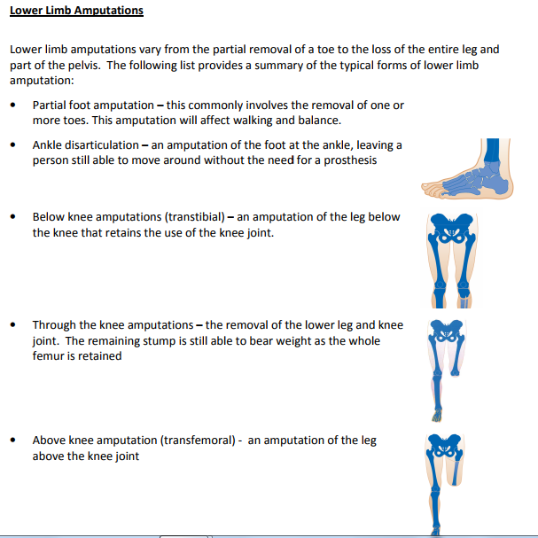

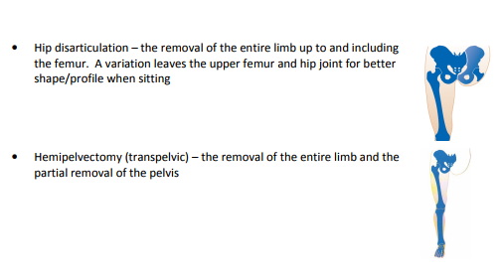
Amputation of a lower limb is most commonly performed due to landmines or disease of the limb. The two most often performed amputation procedures are truncation of the femur bone above the knee (AK) and truncation of the tibia bone below the knee (BK). Physical loss of the anatomy of the Lower limb results in loss of gait function. In BK amputees this loss is due partly to the loss of the articulated ankle joint, the loss of the joints of the foot (including the metatarsalphalangeal joints), and the loss of the muscles of the anterior and posterior compartments of the shank . The levels and classification of below the knee amputations are shown in Figure (6) .These are, very short below knee (less than 4 cm from the knee); standard below knee (12.4-18cm); long below knee; and Symes below knee.
The main purpose of a prosthetic foot, shank and socket is to provide means of replacing the lost structure and function of the skeleton and muscles of the foot, ankle and shank. This includes the provision of a stable base of support, flexibility which would simulate the normal taio-crurai and subtalar joints and shock absorption during heel contact. The compensation for the energy absorbed or generated by the ankle musculature is also important due to the contraction of muscles. This includes energy generation during push-off and energy absorption during heel contact and with foot flat. There is currently no good estimate for the unmet need although the number is estimated in millions.

This is due to the difficulty in collecting and analysing data from various countries around the world; this lack of data is an area of concern that requires future study, for example the number of amputee population in five countries with high amputee ratio due to landmines , according "landmine-statistics one world international, London 2001" is given in (Table)
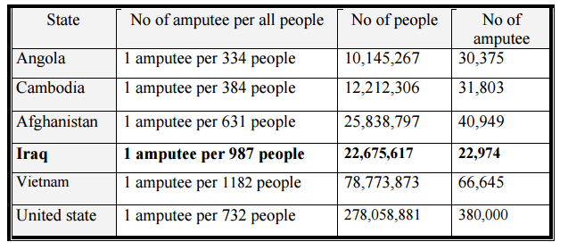
BK prostheses, Figure (7) are typically comprised of four major components ,these are:
1) Socket 2) Pylon 3) Foot prosthetic 4) Couplings The BK socket that supports the residual limb (or stump) is normally custom built to the individual's anthropometric specifications.
The design of a prosthetic socket largely determines the overall comfort and function of a below knee (BK) prosthesis. The shape of this socket is not an exact replica of the residual limb, but includes modifications (rectifications) such that effective load transfer between the prosthesis and residual limb is attained
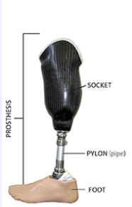
THE PROSTHETIC SOCKET:
The socket is the interface between the patient and the prosthetic. It is the most important part of the prosthetic. It has to be stable, sturdy, and yet comfortable. If these requirements are not met, the patient will not want to wear the prosthetic, or will be quite unhappy with it. In the past, sockets were carved from wood, and formed from aluminium. Both materials, while capable of support, made construction difficult and time consuming. Today, manufacturing technology has progressed and allows them to be made from polyurethane and fiberglass, which are lighter and stronger materials.
The socket manufacturing may achieved by three methods:
1- The polypropylene prosthetic component system developed by the ICRC (International Committee of the Red Cross ) is made of polypropylene thermoplastic sheet, the disadvantage for use of this material is that the mechanical properties decrease with time.
2- Composite material is used in rehabilitation centre (for example in Iraq such as Baghdad centre of artificial limb). The disadvantage of this method is that the stiffness is very high and that causes uncomforted to amputee. Sockets are now produced largely by hand.A cast is made of the residual limb, and plaster is poured into the cast.
3- modular socket system method :carbon fibre , fast method (2- hours )
to make a positive mold. The mold is then used to create a plastic or laminated polyester socket that fits over the residual limb.
THE PROSTHETIC FOOT: There was a variety of artificial foot designs available for use with prosthetic legs. Most of the designs can be divided into two classes, articulated feet are feet with moving joints, and non articulated are feet that do not have moving joints. Generally, articulated feet tend to behavior and require more maintenance than non-articulated feet. Two common articulated feet are the single-axis foot and the multi-axis foot. The singleaxis foot has only one joint to allow rotation. Two rubber bumpers are in this foot . On the other hand, the multi-axis foot, allows some motion about three axes. The motion about three axes allows the patient to rotate the foot. This foot allows the patients to walk on uneven terrain. The multi-axis foot is slightly heavier than the single-axis foot, and also requires more maintenance. Two common non-articulated feet are the SACH and the SAFE. The solid ankle-cushion heel foot referred to as the SACH foot has a rigid keel. The keel, which can be seen supports the frame of the foot. In walking, a normal ankle swings about a hinge, but in the SACH foot the ankle is rigid and cannot swing. Therefore the soft rubber heel provides the ankle action by compressing during the early phase of walking. The rubber heel wedges are available in soft, medium, and hard densities. The different densities allow for different gaits. The SAFE foot has the same characteristics as the SACH foot with added the ability for the sole to conform on uneven surfaces. The flexibility of the sole allows for an easier and more comfortable style of walking.
Note
There were two type of prosthetic feet
- Articulated feet, such as (Single and Multi axis feet) .
- Non-articulated feet, such as (The SAFE, STEN, SACH, Carbon Copy II and Dynamic feet).
In Iraq the SACH foot is commonly used. It consists of wooden keel embedded in foam rubber materials the density of the heel wedge can vary between soft, medium and hard according to the gait characteristic, age, weight and preference of amputee. The disadvantages for used this foot are minimum plantar flexion, dorsiflexion and fatigue failure.
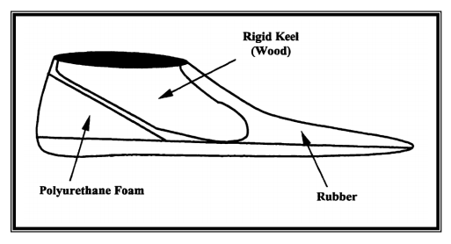

GAIT ANALYSIS AND GROUND REACTION FORCES:
Gait analysis provides the clinician and the researcher with useful information regarding the performance or status of a patient's walking ability. The gait cycle can most simply be described by its division into a stance phase which is defined by initial heel contact to toe-off and a swing phase from toe-off to ipsilateral heel contact as Figure (9). Stance phase accounts for approximately 60% of the total gait cycle and swing phase account for 40%. The stance phase is divided in to a number of sub- phases which include a weight acceptance phase, mid stance phase and push-off phase .The swing phase was also divided into early and late swing. The patterns, magnitude, and timing of GRF events can be measured force plate. A force plate is instrument which provides reading of force and moment applied to its top surface while the foot of subject is in contact with the plate. The parameter derived from GRF data are a valuable means of assessing overall gait performance by providing information on the magnitude and direction of the forces acting on the body during gait. Prior to hell strike, the body's center of mass is accelerating forward and moving outside the base of support. At heel strike force produced by the muscles of the lower limbs is applied to the ground through the foot to create an impulse in the direction opposite to movement to the center of mass .The impulse causes a deceleration of the body's center of mass in the fore-aft direction and is a "braking "impulse . Prior to toe off, force created by leg muscle contraction applied through the foot to the ground creates an impulse in the direction of forward progression. This impulse is referred to as "propulsive" impulse and accelerates the body forward. Observing the magnitude of these impulses allows the determination of how effectively a prosthetic foot transfers force produced by the musculature of the residual limb to the ground to create forward momentum in gait. Decreases in either the braking or propulsion impulse indicate a less efficient transfer of force and therefore a less efficient gait .
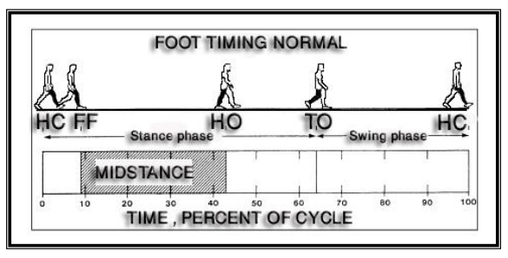
MUSCLE ACTIONS:
Muscle actions (or contractions) are described as isometric contraction (constant length) or dynamic contractions consisting of concentric contraction (shortening of the muscle under load) and eccentric contraction (lengthening of the muscle under load). The tension generated in a muscle cannot be controlled or kept constant, Therefore, the type of muscle actions that will be considered in the following section is isometric, concentric, and eccentric .Two types of exercise, iso-kinetic and iso-inertial, which are sometimes referred to as types of muscle contraction. During a concentric contraction, the bones come closer together as the whole muscle shortens. Positive work is being done by the muscle. During an eccentric contraction, the bones move away from each other as the muscle tries to control the descent of the weight. In leg shortening, the problems are to maintain alignment and secure union .
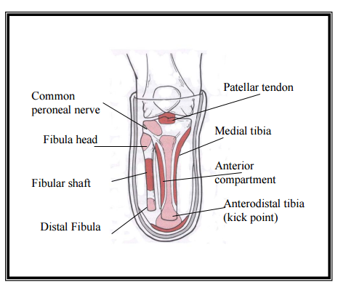

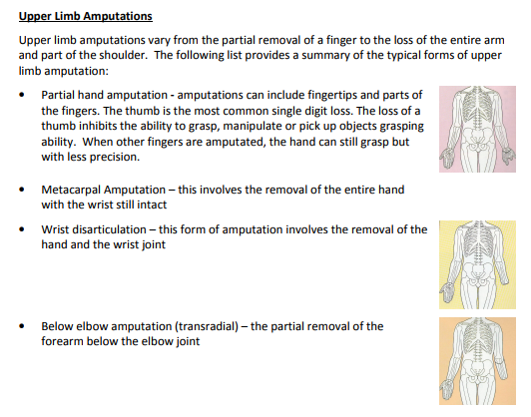

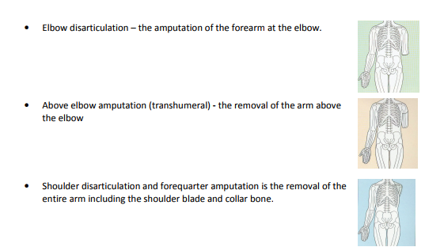
Materials of prosthetic :
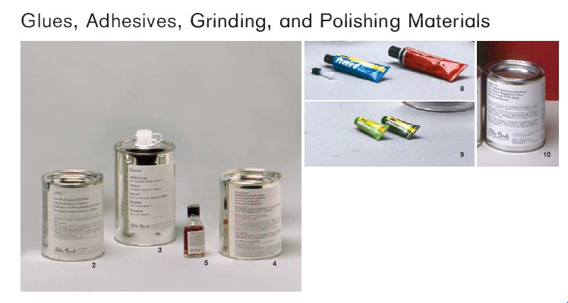

II - artificial cartilage
Artificial cartilage is a synthetic material made of hydrogels or polymers that aims to mimic the functional properties of natural cartilage in the human body. Tissue engineering principles are used in order to create a non-degradable and biocompatible material that can replace cartilage .
Materials of artificial cartilage

PVP/PVA hydrogels for articular cartilage replacement , Poly(vinyl alcohol) (PVA) hydrogels were used in this study. It was difficult to meet the mechanical properties of articular cartilage using this hydrogel.
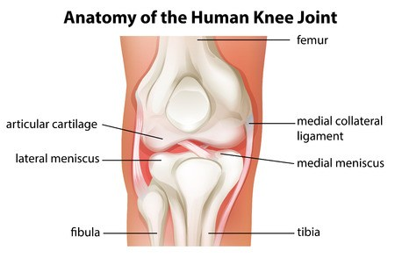
Properties of artificial cartilage
The prerequisites of a biomaterial to be used for an artificial articular cartilage include:
• Frictionless lubrication.
• Provide sufficient cushion effect against shocks
• Excellent wear resistant.
• Should be biocompatible.
• Simple and firm attachment mechanism to the underlying bone.

III – Dental materials

All dental material fall under 4 main groups:

1-Polymers
2-metals
3-ceramics
4-composites

Polymers The most widely used impression materials are elastomeric polymers. Another major type of polymeric dental material is the composite filling material for anterior teeth. Removable dentures are made from acrylic resin and other polymers.

Metals and alloys have many uses in dentistry. Steel alloys are commonly used for the construction of instruments and of wires for orthodontics.
Gold alloys and alloys containing chromium are used for making crowns, inlays and denture baseswhilst dental amalgam, an alloy containing mercury, is the most widely used dental filling material.
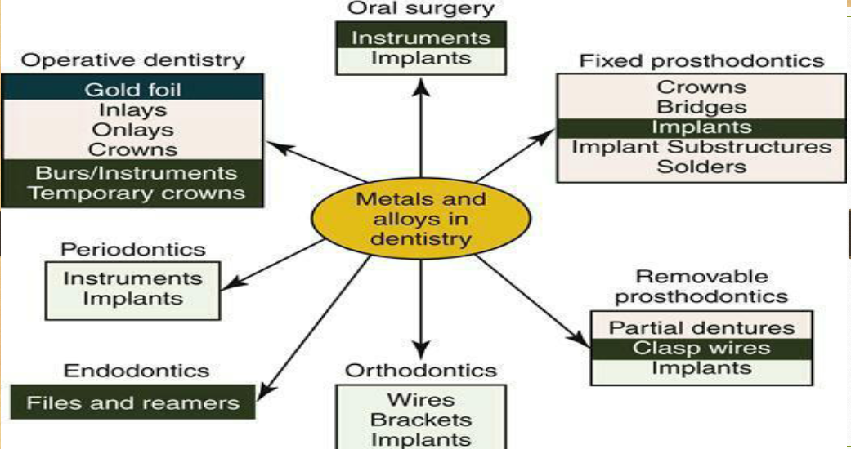

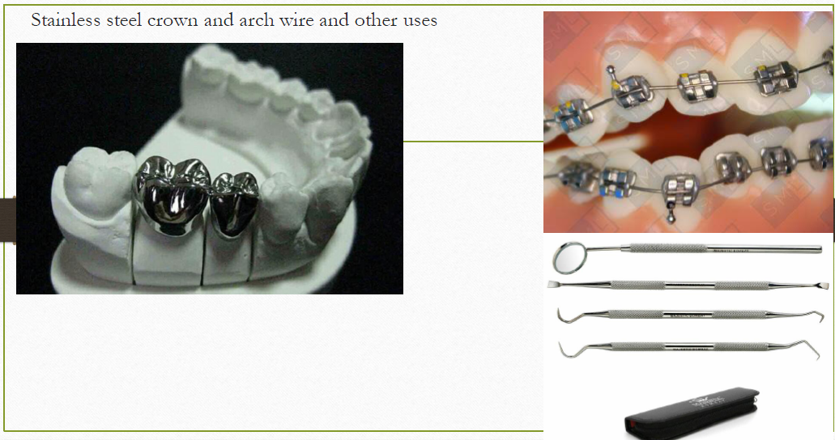

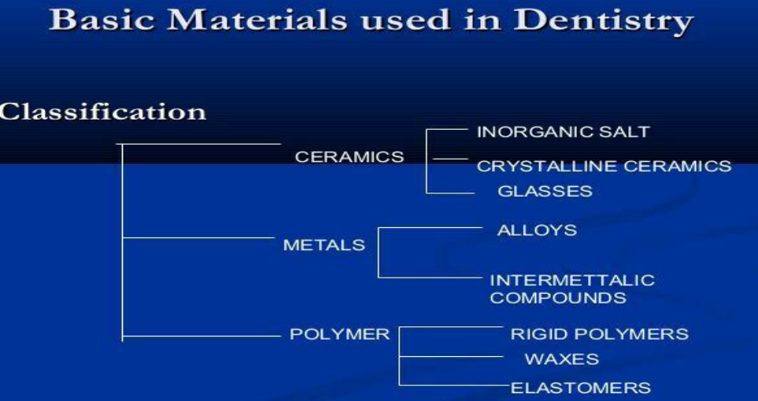

Dental porcelain(also known as dental ceramic) is a porcelain dental material used by a dental technician to create biocompatible life like dental restorations, such as crowns, bridges, and veneers, for the patient. Evidence suggests they are effective (they are biocompatible, esthetic, insoluble and have hardness of 7 on the Mohs scale). For certain dental prostheses(such as three-unit molars porcelain fused to metal or in complete porcelain group) only zirconia-based restorations are recommended.

Veneers Ceramic ( alumina)
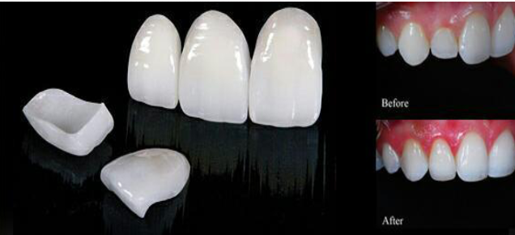

Characteristics of ideal dental material
1-biocompatible (non toxic , non irritating, non allergenic)
2-Machanically stable and durable. (Strong, resistance to fracture)
3-Resistance to corrosion (Doesn’t deteriorate over time)
4-Dimensionally stable.(Little change by temperature and Solvent)
5-Minimal conduction.(Insulate against thermal /electrical change)
6-Adheres to tissues

