Smart materials are designed materials that have one or more properties that can be significantly changed in a controlled fashion by external stimuli, such as stress, temperature, moisture, pH, electric or magnetic fields.
There are a number of types of smart material, some of which are already common. Some examples are as following:
- Piezoelectric materials are materials that produce a voltage when stress is applied. Since this effect also applies in the reverse manner, a voltage across the sample will produce stress within the sample. Suitably designed structures made from these materials can therefore be made that bend, expand or contract when a voltage is applied.
- Shape-memory alloys and shape-memory polymers are materials in which large deformation can be induced and recovered through temperature changes or stress changes (pseudoelasticity). The shape memory effect results due to respectively martensitic phase change and induced elasticity at higher temperatures.
- Magnetic shape memory alloys are materials that change their shape in response to a significant change in the magnetic field.
- pH-sensitive polymers are materials that change in volume when the pH of the surrounding medium changes.
- Temperature-responsive polymers are materials which undergo changes upon temperature.
- Halochromic materials are commonly used materials that change their colour as a result of changing acidity. One suggested application is for paints that can change colour to indicate corrosion in the metal underneath them.
- Photomechanical materials change shape under exposure to light.
- Polycaprolactone (polymorph) can be molded by immersion in hot water.
- Self-healing materials have the intrinsic ability to repair damage due to normal usage, thus expanding the material's lifetime.
- Dielectric elastomers (DEs) are smart material systems which produce large strains (up to 300%) under the influence of an external electric field.
- Thermoelectric materials are used to build devices that convert temperature differences into electricity and vice versa.

1- Piezoelectricity : is the electric charge that accumulates in certain solid materials (such as crystals, certain ceramics, ) in response to applied mechanical stress. The word piezoelectricity means electricity resulting from pressure.
The piezoelectric effect is understood as the linear electromechanical interaction between the mechanical and the electrical state in crystalline materials with no inversion symmetry. The piezoelectric effect is a reversible process in that materials exhibiting the direct piezoelectric effect (the internal generation of electrical charge resulting from an applied mechanical force) also exhibit the reverse piezoelectric effect (the internal generation of a mechanical strain resulting from an applied electrical field). For example, lead zirconate titanate crystals will generate measurable piezoelectricity when their static structure is deformed by about 0.1% of the original dimension. Conversely, those same crystals will change about 0.1% of their static dimension when an external electric field is applied to the material. The inverse piezoelectric effect is used in the production of ultrasonic sound waves.
The nature of the piezoelectric effect is closely related to the occurrence of electric dipole moments in solids. The latter may either be induced for ions on crystal lattice sites with asymmetric charge surroundings (as in BaTiO₃ and PZTs)
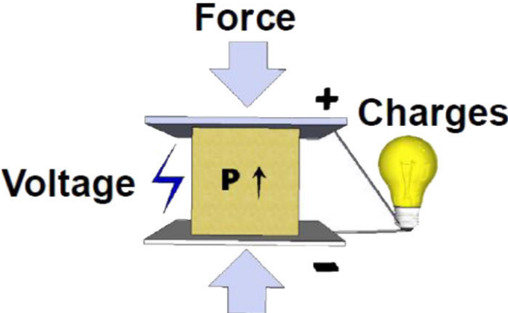

Materials of piezoelectric
Many materials, both natural and synthetic, exhibit piezoelectricity:

Naturally occurring crystals
- Quartz
- Berlinite (AlPO₄),
- Rochelle salt
- Topaz
- Tourmaline-group minerals
- Lead titanate (PbTiO₃). Although it occurs in nature as mineral macedonite, it is synthesized for research and applications.
The action of piezoelectricity in Topaz can probably be attributed to ordering of the (F,OH) in its lattice, which is otherwise centrosymmetric: orthorhombic bipyramidal (mmm). Topaz has anomalous optical properties which are attributed to such ordering.

Natural materials
- Silk
- Wood due to piezoelectric texture

Synthetic crystals
- Lithium niobate (LiNbO₃)
- Lithium tantalate (LiTaO₃)

Synthetic ceramics

Polymers
- Polyvinylidene fluoride (PVDF): PVDF exhibits piezoelectricity several times greater than quartz.

Application of piezoelectric materials :

1- High voltage and power sources ( cigarette lighter)

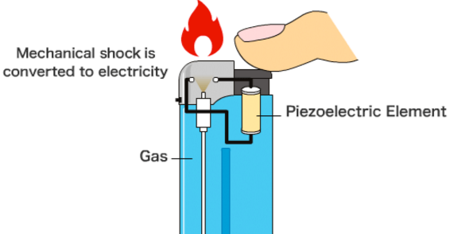

2-Sensors : The principle of operation of a piezoelectric sensor is that a physical dimension, transformed into a force, acts on two opposing faces of the sensing element. Depending on the design of a sensor, different "modes" to load the piezoelectric element can be used: longitudinal, transversal and shear.
2- Actuators : such as AFM (Atomic force microscopes)
3- Reduction of vibrations and noise
4- Surgery
5- Construction
In view of the feature of the piezoelectric effect as mentioned in the above section, it is desirable to use piezoelectric material for developing a sustainable building system with low life cycle energy demand. Construction material with good piezoelectricity can benefit the implementation of a variety of applications such as energy harvesting and storage, self-powered sensing and structural control with actuators .Since cement-based material is one of the most common construction materials used in building structures, its piezoelectric capacity draws wide attention. Numerous investigations have been conducted to understand the piezoelectric properties of cement-based material as well as its potential to produce a sufficient and storable amount of energy. While a few experimental research studies have claimed that plain cement paste exhibits piezoelectric behavior, its piezoelectric capacity is not enough for energy harvesting, rendering it necessary tooptimize the piezoelectricity. Resolving this key question, in this sec-tion, the piezoelectricity of cement paste is discussed and state-of-the-art approaches for enhancing cementitious piezoelectricity are re-viewed.
A recent application of piezoelectric ultrasound sources is piezoelectric surgery, also known as piezosurgery. Piezosurgery is a minimally invasive technique that aims to cut a target tissue with little damage to neighboring tissues.
2- Shape memory alloys (SMA)

Shape memory alloys (SMAs) are the most important branch of smart or intelligence materials, it's a metallic alloys which undergo solid-to-solid phase transformations induced at appropriate temperature or stress changes and during which they can recover seemingly permanent strains. The shape memory alloys were first observed in the 1930s, by Arne Olander while working with an alloy of gold and cadmium. This gold and cadmium alloy was plastically deformed when cooled but returned to its original configuration when heated.

Shape memory alloys have two phases namely austenite and martensite; Austenite is the high temperature or “parent” phase and exhibits a (cubic ) crystalline structure while martensite is the low temperature phase that exhibits a crystalline structure . The transformation from austenite to martensite may lead to twinned martensite in the absence of internal and external stresses or detwinned martensite if such stresses exist at a sufficient level.
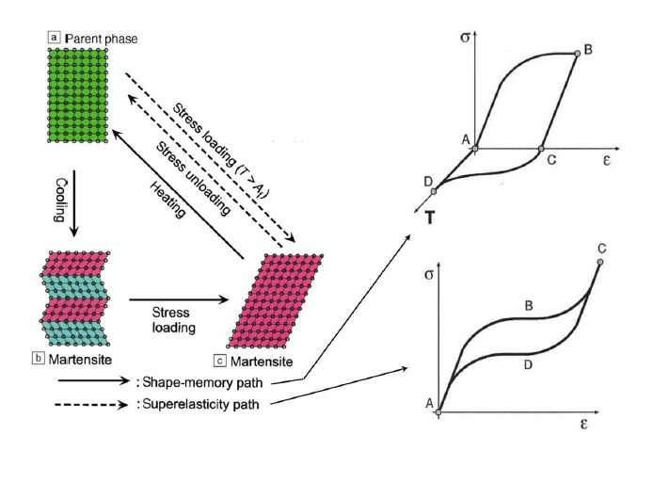

The two main types of shape-memory alloys are copper-aluminium-nickel, and nickel-titanium (NiTi) alloys but SMAs can also be created by alloying zinc, copper, gold and iron. Although iron-based and copper-based SMAs, such as Fe-Mn-Si, Cu-Zn-Al and Cu-Al-Ni, are commercially available and cheaper than NiTi, NiTi based SMAs are preferable for most applications due to their stability .

Although Ni-Ti is the most widely used shape memory alloys for technological applications, Cu-based alloys have been used as an excellent alternative because they offer a wide range of transformation temperatures up to 200°C, a large superelastic effect, small thermal hysteresis and high damping coefficient. The main Cu-based alloys are Cu-Al-Ni and Cu-Zn-Al alloys . Cu-Al-Ni SMAs have been used in a wide range of applications, especially when the high temperatures are required. This is attributed to their high thermal stability and high transformation temperatures.
Shape-Memory Effect
Shape-memory effect (SME) is a phenomenon by which SMAs that have been permanently deformed can recover their original configuration after being heated above a certain transition temperature. SME is based on the reversible martensitic transformation of the SMA between an austenitic phase and a martensitic phase by the application of heat or stress
Nitinol shape memory alloys:

There are many types of shape memory alloy such alloys include NiTi, CuZnAl, CuAlNi, and many other metallic alloy systems , The most common shape memory alloy is the (nitinol) Shape memory alloys based on Ni and Ti has today provided the best combination of material properties for most commercial applications. The discovery took place at NOL (the Naval Ordnance Laboratory) and hence the acronym NiTi-NOL or Nitinol .The properties of Nitinol are particular to the exact composition of the metal and the way it was processed. The physical properties of Nitinol include a melting point around 1240 ° C to 1310°C, and a density of around 6.5 g/cm³ The large force generated upon returning to its original shape is a very useful property. Other useful properties of Nitinol are its "excellent damping characteristics at temperatures below the transition temperature range, its corrosion resistance, its nonmagnetic nature, its low density and its high fatigue strength. These properties translate into many uses for Nitinol

Copper-aluminium-nickel shape memory alloys:
Copper based alloys exhibit shape memory within a certain range of composition, the SMAs have two phase these two phases occurs diffusion less and is therefore called martensitic and austenitic, the solid phase obtained during cooling is called martensite or ( low temperature phase). The parent phase in which the transformation occurs is called the beta ß-phase which is known as ( high temperature phase ). The reversible phase transformation from austenite (parent phase) to martensite (product phase) and vice versa forms the basis for the unique behavior of SMAs is represented the key characteristic of all shape memory alloys , which is known as phase transformation which can be define as a phase change between two solid phases and involves rearrangement of atoms within the crystal lattice. The phase transformation is associated with an inelastic deformation of the crystal lattice with no diffusive process involved ,its involved shear lattice distortion .
there are four characteristic temperatures associated with the phase transformation, martensitic start temperature (M_{s}), martensitic finish temperature (M_{f} ),austenitic start temperature (A_{s}),austenitic finish temperature (A_{f}),as shown in figure and the more details will illustrated in the following section .
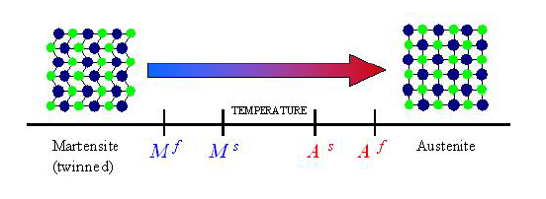

Application of shape memory alloys :
SMAs have found applications in many areas due to their high power density, solid state actuation, high damping capacity, durability and fatigue resistance. Accordingly their use gives new possibilities of introduction on the market of innovative commercial products based on their particular characteristics, these characteristics of SMAs can be used for a number of applications, like free recovery applications as blood-clot filters ( medical application ) , constrained recovery applications as hydraulic couplings, force actuators as fire safety valves, proportional control as fluid flow control valve . Superelastic applications as eyeglass frames and guide wires for steering catheters into vessels in the body.

