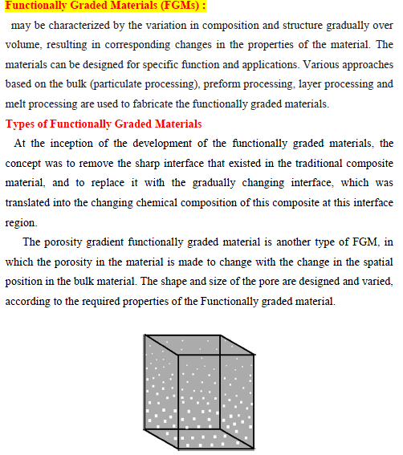

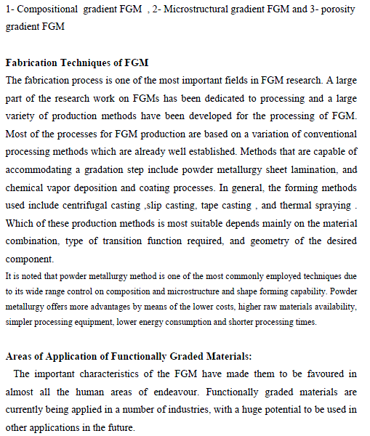

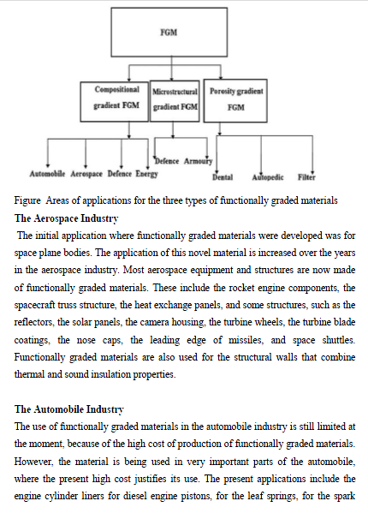
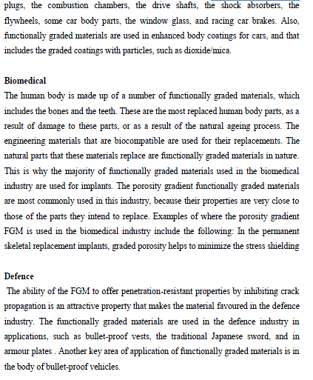
Material property charts (Ashby charts):
The material charts map the areas of property space occupied by each material class. They can be used in three ways: (a) to retrieve approximate values for material properties (b) to select materials which have prescribed property profiles (c) to design hybrid materials. The collection of process charts, similarly, can be used as a data source or as a selection tool. Sequential application of several charts allows several design goals to be met simultaneously. More advanced methods are described in the book cited above. The best way to tackle selection problems is to work directly on the appropriate charts. Permission is given to copy charts for this purpose. Normal copyright restrictions apply to reproduction for other purposes. It is not possible to give charts which plot all the possible combinations: there are too many. Those presented here are the most commonly useful. Any other can be created easily using the CES software.
Material classes and class members The materials of mechanical and structural engineering fall into the broad classes listed in this Table. Within each class, the Materials Selection Charts show data for a representative set of materials, chosen both to span the full range of behaviour for that class, and to include the most widely used members of it. In this way the envelope for a class (heavy lines) encloses data not only for the materials listed here but virtually all other members of the class as well. These same materials appear on all the charts.
The charts that follow display the properties listed here. The charts let you pick off the subset of materials with a property within a specified range: materials with modulus E between 100 and 200 GPa for instance; or materials with a thermal conductivity above 100 W/mK.

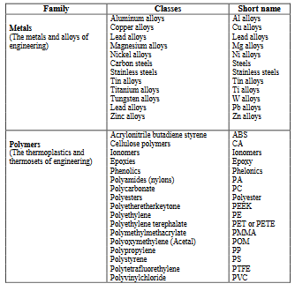
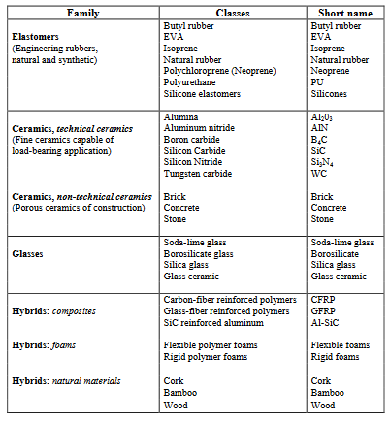

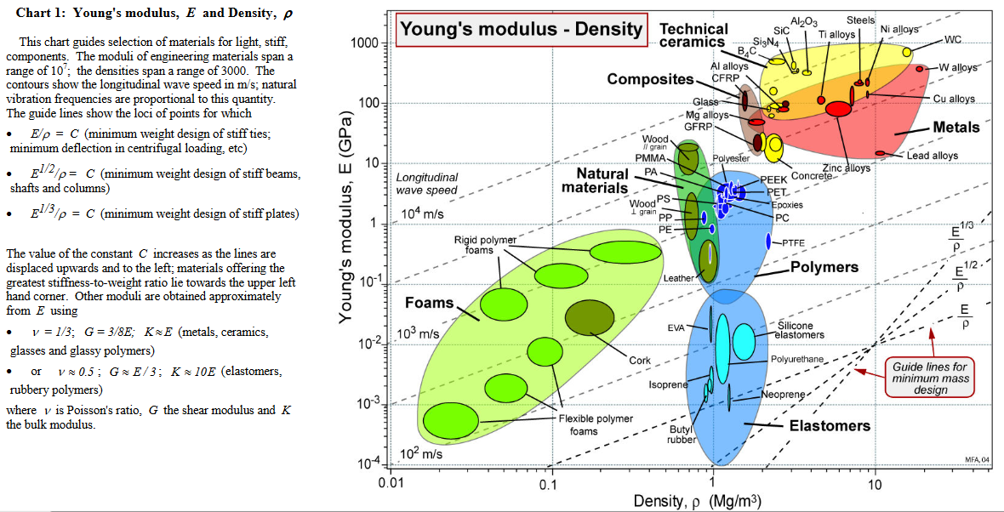
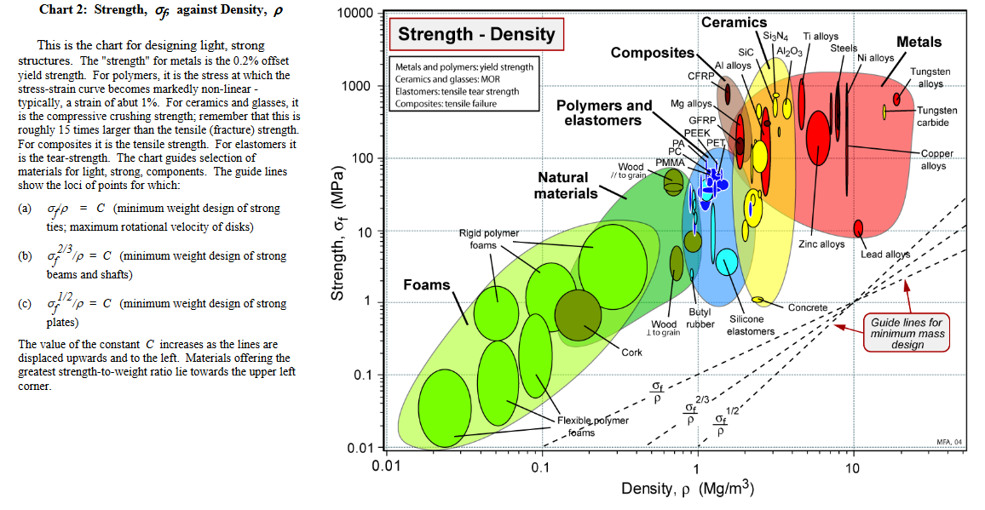
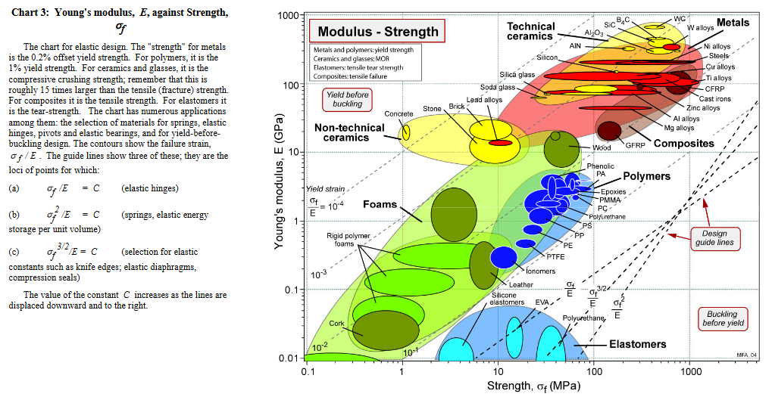
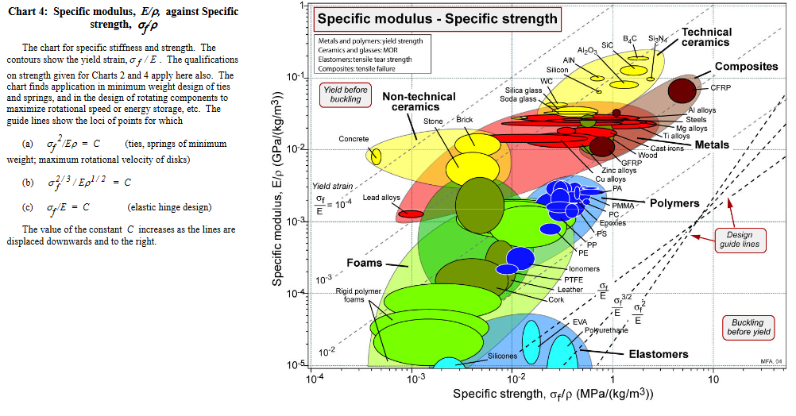
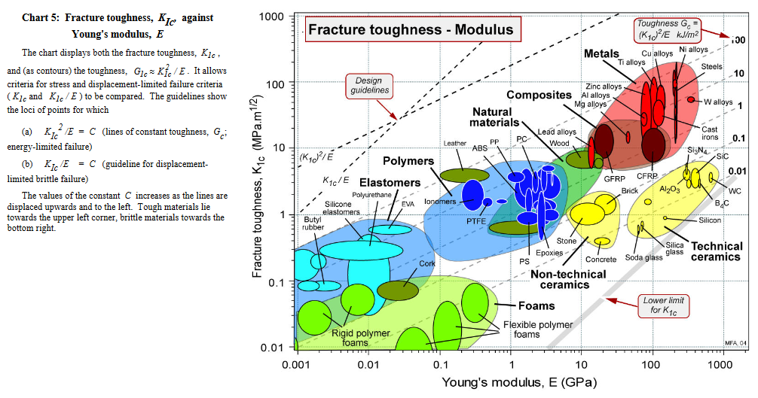
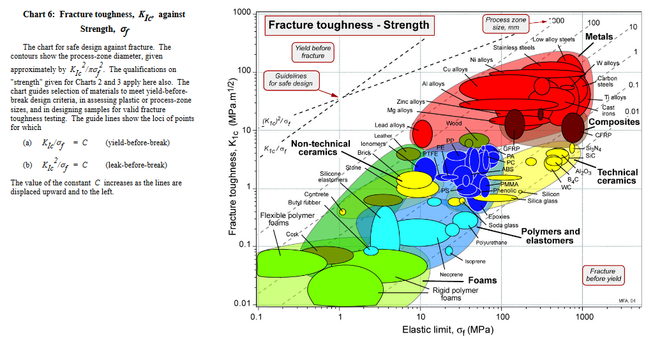
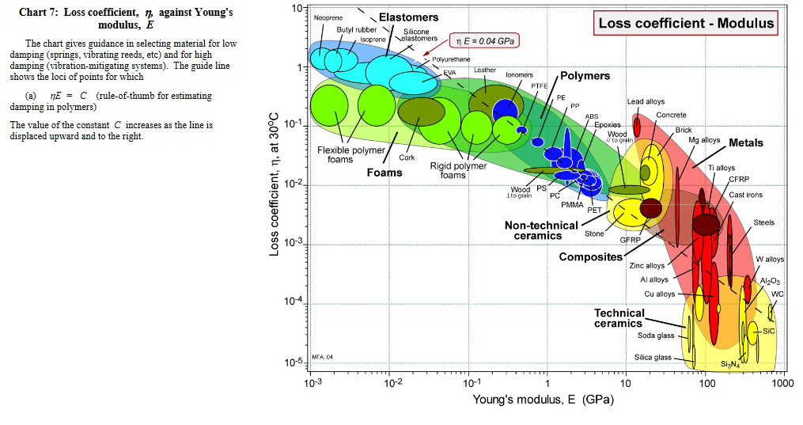

CES Selector for Materials Selection software:

Link :

https://www.youtube.com/watch?v=E8ZuOAusTxg

With CES Selector, you can customize the software based on your teaching/research requirements. Choose from:
- Editions providing tailored data: Base, Additive Manufacturing, Aero, Metal, Polymer, and Medical
- Optional software tools: FE Exporters, Eco Audit Tool, Synthesizer Tool, CES Constructor
- A range of additional databases: see below.

