# Chapter Three

# Understanding Software

**Software** is a computer program that tells computer hardware how to operate. Software ranges from the Windows XP operating system that manages your computer, to the word processor you use to print letters, to the Web browser you use to peruse the Internet.

****Understanding Graphical User Interfaces (GUIs):** The graphical images that appear on the computer’s screen when it is started are called ***icons***. Along with the introduction of icons came the development of ***graphical user interfaces*** which allow computer users to point at pictures and icons and then click the icon to manipulatethat program or file, thus the phrase point and click.

***Graphical User Interface***

The following table describes some of the most common icons you’ll see in the Windows XP GUI.

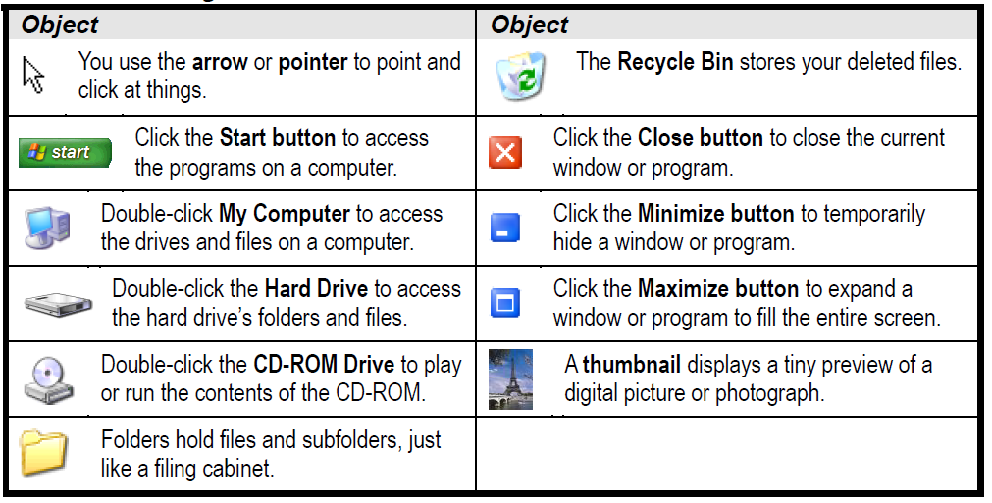

**Types of Software:** The software can be classified as operating system and application programs.

**1-Operating System:** An operating system is a software program that loads automatically and controls everything on your computer like MS-DOS and Microsoft Windows XP. The operating system does:

* **Controls Your Computer’s Hardware:** Windows controls the different devices of your computer system. It’s what makes your printer print and what makes your mouse point and click.
* **Runs Your Computer’s Programs:** Without an operating system, your word processor, Web browser (Internet), and games wouldn’t work.
* **Organizes Files** An operating system stores information in files and folders on your computer’s local disk.

**Types of Operating Systems:**

|  |  |  |
| --- | --- | --- |
| **Operating System** | **Released** | **Description** |
| MS-DOS (Microsoft Disk Operating System) | 1980 | one of the earliest PC operating systems that displayed boring lines of text on the screen instead of icons and pictures. |
| Windows 3.1 | 1992 | the first successful operating system that featured a GUI and used pictures easily but it still required MS-DOS to operate. |
| Windows 95, 98, ME, NT, 2000 | 1995 | It featured long file names, better performance, and a greatly improved interface without needing MS-DOS. |
| WindowsXP Home | 2001 | designed for home and consumer computing. It‘s much more stable than earlier versions of Windows. |
| UNIX | varies | is an older, very powerful operating system that can run on a computer, mainframe, or network. UNIX features great performance, security, and reliability. |
| Linux | varies | Linux is a newer UNIX-base operating system that is available for FREE on the Internet. |

**2- Application Program:** An application program helps you accomplish a certain task, such as writing a letter, browsing the Internet, or playing a game. Examples include word-processing programs, spreadsheets, databases, and games. The following are the most common used programs.

**A- Word Processing Program:** by using word processing software you can do the following:

* Create Letters and Documents: a word processor lets you add, delete, or rearrange the text in a document and check your documents for spelling and grammar errors before it appears on paper.
* Format Text: you can use various fonts, or typefaces, create bulleted or numbered lists, and change the alignment of text on the page.
* Create Tables and Add Images.

**B- Spreadsheets (Excel Program):** Spreadsheet programs are super-powered calculators make working with numbers faster, easier, and more accurate. You can do the following with a spreadsheet:

* Perform Calculations: A spreadsheet perform powerful formulas, and calculate and analyze information.
* Manage and Organize Information: Spreadsheets arrange values by columns and rows. You can present information in a professional and easy-to-read format and store large collections of data.
* Format and Present Information: You can enhance the appearance of all those numbers by using various fonts, or typefaces, borders, shading, and more.
* Create Charts: Charts are better in presenting information than reading numbers in a spreadsheet. A chart illustrates data, relationships, or trends graphically.

**C- Databases:** is a collection of information that is organized into a list such as names, addresses, products. A database program lets you:

* Store Information: A database stores lists of information related to a particular subject. It is easy to add, update, organize, and delete information.
* Analyze and Print Information.
* Manage Information Databases: make it easy to work with and manage huge amounts of information.
* Share Information: Most database programs allow more than one user to view and work with the same information at once. Such databases are called multi-user databases.

**D- Presentation Software (Microsoft PowerPoint):** This program lets you create slides that include text, graphics, charts, and even digital movies. Once you have created a presentation, you can display it as an electronic slide show on any computer.

**E- Web Browsing:** is a program that is used to show Web pages. Web pages make up what is known as the World Wide Web (WWW) or Web for short. A web browsing program lets you:

* Browse and View Web Pages: Web pages are written in a simple language called HTML, which stands for Hypertext Markup Language. A Web browser converts the HTML in a Web page into a readable format and displays that information on your computer screen.
* Find Information: Using a search engine to find anything on the World Wide Web. Google and Yahoo are two of the most popular search engines out there.
* Download Files: You can download files, programs, images and pictures, even MP3 files that you can listen to.
* Shopping: People use the Internet to shop for books, computers, clothes, and cars.

**Programming Languages:** All software programs are written in a programming language which is a set of grammatical rules for instructing a computer to perform specific tasks such as C++, FORTRAN and Java.

Every language has its strengths and weaknesses. For example, FORTRAN is a good language for processing numbers, but it’s not well for large programs. C++ has powerful object-oriented features, but it is complex and difficult to learn. The following table describes some of the more common programming languages:

|  |  |
| --- | --- |
| **Language** | **Description** |
| Machine Language | can be read by computers, but are impossible for humans to use because they consist entirely of numbers. |
| BASIC | is one of the earliest and simplest high-level programming languages and was taught by educators to students during the 1970s and 80s. |
| C, C++ | one of the most popular programming languages in use today. |
| FORTRAN | the oldest high-level programming language that is popular for scientific applications that require extensive mathematical computations. |
| Visual Basic (VB) | Based on BASIC which allows users to create programs with a graphical programming environment and painting metaphor. |
| HyperText Markup Language (HTML) | is the authoring language used to create documents, or Web pages on the World Wide Web. HTML defines the structure and layout of a Web document by using tags and attributes. |