Chapter Eight
Working with Files and Folders
Computers store information in files, which are organized and grouped in folders, and stored on disks. A disk drive is the part of the computer that reads and writes information onto disks. There are several types of disks and disk drives located in (My Computer) that computers use to store their information such as:
1- Local Disk (C), (D), (E) and (F): Local disks, or hard disks, hide permanently inside the computer where it stores almost all of its programs and files.
2- CD-ROM or DVD: Compact discs, or CD-ROMs are cheap and they can store a lot of information. DVDs are similar to CDs, but they hold even more information. DVDs are becoming the most common storage device for movies.
3- Removable Drive: Removable storage drives can read and write information. They are as fast as a hard drive.
In order to see what’s inside something, all you have to do is double-click the drive, folder, or file you want to open. Also, you can display the properties of any drive or file or folder by pressing the right button in the mouse and select Properties from the shortcut menu. The Properties window displays the amount of used and free space on the disk in megabytes (MB) and gigabytes (GB).
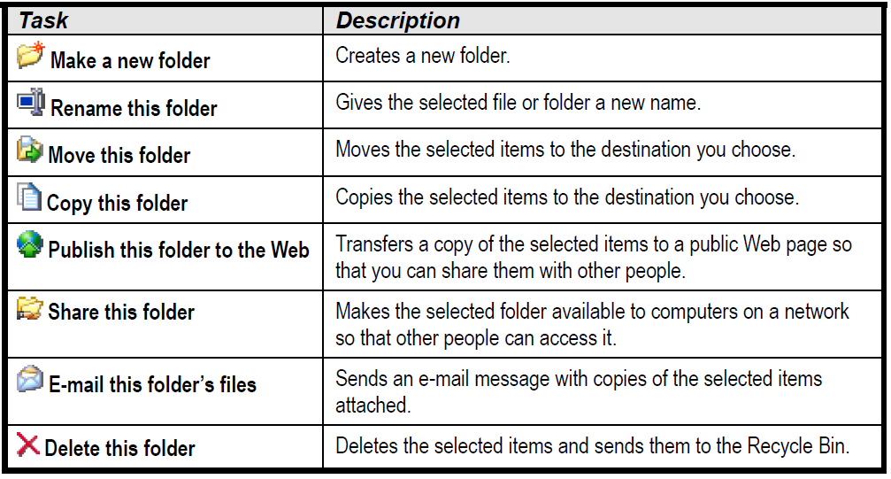
Files and Folders Tasks: In any file or folder you can do the following:

A Closer Look at Files and Folders: There are two parts to every file: the file name, which you’ve already seen and are familiar with; and the file extension, which is three letters that tell Windows what type of file it is. Since Windows assigns pictures or icons to the types of files it recognizes, it normally hides these file extensions from view.
The path of a file or folder is another common term. A file path is the drive and folder(s) where a file or folder is located—think of it as a street address. A path contains the drive letter, followed by a colon, followed by any folders (which must be separated by backslashes \), and last comes the name of the file. For example C:\Program Files\Accessories\WordPad.EXE.

The extension of files is different depending on the type of that file, the following shortenings displays the extension of some file types:
File | Extension shortening
pictures and digital photos | (.jpg, jpeg, .gif, and .bmp)
music files | (.mp3)
digital video files | (.avi and mpeg)
Microsoft Access | (.mdb)
Microsoft Excel | (.xls)
Microsoft PowerPoint | (.ppt)
Microsoft Word | (.doc)
Notepad | (.txt)
MS-DOS | All Windows or DOS programs have .EXE, or sometimes, .COM, extensions. EXE stands for executable, meaning the file is a program that will run or execute when you open it.
Paint File | (.bmp)
Setup Program File | (.exe)

Changing How Information is Displayed: When you work with files and folders on your computer, you may find that you need to change the appearance of items by using one of these modes: Thumbnails, Icons, Tiles, List, or Details. The description of each view is illustrated in the following table:

View | Description
Icons | Files and folders are displayed as icons. This is a good view if you‘re learning to use Windows or have trouble clicking a file with the mouse.
Tiles | Files and folders are displayed as icons, but with more information. The type and size of a file is displayed to the right of the icon.
List | Files and folders are displayed as small icons in a list. This is a great default view, because it allows you to see the most files at a time.
Details | Displays information about every file and folder, such as its name, size, type, and when it was last modified. You can change how the list is sorted by clicking the column headings.
Thumbnails | This view is useful if you are working with pictures and graphics because it previews every graphic file instead of only displaying a file name.

Selecting Multiple Files and Folders: To Select Multiple Items:
- If the items are next to each other, you can click and drag a rectangle around the items you want to select OR you can click the first item you want to select, press and hold down the <Shift> key, and click the last item you want to select.
- If the items aren’t next to each other, you can select non-adjacent items by holding the <Ctrl> key and clicking the items you want to select.
- To Select All Files at Once: Select Edit then Select All from the menu.

Finding a File Using the Search Companion: The Search Companion can search for files even when you can’t remember the exact file name or location. You can search for a file by:
• The file name or any part of the file name.
• The date the file was created or modified.
• The type of file, such as a Microsoft Word document or graphic file.
• The text within the file.
• The size of the file.

