Lecture 5
CHARACTERIZATION TECHNIQUES

Assistant Professor
Dr. Raouf Mahmood

Lecture 5
CHARACTERIZATION TECHNIQUES
Introduction
Two of the main parameters studied in the characterization of nanoparticles (NPs) are size and shape. Also can measure size distribution, degree of aggregation, surface charge and surface area, and to evaluate the surface chemistry. Size distribution and organic ligands (an ion or molecule -functional group- that binds to a central metal atom to form a coordination complex) present on the surface of the particles may affect other properties and possible applications of the NPs.
In addition, the crystal structure of the NPs and their chemical composition are carefully investigated as a first step after nanoparticle synthesis.
Until now, there were no standardized protocols for this aim. Credible and strong measurement methods for NPs will greatly affect the acceptance of these materials in industrial applications and allow the industry to conform to rule.
Yet, there are important challenges in the analysis of nanomaterials because of
- The interdisciplinary nature of the field.
- The absence of suitable reference materials for the calibration of analytical tools.
- The difficulties linked to the sample preparation for analysis and the interpretation of the data.
- Challenges in the characterization of NPs such as the measurement of their concentration.
- Analysis in complex matrices.
- With the scale-up of nanoparticle manufacture, more dependable quantification techniques will be required. For this reason, it is fundamental to characterize the. We do not only focus on the characterization of the nanoparticle core, but also on the surface ligands that influence the physical properties.
Characterization techniques
Characterization techniques are classified as a chemical characterization and Structural characterization:
- Chemical characterization
- Optical Spectroscopy:
- Optical absorption spectroscopy (OAS)
- Photoluminescence (PL)
- Fourier Transform Infrared Spectroscopy (FTIR)
- Raman Spectroscopy
- Electron Spectroscopy:
- Energy Dispersive X-ray Spectroscopy (EDS)
- X-ray Photoelectron Spectroscopy (XPS)
- Auger Electron Spectroscopy (AES)
- Ultraviolet photoelectron spectroscopy (UPS)
- Ionic Spectrometry
- Rutherford Backscattering Spectrometry (RBS)
- Secondary Ion Mass Spectrometry (SIMS)
- Structural characterization
Variation in the size of nanoparticle determines the optical properties of the material. Similarly, for different applications of the nanomaterial, the information about the shape, lattice constants and crystallinity are important. To know the size, shape, lattice constants and crystallinity of the material, structural characterization is done. The techniques are:
- X-ray diffraction technique
- Electron microscopy:
a) Scanning Electron Microscopy (SEM)
b) Transmission Electron Microscopy (TEM)/High Resolution (HR) TEM with
Selected Area Electron Diffraction (SAED)
c) Small Angle X-ray Scattering (SAXS)
d) Environmental Transmission Electron Microscopy (ETEM)
e) Scanning Probe Microscopy (SPM):
- Atomic Force Microscopy (AFM)
- Scanning Tunnelling Microscopy (STM)

- Dynamic light Scattering
Chemical Characterizations:
Optical Spectroscopy:
Optical spectroscopy uses the interaction of light with matter as a function of wavelength or energy in order to obtain information about the material. Absorption or emission experiments with visible and UV light tend to reveal the electronic structure. Vibrational properties of the lattice (i.e., phonons) are usually in the IR and are studied either using IR absorption or Raman spectroscopy. Optical spectroscopy is attractive for materials characterization because it is fast, non-destructive and of high resolution.
Optical Absorption Spectroscopy:
UV-visible spectroscopy
This technique involves the absorption of near-UV or visible light Absorption spectroscopy is employed to determine the presence of a particular substance in a sample and, in many cases, to quantify the amount of the substance present, When organic compounds absorb UV or visible light, energy from the light is used to promote an electron from a bonding or non-bonding orbital into one of the empty anti-bonding orbitals. In each possible case, an electron is excited from a full orbital into an empty anti-bonding orbital. Each jump takes energy from the light, and a big jump needs more energy than a small one. Figure 1 showing the possible electron jumps that light may cause.
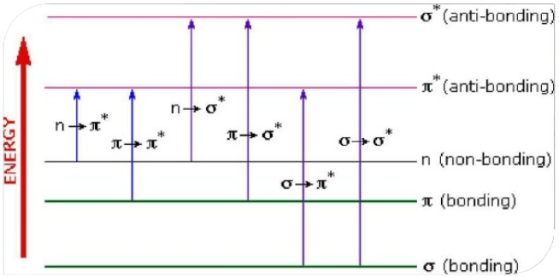
Figure 1: Possible electron jumps
The relationship between the frequency of light absorbed and its energy
E=hν (1)
Where, E is the energy of each quanta of light, h is the Planck’s constant and v is the frequency of light For higher energy jump, light of a higher frequency is to be absorbed.
UV-visible spectrophotometer measures both intensity and wavelength. It is usually applied to molecules and inorganic ions in solution. For each wavelength of light passing through the spectrometer, the intensity of the light passing through the reference cell is measured. This is usually referred to as l0 .The intensity of the light, I passing through the sample cell is also measured for that wavelength. If I is less than I₀ then obviously the sample has absorbed some of the light.
The Beer-Lambert Law gives, the relationship between A (the absorbance) and
the two intensities is given by:
An absorbance of 0 at some wavelength means that no light of that particular wavelength has been absorbed. An absorbance of 1 happens when 90% of the light at that wavelength has been absorbed that means that the intensity is 10% of what it would otherwise be. A spectrophotometer can be either single beam or double beam.
References:
1. Bhat, S., Chakraborty, I., Baksi, A., Narayanan, R.P. and Pradeep, T., 2016. Evolution of atomically precise clusters through the eye of mass spectrometry. Nanoscience, 3, pp.343-385.2. G. Cao, Nanostructures and nanomaterials: Synthesis, properties and applications, (Imperial College Press, 2004).
2. Clark, B.J., Frost, T. and Russell, M.A. eds., 1993. UV Spectroscopy: Techniques, instrumentation and data handling (Vol. 4). Springer Science & Business Media.

