Highway Pavement

Civil Engineering Department
4th stage, 2nd Semester, 2019-2020
6th Lecture: Mass Haul Diagram , Cost estimation

Lecturer:
Dr. Maha Al-Mumaiz
Dr. Abeer K. Jameel

Free Haul Distance (F.H.D) is the specified distance wherein an excavated material will be hauled without additional cost (there is a fixed cost for each m³ excavation hauling and dumping).
→ depends on 1) Terrain 2) Equipment
Ex: Free haul cost = 4500 ID/m³

Overhaul is an authorized hauling in excess of the free haul distance.
- Units for overhaul is cubic meter-station or cubic yard-mile.
- The FHWA specifications define overhaul as the “the number of cubic yards of overhauled material multiplied by the overhaul distance”.

Overhaul distance (O.H.D): distance behind free haul distance with in which there is an additional cost for each 1 m³.st
Ex: Over haul cost = 1500 $\frac{ID}{m^{3}.st}$

Balance Point (cut=fill) anywhere the mass haul line crosses the 0 (zero) cumulative volume line on a mass haul diagram. This indicates that up to this station the cumulative cut and fill volumes are equal.

Grade Point transition between cut and fill on a mass haul diagram. This point coincides with a design profile intersecting the original ground profile. A “crest” on the mass haul line indicates a transition from cut to fill, and “sag” indicates a transition from fill to cut.

Limit of economical haul (L.E.H): F.H.D + Max over haul distance
$=F.H.D+ \frac{Borrow cost (\frac{ID}{m^{3}})}{Over haul distance cost (\frac{ID}{m^{3}.st})}=st$
Beyond which it is more economical to use (waste + borrow) rather than to pay for over hauling.

Borrow it is the location away from right of way and it is chosen by the engineer.
- borrow material often must be brought into the roadway from outside the grading prism (nearby borrow pit.).
- pay for borrow usually is by cubic yard, measured in the space originally occupied in the borrow pit. Occasionally, the borrow volume is determined in the completed fill.

Waste it is the unwanted excavation material which should be disposed out of right way.
Waste volume: excavated and dumped away at highway section cost = 4500 $\frac{ID}{m^{3}}$

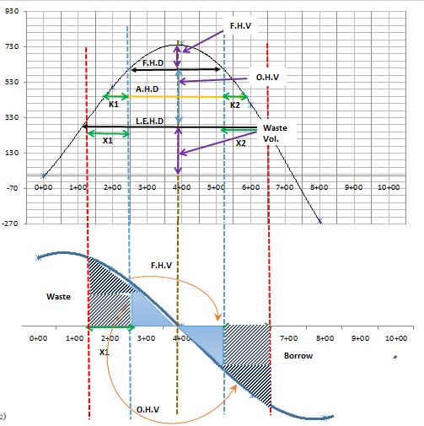

      - F.H.D= F.D
- F.H.V= free haul volume (m³)
- L.E.H= LH
- O.H.V= over haul volume (m³)
- X₁ + X₂ = max over haul distance
- K₁ + K₂ = average over haul distance
- Waste vol. (W. Vol) = B. Vol. (Borrow Volume)
- Total free haul cost = F.H.V * $\frac{ID}{m^{3}}$
- Total over hauling cost = $\frac{ID}{m^{3}.st}$ * O.H.V * (K₁ + K₂)
- Total Borrow cost = $\frac{ID}{m^{3}}*B. Vol$

Method of Measurement
The overhaul distance for material obtained and placed within the roadway limits will be measured along the centerline of the roadway. No allowance will be made for transverse of lateral movement to or from the centerline except materials moved to or from designated areas outside the roadway limits. If the contractor chooses to haul materials from other route which is longer than the designated source, payment will be based on the overhaul distance measured along the route designated by the engineer.

$$Cost of earthwork= \frac{ID}{m^{3}}*m^{3}=ID$$

Example 1:
F.H.D= 700m =7 st
Over haul cost = 1500 $\frac{ID}{m^{3}.st}$
Waste cost = free haul distance = 4500 $\frac{ID}{m^{3}}$
Borrow cost = 6000 $\frac{ID}{m^{3}}$
Find cost for each m³, L= 5st, 9, 13 and 15st.

Solution:
F.H.D =7 st
1) L= 5st < 7st
Cost = free haul cost = 4500 $\frac{ID}{m^{3}}$
2) L= 9st> 7st
L.E.H $=F.H.D+ \frac{Borrow cost (\frac{ID}{m^{3}})}{Over haul distance cost (\frac{ID}{m^{3}.st})}$
$=7+ \frac{6000}{1500}=11 st$ > 9st
Cost = 4500 + 2*1500=7500 $\frac{ID}{m^{3}}$
3) L = 13st > L.E.H

Cost = waste cost + borrow cost
$=4500+6000=10500 \frac{ID}{m^{3}}$

4) L= 15st > L.E.H
Cost = 4500 + 6000 = 10500 $\frac{ID}{m^{3}}$

Example2: Determine the cost of total earthwork of a highway section having the cumulative volume shown in the table below:
Station | 0 | 5 | 9 | 13 | 15
Cumm. Vol. | 0 | 250 | 350 | 220 | 0
Given that the overhaul cost =750 $\frac{ID}{m^{3}.st}$ , Borrow cost= 2500 $\frac{ID}{m^{3}}$, Free haul cost = 1250 $\frac{ID}{m^{3}}$, and overhaul volume =170 m³, Free haul distance = 500m

Solution
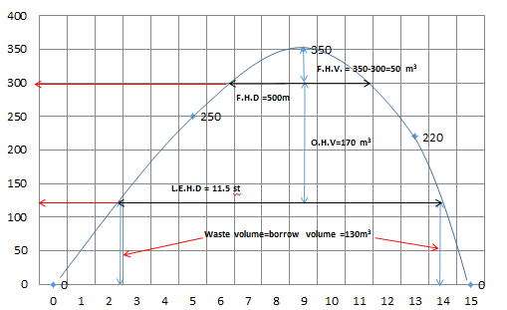

F.H.V = 350 -300=50 m³
L.E.H.D= 11.5 st
Waste volume = borrow volume= 130 m³
Total F.H.C = F.H.C * F.H.V = 1250* 50= 62500 ID
Total W.C = F.H.C *W.V = 1250*130=162500 ID
Total B.C = B.C *B.V=1500*130=195000 ID
Total O.H.C = 1250*170+750*170((11.5-5)/2)= 626 875 ID
Total Cost = 62500+162500+195000+626 875=1046875 ID
Example 3: Determine the cost of total earthwork of a highway section having the cumulative volume shown in the table below:
Station | 0 | 5 | 9 | 13 | 15
Cum. Vol. | 0 | 250 | 350 | 220 | 0
Given that the overhaul cost =750 $\frac{ID}{m^{3}.st}$ , Borrow cost=2500 $\frac{ID}{m^{3}}$, Free haul cost = 1250 $\frac{ID}{m^{3}}$, Free haul volume = 100 m³

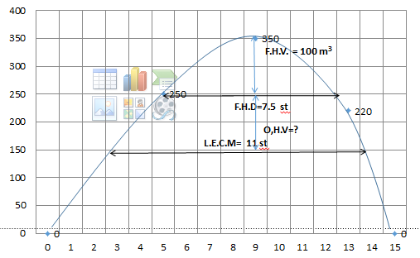
$$L.E.H.D=F.H.D+ \frac{Borrow cost (\frac{ID}{m^{3}})}{Over haul distance cost (\frac{ID}{m^{3}.st})}=7.5+\left(\frac{2500}{750}\right)=11 st$$

Find the total cost by the same steps

Example 4: Determine the cost of total earthwork of a highway section having the cumulative volume shown in the table below:
Station | 0 | 5 | 9 | 13 | 15
Cum. Vol. | 0 | 250 | 350 | 220 | 0
Given that the overhaul cost =750 $\frac{ID}{m^{3}.st}$ , Borrow cost=2500 $\frac{ID}{m^{3}}$, Free haul cost = 1250 $\frac{ID}{m^{3}}$, Borrow volume = 100 m³
Solution
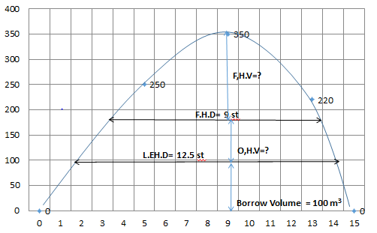

$$L.E.H.D=F.H.D+ \frac{Borrow cost \left(\frac{ID}{m^{3}}\right)}{Over haul distance cost \left(\frac{ID}{m^{3}.st}\right)}=$$
$$F.H.D=12.5-\left(\frac{2500}{750}\right)=9 st$$

Find the total cost by the same steps

Example 5: Determine the cost of total earthwork of a highway section having the cumulative volume shown in the table below:
Station | 0 | 5 | 9 | 13 | 15
Cum. Vol. | 0 | 250 | 350 | 220 | 0
Given that the overhaul cost =750 $\frac{ID}{m^{3}.st}$ , Borrow cost= 2500 $\frac{ID}{m^{3}}$, Free haul cost = 1250 $\frac{ID}{m^{3}}$, and overhaul volume =170 m³, L.E.H.D = 17 st

Solution:
L.E.H.D = 17 st >15 st
L.E.H.D = 15 st
$$F.H.D=15-\left(\frac{2500}{750}\right)=11.5 st$$
Borrow volume = waste volume = zero

Find the total cost by the same step

Example 6: For the given cumulative volume measurements,
Station | 0 | 1 | 2 | 3 | 4 | 5 | 6 | 7 | 8 | 9 | 10 | 11
Cum. Vol. | 0 | 1100 | 2400 | 3900 | 5400 | 5475 | 4045 | 2395 | 965 | -1635 | -255 | 1345

Draw the M.H.D. and the longitudinal profile of the earthworks and find the following:
a) Limit of Economic Haul (L.E.H.)
b) Free Haul Volume (F.H.V.)
c) Over Haul Volume (O.H.V)
d) Waste Volume
e) Borrow Volume
f) Total cost of the earthworks
Given that:
- Cost of overhaul = 30 ID/m³.station
-Cost of borrow = 120 ID/m³.
-Cost of free haul = 70 ID/m³.
-Free Haul Distance (F.H.D.) = 200m = 2 stations

Solution
F.H.V 1= 5475-4650=825
F.H.V2= 1635
$$L.E.H.D=F.H.D+ \frac{Borrow cost \left(\frac{ID}{m^{3}}\right)}{Over haul distance cost \left(\frac{ID}{m^{3}.st}\right)}=$$
$$L.E. H.D=2+\left(\frac{120}{30}\right)=6 st$$
O.H.V= 4650-=1700=2950m3
Waste volume = 1700+1345=3045 m³
Borrow volume= 1700

Free Haul Cost= 70*(825+1635)= 172900 ID
Overhaul cost= 70*2950+30*2950((6-2)/2)= 383500 ID
Waste cost= 70*3045 = 213150 ID
Borrow cost= 120*1700= 204000 ID
Total cost = 973550 ID
