Bus Concepts
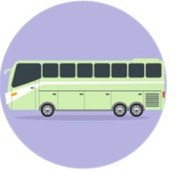
Bus Priority Treatments
Bus Preferential Treatments at Intersections
When buses operate in mixed traffic, the interference decreases bus speeds and lowers overall bus-vehicle and person capacity. The bus preferential treatments described in this section compensate by removing or reducing sources of delay, increasing bus speeds. When considering bus preferential treatments, the total change in person delay (both for passengers in buses and for motorists) should be taken into account. Bus priority treatments provide faster, more reliable bus operations, improving passenger quality of service.
Single Priority
Bus-signal priority measures at signalized intersections include passive systems, which are pretimed treatments adjusted manually to determine the best transit benefit while minimizing the effect on other vehicles, and active systems, which adjust the signal timing after sensing the arrival of a bus. Table (1) lists the most common bus-signal priority systems at intersections. Bus-signal priority measures can be passive (pretimed) or active (operated when a bus is detected).

Table (1): Bus Signal Priority System.

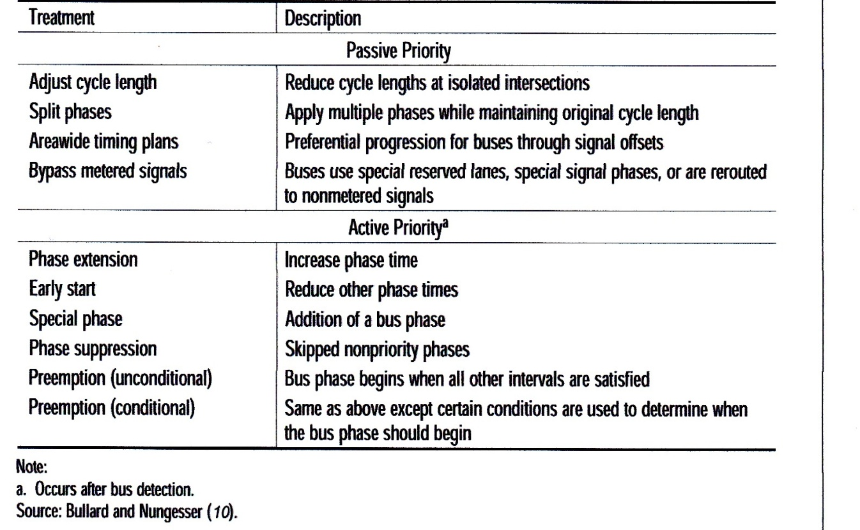
Active priority should be implemented only at intersections operating at less than capacity, so that the changes to signal timing whenever a bus passes through the intersection do not worsen the intersection LOS. Automated systems that do not require bus driver intervention are preferable, since drivers might not always remember to activate the system. When coupled with two-way data communication and automatic vehicle location (AVL) equipment, on-bus signal priority systems can be set to activate signal priority only when a bus is behind schedule.

Queue Bypass
Queue bypasses allow buses to avoid queues of vehicles (such as those that develop at signalized intersections or freeway ramp meters) by providing a special lane. Queue bypass lanes can be shared with carpools and van pools.

Queue Jump
Queue jumps allow buses to move past long queues of vehicles at signalized intersections by using right-turn lanes or long off-line bus stops. Buses are exempted from any right-turn requirements at the intersection. Queue jumps allow buses to bypass long queues of vehicles at signalized intersections.
A special right-lane signal provides a green indication for a brief time before the green for the adjacent general traffic lanes. The bus then exits the right lane and merges into the lane to the left, ahead of the other traffic still stopped for the signal.
Alternatively, the bus can pull into the right-turn lane on a red signal and proceed to a farside off-line bus stop on green, avoiding the delay behind the queue in the regular lanes of the intersection.

Curb Extensions
Where streets have curbside parking and high traffic volumes, it may not be desirable for a bus to pull to the curb to stop, because it must then wait for a gap in traffic to pull back into the travel lane. In these situations, the curb can be extended into the parking lane so that buses can stop in the travel lane to pick up and discharge passengers. The additional area curbside can provide a clear area to load and unload wheelchair passengers in compliance with the ADA, to provide a bus shelter where otherwise there would not have been enough space, and to provide more room for passengers waiting for the bus. Curb extensions also can create more on-street parking, as the area before the bus stop, previously used for buses to pull to the curb, now can be used for additional parking. If there are bicycle lanes, they can be routed around the curb extension; but this can introduce potential bicycle- pedestrian conflicts. At intersections, curb extensions benefit pedestrians by reducing the width of street to cross.

Boarding Islands
Significant parking activity, stopped delivery vehicles, heavy right-turning traffic volumes, and other interferences often slow traffic in the right lane of a street with multiple lanes in the same direction. In these situations, buses might be able to travel faster in the lane to the left. Boarding islands allow bus stops between travel lanes; buses then can remain in a faster lane without merging to the right before every stop. However, pedestrian safety must be addressed in conjunction with boarding islands.

Person -Delay Considerations
In many cases, providing transit priority involves tradeoffs among the various users of a roadway. A bus queue jump at a traffic signal, for example, provides a time-saving benefit for bus passengers but causes additional delay for motorists, their passengers, bicyclists, and some pedestrians. Any consideration of transit priority measures should include the net change in person delay to all roadway users as a result of the priority treatment. Of course, other factors, such as cost, change in transit quality of service, and local policies encouraging transit use, also should be considered. Table (2) summarizes the advantages and disadvantages of the bus preferential treatments.

Table(2): Comparison of Bus Preferential Treatments.
