Total in Array
Displays the total number of entities that the array operation will create, including the current selection. If you're arraying a selection set, the total number of objects will be the result of multiplying this value times the number of objects in the selection set.
Preview group
Preview
When on, viewports display previews of the current array settings. Changing a setting updates the viewports immediately. If the update slows down feedback with large arrays of complex objects, turn on Display As Box.

Display as Box
Displays the array-preview objects as bounding boxes instead of geometry.
Reset All Parameters
Resets all the parameters to their default settings.
Topics in this section
- Creating Linear Arrays
A linear array is a series of clones along one or more axes. A linear array can be anything from a line of trees or cars to a stairway, a picket fence, or a length of chain. Any scene requiring repeated objects or shapes is a candidate for a linear array.
- Creating Circular and Spiral Arrays
Creating circular and spiral arrays typically involves some combination of moving, scaling, and rotating copies along one or two axes and around a common center. The effects can vary from the uniform radial arrangement of bolts on a wheel hub to the complex geometry of a spiral staircase. You can model many circular

Snapshot
Snapshot clones an animated object over time.
- Extras toolbar > (Snapshot), on Array flyout
- Default menu: Tools menu > Snapshot
- Alt menu: Edit menu > Duplicate > Snapshot
Note: The Array flyout is on the Extras toolbar, which is off by default. You can toggle display of this toolbar by right-clicking an empty spot on the main toolbar and choosing Extras from the Customize Display right-click menu.
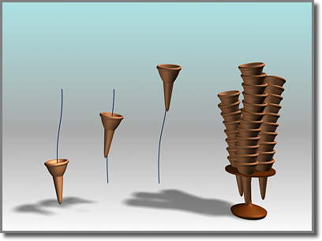
Using an ice-cream cone animated along a path, Snapshot creates a stack of cones.
Snapshot spaces the clones equally in time. Adjustments in Track View let you space the clones equally along the path instead (see the second procedure, below).
To clone an object with Snapshot, the object must already be animated. You can use Snapshot from any frame on the path. The Auto Key button has no effect on Snapshot, since Snapshot creates static clones, not animation.
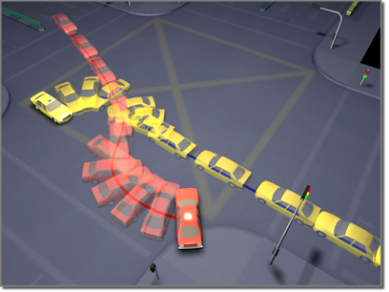
Using car models animated along paths, Snapshot creates an image of a collision.
Like other clone techniques, Snapshot creates copies, instances, or references. You can also choose a mesh option for use with particle systems.
Particle Snapshots
You can clone particle systems as static mesh objects. You can also produce clones of the particles themselves as meshes, when using the Snapshot dialog Clone Method Mesh option. This works with all configurations of particle systems, including those using MetaParticles. Usage is the same as with other types of objects.
Procedures
To clone an object over time:
-  Select an object with an animation path.
Snapshot also shows the effect of any other transform animations, such as rotate or scale as well as parametric modifier animation.
You can also select a particle system.
- Do one of the following:
  - On the Extras toolbar, click (Snapshot), which is on the Array flyout.
  - From the Tools menu, choose Snapshot. If using the Alt menu system, choose Edit menu Duplicate Snapshot.
3ds Max opens the Snapshot dialog.
- Set parameters on the dialog, and click OK.
To space clones evenly by distance:
- Select an object with an animated position.
- Open Track View and find the Position track for the original object.
- Click Assign Controller and check that the track is using a Bezier Position controller. Do one of the following:
  - If the track is already using a Bezier Position controller, proceed to step 4.
  - If the track is not using a Bezier Position controller, change the controller, then proceed to step 4.
- Select all the transform keys and right-click one of the selected keys to display the Key Info dialog.
- Click Advanced to expand the dialog.
- Click Normalize Time.
- Set Constant Velocity on.
- Choose Tools menu Snapshot.
3ds Max opens the Snapshot dialog.
- Set parameters in the dialog, and click OK.
Interface
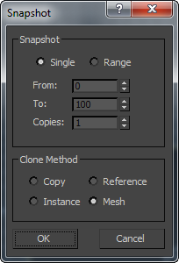
Snapshot group
- Single Makes a clone of the geometry of the object at the current frame.
- Range Makes clones of the geometry of the object along the trajectory over a range of frames. Specify the range with the From/To settings and the number of clones with the Copies setting.
From/To
Specifies the range of frames to place the cloned object along the trajectory.
Copies
Specifies the number of clones to place along the trajectory. They are evenly distributed over the time period, but not necessarily over the spatial distance along the path.
Clone Method group
- Copy Clones copies of the selected object.
- Instance Clones instances of the selected object. Not available with particle systems.
- Reference Clones references of the selected object. Not available with particle systems.
- Mesh Creates mesh geometry out of a particle system. Works with all kinds of particles.

Spacing Tool
The Spacing tool lets you distribute objects based on the current selection along a path defined by a spline or a pair of points.
- Extras toolbar > (Spacing Tool), on Array flyout
- Default menu: Tools menu > Align > Spacing Tool
- Alt menu: Edit menu > Duplicate > Spacing Tool
The distributed objects can be copies, instances, or references of the current selected object. You define a path by picking a spline or two points and by setting a number of parameters. You can also specify how the spacing between objects is determined and whether the pivot points of the objects align to the tangent of the spline.
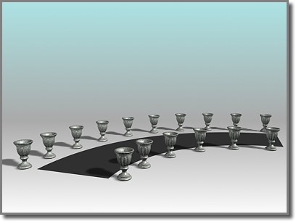
The Spacing tool distributes the vases along the sides of the curved street. The vases are all the same distance from each other; fewer appear on the shorter side.
Tip: You can use compound shapes containing multiple splines as the spline path for distributing objects. Before creating shapes, turn off Start New Shape on the Create panel. Then create your shapes. 3ds Max adds each spline to the current shape until you turn Start New Shape back on. When you select the compound shape so that the Spacing tool can use it as a path, objects are distributed along all of the splines of the compound shape. For example, you might find this technique useful in spacing light standards along a path defined by separated splines.
You can pick splines within an XRef scene as path reference.
Procedures
To distribute objects along a path:
- Select the objects to distribute.
- Do one of the following:
  - On the Extras toolbar, click (Spacing Tool), which is on the Array flyout.
  - From the Tools menu, choose Align Spacing Tool. If using the Alt menu system, choose Edit menu Duplicate Spacing Tool.
3ds Max opens the Spacing Tool dialog.
Note: The Spacing tool is also available on rollouts for various components of the Railing object.
- On the Spacing Tool dialog, click Pick Path or Pick Points to specify a path.
If you click Pick Path, select a spline from your scene to use as the path.
If you click Pick Points, pick a start and an end to define a spline as the path. When you're finished with the Spacing tool, 3ds Max deletes this spline.
- Choose a spacing option from the Parameters list.
The parameters available for Count, Spacing, Start Offset, and End Offset are dependent on the spacing option you choose.
- Specify the number of objects to distribute by setting the value of Count.
- Depending on the spacing option you choose, adjust the spacing and offsets.
- Under Context, choose Edge to specify that spacing be determined from the facing edges of each object's bounding box, or choose Centers to specify that spacing be determined from the center of each object's bounding box.
- Turn on Follow if you want to align the pivot points of the distributed objects to the tangent of the spline.
- Under Type of Object, select the type of object to output (copy, instance, or reference).
- Click Apply.
Interface
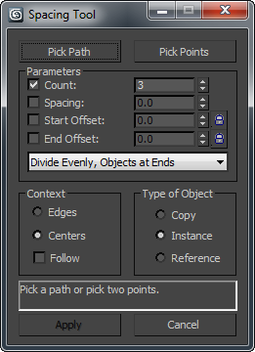
The Spacing tool gives you a choice of two basic methods for setting spacing: using a path, or specifying endpoints explicitly.
Pick Path
Click this, and then click a spline in the viewport to use as the path. 3ds Max uses the spline as the path along which to distribute objects.
Pick Points
Click this, and then click a start point and an end point to define a path on the construction grid. You can also use object snap to specify points in space. 3ds Max uses these points to create a spline as the path along which to distribute objects. When you're finished with the Spacing tool, 3ds Max deletes the spline.
Parameters group
Count
The number of objects to distribute.
Spacing
Specifies the space in units between the objects. 3ds Max determines this spacing based on whether you chose Edges or Centers.
Start Offset
The number of units specifying an offset from the start of the path. Clicking the lock icon locks the start offset value to the spacing value and maintains the count.
End Offset
The number of units specifying an offset from the end of the path. Clicking the lock icon locks the end offset value to the spacing value and maintains the count.
Distribution drop-down list
This list contains a number of options for how to distribute the objects along the path, as follows:
- Free Center Distributes equally spaced objects along a straight line toward the end point of the path, beginning at the start of the path. A spline or a pair of points defines the path. You specify the number of objects and the spacing.
- Divide Evenly, Objects at Ends Distributes objects along a spline. The group of objects is centered at the middle of the spline. The Spacing tool evenly fills the spline with the number of objects you specify and determines the amount of space between objects. When you specify more than one object, there are always objects at the ends of the spline.
- Centered, Specify Spacing Distributes objects along a path. The group of objects is centered at the middle of the path. The Spacing tool attempts to evenly fill the path with as many objects as it can fit along the length of the path using the amount of space you specify. Whether there are objects at the ends of the path depends on the length of the path and the spacing you provide.
- End Offset Distributes the number of objects you specify along a straight line. The objects begin at an offset distance that you specify. This distance is from the end of the spline to its start point, or from the second pair of points to the first point. You also specify the spacing between objects.
- End Offset, Divide Evenly Distributes the number of objects you specify between the start of a spline or a pair of points and an end offset that you specify. 3ds Max always places an object at the end or its offset. When you specify more than one object, there is always an object placed at the start. The Spacing tool attempts to evenly fill the space with the objects between the end offset and the start.
- End Offset, Specify Spacing Distributes objects toward the start of a spline or a pair of points, starting at the end or its offset. 3ds Max always places an object at the end or its offset. You specify the spacing between objects and the offset from the end. The Spacing tool attempts to evenly fill the space with as many objects as it can fit between the end or its offset and the start. There might not always be an object placed at the start.
- Start Offset Distributes the number of objects you specify along a straight line. The objects start at an offset distance that you specify. This distance is from the start of the spline to its end point, or from the first of a pair of points to the second. You also specify the spacing between objects.
- Start Offset, Divide Evenly Distributes the number of objects you specify between the end of a spline or a pair of points, starting at an offset that you specify from the start. 3ds Max always places an object at the start or its offset. When you specify more than one object, there is always an object placed at the end. The Spacing tool attempts to evenly fill the space with the objects between the start or its offset and the end.
- Start Offset, Specify Spacing Distributes objects toward the end of a spline or a pair of points, starting at the start. 3ds Max always places an object at the start or its offset. You specify the spacing between objects and the offset from the start. The Spacing tool attempts to evenly fill the space with as many objects as it can fit between the start or its offset and the end. There might not always be an object placed at the end.
- Specify Offsets and Spacing Distributes as many equally spaced objects as possible along a spline or between a pair of points. You specify the spacing between objects. When you specify offsets from the start and end, 3ds Max distributes equally spaced objects between the offsets. There might not always be an object placed at the start and ends.
- Specify Offsets, Divide Evenly Distributes the number of objects you specify along a spline or between a pair of points. If you specify one object, 3ds Max places it at the center of the path. If you specify more than one object, 3ds Max always places an object at the start offset and the end offset. If you specify more than two objects, 3ds Max evenly distributes the objects between the offsets.
- Space from End, Unbounded Distributes the number of objects you specify along a straight line from the end toward the start of a spline or a pair of points. You specify the spacing between objects. 3ds Max locks the end offset so that it's the same as the spacing.
- Space from End, Specify Number Distributes the number of objects you specify toward the start of a spline or a pair of points, starting at the end. The Spacing tool determines the amount of space between objects based on the number of objects and the length of the spline or the distance between the pair of points. 3ds Max locks the end offset so that it's the same as the spacing.
- Space from End, Specify Spacing Distributes as many equally spaced objects as possible toward the start of a spline or a pair of points, starting at the end. You specify the spacing between objects. 3ds Max locks the end offset so that it's the same as the spacing.
- Space from Start, Unbounded Distributes the number of objects you specify along a straight line toward the end of a spline or a pair of points, starting at the start. You specify the spacing between objects. 3ds Max locks the start offset so that it's the same as the spacing.
- Space from Start, Specify Number Distributes the number of objects you specify toward the end of a spline or a pair of points, starting at the start. The Spacing tool determines the amount of space between objects based on the number of objects and the length of the spline or the distance between the pair of points. 3ds Max locks the start offset so that it's the same as the spacing.
- Space from Start, Specify Spacing Distributes as many evenly spaced objects as possible toward the end of a spline or a pair of points, starting at the start. You specify the spacing between objects. 3ds Max locks the start offset so that it's the same as the spacing.
- Specify Spacing, Matching Offsets Distributes as many evenly spaced objects as possible along a spline or between a pair of points (and their offsets). You specify the spacing. 3ds Max locks the start and end offsets so that they're the same as the spacing.
- Divide Evenly, No Objects at Ends Distributes the number of objects you specify along a spline or between a pair of points (and their offsets). The Spacing tool determines the amount of space between objects. 3ds Max locks the start and end offsets so that they're the same as the spacing.
Context group
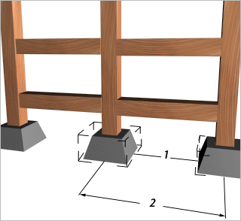
1. Edge-to-edge spacing
2. Center-to-center spacing
- Edges Use this to specify that spacing is determined from the facing edges of each object's bounding box.
- Centers Use this to specify that spacing be determined from the center of each object's bounding box.
Follow
Turn on to align the pivot points of the distributed objects to the tangent of the spline.
Type of Object group
Determines the type of copies made by the Spacing tool. The default is Copy. You can copy, instance, or reference objects.
- Copy Distributes copies of the selected object to the specified position.
- Instance Distributes instances of the selected object to the specified position.
- Reference Distributes references of the selected object to the specified position.
Tip: You can use compound shapes containing multiple splines as the spline path for distributing objects. Before creating shapes, turn off Start New Shape under Shapes on the Create panel. Then create your shapes. 3ds Max adds each spline to the current shape until you click the Start New Shape button so that it's checked. When you select the compound shape so that the Spacing tool can use it as a path, objects are distributed along all of the splines of the compound shape. For example, you might find this technique useful in spacing light standards along a path defined by separated splines.

Align

Align lets you align the current selection to a target selection.
- Main Toolbar > Align, on Align flyout
- Default menu: Tools menu > Align > Align
- Alt menu: Edit menu > Transform > Align
- Keyboard > Alt+A
Procedures Interface
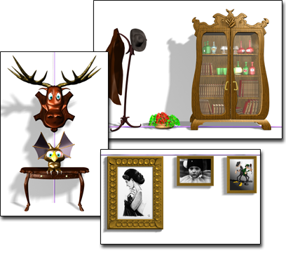
Aligning objects along an axis:
Left: X position, center
Upper right: Y position, minimum
Lower right: Y position, maximum
After selecting an object to align, you click Align, available on the Align flyout, and then select another object to align the first object to. This opens the Align dialog with the name of the target object on its title bar. When performing sub-object alignment, the title bar of the Align dialog reads "Align Sub-Object Selection."
You can align the position and orientation of the bounding box of the source object to the bounding box of a target object.
You can use the Align tool with any selection that can be transformed. If an axis tripod is displayed, you can align the tripod (and the geometry it represents) to any other object in the scene. You can use this to align an object’s pivot point.
You can use objects within an XRef scene as references with all alignment tools on the Align flyout, except Align to View.
When performing sub-object alignment, the Current Object options and the Match Scale boxes are disabled. If you plan to align orientation for sub-objects, first switch to Local transform mode on the main toolbar so that the axis tripod is properly aligned with your sub-object selection.
Other alignment tools on the Align flyout are Quick Align, Normal Align, Place Highlight, Align to Camera, and Align to View.
Procedures
To align objects by position:
Play
Play
Mute
Current Time 0:00
/
Duration 0:32
Playback Rate
1x
Fullscreen
To align an object with a point object:
- Create a point helper object and position it at a target location in your scene. Rotate it as necessary to adjust final orientation.
- Select a source object.
- Do one of the following:
  - On the main toolbar, click Align.
  - From the Tools menu, choose Align Align. If using the Alt menu system, choose Edit menu Transform Align.
3ds Max displays the Align cursor. It is attached to a pair of cross hairs.
- Move the cursor over the point object and click.
3ds Max opens the Align Selection dialog. If necessary, move the dialog out of the way so you can see the active viewport.
- In the Align Position group, turn on X Position.
The selected source object shifts to align with the X axis of the point object.
- Turn on Y Position and Z Position.
The source object moves so its center is at the point object.
- Turn on X Axis, Y Axis, and Z Axis in the Align Orientation group to reorient the object to match the coordinates of the point.
To align objects by position and orientation:
- Select a source object (the object to move into alignment with the target object).
- Do one of the following:
  - On the main toolbar, click Align.
  - From the Tools menu, choose Align Align. If using the Alt menu system, choose Edit menu Transform Align.
3ds Max displays the Align cursor. When it is over an eligible target object, the cursor also shows crosshairs.
- Position the cursor over the target object and click.
The Align Selection dialog appears. By default, all options in the dialog are turned off.
- In the Current Object and Target Object groups, choose Minimum, Center, Pivot Point, or Maximum.
These settings establish the points on each object that become the alignment centers.
- Begin alignment by turning on any combination of X Position, Y Position, and Z Position.
The source object moves in relation to the target object, along the axes of the reference coordinate system. Setting all three moves the objects as close as possible, given the Current Object and Target Object settings.
- In the Align Orientation group, turn on any combination of X Axis, Y Axis, or Z Axis.
The source object realigns accordingly. If the objects already share an orientation, turning on that axis has no effect. Once two axes are aligned in orientation, the third is automatic.
To align a gizmo to another object:
- Display the gizmo level of the Sub-Object selection.
- Do one of the following:
  - On the main toolbar, click Align.
  - From the Tools menu, choose Align Align. If using the Alt menu system, choose Edit menu Transform Align.
- Click to select a target object in the viewport. (You can select the same object containing the gizmo to align the gizmo to a part of its own object.)
- Use the available settings in the Align dialog to adjust the transformation of the gizmo.
To align a sub-object selection of geometry to another object:
- Do one of the following:
  - Convert the object to an editable mesh, and then make the sub-object selection at any level.
  - Apply a Mesh Select or Poly Select modifier, make a sub-object selection, apply an XForm modifier (The Mesh/Poly Select modifier by itself doesn't allow transforms.), and then activate the Gizmo sub-object level of the XForm modifier.
- Do one of the following:
  - On the main toolbar, click Align.
  - From the Tools menu, choose Align Align. If using the Alt menu system, choose Edit menu Transform Align.
- In a viewport, click a target object.
- Use the Align dialog controls to perform the alignment.
Interface
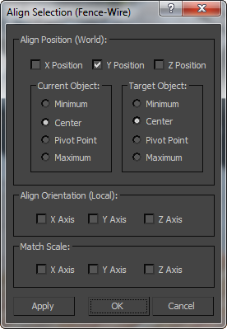
Align Position group
X/Y/Z Position
Specifies the axis or axes on which to perform the alignment. Turning on all three options moves the selection to the target object's location.
Current Object and Target Object groups
Specify the points on the objects' bounding boxes to use for the alignment. You can choose different points for the current object and the target object. For example, you can align the current object's pivot point with the center of the target object.
- Minimum Aligns the point on the object's bounding box with the lowest X, Y, and Z values with the chosen point on the other object.
- Center Aligns the center of the object's bounding box with the chosen point on the other object.
- Pivot Point Aligns the object's pivot point with the chosen point on the other object.
- Maximum Aligns the point on the object's bounding box with the highest X, Y, and Z values with the chosen point on the other object.
Align Orientation (Local) group
These settings let you match the orientation of the local coordinate systems between the two objects on any combination of axes.
This option is independent of the position alignment settings. You can leave the Position settings alone and use the Orientation checkboxes to rotate the current object to match the orientation of the target object.
Position alignment uses world coordinates, while orientation alignment uses local coordinates.
Match Scale group
Use the X Axis, Y Axis, and Z Axis options to match the scale axis values between the two selected objects. This matches only the scale values you'd see in the Transform Type-In. It does not necessarily cause two objects to be the same size. There will be no change in size if neither of the objects has previously been scaled.

Default Hotkey Maps
Use the default keyboard shortcuts to quickly accomplish common tasks.
The following keyboard maps show the default keyboard shortcuts, organized by Main UI, Schematic View, Track View, Material Editor and SME, Edit Normals, and Unwrap UVW. A map of retired and changed hotkeys is shown at the bottom.
With hotkeys such as SHIFT+A, the combination key to hold down is shown in green. You can customize any of these keys using the Hotkey Editor.
For a list of all hotkeys, see Keyboard Shortcuts Tables.

Group | Category | Action | Hotkey
Main UI | Asset Tracking System | Asset Tracking Toggle | Shift+T
Main UI | Edit | Align | Alt+A
Main UI | Edit | Clone | Ctrl+V
Main UI | Edit | Delete Objects | Del
Main UI | Edit | Fetch | Ctrl+Alt+F
Main UI | Edit | Hold | Ctrl+H
Main UI | Edit | Normal Align | Alt+N
Main UI | Edit | Redo Scene Operation | Ctrl+Y
Main UI | Edit | Transform Type-In Dialog Toggle | F12
Main UI | Edit | Undo Scene Operation | Ctrl+Z
Main UI | Editable Polygon Object | Extrude Face (Poly) | Alt+Shift+E
Main UI | Editable Polygon Object | Select Sub-object Loop | Alt+L
Main UI | Editable Polygon Object | Select Sub-object Ring | Alt+R
Main UI | Editable Polygon Object | Soft Selection Toggle (Poly) | Shift+B
Main UI | Editable Spline Object | Refine (Spline) | Alt+Shift+1
Main UI | File | New Scene | Ctrl+N
Main UI | File | Open File | Ctrl+O
Main UI | File | Save File | Ctrl+S
Main UI | File | Save File As | Ctrl+Shift+S
Main UI | Groups | Group Attach | Ctrl+U
Main UI | Lights and Cameras | Create Camera (Physical) From View | Ctrl+C,  Alt+Shift+C
Main UI | MAX Script | MAXScript Listener | F11
Main UI | Modifier Stack | Show End Result | Alt+`
Main UI | Modifier Stack | Sub-Object Level 1 | 1
Main UI | Modifier Stack | Sub-Object Level 2 | 2
Main UI | Modifier Stack | Sub-Object Level 3 | 3
Main UI | Modifier Stack | Sub-Object Level 4 | 4
Main UI | Modifier Stack | Sub-object Level 5 | 5
Main UI | PolyTools | Circle Loops | Alt+Shift+3
Main UI | PolyTools | Geo Poly | Alt+Shift+4
Main UI | PolyTools | Insert Loop | Alt+3
Main UI | PolyTools | PolyShift Move | Alt+4
Main UI | PolyTools | Set Flow | Alt+2
Main UI | PolyTools | Spin Edge | Alt+5
Main UI | PolyTools | Straighten Loops | Alt+Shift+2
Main UI | PolyTools | Swift Loop | Alt+1
Main UI | Quad Menu Sets | Lock | Spacebar
Main UI | Quad Menu Sets | Modeling [Ctrl+RMB] | Ctrl+RMB
Main UI | Quad Menu Sets | Snap [Shift+RMB] | Shift+RMB
Main UI | Quad Menu Sets | Viewports | V
Main UI | Quad Menu Sets | Windows | J
Main UI | Render | Advanced Lighting Panel | 9
Main UI | Render | Create Animated Sequence File... | Shift+V
Main UI | Render | Environment Dialog Toggle | 8
Main UI | Render | Render | Shift+Q, Shift+F9
Main UI | Render | Render Last | F9
Main UI | Render | Render SetUp... | F10
Main UI | Selection | Select All | Ctrl+A
Main UI | Selection | Select By Name | H
Main UI | Selection | Select Invert | Ctrl+I
Main UI | Selection | Select None | Ctrl+D
Main UI | Selection | Select Similar | Ctrl+Shift+A
Main UI | Selection | Selection Lock Toggle | Ctrl+Shift+N
Main UI | Selection | Smart Select | Q
Main UI | Set Key Tools | Auto Key Mode Toggle | N
Main UI | Set Key Tools | Set Keys | K
Main UI | Snaps | Angle Snap Toggle | A
Main UI | Snaps | Cycle Active Snap Type | Alt+S
Main UI | Snaps | Enable Axis Constraints in Snaps Toggle | Alt+F3
Main UI | Snaps | Snaps Toggle | S
Main UI | Tools | Center Point Cycle | Alt+Shift+5
Main UI | Tools | Cycle Selection Method | Ctrl+F
Main UI | Tools | Display as See-Through Toggle | Alt+X
Main UI | Tools | Hide Selection | Alt+H
Main UI | Tools | Hide Unselected | Alt+I
Main UI | Tools | Isolate Selection | Alt+Q
Main UI | Tools | Isolate Selection Toggle | Ctrl+Alt+Q
Main UI | Tools | Keyboard Shortcut Override Toggle | Ctrl+Alt+Shift+X
Main UI | Tools | Lock User Interface Toggle
Main UI | Tools | Material Editor Toggle | M
Main UI | Tools | Maximize Viewport Toggle | Alt+W
Main UI | Tools | Pan Viewport | I
Main UI | Tools | Quick Align | Shift+A
Main UI | Tools | Scale Cycle | Ctrl+E
Main UI | Tools | Select and Move | W
Main UI | Tools | Select and Rotate | E
Main UI | Tools | Show Statistics Toggle | 7
Main UI | Tools | Smart Scale | R
Main UI | Tools | Spacing Tool | Shift+I
Main UI | Tools | Sub-object Selection Toggle | Ctrl+B
Main UI | Tools | Transform Gizmo Plane Constraint Cycle | F8
Main UI | Tools | Transform Gizmo Size Down | -
Main UI | Tools | Transform Gizmo Size Up | =
Main UI | Tools | Transform Gizmo X Constraint | F5
Main UI | Tools | Transform Gizmo Y Constraint | F6
Main UI | Tools | Transform Gizmo Z Constraint | F7
Main UI | Tools | Unhide All | Alt+U
Main UI | Tools | Viewport Lighting Illuminate with Default / Scene Lights Toggle | Ctrl+L
Main UI | Tools | Viewport Safe Frames Toggle | Shift+F
Main UI | Tools | Viewport Selection Shade Selected Faces Toggle | F2
Main UI | Tools | Viewport Selection Show Selection Bracket Toggle | Shift+J
Main UI | Tools | Window / Crossing Toggle | Shift+O
Main UI | Tools | Zoom Extents | Ctrl+Alt+Z
Main UI | Tools | Zoom Extents All | Shift+Ctrl+Z
Main UI | Tools | Zoom Extents Selected | Z
Main UI | Tools | Zoom In 2X | Ctrl+Alt+Shift+Z
Main UI | Tools | Zoom Mode | Alt+Z
Main UI | Tools | Zoom Region Mode | Ctrl+W
Main UI | Tools | Zoom Viewport In | [, Ctrl+=
Main UI | Tools | Zoom Viewport Out | ], Ctrl+-
Main UI | Track View | Add/Edit Parameters... (TV) | Ctrl+1
Main UI | User Interface | Launch Global Search | X
Main UI | Viewport Lighting and Shadows | High Quality | Shift+F3
Main UI | Views | Adaptive Degradation Toggle | O
Main UI | Views | Camera View | C
Main UI | Views | Disable Viewport | Ctrl+Shift+D
Main UI | Views | Expert Mode Toggle | Ctrl+Alt+X
Main UI | Views | Front View | F
Main UI | Views | Hide Cameras Toggle | Shift+C
Main UI | Views | Hide Geometry Toggle | Shift+G
Main UI | Views | Hide Grids Toggle | G
Main UI | Views | Hide Helpers Toggle | Shift+H
Main UI | Views | Hide Lights Toggle | Shift+L
Main UI | Views | Hide Particle Systems Toggle | Shift+P
Main UI | Views | Hide Shapes Toggle | Shift+S
Main UI | Views | Hide Space Warps Toggle | Shift+W
Main UI | Views | Home View | Alt+Home
Main UI | Views | Left View | L
Main UI | Views | Orbit View Mode | Ctrl+R
Main UI | Views | Orthographic User View | U
Main UI | Views | Pan View | Ctrl+P
Main UI | Views | Perspective User View | P
Main UI | Views | Redo Viewport Operation | Shift+Y
Main UI | Views | Selection/Preview Highlights Toggle | Alt+J
Main UI | Views | Spot/Directional Light View | Shift+4
Main UI | Views | Top View | T
Main UI | Views | Undo Viewport Operation | Shift+Z
Main UI | Views | View Edged Faces Toggle | F4
Main UI | Views | Viewport Background | Alt+B
Main UI | Views | WalkThrough View Mode | Up
Main UI | Views | Wireframe / Smooth+Highlights Toggle | F3
Main UI | Asset Tracking System | Asset Tracking Toggle | Shift+T
Main UI | Edit | Align | Alt+A
Main UI | Edit | Clone | Ctrl+V
Main UI | Edit | Delete Objects | Del
Main UI | Edit | Fetch | Ctrl+Alt+F
Main UI | Edit | Hold | Ctrl+H
Viewport Navigation
At the right end of the status bar are the buttons that control the display and navigation of the viewports.
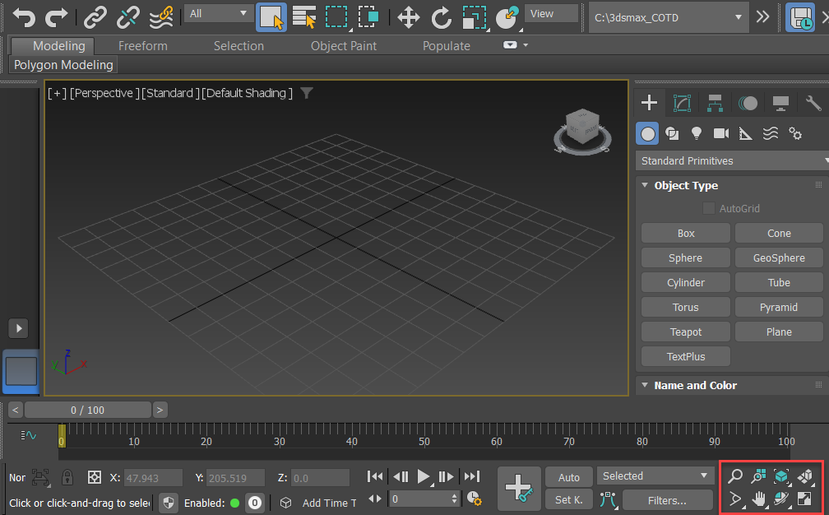
The location of the Viewport Navigation controls
Some of the buttons change for camera and light viewports. The Field Of View button changes for Perspective viewports.
The state of the navigation-button flyouts for all viewport types is saved in the [Performance] section of the Initialization file.
Viewport Navigation Controls
The navigation controls depend on the active viewport. Perspective, orthographic, camera, and light viewports all have specialized controls. The term “orthographic” refers to User viewports as well as viewports like Top, Front, and so on. The Zoom Extents All flyout and Maximize Viewport toggle, available in all viewports, are included with the perspective and orthographic viewport controls.
Many of these controls are modal, meaning the tool stays active for repeated use. The button highlights when on. To turn it off, press Esc, right-click in a viewport, or choose another tool.
2D Pan Zoom Mode
Controls Available in All Viewports
Zoom Extents All, Zoom Extents All Selected
Maximize Viewport Toggle
Perspective and Orthographic Viewport Controls
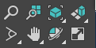
Zoom
Zoom All
Zoom Extents/Zoom Extents Selected
Field-of-View Button (Perspective) or Zoom Region
Pan View
Walk Through
Orbit, Orbit Selected, Orbit Sub-Object
Camera Viewport Controls
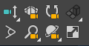
Dolly Camera, Target, or Both
Perspective
Roll Camera
Field-of-View Button
Truck Camera
Walk Through
Orbit/Pan Camera
Light Viewport Controls
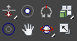
Dolly Light, Target, or Both
Light Hotspot
Roll Light
Light Falloff
Truck Light
Orbit/Pan Light
Topics in this section
- 2D Pan Zoom Mode
In 2D Pan Zoom Mode, you can pan or zoom a viewport without changing the rendering frame.
- Navigating in All Viewports
The topics in this section describe viewport controls that are available in all viewports: orthographic, perspective, camera, and spotlight or directional light.
- Navigating in Camera and Perspective Viewports
The topics in this section describe viewport controls available in camera and perspective viewports.
- Navigating in Perspective and Orthographic Viewports
Perspective, orthographic, user, grid, and shape viewports all share the same viewport controls.
- Navigating in Camera and Light Viewports
The Camera and Light view navigation buttons are the same with a few exceptions. The buttons are visible when a viewport with a Camera or Light view is active. The Camera and Light view navigation buttons do more than adjust your view. They transform and change the parameters of the associated camera or light object.
- SteeringWheels
The SteeringWheels ® 3D navigation controls are tracking menus that allow you to access different 2D and 3D navigation tools from a single tool.
- ViewCube
The ViewCube ® 3D navigation control provides visual feedback of the current orientation of a viewport, lets you adjust the view orientation, and also switch between standard and isometric views.
Viewport Navigation (Expanded)
Viewport navigation tools control how you view and explore your 3D scene. They do not affect the objects themselves but change only the camera/viewpoint in the viewport.
🔹 Pan
- Shortcut: Middle Mouse Button (MMB) drag, or Ctrl+P.
- Function: Moves the scene view horizontally or vertically without changing zoom or perspective.
- Notes: Useful for shifting focus when working on detailed areas of a model.

🔹 Zoom
- Shortcut: Mouse Scroll Wheel, or Ctrl+Alt+Z.
- Function: Zooms in and out of the viewport along the current camera direction.
- Additional Options:
  - Zoom Region (Ctrl+W): Drag a box to zoom into a specific area.
  - Zoom In/Out Selected (Alt+Ctrl+Z): Zoom to frame the selected objects.

🔹 Orbit
- Shortcut: Alt + Middle Mouse Button, or Ctrl+R.
- Function: Rotates the camera around the center of the current scene or selected object.
- Modes:
  - Orbit Sub-Object: Rotates around selected sub-geometry (vertex/edge/face).
  - Orbit Point of Interest: Rotates around the last clicked point in the viewport.

🔹 Zoom Extents
- Shortcut: Z (all objects) / Alt+Z (selected objects only).
- Function: Fits all scene objects (or only the selected ones) to fill the viewport.
- Usage: Essential for quickly re-centering after losing sight of your model.

🔹 ViewCube
- Location: Upper-right corner of each viewport.
- Function: Provides quick access to standard orthographic views (Top, Front, Left, Right, etc.) and 3D orientations (Isometric, Perspective).
- Features:
  - Click faces/edges/corners to snap the view.
  - Right-click to reset view or switch projection mode (Perspective/Orthographic).

🔹 SteeringWheels
- Shortcut: Shift+W.
- Function: On-screen navigation tool combining Pan, Orbit, Zoom, Rewind, and Walkthrough functions.
- Types:
  - Full Navigation Wheel: All navigation tools.
  - Mini View Wheel: Simplified version with key functions.
  - Walkthrough Wheel: Allows first-person camera navigation, useful for interior spaces.

🔹 Additional Navigation Tools
- Field-of-View (Ctrl+Shift+Z): Adjusts the camera angle, similar to changing a real lens.
- Walkthrough Mode (W + Up/Down/Left/Right): Navigate like a video game character, ideal for exploring interiors.
- Pan/Zoom Toggle (Ctrl+Shift+Middle Mouse): Temporarily switches between Pan and Zoom.
- Adaptive Degradation (O): Temporarily reduces scene quality during navigation for smoother performance.

🔑 Tip for Students:
If you "lose" an object in the viewport, press Z to zoom extents or use the ViewCube to reorient. Always combine Pan + Zoom + Orbit for efficient modeling navigation.

Setting Viewport Layout
3ds Max defaults to a 2 x 2 arrangement of viewports. Thirteen other layouts are available, but the maximum number of viewports on the screen remains four.

