Resized viewport
Changing the View Type
As you work, you can change the view in any viewport quickly. For example, you can switch from front view to back view. You can use either of two methods: menu or keyboard shortcut.
• Click or right-click the Point-Of-View (POV) viewport label of the viewport you want to change. Then from the POV viewport label menu, click the view type that you want.
• Click the viewport you want to change, and then press one of the keyboard shortcuts in the following table.
Key View type
T Top view
B Bottom view
F Front view
L Left view
C Camera view. If your scene has only one camera, or you select a camera before using this keyboard shortcut, that camera supplies the view. If your scene has more than one camera, and none are selected, a list of cameras appears.
P Perspective view. Retains viewing angle of previous view.
U Orthographic User view. Retains viewing angle of previous view. Allows use of Zoom Region.

none Right view. Use the POV viewport label menu.

none Shape view. Use the POV viewport label menu. Automatically aligns view to the extents of a selected shape and its local XY axes.

Viewport Menus
Depending on the display driver selected, each viewport contains a series of up to five menus in the top left hand corner that control viewport display.

The menus are:
1. General
2. Point-of-View (POV)
3. Shading
4. Per-View Preference (Nitrous only)
5. 2D Pan Zoom (displayed only in 2D Pan Zoom mode)
Click or right-click a menu to view its specific options.
Tip: If the viewport menu label bar becomes disabled, you can restore it by refreshing the UI scheme. Use Customize menu Load Custom UI Scheme to load a different CUI file, then reload the original CUI file again. The label bar will become available after either the new or original UI scheme is loaded.
Topics in this section
• Viewport's General Menu
Use this menu to adjust general options for viewport display and configuration.
• Point-Of-View (POV) Viewport Label Menu
Use this menu to change the active point-of-view and enable other integrated viewport elements.
• Shading Viewport Label Menu
Use this menu to set shading and other visual options.
• Per-View Preference Viewport Label Menu
The Per-View Viewport Label menu provides additional options for Nitrous displays.
• 2D Pan Zoom Viewport Menu
Shows the zoom level when 2D Pan Zoom mode is enabled. Available for Nitrous displays only.
• Active Viewport Settings
Use this dialog to apply presets and preferences to viewports.

2D Snap, 2.5D Snap, 3D Snap

The buttons on the Snaps Toggle flyout provide control over the range of 3D space where snaps are active.
- Main Toolbar > 2D Snap, 2.5D Snap, or 3D Snap on the Snaps Toggle flyout
- Default menu: Tools menu > Grids and Snaps > Snaps Toggle
- Alt menu: Scene menu > Grids and Snaps > Snaps Toggle
- Keyboard > S

2D, 2.5D, 3D Snaps flyout
A variety of snap types is available from the Snaps dialog, which you can use to activate different snap types as you work.
Object Snapping
Object snapping lets you snap to specific portions of existing geometry during creation and transforms of objects or sub-objects. You can also snap to the grid, and you can snap to tangents, midpoints, pivot points, face centers and other options.
The mode you choose maintains its state when you switch levels.
Transforming Around Snap Points
When snapping is on and Auto Key is off, rotations and scales occur about the snap point. For example, if you're using Vertex snapping and you're rotating a box, you can rotate it about any of its corner vertices. See To use snaps to move an absolute distance, below.
When Auto Key is on and either Select And Rotate or Select And Scale is active, the Snaps Toggle button is disabled, and rotation and scaling take place about the pivot point of the object.
Snap Handle When Moving an Object
When both the Snap tool (any mode) and the Move tool are active and Enable Axis Constraints is on, the Move gizmo shows a circle at its center.
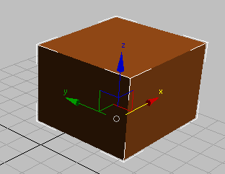
A circle at the center of the Move gizmo shows that snapping is active.
Not only does the circular handle indicate that snapping is active, it helps increase the accuracy of snapping. You can use the gizmo controls as before, or drag the handle itself: In either case, 3ds Max shows the original position of the object, and by default a rubber-band line stretches from the original position to the new destination. When you drag the snap handle or the Move gizmo, the axis center is the start snap point.
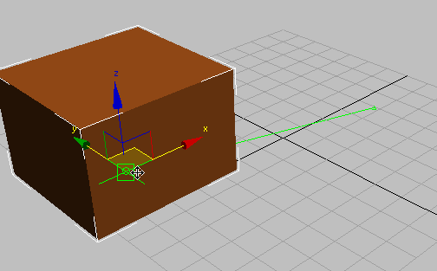
The green line shows start and destination points.
- When you drag the circular snap handle, axis constraints don’t apply, and Enable Axis Constraints is automatically turned off.
- When you drag an axis or a plane, axis constraints apply, and if Enable Axis Constraints is on, the snapping uses it.
- When you drag from a snap point other than the axis center (for example, a vertex), the state of Enable Axis Constraints determines whether movement is constrained or not.
When start and destination points are snapped or aligned, the color of the snap points and rubber band changes from Snap Point Active (default=green) to Snap Point Snapped (default=yellow).
Note: You can customize the colors of the snap indicators: In the Customize User Interface dialog Colors panel, choose Elements Snaps.
Dragging from the snap handle is equivalent to using the Snap Option Use Axis Center As Start Snap Point that was available in versions of 3ds Max prior to version 2011. In addition, you can use other snap points on the object that you are moving. For example, when snapping to vertices, the following illustrations show that you can snap from a vertex on the object you are moving.
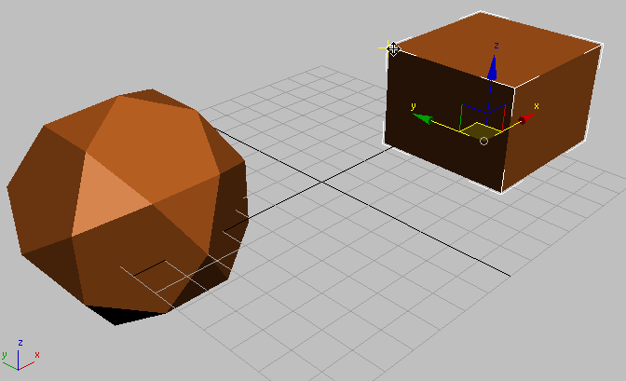
Vertex snap: Snapping from the upper-left corner of the box.
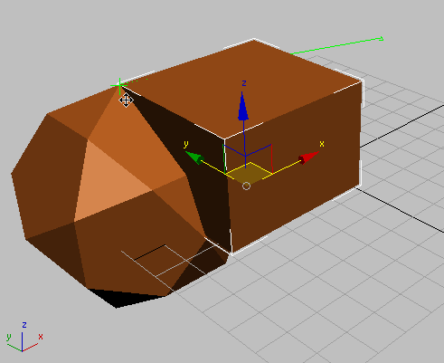
Snapping the upper-left corner of the box to a vertex on the dodecahedron.
Tip: When you snap from a location other than the snap handle (the axis center), be careful of two things:
- Make sure the Move cursor is visible when you click. Otherwise, you might deselect the object you are trying to move.
- If the vertex (or other snap location) is close to an axis of the Move gizmo, the move might be constrained along that axis.
Using the snap handle or the Move gizmo corresponds to the toggle Enable Axis Constraints, or to Snaps Use Axis Constraints Toggle on the Axis Constraints toolbar
Procedures
To turn snap off during a transform:
- Press S to toggle snapping off when it gets in the way. Press S again to turn it back on.
To use snaps to move a relative distance:
- Turn on Snaps with the S key, or by clicking Snaps Toggle.
- Lock your selection set by pressing Ctrl+Shift+N or by clicking Selection Lock Toggle on the status bar.
- Wherever you click in the viewport, the snap will stay relative to the distance of your cursor to the object.
To use snaps to move an absolute distance:
- Turn on Snaps Toggle.
- Click the selection. Snap uses the point you click for the snap source.
- Move to whatever target snap you desire. The object will snap to an absolute distance.
Example: To rotate a box around a vertex using snaps:
- Make sure AutoKey is off.
- Select the box.
- On the main toolbar, click Select And Rotate.
- Turn Snaps on by pressing S on the keyboard.
- On the Tools menu, choose Grids And Snaps Grid And Snap Settings. Turn on Vertex and turn off Grid Points.
- Lock your selection set by clicking Selection Lock Toggle on the status bar.
- On the toolbar, choose Use Transform Coordinate Center (hold the mouse down on Use Pivot Point Center to open the flyout).
- Move your cursor over any vertex in the box. The snap cursor appears, and then you can rotate the box around that vertex.
Interface
3ds Max supports three snap modes as described following. How a particular snap tool works in practice depends on the active function (for example, moving an object vs. creating one) and the snap settings, particularly those on the Snaps panel.
Here's a brief example: Say you have a box positioned above the home grid. In the Perspective viewport, you're looking at it from above, at an oblique angle. You're using the Move tool to translate the box parallel to the grid, and on the Snaps panel only Grid Points is on. With Snaps Toggle on and set to 2D, no snapping is performed. As its name suggests, 2D snapping is best for operations that involve two dimensions only, such as creating a Plane primitive on the grid. Using 2.5D, the box moves parallel to the grid (assuming you're moving it that way) and snapping occurs when the box is above the grid, because it's using the projected snapping, but not when it is beyond the grid limits. And using 3D snapping, the box moves to the grid so as to snap the starting point (represented by a green circle when Enable Axis Constraints is on) to an actual grid point rather than its projection.
2D Snap
The cursor snaps only to the active construction grid, including any geometry on the plane of that grid. The Z axis, or vertical dimension, is ignored.
2.5D Snap
The cursor snaps only to the vertices or edges of the projection of an object onto the active grid.
Suppose you create a grid object and make it active. You then position the grid object so you can see through the grid to a cube further off in 3D space. Now with 2.5D set, you can snap a line from vertex to vertex on the distant cube, but the line is drawn on the active grid. The effect is like holding up a sheet of glass and drawing the outline of a distant object on it.
3D Snap
This is the default tool. The cursor snaps directly to any geometry in 3D space. 3D snapping lets you create and move geometry in all dimensions, ignoring the construction plane.
Right-click this button to display the Grid and Snap Settings dialog, which lets you change snap categories and set other options.

Setting Snap Options
You can access a number of snap features from the Options tab of the Grid And Snap Settings dialog. Right-click any of the snap buttons on the main toolbar to display the Grid And Snap Settings dialog or choose Tools menu (or Scene menu if using the Alt menu system) Grids And Snaps Grid And Snap Settings, then click the Options tab.
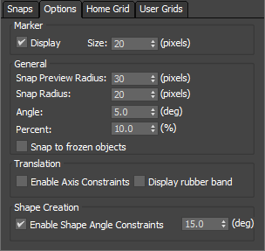
Display and General Settings
Marker settings
Determine the size of the snap cursor. To prevent the snap cursor from appearing, turn off Display.
Snap Radius settings
Determines how close the cursor needs to approach a snap point before the snap preview or actual snap takes place. These are global settings, affecting all snap interactions, and are measured in terms of the pixels in a "search region" around the active point of the cursor.
Snap to Frozen Objects
Normally, if an object is frozen you can't snap to it; this option lets you snap to frozen objects.
Settings for Angle and Percent Snap
The following Options settings are for two snap buttons that operate independently of standard snaps.
Angle (deg)
A global setting, in degrees, that determines the angle of rotation for a number of features in 3ds Max, including the standard Rotate transform. As you rotate an object (or group of objects), the object moves around a given axis in the increment you set. Angle snap also affects the following:
- Pan/Orbit camera controls
- FOV and Roll camera settings
- Hotspot and Falloff light angles
For more information, see Angle Snap.
Percent
Sets a percentage increment during a scaling operation.
For more information, see Percent Snap.
Rotating and Scaling with Snaps
The effect of rotating and scaling with snaps depends on whether Auto Key is on or off:
- With Auto Key on, snap toggles are disabled, while Angle and Percent snaps remain active. Rotation and scaling occur around the pivot point of the object.
- With Auto Key off, rotations and scales occur around the snap point. For example, using Vertex snap, you can rotate a box about any of its corners.

Animation and Time Controls
The main animation controls are found at the bottom of the program window, between the status bar and the viewport navigation controls, along with the time controls for animation playback within viewports.
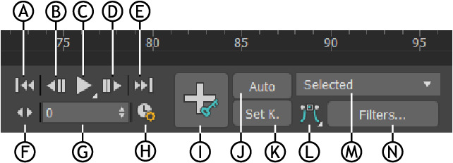
Animation and Time Controls: A. Go to Start,B. Previous Frame/Key, C Play/Stop, D. Next Frame/Key, E. Go to End, F. Key Mode toggle, G. Current Frame (Go To Frame), H. Time Configuration, I. Set Key animation mode, J. Auto Key mode toggle, K. Set Key mode toggle, L. Default In/Out Tangents for New keys, M. Selection List, N. Key Filters
Two additional important animation controls are the time slider and track bar, found on the status bar to the left of the main animation controls, both of which can be floated and docked.
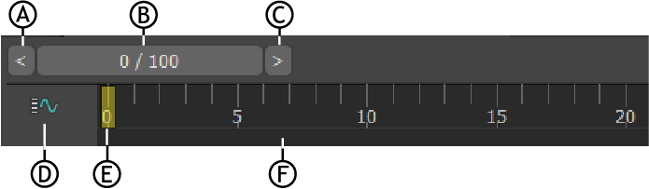
The time slider and track bar: A. Back up Time One Unit,B. Time Slider, C. Forward Time One Unit, D. Open Mini Curve Editor, E. Current frame indicator, F. Timeline
Animation Controls
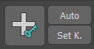 Auto Key Animation Mode and Set Key Animation Mode
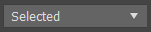 Selection List
Default In/Out Tangents for New Keys
Key Filters
Go To Start
Previous Frame/Key
Play/Stop
Next Frame/Key
Go To End
Current Frame (Go To Frame)
Time Controls
Key Mode
Time Configuration

Creating Geometry
In 3ds Max, every 3D object is created through the Command Panel → Create tab. Geometry is divided into several categories, each containing specific object types with adjustable parameter
Modeling Objects
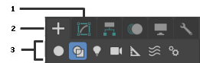
You model objects in your scene by creating standard objects, such as 3D geometry and 2D shapes, and then applying modifiers to those objects. 3ds Max includes a wide range of standard objects and modifiers.

1. Modify panel
2. Create panel
3. Object categories

Creating Objects
You create objects by clicking an object category and type on the Create panel and then clicking or dragging in a viewport to define the object's creation parameters. 3ds Max organizes the Create panel into these basic categories: Geometry, Shapes, Lights, Cameras, Helpers, Space Warps, and Systems. Each category contains multiple subcategories from which you can choose.
You can also create objects from the Create menu by choosing an object category and type and then clicking or dragging in a viewport to define the object's creation parameters. 3ds Max organizes the Create menu into these basic categories: Standard Primitives, Extended Primitives, AEC Objects, Compound, Particles, Patch Grids, NURBS, Shapes, Lights, Cameras, Helpers, Space Warps, and Systems.
Selecting and Positioning Objects
You select objects by clicking or dragging a region around them. You can also select objects by name or other properties such as color or object category.
After selecting objects, you position them in your scene using the transform tools Move, Rotate, and Scale. Use alignment tools to precisely position objects.
Modifying Objects
You sculpt and edit objects into their final form by applying modifiers from the Modify panel. The modifiers you apply to an object are stored in a stack. You can go back at any time and change the effect of the modifier, or remove it from the object.

1. Standard Primitives
Standard Primitives are the basic building blocks in 3ds Max. They are parametric objects, meaning their dimensions and segments can be controlled numerically at creation or later in the
Modify Panel.
You can access them from:
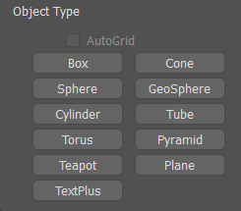
Command Panel → Create → Geometry → Standard Primitives.

🔹 Box
- Description: A rectangular solid.
- Parameters:
  - Length, Width, Height – Control dimensions.
  - Length Segs, Width Segs, Height Segs – Divide the box into subdivisions, useful for deformation.
- Usage: Building blocks, walls, furniture.

🔹 Sphere
- Description: A perfect sphere.
- Parameters:
  - Radius – Defines size.
  - Segments – Controls smoothness (more segments = smoother surface).
- Usage: Decorative elements, lighting fixtures, organic forms.

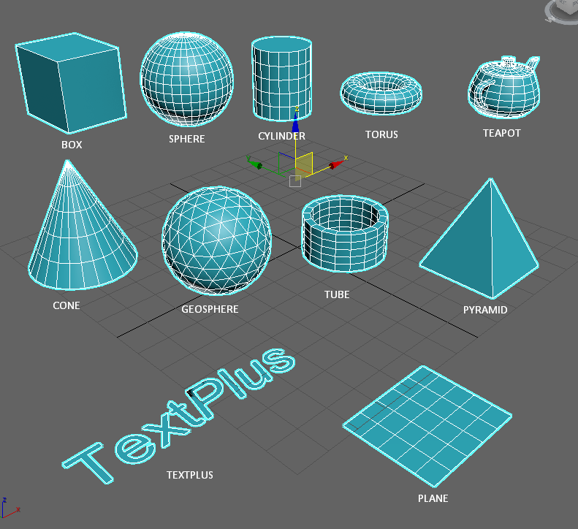
🔹 Cylinder
- Description: A circular base with vertical sides.
- Parameters:
  - Radius 1, Radius 2, Height.
  - Height Segs, Cap Segs, Sides.
- Usage: Columns, pipes, structural elements.

🔹 Cone
- Description: A tapered cylinder.
- Parameters:
  - Radius 1 (base), Radius 2 (top), Height.
  - Height Segs, Cap Segs, Sides.
- Usage: Towers, roofs, funnels.

🔹 GeoSphere
- Description: A sphere created using geodesic methods (fewer polygons than a regular Sphere).
- Types: Icosa, Octa, Tetra.
- Parameters:
  - Radius, Segments.
- Usage: Game modeling, low-poly design, planets.

🔹 Tube
- Description: A hollow cylinder.
- Parameters:
  - Inner Radius, Outer Radius, Height.
  - Height Segs, Cap Segs, Sides.
- Usage: Pipes, frames, tunnels.
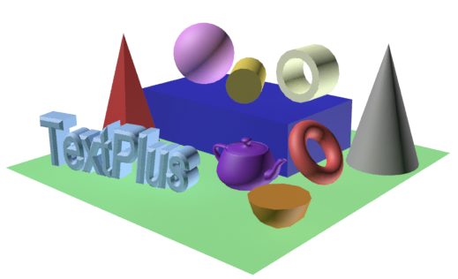

🔹 Torus
- Description: A donut-shaped object.
- Parameters:
  - Radius 1 (major), Radius 2 (minor).
  - Rotation Segs, Sides.
- Usage: Rings, handles, curved geometry.

🔹 Pyramid
- Description: A polyhedron with a rectangular or square base tapering to an apex.
- Parameters:
  - Length, Width, Height.
  - Cap Segs, Sides.
- Usage: Roof forms, monuments, decorative elements.

🔹 Plane
- Description: A flat surface.
- Parameters:
  - Length, Width.
  - Length Segs, Width Segs.
- Usage: Floors, terrain bases, backgrounds.

🔹 Teapot
- Description: A predefined model of a teapot (the "Utah Teapot"), used for testing.
- Parameters:
  - Radius.
  - Options for Body, Handle, Spout, Lid (can be toggled on/off).
- Usage: Render testing, material previewing.

📝 Notes for Students
- Parametric Editing: All values can be changed anytime from the Modify Panel.
- Segmentation: Always add enough segments if you plan to deform objects with modifiers (e.g., Bend, Twist).
- Practical Tip: Start modeling with primitives, then refine using Editable Poly or Modifiers.

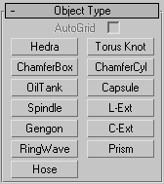
Extended Primitives
Extended Primitives are specialized parametric objects that offer more complex geometry than Standard Primitives.
They are found in:
Command Panel → Create → Geometry → Extended Primitives.

🔹 ChamferBox
- Description: A box with rounded (beveled) edges.
- Parameters:
  - Length, Width, Height – Dimensions.
  - Fillet – Amount of edge beveling.
  - Length/Width/Height Segs – Subdivisions.
- Usage: Architectural models where sharp corners need softening (e.g., furniture, equipment).

🔹 ChamferCyl
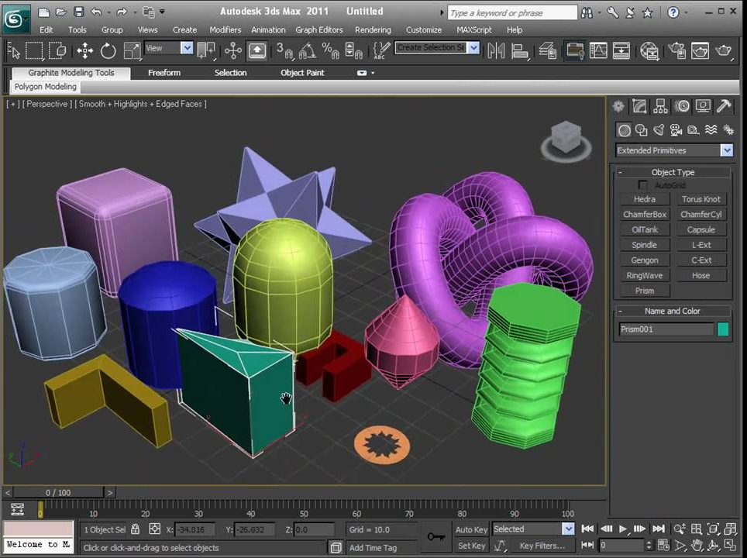
- Description: A cylinder with beveled top and bottom edges.
- Parameters:
  - Radius, Height, Fillet.
  - Height Segs, Cap Segs, Sides.
- Usage: Columns, decorative elements with smooth edges.

🔹 Capsule
- Description: A cylinder capped with hemispheres.
- Parameters:
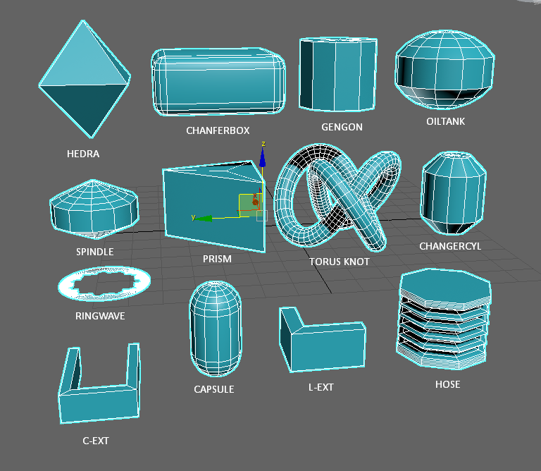
  - Radius, Height.
  - Height Segs, Cap Segs, Sides.
- Usage: Pill-like shapes, bolts, modern furniture parts.

🔹 OilTank
- Description: A cylinder with two hemispherical ends, like a storage tank.
- Parameters:
  - Radius, Height.
  - Cap Segs, Height Segs, Sides.
- Usage: Industrial tanks, silos, architectural details.

🔹 Spindle
- Description: A shape resembling a lathed object with curved sides.
- Parameters:
  - Radius 1, Radius 2, Height.
  - Side Segs, Height Segs.
- Usage: Furniture legs, architectural ornaments.

🔹 Gengon
- Description: A prism-like object with a polygonal cross-section.
- Parameters:
  - Sides, Radius, Height.
  - Fillet – Bevel on edges.
- Usage: Polygonal columns, structural bases.

🔹 Prism
- Description: A three-sided polyhedron (triangular prism).
- Parameters:
  - Side Length, Height.
  - Cap Segs, Height Segs.
- Usage: Roof forms, trusses, triangular structures.

🔹 Torus Knot
- Description: A complex twisted knot shape generated mathematically.
- Parameters:
  - Radius, Segments, P, Q (define knot complexity).
  - Thickness.
- Usage: Decorative objects, abstract modeling, parametric studies.
🔹 RingWave
- Description: Multiple concentric rings stacked along height.
- Parameters:
  - Radius, Cycles, Amplitude.
  - Height.
- Usage: Ripple effects, water-wave modeling, abstract design.

🔹 Hedra
- Description: A polyhedron based on three integer parameters (P, Q, R).
- Parameters:
  - Radius – Controls overall size.
  - P, Q, R – Define topology type.
- Usage: Geometric studies, crystalline structures, sci-fi elements.
🔹 Hose
- Description: A flexible, hose-like tube with spring characteristics.
- Parameters:
  - Height, Diameter, Thickness.
  - Turns, Bias.
- Usage: Springs, hoses, animated cables.

📝 Notes for Students
- Extended Primitives allow more organic and architectural forms than Standard Primitives.
- Many include Fillet parameters for soft edges.
- They are fully parametric, so you can refine dimensions at any stage.
- Ideal for quick prototyping of objects like tanks, columns, ornaments, or abstract structures.

📝 Note on Segments
- Definition: Segments are the subdivisions of a 3D object’s geometry. They divide the surface or volume of an object into smaller polygons (faces), usually quads or triangles.
- Purpose:
  - Smoothing & Detail – More segments create smoother curves and surfaces.
  - Deformation – Modifiers such as Bend, Twist, or Taper require enough segments for the object to deform naturally.
  - Optimization – Fewer segments reduce polygon count and improve performance, but at the cost of realism.
- Examples:
  - A Sphere with 8 segments looks faceted (low-poly).
  - The same Sphere with 64 segments appears smooth.
Practical Tip for Students:
Always balance visual quality with scene performance. Use fewer segments during modeling for speed, and increase them only where needed (e.g., close-up renders or curved details).

In 3ds Max, you can show the segments (edges/faces) of any object in the viewport with simple shortcuts. Here’s how:

🔹 Show Edges / Segments in Viewport
- F4 → Edged Faces
  - Toggles between shaded view with edges visible (shows all polygons/segments) and shaded view without edges.
- F3 → Wireframe / Shaded
  - Toggles between full wireframe mode (all segments visible) and shaded mode.

🔹 Editable Object Edge Display
When you convert an object to Editable Poly / Editable Mesh, you can also:
- Use 1–5 keys to switch sub-object levels:
  - 1 → Vertex
  - 2 → Edge
  - 3 → Border
  - 4 → Polygon
  - 5 → Element
At Edge level (2), segments appear highlighted and you can select/edit them.

📝 Quick Tip for Students:
Press F4 often when modeling → it’s the fastest way to check how many segments your object has.

